END TERM 2 2025
JULY 2025
GEOGRAPHY MARKING SCHEME PAPER 1
1. (a) Define the solar system (2 marks)
- Is a group of heavenly bodies comprising of the sun, planets and t heir satellites, asteroids and comets and meteors which orbit the sun in the universe or space

(b) main layers of the earth (3 marks)
-crust
-mantle
-core

2. (a) Differentiate between a plug dome or spine and a volcanic plug/neck (2 marks)
- A plug dome/spine is a rigid cylindrical column of very viscous lava forced out of the ground and sticks above the ground like a pillar while a volcanic plug/neck is a column of solidified magma inside the vent of volcanic cone that is exposed after erosion of a volcano as a resistant column.

(b) State 3 effects of earthquakes (3 marks)
- When earthquakes occur they cause damage of property as well as result in loss of lives.
- Earthquakes cause huge sea waves called Tsunamus which flood the neighbouring coastal areas
- Earthquakes may make parts of the sea floor to be raised or lowered.
- Earthquakes will cause vertical and lateral displacement of t he land that damage transport and communication lines.
- Earthquakes can trigger off faulting, folding and vulcanicity
- Earthquakes give off a lot of energy more powerful than atomic bombs that cause destruction and psychological trauma
- Earthquakes can lead to landslides.

3. (a) Describe the characteristics of savanna vegetation (5 marks)
- Are grasslands with widely spaced trees
- The trees are of medium height (3M) and their crowns are umbrella-shaped
- Trees have small leaves and thorns
- The savanna grasses are tall up to 3M with stiff blades
- Grass changes colour with the seasons, green during rainy season and turns brown during dry spell.
- Trees have deep roots and thick barks to reduce transpiration
- Savanna vegetation differs with the range of rainfall. i.e. in wet areas trees are dense with tall grass and in drier areas, poorer type like in semi arid grasslands

4. (a) Name any three glacial erosion features on a highland region (3 marks)
Cirque
Arêtes
Pyramidal peak/Horn
Hanging valley
V –shaped valley

b) list two factors influencing glacial erosion (2mks)
-nature of the underlying rock
-speed of the glacier
-thickness and weight of the ice
-availability of ice

5. (a) Name three process of wind erosion in deserts (3 marks)
- Abrasion
- Attrition
- Deflation
(b) Differentiate between a Zeugen and a Yardang (2 marks)
- A Zeugen – is a ridge and fullow feature produced through weathering and abrasion by wind when rocks are alternating hard and soft horizontallyin the direction of prevailing winds
While a
- A yardang – a ridge and fullow feature produced through wind abrasion when hard and soft rocks are tyingvertically parallel to each other in direction of the prevailing winds

SECTION B
ANSWER QUESTION 6 AND ANY OTHER TWO QUESTIONS FROM THIS SECTION

6. (a) Study the map of Tambach 1:50 000 (sheet 90/3) provided and answer the Following questions.

(i) Name three human features found in grid square 8260.(3 marks)
- All weather Road Loose surface.
- Shop
- Houses
- School

(ii) Measure the length of all-weather road loose surface C 51from the junction near the mining camp to the southern edge of the map. Give your answer in Km. (2 marks)

- 5.5 Km 0.1 Km (5.4-5.6)

(iii) Convert the map scale into a statement scale? (2 marks)
1:50000
50000cm = 50000 km
100000
= 0.5km
1cm represents 0.5km
(iv) Give two ways through which relief has been represented in the area covered by the map. (2 marks)

- - By use of contours
- By use of trigonometric station.
- By use of Spot Heights

(c) Draw a square 15cm by 10cm to represent the area enclosed by easting 78 and 95 and northing 60 and 70. (1 mark)

On it mark and label the following features. (i) River Kerio. (1 mark)
(ii) Lake Kamnorok. (1 mark)
(iii) Seasonal swamp. (1 mark)
(iv Tambach Municipality (1 mark)

(d) (i) Describe the drainage of the area covered by the map. (6 marks)
- The area is has many permanent rivers.
- Most rivers are vanishing
- Most of the rivers originate from the escarpments in the western and eastern part of the map.
- There is seasonal river in the south western part of the map.
- The area has seasonal swamps in Kerio valley.
- The area has papyrus swamp around lake Kamnorok.
- River Kerio and its tributaries form dendritic pattern.
- River Kerio has meanders.
- River Kerio flow from the south towards the north..

(ii) Citing evidence from the map, state five functions of Tambach town. (5 marks)
- Education centre evidence by school.
- Administrative centre evidence by District office / police line/county council
- Recreational centre evidence by rest house
- Religious centre evidence by church / mission
- Medical centre evidence by Hospital
- Transport centre evidence by roads.
commercial centre evidence by shops/petrol pump
7. (a)(i) Define a mineral (2 marks)
- A mineral is a naturally occurring crystalline inorganic substance which define chemical composition and physical characteristics.

(ii) Rocks are classified according to their mode of formation into three: namely (3 marks)
- Igneous rocks
- Sedimentary rocks
- Metamorphic rocks

(b)i) Name three types of plutonic igneous rock. (3 marks)
- Peridotite
- Gabbro
- Granite
- Diorite
- syenite

(b)(ii) Briefly describe the formation of mechanically/physically sedimentary rocks.
(5 marks)
- Rocks formed from sediments/particles of other rocks derived from many sources.
- Weathered materials are transported and deposited by agents (Ice, water wind) either on land or in sea waters
- Over a period of time the materials consolidate, get compacted cemented into a hard rock.
- The rocks are formed in layers according to different periods the materials were laid down.
- They are classified according to the size of materials laid down into mendacious (large), Arenaceous (medium) and Argillaceous (fine).

(b)(iii) State any five significance of rocks (5 marks)
- Formation of soils for agri; after weathering
- Stores underground water
- Fossil fuels are obtained from rocks;
- Various salts are obtained from rocks e.g rock salt.
- Building materials; for building and construction.
- Some rocks form fascinating features that are tourist attractions.
- Some rocks are used in heavy industries i.e. limestone used in copper and iron smelting
- Some are used in making ornaments and sculptures and decorations.
- Contain mineral deposits

(c) Students from Bonyunyu Sec. School in Nyamira County, set out for a field study on rocks within Nakuru County
(i) List down any four preparations they will make for their study (4 marks)
- Ask permission from school and county of Nakuru
- Organize for means of transport
- Set their objectives and hypotheses for the study.
- Divide themselves into groups
- Draw their schedule
- Prepare their questionnaires
- Have the map of Nakuru County.

c) ii) Give three reasons why it’s necessary to make a reconnaissance survey (3 marks)
- To know the direction/routes of area to visit
- To prepare for the means of transport and draw time schedule
- Help them prepare on the method to use to collect their data.
- To ask for permission from the county of Nakuru.
- To help them to identify the problems to encounter.

8a) A spring is a natural outflows of water from the rocks while a well is hole sunk into a permeable rock to reach the water. (2mks)

b)
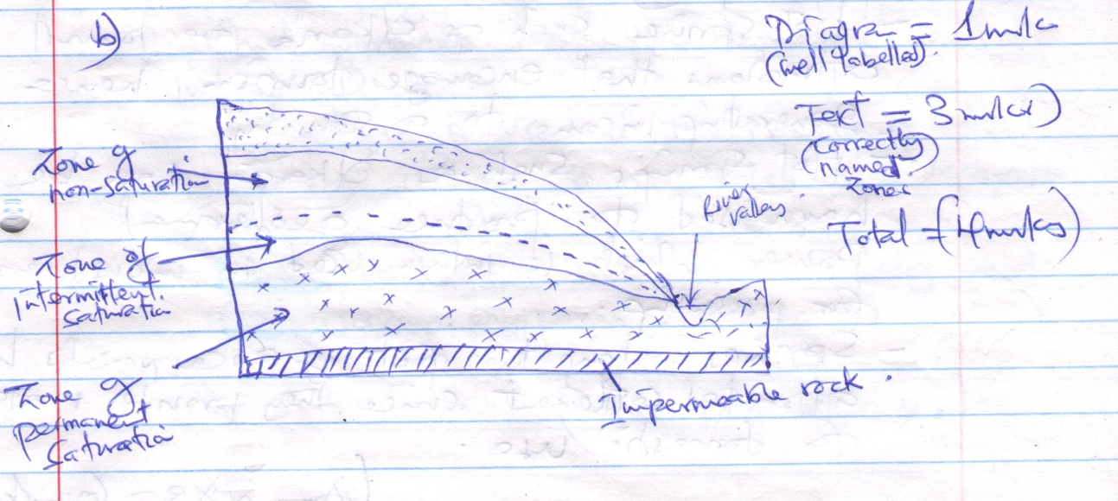

- c) – Aquifer must me of permeable materials rocks
  - The aquifer must be exposed in an area of sufficient precipitation
  - The aquifer must be in between two impermeable rocks for it to detain water.
  - The mouth of the well must lower than the intake area to allow water to be forced to the surface by pressure with no neet of pumping it.
  - The aquifer must dip from a region of water intake and rocks layers must form a broad syncline or basin
- d)
    - Many springs are source of rivers or their tributaries which provide water for industrial uses.
    - Ground water is used in irrigating land hence promoting agricultural activities.
    - Hot springs such as olkaria are tourist attraction that encourage tourism hence generating income to a county.
    - Hot springs such as Olkaria can be harnessed to produce geothermal power which is inturn used in industrial for processing.
    - Springs along the foot of escarpments have attracted settlement since they provide water for domestic use.

e) i) Karts scenery is a limestone region where water action has created unique features on the surface as well as underground. (2x1=2mks)
ii)The surface rock and the rock beneath should be thick limestone,……. Or chalk.
    - The rock should be harf and well jointed.
    - The climate should be hot and …..
    - The water table should be deep below the surface. (1x3=3mks)
iii)
- The features form good tourist attraction i.e Gorges who intun bring foreign exchange to a country.
- Collapse of dolines into the water table may lead to formation of lakes which provide water for domestic and industrial use.
- Limestone is used in the iron and steel industry where it is used to separate iron from other impurities.
- Limestone’s regions are very good for grazing purposes.

- a) i) Ocean is a vast body of salty water on the earths surface that surround the land or continent while sea is a large salty water body found at the margins of continents

ii)
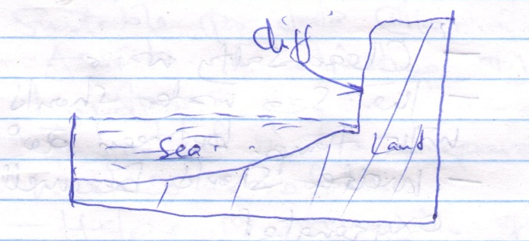
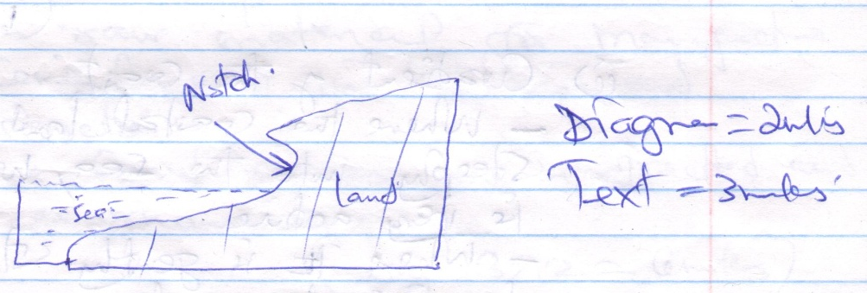

- Wave erosion attacks a steeply sloping coast at the high tide level work.
- A notch is formed and an overhanging block is suspended above the notch
- The overhanging block eventually collapse and vertical or near vertical rock face is exposed to form a cliff
b) i) Climate
- Climate influences weathering of coastal rocks hence causing wave erosion along the coastal land to be more effective since rocks are already weakened.
- Coral coasts develop in the tropical regions of the world in the warm seas. (1x2=2mks)
ii) Gradient of the coast
- Where the coastal land slopes steeply into the sea, wave erosion is very active.
- Where is gently steeping, wave deposition dominates.

c) i) – Clear salty water
- The sea water should be warm with temperature between 20⁰ and 29⁰
- Water should be well oxygenated
- Water should be clear, free from silt or mud.

ii) Coral features such as fringing reefs attract tourist who bring foreign exchange into the country.
- Coral reefs provide breeding ground for fish which inturn promote fish industry and provision of food
- Coral rocks provide limestones which is a raw materials for manufacture of ….. used in building and constructions.
- Some coral stones are extracted and sold as ornaments.

d) i) Enables them to determine the methods suitable for data collection
- Assists in adjusting objectives and hypothesis
- Important in the preparation of a working schedule
- Helps in preparation of a route map. (1x3=3mks)

ii) Affected by elements of subjectivity as it depends on one persons observation.
- Encourages biasness as the choice of where to conduct the study depends on an individual.
- Visual fisability may reduce its effectiveness
- It is tiresome and expensive since it involves a lot of travelling (1x2=2mks)
10. a)Outline two factors that influence the development of drainage patterns.
- Direction of the slope of the land.
- Difference in rock resistance /hardness.
- The arrangement of rock layers/rock structure 2 mks
(ii) Outline five characteristics of a river in its youthful stage.
- the river has a steep river gradient.
- the river channel is narrow.
- the river has deep/steep-sided/V-shapedvalley
- the river flows at a high speed/high stream velocity.
- the vertical erosion/down cutting is dorminant.
- the river channel is generally winding
- Erosional featuresare common rapids/waterfalls/cataracts/cascades/ interlocking
spurs/potholes/ plunge pools/
- the type of flow is torrential.
- the river has a small load
- the river has a small volume of water
b) Describe the following processes of river erosion.
i)Attrition: As rock materials are transported downstream, they constantly collide against each
other.
The materials gradually wear down/reduce in sizes
Corrasion : As solid rock materials are transported downstream, they are hurledagainst the banks
and drapedalong the river bed
The rock materials chip off pieces of rock from thechannel and the river bed,
Eddy currents rotate pieces of rock around the hollows breaking/ grinding the river bed.
c)Explajn three negative effects of rivers to the human environment.
-When rivers flood, they destroy a lot of property/crops lead to loss of human life.
- Wide/deep rivers are a barrier to transport especially where bridges have not been constructed.
- River water can be a medium of spreading water-born diseases, since flood waters may spread
chemicals from farms/human waste which contaminatessources of water
- Some rivers are habitat to dangerous animals which may attack human beings/destroy crops.
(d) Your class is planning to carry out a field study of a river in its old stage,
(i)State three reasons why it would be necessary to pre-visit the area of study.
- It helps to draw up objectives/hypothesis for the study,
- It helps to prepare a route map.
- it helps to design a working schedule.
- it helps to identify the probable problems/how to solve problems.
-it helps to asses the suitability of the study area
(ii) State three activities you would carry out to determine why deposition occurs at this
stage.
- Measuring of gradient.
- Finding out the nature of the load.
- Finding out the amount of the load.
- Establishing the velocity of the river.
- Observing obstacles in the stream channel/distributaries.
- Measuring of the width of the river. any 3x1=3 mks

