KENYA EARLY YEAR EDUCATION ASSESSMENT
GRADE 3 END TERM 2 2025 MATHEMATICS ACTIVITIES
NAME_____________________________DATE_______________
6. Work out (5)
438 532 9
+240 + 18 +2

600+49= 15+2=

7.How many trees will joyce have altogether if she is given 500 seedlings and 400 seedlings (2)

8. What is the time? (2)

9 Subtract (3)
26-5=
34 60
- 6 -50
1.Place value (2)
- 456=_____hundreds_____ten ______ones(2)
- 4 hundred 0 tens 2 ones
= _________________
2.Write three hundred and seven in symbol ___________(1)

3. Circle the largest number (1)
40 , 6, 102, 30, 80

4.Shade ½ (2)

5. Write in words (3)
1^{st __________________}
2^{nd___________________}
5th ___________

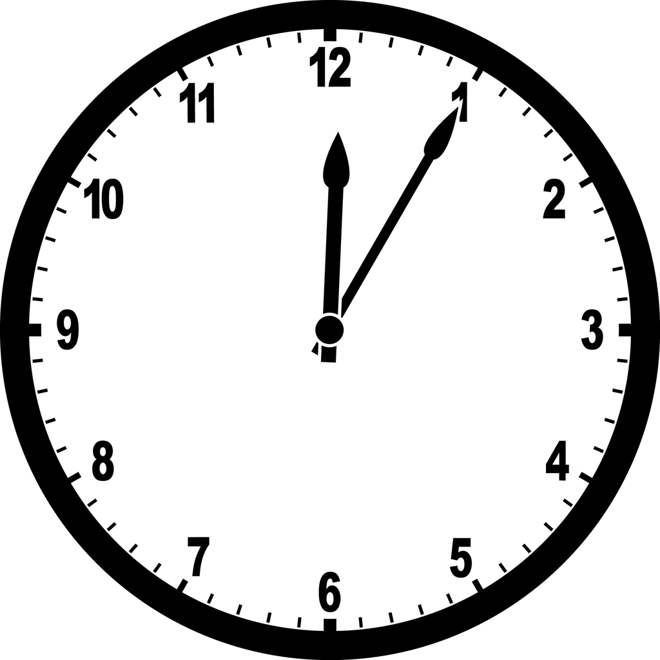
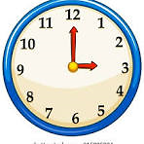

13.Name the shapes (3)

_______ ______ _______

14.Divide (5)
a) 6÷2=____________
b) 72÷9=_____________
c) 12×3=______________
d) 50÷10=______________
e) Share equally 20 books among
4 pupils ________________

15.Who will form longest shadow
(1)

noon |  | morning
16.Name direction A (1)

17.Name the note (1)

___shillings

10.Work out(3mks)
110m-100m= ________
80kg-60kg= __________
300L-200L=___________
11.What fraction is shaded (1)

12.work out (5)
  - 2 x 2 = __________

  - 2 x 6 =___________

  - 7 x 3 =__________

  - 5×3=____________

e.

A
4× ____ =8
left


Assessment Rubrics 40×2.5= 100%
Score % | Below expectation  0-39 | Approaching expectation  40-59 | Meeting expectation  60-79 | Exceeding expectation  81-100
Level | 1 | 2 | 3 | 4
Pupil score level

