KENYA EARLY YEAR EDUCATION ASSESSMENT
GRADE 3 END TERM 2 2025 INTEGRATED ACTIVITIES
NAME_____________________________DATE____
Environmental (20mks)
1.Draw the sources of water (2)

2.Name one effect of floods that occurs during heavy rain (1)

3.Name weather suitable for the
Items worn (2)
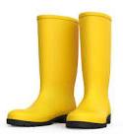 | 

4.A long shadow is form in (1)

5._______________ is energy giving food(1)
(Vitamins, carbohydrate, protein)
6. This plant need ________type of soil to grow(1)
7. Name parts of the plant (2½)

8.Write true or false (3)
a) we get drinking from hole
_______________
b) drinking water should be boiled to kill germs__________
c) heat is used for warming____
9.Name the following source of heat(3) (solar, iron box, gas cooker)

_______ ______ ______
10.Use chart to answer the question
Days | morning | noon | Evening
Saturday |  | 
Sunday |  | 
Monday |  | 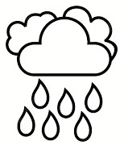
a) Which day was rainy on noon______
_________________(1)
b).Which day will you your wash clothes
_______________________(1)
c) Which day was sunny in the morning
and cloudy in the evening_______(1)

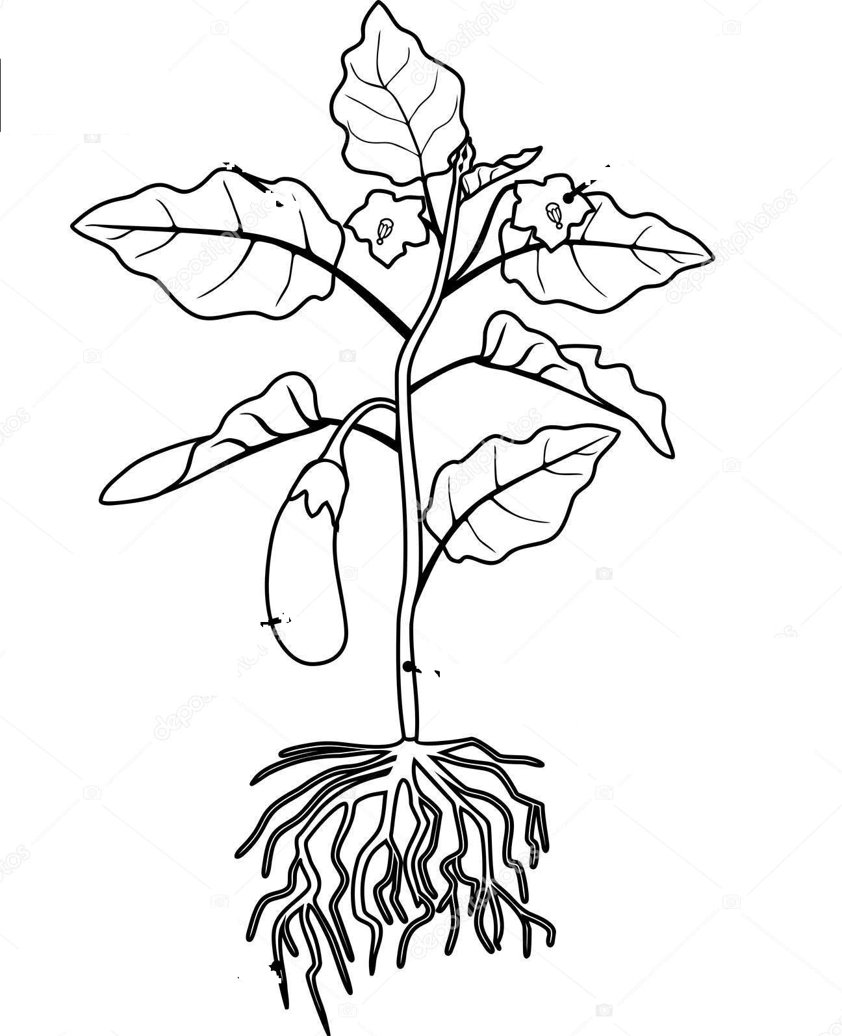

well
river

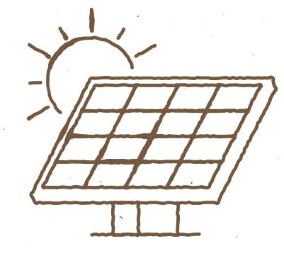
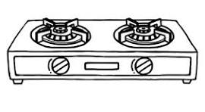
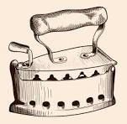

CREATIVE ACTIVITIES(10)
1. Name the movements (2)

__________ __________
(swing, skipping )
2. This basket is made (1)
through _________

3. Name one material used for
Mosaic/ collage picture _________________(1)
4. Write whether is backword or forward ball dribbling (2)

__________ ________
5. Draw the musical instruments(3)
guitar | shakers | horn

A guitar is play by___________(1)
(Hitting, shaking, plucking)

d) This table is called ________chart
(weather table, weather chart)(½
CRE ACTIVITIES (10mks)
1__________took his sandals (1
(John , Jonah, Moses)
2 ___________was swallowed by big fish (1)
3 _____and ______were the first people created by God (2)
4. Name two family members (2)
_________________
___________________-
5.Name three sons of Noah (3)
________________________
6. Fill the table (1)
Father of Jesus | Mother of Jesus




Assessment Rubrics 40×2.5= 100%
Score % | Below expectation  0-39 | Approaching expectation  40-59 | Meeting expectation  60-79 | Exceeding expectation  81-100
Level | 1 | 2 | 3 | 4
Pupil score level



