Kenya Certificate of Secondary Education(KSCE)
451/1
COMPUTER STUDIES
PAPER 1
(Theory)
END TERM 2 2025
JULY 2025
TIME: 2 ¹/₂ HOURS

MARKING SCHEME
SECTION A (40 MARKS)
1 (a) Peripheral devices
-Used for entering data into the computer.
-Used to provide the user with the processed results (information). (1 mark)
(b) system software
-Booting the computer and ensuring that all the hardware elements are working properly.
-Performing operations such as retrieving, loading, executing and storing application programs.
-Storing and retrieving files.
-Performing a variety of system utility functions. (1 mark)
2.
- Standard furniture in the laboratory
- To avoid poor posture during machine use this may lead to strain, injury and limb fatigue
- Antiglare screen/ monitor
- To avoid eye strain and fatigue caused by over bright cathode ray tube monitors (CRT)
- UPS
- Temporary power supply to the computer to allow the user to save the work (power back up)
- Stabilize power (clean unstable power supplied from the main source to clean stable voltage)

3. Describe future trends in microcomputers in relation to:
(a) Hardware (2 marks)
-Increase in processor speeds and capabilities.
-Reduction in size and increase in capabilities, leading to emergence of smaller but smart devices.
-Reduction in cost of components.
(First 2, 1 mark each)
(b) Software (2 marks)
-Development of operating system that will handle real time data analysis and object- oriented;
-Improved user interfaces that offers users easier and more intuitive access to information;
-Development of multi-media applications that will be fully incorporated into some information systems because data is easier to interpreted when presented as a combination of sight, sound and motion.

4. Explain the meaning of BACKUP. (2mks)
- This is storage of a copy of program or data in another place to be used if the original is lost or damaged.

5. Differentiate between the following terms as used in word processing (3marks)
- Drop cap is a large character at the start of paragraph that occupies more than one line downwards while text case is capitalization of text ( you can switch from either lower or uppercase)
- A superscript appears just above the rest of the characters while subscript appears just below other characters while subscript appears just below other characters
- An indent is a white space at the beginning of each line while tabs are used to add uniform spacing in the line of text
6. State two advantages of electronic spreadsheets over manual worksheets. (2marks)
-It enables automatic recalculation
-Editing is easy
-Analysis of data is easy due to the use of formulas
-Work is neat
7. (a) Computer processing file
- Master file – Is the main file that contains permanent records of a particular entry.
(ii) Transaction – Working file whose information is expected to change regularly – i.e. daily
(iii) Reference
(vi) Back up
(v) Sort
(vi) Report ½ mk stating , ½ mk explanation

(b) List any two organization methods (2marks)
- Hierarchical file organization
- Horizontal

8. Define a primary key field (3marks)
-This is a field that is used to distinguish one record from another.
-A candidate key that is selected to identify all the attributes uniquely.

9. -Compiler
-Test data

10. A computer studies form one student was requested to format his diskette in Windows XP Operating System environment. Instead, he selected and formatted the hard drive by mistake.
(a) -In order for the operating system to recognize it during the storage and retrieval operations.(1 mark)

(b) It resulted in the loss of data, information and programs.(1 mark)
(c) Describe two situations when the computer user will be required to format a storage media. (1 mark)
-When the diskette is new.

11. a)-value
b)-C6
c)- =sum (B6: E6) or =b6+c6+d6+e6 (must have an equal sign to earn a mark)

12. What is deadlock in reference to operating systems (1mark)
Is a situation that results when several tasks complete for a resource which is held and not being released for use by another task.

13. -The initial setup cost is high.
-Through e-mails, viruses and worms are transmitted which can cause havoc on the computer system.
-Hackers and crackers easily interfere with other peoples’ privacy.
(First 2, ½ mark each)
14. Baseband signal – Digital signal transmitted through a digital channel without modulation( 1mk)
Broad band - A group of analog signals transmitted through a common channel but with varying signal frequency
15. Explain two ways of protecting data and information against unauthorized access (2marks)
- Password protection – A password to open or exit the database file i.e. lets any user who wishes to do any action
- Data encryption – If the database is to be sent electronically encryption secures the data from un authorized access
- User and group permission to users on data base object such as queries form and reports
- User level security – this feature is used to assign permission to users in order to limit user access to certain database object

SECTION B (60 MARKS)
Answer question 16 (compulsory) and any other three questions from this section.
16. (a) (i) -It indicates that a processing or data transformation is taking place.
(1 mark)
(ii) -It represents a transaction file used to store input data during transaction processing (1 mark)
(b)
(i) (7 marks)
SRART
PRINT “Enter time of day and call type”
READ timeofDay, calltype ½ mk
IF call type is safaricom THEN ½ mk
IF TimeofDay is between 8am to 12noon THEN
Charges =6Ksh

ELSE
IF TimeofDay is between 12noon to 2pm THEN
Charges =0.8kshs

ELSE 2mks
IF TimeofDay is between 2pm to 1am THEN
Charges = 4kshs
ELSE
Charges = 1ksh
ENDIF
ENDIF
ENDIF
ELSE ½ mk
IF calltype = other networks THEN
Logic = ½ mk IF TimeofDay is 8am to 8pm THEN 1mk
Charges = 7kshs
ELSE
Charges = 5kshs
END IF
ELSE ½ mk
IF TimeofDay is 8am to 8pm THEN
Charges = 25kshs
ELSE
Charges = 35kshs 1mk
END IF
ENDIF
ENDIF
PRINT charges ½ mk
STOP

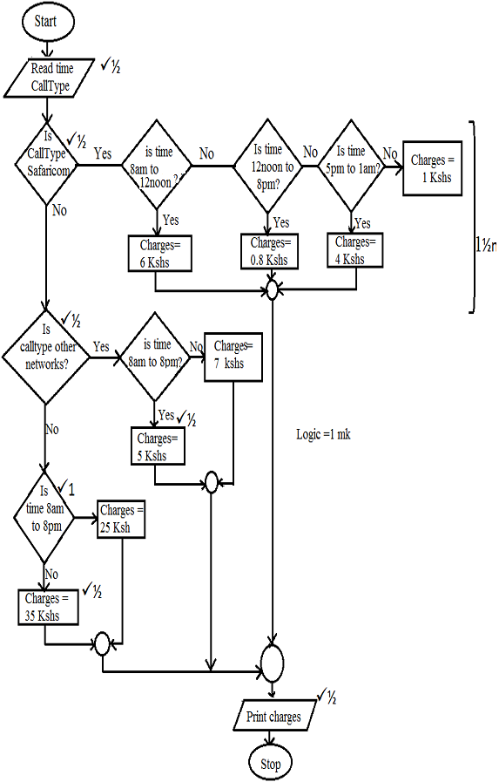(6 marks)
17. (a) i.
1010.101
11.011 +
1110.000 =14₁₀

ii)
1010.011
11.011 –
111.000 =7₁₀

b)
i. 1001₂
ii.

c)
1110₂

18. A school computer laboratory is scheduled to undergo major renovations. The lab is schedule to receiver new computer whose specifications are given below:-
Pentium IV 2.8GHz processor
40GB HDD
3 ½ FDD
256MB RAM
56CD Rom
17” SVGA TFT monitor
The computers are gong to be networked and will be able to browse the internet.
- Explain what is meant by the terms:- (2marks)
- FDD
- An acronym for floppy disk drove which the computer possesses for 3 ½ size disks
- HDD
- An acronym for hard disk which the computer possess and its storage size is 40GB
- SVGA
- An acronym for thin film transistor monitor type
- TFT
- An acronym for thin film transistor monitor type
- The computer is to be networked, name one extra device that should be fitted on every computer to enable this to happen (1mark)
- NIC (network interface Card)
- The computer is to receive internet facilities through the server on a dial; up system. Name and describe the function of a special device that needs to be connected to the server to complete the connection. (1mark).
- A modem

- (i) The school has to apply he star topology to link up the computer. List two advantages of this
type of topology. (1mark)
- Easy to configure
- Allows centralization of key networking resources like concentration and servers
- Gives network administration focal point for network
- Name the central device used to connect the computers in this topology. (1mark)
- Hub
- List two other types of topologies that the school could have opted for (1mark)
- Bus topology
- Ring topology
- Mesh topology
- Tree/ hierarchical topology

- List four advantages of using a network (2marks)
- Improves reliability e.g. incase one computer breaks down, users can still access data and information from other computer on network
- Resources sharing i.e. data/ information, files, printers, modems, programs etc can be attached to the network for access by all users
- Distributed processing facilities
- Remote communication i.e. transfer of data signals between two communication devices located differently
- Cost effectiveness. Although initial cost of laying down the network components may be expensive the savings experienced and the value added to service delivery make them a
- (i) Data transmission via the internet is done using a mode known as packet switching. Describe this data transmission mode (1mark)
- Refer to the process over the network of breaking down into discrete systematic steps the data transmission process and at each step a certain action takes place.
- Name two other modes of transmission (1mark)
Simplex Mode
Half Duplex and Full Duplex
h) (i) The school’s LAN is done using UTR cable. List two advantages of using this type of cable.
(1mark)
- Don’t have shield that prevent electromagnetic interference (EMI)
- Cheap (not costly)
- List two advantages of using fibre cable in networking. (1mark)
- Hard to tap (security)
- Immune to effects of moisture and light.
- Does not suffer from E.M.I
- Flexible in size.
iii) Data flows in the school’s LAN in a duplex manner. Discuss two other types of data transmission in network giving examples (2marks)
- Hard duplex (Bi – directional)
- Data flows in both direction but only one direction at a time.
- Simplex
- Data flows in one direction on the communication media.

19. (a) The growth and widespread use of computers and its related technologies has led to job displacement, creation and replacement. Define the following terminologies.
(i) Job displacement (1 mark)
- This is where an employee is moved to place where or department where computer skills are not required.

(ii) Job creation (1 mark)
- ICT has introduced new employment opportunities that never existed before.

(iii) Job replacement (1 mark)
This is where some clerical and repetitive tasks that required a large number of employees have been made redundant. For example, computer illiterate people have been replaced with those who have the desired computer skills.

(b) (i) - Natural language processing is aimed at coming up with programming languages that would make computers recognize and understand natural languages, whether spoken or written while voice input refers to a data entry method where data is entered into the computer in form of spoken words using a microphone.
(2 marks)
(ii) State any two difficulties of implementing natural language processing. (2 marks)
- The complexity of natural languages which are ambiguous and may be interpreted differently by different people.
(c) (i) Explain three ways in which computers and related technologies can increase stress in the workplace. (3 marks)
- Computers are used to monitor employees’ performance.
- “Technophobia” – the fear of computers by older staff and their concern that hey will become de-skilled by the introduction of IT.
- When employees experience “information overload” i.e. computers can bombard people with more information than they can assimilate.
- The pace at which ICT changes may put the employees under pressure in order to keep up with every new development.
(ii) Suggest two ways in which computer related stress in the workplace can be minimized. (2 marks)
-The office layout and design should be reorganized in such a way that it forces people to interact.
- There should also be development of small teams to allow personal interaction

(d) -Using it to spread viruses or malware
-Using it to spy on other users.
-Committing computer crimes such hacking, cracking, etc.
-Accessing pornographic materials.
(First 3, 1 mark each)
20. (a) Define the following terms
- Database ( ½ mark)
- It is a collection of data stored for organizational use
- Database management system ( ½ mark)
- A collection of programs required storing, organizing and retrieving data from a database
- Hierarchical database (1mark)
- A database structure where data is organized like a family tree having branches made up of parent and child records with each parent record having several child records and never vice versa
- Relational database (1mark)
- A database structure in which data is organized in two dimensional tables called relations where an element in any one table can be related to another piece of data in another table as long as they have a common data element.
Diagram
- Network database (1mark)
Diagram
(b) List the advantages of using an electronic database system for storage of data over the file approach. (4marks).
- Data is input only once and is made available to the many files
- Avoids duplication of files
- Avoids duplication of tasks at different points hence being economical
- Due to shared records, there is reduced processing time, reduction in use of hardware and lead to ‘√
- More efficient use of data processing personnel ‘√
- Leads to improved flow of data that is valuable to management as it is comprehensive (encompassing all) ‘√
- Leads timely and accurate reporting of data to all maintenance centres ‘√
- Reduction of paper costs ‘√
- Saving on storage space

(c )
- Write down the formula that can be used to find the price of the most costly book (1mark)
= large ((c3:c9),1) or = max (c3..c9)
- Write down the formula that can be used to determine the total sales for the book titled COMPUTER STUDIES (1mark)
=b8*c8
- Write down the formula that can be used to determine the average price of the books. (1mark)
=ave(B3.B9) or + (B3 + B4 ÷ B5 + B6 + B7 + B8 + B9)/7
- Write down the formula in cell D6 that can be used to find the new per book if they went up by a percentage written in cell B 10 and the formula has to be entered only in cell D3 then be copied to others. (1mark)
=b6*$B$10
- Write down the output in D7 if in B6 is 10% (1mark)
770
(d) State any four advantages of using an electronic spreadsheet as compared to a traditional worksheet. (2mark)
- Utilizes powerful aspects of computer like speed, accuracy and efficiency to enable the user quickly accomplish his/ her tasks
- Have inbuilt formulae called functions that enable the user to quickly manipulate mathematical data
- Have better document formatting capabilities
- Automatically adjust the result of a formula if the values in a worksheet are changed i.e. automatic recalculation
- Enables the user to produce neat work because traditional papers, pencil, rubber and calculator are put aside.
- Utilities the large storage space on computer storage devices to save or retrieve documents.

