Name: _____________________________________________Adm No: ____________Class: _____
Candidate’s Signature: ________________________ Date: _________________________

CHEMISTRY
FORM 2
END TERM 2 EXAMINATION
JULY/AUGUST 2025
Time: 2 HOURS

Instructions to Candidates
- Write your name and other details on the space provided above
- Answer all the questions in the spaces provided for each question.
- All working must be clearly shown where necessary. Name
- Mathematical tables and non-programmable electronic calculators may be used.
For Examiners Use Only

Questions | Total marks | Student’s score
1 - 18 | 80

- (a) Define the term ionization energy. (1 mark)

(b) The table below shows the 1st ionization energy for elements F, G and H.
Element | 1st ionization energy
F | 494
G | 519
H | 418
- Which element has the smallest radius? Explain. (1 mk)

- Which element is the most reactive? Explain. (1 mk)

- (a) Give the meaning of the term isotopes. (1 mk)

(b) Calculate the percentage abundance of lithium - 7 and lithium - 6 given that the relative atomic mass of lithium is 6.94. (2mks)

- (a) The atomic number of element Q is 16. Write the electron arrangement of the ion Q²⁻.
(1mks)

(b) Write the formula for the compound formed when sodium reacts with element Q.
(1mks)
(c) To which group and period of the periodic table does element Q belong? (1mk).
Group
Period

- The table below shows the behaviour of some metals W, X, Y and Z. Study it and answer the following questions.
Metal | Appearance on exposure to air | Reaction with water | Reaction with hydrochloric acid
W | Slowly tarnishes | Slow | Vigorous
X | No change | Does not react | Does not react
Y | Slowly turns white | Vigorous | Violent
Z | No change | No reaction | Reacts moderately

- Arrange the metals in order of their reactivity starting with the least reactive. (1mk)

- Name a metal that is likely to be X. (1mk)

- Metal Z is in group II of the periodic table. Write an equation for the reaction of metal Z with dilute hydrochloric acid. (2mks)

- (a) Give the meaning of the term indicator. (1mk)

(b) Classify the following substance as acidic, basic or neutral. Wood ash, lemon juice and common salt. (3mks)
Acid | Base | Neutral

- Crystals of iron (III) chloride were heated in a test tube.
- Give the name of the process that takes place. (1mk)

- Name two other substances that undergo the process named in (a) above. (1mk)

- Write an equation to represent the process. (1mk)

- A student accidentally mixed two solids of sodium chloride and copper (II) oxide.
- What is the colour of: (1mk)
- Sodium chloride?

- Copper (II) oxide?

- Describe a procedure that can be used to obtain the two solids separately. (2mks)

- The table below represents part of the periodic table. The letters are not actual symbols of the elements. Study it and answer the questions that follow.
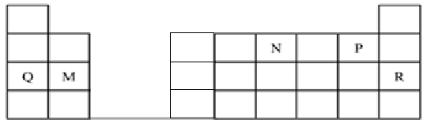
- State the most unreactive element. (1mk)

- Compare the atomic radius of element N and P. Explain. (1mk)

- Write the formula of the nitride of M. (1mk)

9. Given that the atomic number of Y is 13 and that of Z is 9:
- Write the electronic arrangement of Y and Z; (1mk)

- Draw the dot (.) and cross(x) diagram for the compound formed by Y and Z (1mk)

- An ion is a particle formed when an atom either gains or loses electrons. Draw the structure of the most stable ions of the following elements.
- Sodium (1mk)

- Oxygen (1mk)

- In an experiment, a burning magnesium ribbon was lowered into a gas jar full of oxygen gas.
- State the observation made. (1mk)

- Write the equation for the reaction that takes place. (1mk)

- Give one use of the product formed from the reaction. (1mk)

- The set-up below was used in an experiment to determine the conditions necessary for rusting.
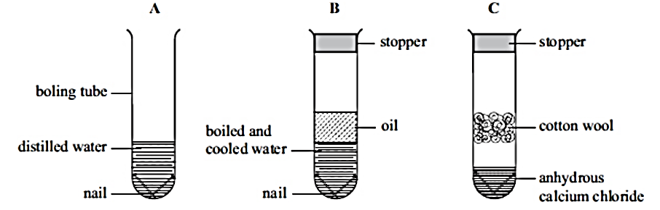
- In which set-up will the iron nails rust? Explain. (2mks)

- A large piece of magnesium buried in the ground and connected to an underground iron pipe prevents the corrosion of the iron pipes. Explain. (1mk)

- Describe an experiment that can be used to investigate that there is an increase in mass when magnesium is burnt in air. (3mks)

- A piece of sodium metal was placed in a beaker half-full of water.
- State two observations that were made. (2mks)

- Explain the observations you have mentioned in (a) above. (2mks)

- Write an equation for the reaction that takes place. (1mk)

- A few drops of phenolphthalein indicator were added to the resulting solution. State and explain the observations that were made. (2mks)

- What observations would be made if a piece of calcium metal was used in the experiment instead of sodium metal? (2 mks)

- Study the information in the table below and answer the following questions.
Substance | Solubility in water | Solubility in ethanol | Effect on heating
Sodium chloride | Soluble | Insoluble | No effect
Candle wax | Insoluble | Soluble | Melts into a thick liquid and vapourises
Sand | Insoluble | Insoluble | No effect
Solid aluminium chloride | Soluble | Insoluble | Sublimes

- Describe how a mixture of sodium chloride and sand can be separated. (3mks)

- A student was given a mixture of solid aluminium chloride and wax and asked to separate the mixture.
- Explain why is not advisable to heat the mixture to separate it. (1 mk)

- Explain how the mixture can be separated. (2mks)

- State one application of the following methods of separation. (1mks)

- Crystallisation

- Matter can be classified as pure substances or mixtures.
- Give the meaning of the following terms that relate to matter. (2mks)
- Atom

- Compound

- Write the chemical formulae of the following compounds. (3marks)

- Ammonium sulphate

- Ammonia gas

- Sulphuric (VI) acid

- Give the meaning of the term oxidation number. (1 mk)

- Acids and some metals react to give a colourless gas.
- Identify solution G and gas X in the following reaction. (1 mks)
Dilute sulphuric (VI) acid + zinc granules → solution G + gas X
Solution G:
Gas X:
- Write the chemical equation for the reaction taking place in (a) above. (1 mark)

- The table below shows pH values of solutions A, B, C, D and E
Solution | pH
A | 5.2
B | 12.0
C | 2.0
D | 9.8
E | 7.0
- Which of the solutions is likely to be: (2 marks)
- Ammonia solution
- Sodium hydroxide
- Hydrochloric acid
- Ethanoic acid
18. The grid given below represents part of the periodic table. Study it answer the questions that follows. The letters do not represent the actual symbols of the elements.
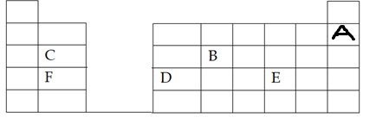

i) What name is given to the group of elements to which “C” and “F” belong? (1mk)
ii) Which letter represents the element that is least reactive? Explain. (2mks)

iii) What type of bond is formed when B and E reacts? Explain. (2mks)

This is the last printed page.

