
MARANDA HIGH SCHOOL
Kenya Certificate Of Secondary Education
THE 2025 MOCK EXAMINATION
233/2 CHEMISTRY PAPER 2
June, 2025 TIME: 2 Hrs

Name: …………………………………….…….…… Admission No: ……………
233/2 - CHEMISTRY

Date……………………………..

Stream: ……………………….. Signature: ……….........
Instructions
- Write your name, admission number, date, stream and signature in the spaces provided above.

- All answers must be written in the spaces provided in the booklet.
- This paper consists of 13 printed pages with 7 questions. Candidates should check the question paper to ascertain that all the pages are printed as indicated and that no questions are missing
- Candidate should answer the questions in English
______________________________________________________
FOR EXAMINERS USE ONLY
Questions | Maximum Score | Candidate’s Score
1 | 12
2 | 10
3 | 11
4 | 12
5 | 13
6 | 10
7 | 12
TOTAL | 80
1. Use standard potential for elements G, M, N, P and Q given below to answer the questions that follow.
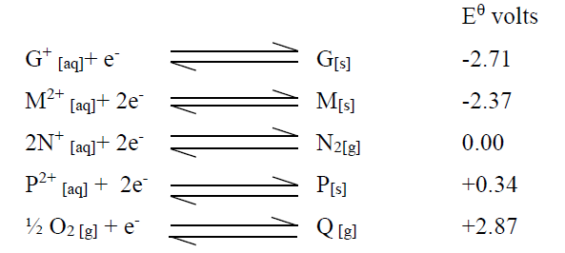
(a) (i)Which element is likely to be hydrogen? Give a reason to your answer. (2marks)
………………………………………………………………………………………………………………..
………………………………………………………………………………………………………………..
ii) What is the $E^{θ} value$ of the strongest oxidizing agent? (1mark)
………………………………………………………………………………………………………………..
………………………………………………………………………………………………………………..
iii) Draw a well labelled diagram of the electrochemical cell that would be obtained when half cells of M and P are combined. (3marks)
………………………………………………………………………………………………………………..
………………………………………………………………………………………………………………..
………………………………………………………………………………………………………………..
………………………………………………………………………………………………………………..
………………………………………………………………………………………………………………..
………………………………………………………………………………………………………………
iv) Determine the $E^{θ} value$ of the electrochemical cell constructed in (iii) above. (2marks)
………………………………………………………………………………………………………………..
………………………………………………………………………………………………………………..
………………………………………………………………………………………………………………..
(b) During the electrolysis of aqueous copper (II) sulphate using copper electrodes a current of 0.8 amperes was passed through the cell for 10hours.
(i) Write ionic equation for the reactions that took place at the cathode. (1mark) ………………………………………………………………………………………………………………..
(ii) Determine the change in mass of the anode which occurred as a result of the electrolysis process.
(Cu = 63.5, 1 Faraday = 96500 Coulombs) (3marks)
………………………………………………………………………………………………………………..
………………………………………………………………………………………………………………..
………………………………………………………………………………………………………………..
………………………………………………………………………………………………………………..
………………………………………………………………………………………………………………..
2. a) Give a reason why the following combination of reagents should not be used to prepare hydrogen gas in the laboratory.
i) Copper and dilute hydrochloric acid. (½ mark)
………………………………………………………………………………………………………………..
………………………………………………………………………………………………………………..
ii) Calcium and dilute sulphuric (VI) acid. (½ mark)
………………………………………………………………………………………………………………..
………………………………………………………………………………………………………………..
iii) Sodium and dilute hydrochloric acid. (½ mark)
………………………………………………………………………………………………………………..
………………………………………………………………………………………………………………..
iv) Zinc and dilute nitric (V) acid. (½ mark)
………………………………………………………………………………………………………………..
………………………………………………………………………………………………………………..
b) A student reacted magnesium with steam as shown below.
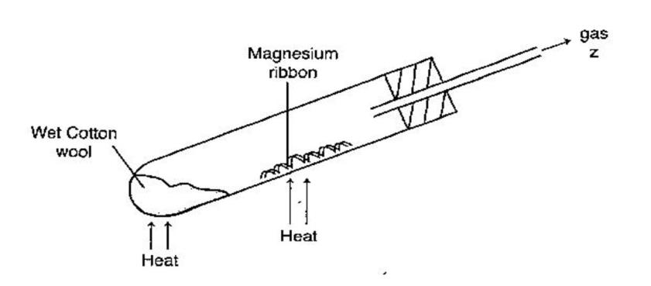
i) Explain why the wet cotton wool should be heated first before heating magnesium. (1 mark)
………………………………………………………………………………………………………………..
………………………………………………………………………………………………………………..
ii) Name gas Z. (1 mark) ………………………………………………………………………………………………………………..
………………………………………………………………………………………………………………..
iii)Write the equation taking place in the boiling tube. (1 mark)
………………………………………………………………………………………………………………..
………………………………………………………………………………………………………………..
c) Dry hydrogen gas was passed over heated lead (II) oxide in a combustion tube as shown below.
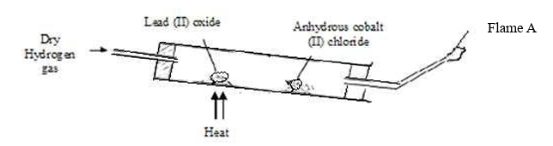
i) State two observations made in the combustion tube. (2 marks)
………………………………………………………………………………………………………………..
………………………………………………………………………………………………………………..
ii) Give the colour of flame A. (1 mark)
………………………………………………………………………………………………………………..
iii) State the type of change undergone by anhydrous cobalt (II) chloride at the end of the reaction.
(1 mark)
………………………………………………………………………………………………………………..
iii) Name one gas used together with Oxygen other than hydrogen gas in welding. (1mark)
………………………………………………………………………………………………………………..
………………………………………………………………………………………………………………..
3.a) The chart below shows the stages involved in the manufacture of fertilizer Q in a factory. Study it and answer the questions that follow.
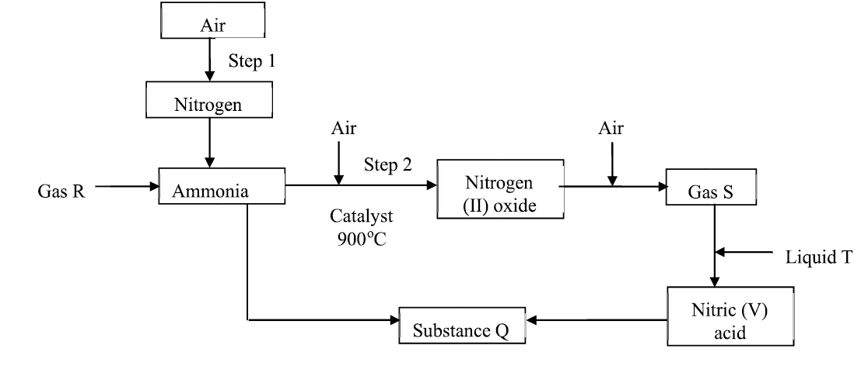
i) State one source of gas R. (1 mark)
………………………………………………………………………………………………………………..
………………………………………………………………………………………………………………..
ii) Identify:
I: Liquid T (1 mark)
………………………………………………………………………………………………………………..
II: Gas S (1 mark)
………………………………………………………………………………………………………………..
iii) Write an equation for the reaction in step 2. (1 mark)
………………………………………………………………………………………………………………..
iv) Name the process in step 1. (1 mark)
………………………………………………………………………………………………………………..
v) Substance Q involves direct reaction between ammonia and nitric (V) acid. If 6.4 x 10³ kg of substance Q is made per day, calculate the mass of ammonia used daily. (N = 14.0, O = 16.0, H = 1.0)
(3 marks)
………………………………………………………………………………………………………………..
………………………………………………………………………………………………………………..
………………………………………………………………………………………………………………..
………………………………………………………………………………………………………………..
vi) Other than use as a fertilizer, state one other use of substance Q. (1 mark)
………………………………………………………………………………………………………………..
………………………………………………………………………………………………………………..
b) In an experiment to prepare nitrogen (IV) oxide gas in the laboratory, a student added copper turnings to liquid P and passed the gas produced over water to collect it and no gas was collected.
i) Name liquid P. (1 mark)
………………………………………………………………………………………………………………..
………………………………………………………………………………………………………………..
ii) Explain why no gas was collected. (1 mark)
………………………………………………………………………………………………………………..
………………………………………………………………………………………………………………..
4.The table below shows the elements in period 3 of the periodic table. Use it to answer the questions that follow
I. a) Write the formulae of two oxides for each of the following
i) Sodium: Oxide (I) Oxide (II) (1 mark)
………………………………………………………………………………………………………………..
ii) Sulphur: Oxide (I) Oxide (II) (1 mark)
………………………………………………………………………………………………………………..
b) The products of the reaction between phosphorus and chlorine depend on the conditions used. Write the equation for the reaction when phosphorus reacts with limited chlorine gas (1mark)
………………………………………………………………………………………………………………..
………………………………………………………………………………………………………………..
c) Identify the most electronegative element. Give a reason (1mark)
………………………………………………………………………………………………………………..
………………………………………………………………………………………………………………..
………………………………………………………………………………………………………………..
d) State and explain the difference in the boiling point of Sulphur and phosphorus (2marks)
………………………………………………………………………………………………………………..
………………………………………………………………………………………………………………..
………………………………………………………………………………………………………………..
II. Study the information below and answer the questions that follow. The letters do not represent the actual symbols of elements
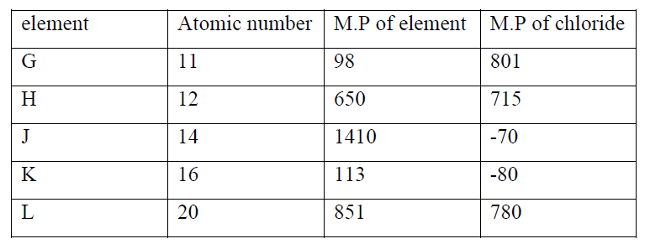
i) Write the formula of the compound formed when element H reacts with element K (1mark)
………………………………………………………………………………………………………………..
………………………………………………………………………………………………………………..
ii) Use dot (.) and cross (x) to show bonding between G and K (2marks)
………………………………………………………………………………………………………………..
………………………………………………………………………………………………………………..
………………………………………………………………………………………………………………………………………………………………………………………………………………………………..
iii) Determine the oxidation number of J in its chloride (1mark)
………………………………………………………………………………………………………………..
………………………………………………………………………………………………………………..
iv) How does the melting point of fluoride of G compare with that of its chloride (2marks)
………………………………………………………………………………………………………………..
………………………………………………………………………………………………………………..
………………………………………………………………………………………………………………..
5. a) The sketch below represents a graph obtained when zinc granules were reacted with excess 0.2M sulphuric (VI) acid in the presence of a catalyst in a conical flask placed on an electric balance.
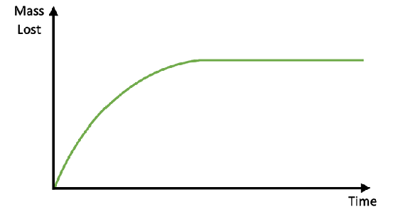
i) Write an equation for the reaction that took place. (1 mark)
………………………………………………………………………………………………………………
ii) Explain why there is loss in mass. (1 mark)
………………………………………………………………………………………………………………..
………………………………………………………………………………………………………………..
iii) Name the catalyst used. (1 mark)
………………………………………………………………………………………………………………..
iv) Sketch, on the same axes, the curves obtained when;
I) The same mass of zinc powder was used under same conditions. (1 mark)
II) No catalyst was used. (1 mark)
b) In the contact process sulphur (IV) oxide is converted to sulphur (VI) oxide in catalytic chamber in which a dynamic chemical equilibrium is reached.
i) What is meant by dynamic equilibrium? (1 mark)
………………………………………………………………………………………………………………..
………………………………………………………………………………………………………………..
ii) State and explain how each of the following would affect the position of equilibrium.
I) Decrease in temperature. (2 marks)
………………………………………………………………………………………………………………..
………………………………………………………………………………………………………………..
II) Decrease in pressure. (2 marks)
………………………………………………………………………………………………………………..
………………………………………………………………………………………………………………..
III) Catalyst (1 mark)
………………………………………………………………………………………………………………..
………………………………………………………………………………………………………………..
c) In a closed system, iron (III) chloride reacts with hydrogen sulphide gas as shown in the equation below.
State and explain the observation that would be made if dilute hydrochloric acid is added to the system at equilibrium. (2 marks)
………………………………………………………………………………………………………………..
………………………………………………………………………………………………………………..
………………………………………………………………………………………………………………..
………………………………………………………………………………………………………………..
6. a) The figures below shows some organic compounds labelled as A, B, C, D and E.
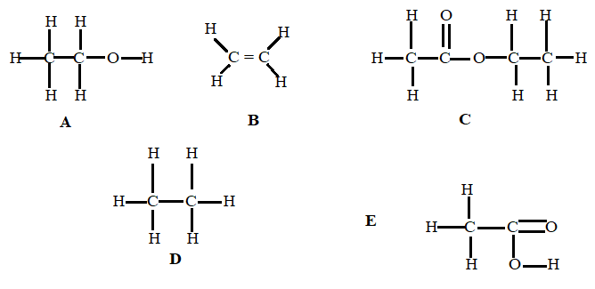
Select the compounds that matches the following descriptions
i) Is a saturated hydrocarbon (½ mark)
………………………………………………………………………………………………………………..
………………………………………………………………………………………………………………..
ii) Has a molecular formula C₂H₆O (½ mark)
………………………………………………………………………………………………………………..
………………………………………………………………………………………………………………..
iii) Reacts with sodium carbonate (½ mark)
………………………………………………………………………………………………………………..
………………………………………………………………………………………………………………..
b) The scheme below shows a series of reactions starting with propanol. Study it and answer questions that follow.
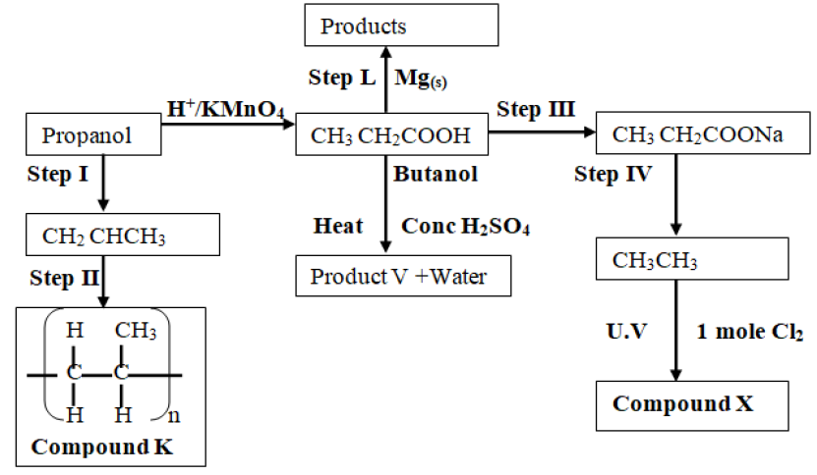
i) Name the type of reaction in step 1 (1 mark)
………………………………………………………………………………………………………………..
ii) Give the reagent and conditions necessary for step 1 to take place
Reagent (½ mark)
………………………………………………………………………………………………………………..
Condition (½ mark)
………………………………………………………………………………………………………………..
iii)Write the equation for the reaction that takes place in step L. (1 mark)
………………………………………………………………………………………………………………..
iv) Name the product V and give the equation responsible for its formation. (2 marks)
………………………………………………………………………………………………………………..
………………………………………………………………………………………………………………..
v) Give the IUPAC name and structural formula of compound X. (1½ mark)
………………………………………………………………………………………………………………..
………………………………………………………………………………………………………………..
vi) Name the compound K and state the type of reaction involved in its formation. (2 marks)
………………………………………………………………………………………………………………..
………………………………………………………………………………………………………………..
7. In an experiment, 20cm³ of 2.0M sodium hydroxide solution was placed in a suitable apparatus and portions of 4.0M hydrobromic acid were added. The resulting mixture was stirred with a thermometer and the temperature recorded after each addition. The following results were obtained.
Volume of HBr (cm³) | 4.0 | 6.0 | 8.0 | 10.0 | 12.0 | 16.0 | 20.0
Temperature (⁰C) | 27.0 | 30.0 | 33.0 | 36.0 | 35.0 | 34.0 | 32.0

a). Draw a graph of temperature against the volume of acid added. (3 marks)

b) Suggest a reason why the temperature decreased during the latter part of the experiment. (1 mark)
………………………………………………………………………………………………………………..
………………………………………………………………………………………………………………..
c) From your graph:
(i) Determine the temperature change (1mark)
………………………………………………………………………………………………………………..
………………………………………………………………………………………………………………..
………………………………………………………………………………………………………………..

(ii) Find the volume of hyrobromic acid which completely neutralized 20cm³ of 2.0M NaOH. (1mark)
………………………………………………………………………………………………………………..
………………………………………………………………………………………………………………..………………………………………………………………………………………………………………..
(iii) Calculate the molar heat of neutralization of hydrobromic acid with sodium hydroxide.
(C = 4.2kJKg-1K-1 density of solution = 1g/cm3). (3marks)
………………………………………………………………………………………………………………..
………………………………………………………………………………………………………………..
………………………………………………………………………………………………………………..
………………………………………………………………………………………………………………..
d) Write a thermochemical equation for the reaction between hydrobromic acid and sodium hydroxide.
(1 mark)
………………………………………………………………………………………………………………..
………………………………………………………………………………………………………………..
e) Draw the energy level diagram for the reaction above. (2 marks)
………………………………………………………………………………………………………………..
………………………………………………………………………………………………………………..
………………………………………………………………………………………………………………..
……………………………………………………………………………………………………………….
……………………………………………………………………………………………………………….
……………………………………………………………………………………………………………….
……………………………………………………………………………………………………………….
……………………………………………………………………………………………………………….

THIS IS THE LAST PRINTED PAGE

