
MARANDA HIGH SCHOOL
Kenya Certificate Of Secondary Education
THE 2025 MOCK EXAMINATION
233/1 CHEMISTRY PAPER 1
June, 2025 TIME: 2 Hrs

Name: …………………………………….…….…… Admission No: ……………
233/1 - CHEMISTRY

Date………………………………

Stream: ……………………….. Signature: ……….........
Instructions
- Write your name, admission number, date, stream and signature in the spaces provided above.

- All answers must be written in the spaces provided in the booklet.
- This paper consists of 13 printed pages with 27 questions. Candidates should check the question paper to ascertain that all the pages are printed as indicated and that no questions are missing
- Candidate should answer the questions in English
______________________________________________________
FOR EXAMINERS USE ONLY

1 | 2 | 3 | 4 | 5 | 6 | 7 | 8 | 9 | 10 | 11 | 12 | 13 | 14 | 15 | 16 | 17 | 18

.
Grand Total
19 | 20 | 21 | 22 | 23 | 24 | 25 | 26 | 27

1. Name the apparatus use to measure the Relative atomic mass. (1mark)
……………………….……………………………………………………………………………………….
b) An element Y has three isotopes, A having 18 neutrons, B having 21 neutrons and C with 25 neutrons. If the relative abundancies of A, B and C are 1,5 and 9 respectively and the number of protons of Y is 20. Calculate the relative atomic mass of Y. (2 marks)
……………………….……………………………………………………………………………………….
…………………………….………………………………………………………………………………….
……………………….……………………………………………………………………………………….
…………………………….………………………………………………………………………………….
2. a) State Boyle’s Law. (1mark)
……………………….……………………………………………………………………………………….
…………………………….………………………………………………………………………………….
(b) A given mass of the gas occupies 20cm³ at 25⁰ C and 670mmHg pressure. Find the volume it will occupy at 10⁰ C and 335mmHg. (2marks)
……………………….……………………………………………………………………………………….
…………………………….………………………………………………………………………………….
……………………….……………………………………………………………………………………….
3. The diagram below shows part of a synthetic polymer. Study it and answer the questions that follow.
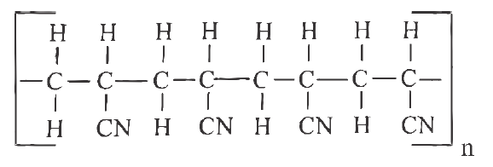
a) Draw the structural formula of the monomer from which the polymer is made. (1mark)
……………………….……………………………………………………………………………………….
…………………………….………………………………………………………………………………….
b) A sample of the polymer has a molecular mass of 63600. Calculate the number of monomers in the sample. (2marks)
……………………….……………………………………………………………………………………….
…………………………….………………………………………………………………………………….
4.Chlorine gas is bubbled into an aqueous solution of potassium iodide
a) State the observation that would be made. (1mark)
……………………….……………………………………………………………………………………….
…………………………….………………………………………………………………………………….
b) Write a balanced chemical equation for the reaction that occurred. (1 mark)
……………………….……………………………………………………………………………………….
5.The flow chart below shows the soda ash manufacturing process at Lake Magadi. Study it and answer the questions that follow.
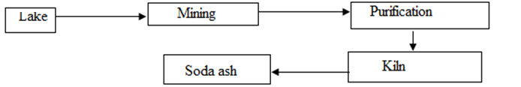
a) Why is it difficult to show that trona contains water of crystallization by heating alone? (1mark)
……………………….……………………………………………………………………………………….
…………………………….………………………………………………………………………………….
b) Name the method used to separate the salts from the lake. (1mark)
……………………….……………………………………………………………………………………….
…………………………….………………………………………………………………………………….
c) State one use of sodium hydrogen carbonate (1mark)
……………………….……………………………………………………………………………………….
…………………………….………………………………………………………………………………….
6. Study the flow chart below representing a part of an industrial process and an industrial process and answer the questions that follow
Product C
Ammonia gas
Reaction chamber
NH₄CI
Conc.NaCI solution
Carbon(IV)oxide

(a) Give the name of the industrial process represented above (1mark)
……………………….……………………………………………………………………………………….
(b) Write an equation that occurs on upper part of the reaction chamber. (1mark)
……………………….……………………………………………………………………………………….
(c) State one use of the main product of the above process. (1mark)
……………………….……………………………………………………………………………………….
………………………………………………………………………………………………………………..
7. 0.2g of organic compound containing carbon, hydrogen and oxygen on combustion gave 0.296g of carbon (IV) oxide and 0.12g of water. Given that its molecular mass is 180, determine its molecular formula. (C=12.0, O=16.0, H=1.0) (3marks)
……………………….……………………………………………………………………………………….
…………………………….………………………………………………………………………………….
……………………….……………………………………………………………………………………….
…………………………….………………………………………………………………………………….……………………….……………………………………………………………………………………….
8.Study the flow chart diagram below and use it to answer the questions that follow
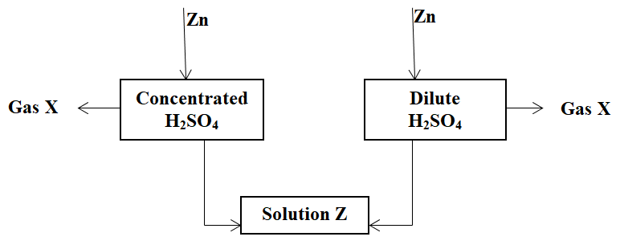
Gas Y
a) Identify gas X (1mark)
……………………….……………………………………………………………………………………….
b) Give the test for gas Y (1mark)
……………………….……………………………………………………………………………………….
c) State the property of concentrated sulphuric (VI) acid demonstrated above. (1mark)
……………………….……………………………………………………………………………………….
9.Solutions can be classified as acids, bases or neutral. The table below shows solutions and their pH values
Solution | pH values
A | 1.6
B | 7
C | 13.7

a) Select any pair that would react to form a solution of pH 7 (1mark)
……………………….……………………………………………………………………………………….
b) Identify two solutions that would react with Aluminium hydroxide. Explain (2marks)
……………………….……………………………………………………………………………………….
…………………………….………………………………………………………………………………….
10. The diagram below shows a hydrogen half-cell.
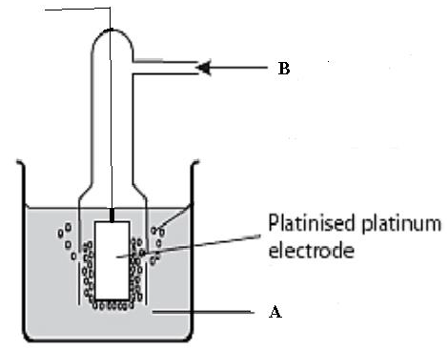
a) Label A (1 mark)
……………………….……………………………………………………………………………………….
b) State one role of platinized platinum in this set up (1 mark)
……………………….……………………………………………………………………………………….
………………………………………………………………………………………………………………..
c) Write an equation for the reaction that takes place in the half cell (1mark)

……………………….……………………………………………………………………………………….
11. When magnesium is reacted with steam, it reacts rapidly forming a white solid and hydrogen gas.
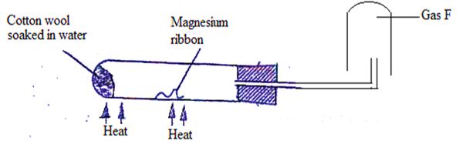
(a) What property of hydrogen gas makes it to be collected as shown above. (1mark)
……………………….……………………………………………………………………………………….
…………………………….………………………………………………………………………………….
(b) How would you show that the gas collected is hydrogen gas? (1mark)
……………………….……………………………………………………………………………………….
…………………………….………………………………………………………………………………….
(c) When copper turnings were used instead of magnesium ribbon, hydrogen gas was not produced. Explain. (1mark)
……………………….……………………………………………………………………………………….
…………………………….………………………………………………………………………………….
12.When calcium carbonate is heated, the equilibrium shown below can be established.
CaCO_{3 (s)} CaO _{(s)} + CO_{2 (g)}
(a) How would the position of equilibrium be affected if a small amount of the dilute potassium hydroxide is added to the equilibrium mixture? Explain. (2 marks)
……………………….……………………………………………………………………………………….
…………………………….………………………………………………………………………………….
……………………….………………………………………………………………………………………
(b) Explain how an increase in pressure would affect the equilibrium position. (1 mark)
……………………….……………………………………………………………………………………….
…………………………….………………………………………………………………………………….13. A sample of sodium chloride was found to be a mixture of two isotopes , and .Determine
the relative formula masses of the compound formed when sodium burns in each of these isotopes (Na= 23.0)
(i) (1mak)
……………………….……………………………………………………………………………………….
…………………………….………………………………………………………………………………….
(ii) (1mark)
……………………….……………………………………………………………………………………….
…………………………….………………………………………………………………………………….
b) Identify the method of salt preparation described in (a) above (1mark)
……………………….……………………………………………………………………………………….
…………………………….………………………………………………………………………………….
14. (a) Explain the factors that lead to emission of gamma rays (1mark)
……………………….……………………………………………………………………………………….
…………………………….………………………………………………………………………………….
(b) Gamma rays are not shown when writing an equation. Explain (1mark)
……………………….……………………………………………………………………………………….
…………………………….………………………………………………………………………………….
(c) Explain how radioactivity is used in food preservation (1mark)
……………………….……………………………………………………………………………………….
…………………………….………………………………………………………………………………….
15. (a) What is the role of froth floatation in extraction of metals. (1 mark)
……………………….……………………………………………………………………………………….
…………………………….………………………………………………………………………………….
(b) State one industrial use of zinc metal (1mark)
……………………….……………………………………………………………………………………….
…………………………….………………………………………………………………………………….
(c)State one reason why alloy of sodium and potassium is used as a coolant in nuclear reactors (1mark)
……………………….……………………………………………………………………………………….
…………………………….………………………………………………………………………………….
16.) Magnesium reacts with air to produce two solids, Name the solids. (2marks)
……………………….……………………………………………………………………………………….
…………………………….………………………………………………………………………………….
b) Cold water reacts slowly with a piece of magnesium to produce bubbles of hydrogen gas. Write the equation for the reaction between cold water and magnesium (1mark)
……………………….……………………………………………………………………………………….
…………………………….………………………………………………………………………………….
17. The curves below were obtained when two equal volumes of hydrogen peroxide of the same concentration were allowed to decompose separately. In one case, manganese(IV) oxide was added to the hydrogen peroxide
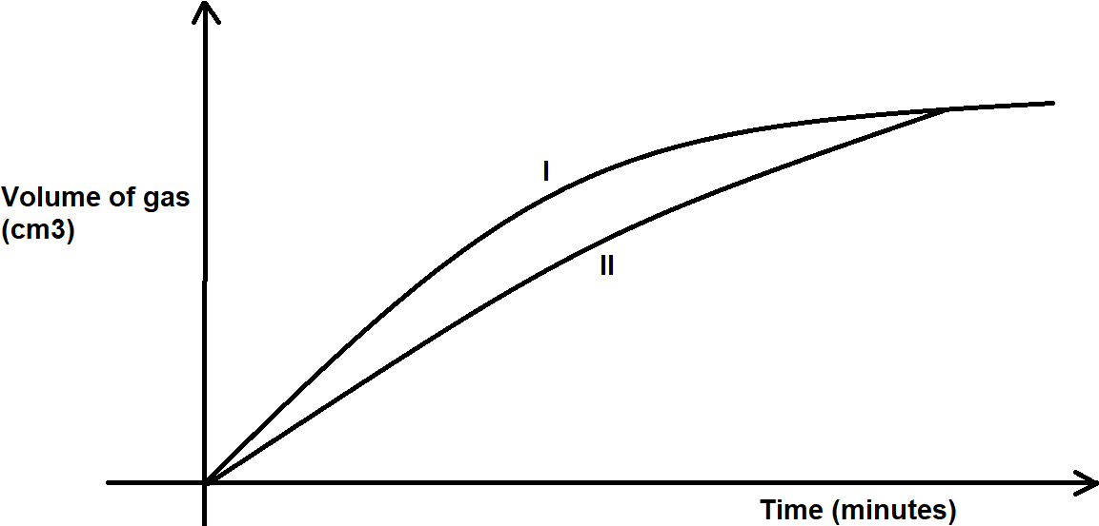
(a)Which curve represents the decomposition of hydrogen peroxide with manganese (IV) oxide? Explain
(2marks)
……………………….……………………………………………………………………………………….
…………………………….………………………………………………………………………………….
……………………….……………………………………………………………………………………….
(b)Give a reason why different reactions have different activation energies (1mark)
……………………….……………………………………………………………………………………….
…………………………….………………………………………………………………………………….
18. a) Name two crystalline allotropes of sulphur (2 marks)
……………………….……………………………………………………………………………………….
…………………………….………………………………………………………………………………….
b) In an experiment to investigate a certain property of sulphur, a student added few drops of concentrated HNO₃ to sulphur in a test tube and warmed the mixture
a) Write a chemical equation of the reaction that occurred (1 mark)
……………………….……………………………………………………………………………………….
…………………………….………………………………………………………………………………….
b) State one observation made (1mark)
……………………….……………………………………………………………………………………….
…………………………….………………………………………………………………………………….
19.The table below gives some properties of three elements in group VII of the periodic table. Study it and answer the questions that follow
Element | Atomic number | Melting point (˚C) | Boiling point (˚C)
Chlorine | 17 | -101 | -34.7
Bromine | 35 | -7 | 58.8
Iodine | 53 | 114 | 184
(a) Which element is a gas at room temperature? Give a reason (2marks)
……………………….……………………………………………………………………………………….
…………………………….………………………………………………………………………………….
(b) Explain why the boiling point of bromine is higher than that of chlorine (1mark)
……………………….……………………………………………………………………………………….
…………………………….………………………………………………………………………………….
20. (a) State two reasons why most apparatus are made of glass (2 marks )
……………………….……………………………………………………………………………………….
…………………………….………………………………………………………………………………….
……………………….……………………………………………………………………………………….

(b) A pipette is used to measure exact volume of liquids. Draw a pipette. (1 mark)
……………………….……………………………………………………………………………………….
…………………………….………………………………………………………………………………….
……………………….……………………………………………………………………………………….
…………………………….………………………………………………………………………………….
21. Use the bond energy value given below for the question that follows
Bond | H – H | C = C | C – C | C – H
Bond Energy(kJmol-1) | 432 | 610 | 346 | 413
Determine the enthalpy change for the conversion of butene to butane (3marks)
……………………….……………………………………………………………………………………….
…………………………….………………………………………………………………………………….
……………………….……………………………………………………………………………………….
…………………………….………………………………………………………………………………….
………………………………………………………………………………………………………………..
22.. Painting, Oiling, galvanizing and or tin plating are methods of rust prevention.
a) Explain the similarity of these methods in the ways they prevent rusting. (1mark)
……………………….……………………………………………………………………………………….
…………………………….………………………………………………………………………………….
………………………………………………………………………………………………………………..
b) The set up below was used to electroplate a silver spoon. Study it and answer the questions that follow
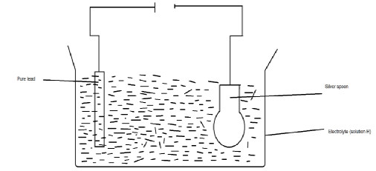
Pure lead
electrolyte (solution H)
Silver spoon
i) Identify the likely electrolyte in solution H. (1mark)
……………………….……………………………………………………………………………………….
…………………………….………………………………………………………………………………….
ii) Write an ionic equation for the reactions at cathode. (1mark)
……………………….……………………………………………………………………………………….
23. A detergent molecule may be represented by the following simplified diagram.
Ionic head

Covalent hydrocarbon tail
a) Explain how the detergent removes grease from a piece of a greasy cloth. (2 marks)
……………………….……………………………………………………………………………………….
…………………………….………………………………………………………………………………….……………………….……………………………………………………………………………………….
…………………………….………………………………………………………………………………….
b) Explain why soapless detergents do not form scum with hard water (1 mark)
……………………….……………………………………………………………………………………….
…………………………….………………………………………………………………………………….
24.The figure below shows a set-up of apparatus used to prepare a sample of nitrogen gas in the laboratory, study it and answer the questions that follow.
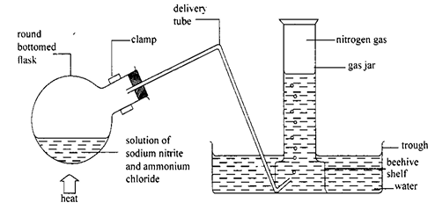
a) Write an equation for the reaction that produced the gas. (1mark)
……………………….……………………………………………………………………………………….
b) What property of nitrogen gas makes it suitable to be collected as shown? (1mark).
……………………….……………………………………………………………………………………….
…………………………….………………………………………………………………………………….
c) State one use of nitrogen gas. (1mark)
……………………….……………………………………………………………………………………….
…………………………….………………………………………………………………………………….
25.Element A atomic No. 6 and element B atomic No. 13 react to form a compound.
(a) Using dots (⚫) and crosses (x) show bond formed in the above compound. (1 mark)
……………………….……………………………………………………………………………………….
…………………………….………………………………………………………………………………….
……………………….……………………………………………………………………………………….
(b) Explain why the compound above has very high melting point. (1 mark)
……………………….……………………………………………………………………………………….
…………………………….………………………………………………………………………………….
(c) Explain how the compound above will conduct electricity. (1 mark)
……………………….……………………………………………………………………………………….
…………………………….………………………………………………………………………………….
26.Study the flow chart below and answer the questions that follow:
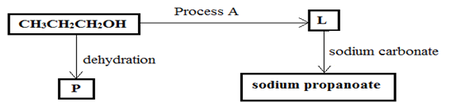
a) Name the homologous series to which P belongs (1 mark)
……………………….……………………………………………………………………………………….
b) Name one reagent that can be used to carry out process A (1 mark)
……………………….……………………………………………………………………………………….
c) The Sodium propanoate formed above is heated with a mixture of quick lime and sodium Hydroxide. Write the formal equation for the reaction that occurs (1 mark)
……………………….……………………………………………………………………………………….
27 a). State two ways in which efficiency of the fractional distillation can be improved when when separating a mixture of water and ethanol (2marks)
……………………….……………………………………………………………………………………….
…………………………….………………………………………………………………………………….
……………………….……………………………………………………………………………………….
b) State one application of chromatography in sports (1 mark)
……………………….……………………………………………………………………………………….
…………………………….………………………………………………………………………………….

THIS IS THE LAST PRINTED PAGE.

