MARKING SCHEME PP2 MOCK 2025

1.
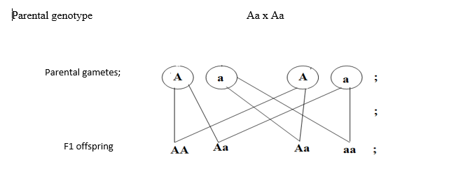
Fusion
(b(i))3/4 or 75%/0.75
(ii)Melanocyte(s)
(c)-independent assortment of homologous chromosomes
_Crossing over (during prophase I)
_Recombination of genes during fertilization
2.(a)Respiration(aerobic)
(b)To confirm absence of CO2 in the atmospheric air
(c)L-Lime water remained clear:since all CO2 was adopted by KOH.
N-White precipited formed since coachroaches respired to release CO2 which reacted with lime water.
(d)-Ethanol
-carbon (iv) oxide
-Energy/Adenosine triphosphate
(e)-To increase supply of Oxygen to the muscles to oxidise lactic acid
-For faster transportation of lactic acid to the liver for break down /conversion to glycogen for storage
3.(a)Protein/dipeptide
(b)(i)Cytoplasm
(ii)-trypsin
-pepsin
(c)Hdrolysis
(d)Ileum
(e)Oxidised during extream starvation to yield energy
-Growth and repair
4.(a)Rhizopus
(b)A-sporangiophore
B-Sporangium
(c)-Absorption of nutrients
-secretes (lytic) enzymes that dissolve the substrate
(d)It is not divided by crosswalls
(e)Haustoria
(f)Sporulation/Sporulation
5.(a) F-Oestrogen
G-Progesterone
(b)-Increase blood supply/ Proliferation
-Repair and healing
(c)(i) Luteinizing hormone
(ii) -stimulate ovulation
-stimulates the corpus leuteum to secretes progesterone
-stimulates development of graafian follicles to yellow body
(d)11th -17th

6(a)
Germinated seeds | Germination%
3 | 15
3 | 15
8 | 40
15 | 75
18 | 90
13 | 65
10 | 50
6 | 30
2 | 10
0 | 0
0 | 0
(b
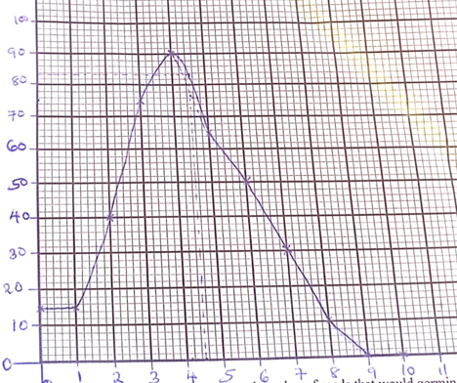
(c)77+ or -1
(d) Between 0-1 minutes, minimum exposure to heat results to minimal germination rate;
-Between 1-4 minutes , there is increase exposure to heat resulting to rapid seed germination;
-4-9 minutes , continued exposure to heat results to decrease in germination

(e) Soaking the seeds in hot water soften the testa/making it more permeable to oxygen and water;the seeds that are not given this hot water treatment takes longer to germinate since the seed coat is hard ,tough; and need to be made soft and permeable by water or by decomposition action of micro-organism.
(f)The seeds were maintained at 50 for a longer duration ; thus the enzymes became denatured completely; and so germination could not take place.
(g) Scarification, roasting
(h)Water ,Oxygen
7. a) When an impulse reaches the presynaptic knob, it stimulates the synaptic vesicles to move towards the presynaptic membrane; releasing acetylcholine; which makes the presynaptic membrane permeable. Acetylcholine then diffuses across the synaptic cleft to the post-synaptic membrane, which becomes depolarised. Sodium ions from the cleft move/diffuse through the post-synaptic membrane into the postsynaptic knob; causing an action potential, which is then transmitted as a nerve impulse. (max 5)
b) Auxins and Geotropism
When a seedling is placed in a horizontal position in the dark, gravity as a stimulus causes greater concentration of auxins to migrate and accumulate on the lower side of the seedling.
Higher auxin concentration on the lower side of the shoot stimulates faster cell elongation; hence faster growth than on the upper side; the shoot grows with its tip bending upwards (curving).
Lower auxin concentration on the upper side of the root stimulates faster cell elongation; hence faster growth than on the lower side; hence root grows with its tip bending downwards (curving). (max 6)

c) Auxins and Phototropism
When a seedling/shoot is exposed to unidirectional light, light as a stimulus causes lateral migration of auxins from the lit side to the dark side.
Higher auxin concentration on the dark side stimulates faster cell elongation; hence faster growth than on the lit side; hence the shoot grows with its tip bending/curving toward the source of light. (max 5)
8(a) -Spiracle has muscular valve ; that control its opening and closing
-Spiracle has hairs ; that prevent excessive loss of water from body tissues by evaporation.
-Trachea consists of bands of chitin ; to keep it open throughout ;/ prevent it from collapsing.
-Tracheoles have thin epithelium ; to reduce diffusion distance;
-Tracheoles are numerous ; to increase S.A for gaseous exchange;
-Tracheoles are numerous ; to increase surface area for gaseous exchange;

(b) position of stomata
-Most xerophytes have less number of stomata on the upper epidermis than lower epidermis ; to lower the rate of transpiration;
Number of stomata
-xerophytes/desert/arid/semi-arid plants have generally reducedd/less number of stomata on the leaf epidermis to reduce S.A for water loss;
Size of stomatal aperture;
-Desert/Arid/Semi-arid plants have stomata with small aperture ; to reduce S.A for transpiration
Reversed stomatal rhythm;
Some/desert/arid/semi- arid plants close their stomata during the day and open them during the night to reduce S.A exposed hence reduce rate of transpiration;
Mid-day closure
-some desert/arid/semi-arid plants /xerophytes close their stomata on a hot dry sunny day; to lower the rate of transpiration
Sunken stomata;
-some desert /arid/semi-arid plants have stomata with deep pits/depressions; where water vapour accumulates; reducing the saturation deficit/diffusion gradi
ent ;hence reducing rate of transpiration. Max (14mks)

