MARANDA HIGH SCHOOL
Kenya Certificate of Secondary Education
C0DE 231/1  MAY 2025 2hrs
FORM 4 MOCK EXAMS
Name: ………………………………………………………Admission No: ……………………
Class: ………………………………… Date: ………………………………
School: …………………………………………..…… Signature: …………………………

INTRUCTIONS TO CANDIDATES

- Write your name,admission number and stream in the spaces provided
- Sign and write date of examination in the spaces provided
- This paper consist of 25 questions
- Answer all the questions in this paper
- This paper consists of 12 printed pages.
- Candidates should check the question paper to ascertain that all the pages are printed as indicated and no questions are missing.
FOR EXAMINERS USE ONLY
Question | Maximum  Score | Candidate’s score
1-25 | 80

1.How does nutrition as a characteristic of living organisms differ in plants and animals.
(2marks)
……………………………………………………………………………………………………………………………………………………………………………………………………………………………………………………………………………………………………...…………………
2.The diagram below represents a certain organ system in human. Study it to answer the questions that follow.
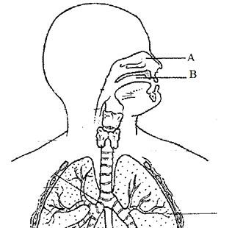
  - Identify the part labeled A. (1 mark)
………………………………………………………………………………………………………………………………………………………….……………………...…………………………………
  - Give two adaptations of the part named above. (2 marks)
…………………………………………………………………………………………………………………………………………………………………………………………………............................................................................................................................................................................................
(iii) A form two student wanted to kill a cockroach by immersing its head in water for 35 minutes. Explain why it could not be drouwn. (1 mark)
..……………………………………………………………………...………………………………………………………………………………………….………………………………………...………
3.(a) What is cell specialization? (1 mark)
………………………………………………………………………………………………………………………………………………………………………………….……………………………...…
(b) State two Specialized cells in pancreas. (2 marks)
……………………………………………………………………………………………………………………………………………………………………………………………………………………
4.(a) Apart from iodine solution, name any other stain used during preparation of a temporary slide.
(1 mark)
………………………………………………………………………………..……………………………………………………………………..…………………………………………………………
(b) Using a microscope, a student counted 45 cells across a field of view. Whose diameter was 5000µm. Calculate the average length of the cells. Show your working. (2 marks)
………………………………………………………………………………………………………………………………………………………………………………………………………………………………………………………………………………………………………………………………
5.(i) Name the two end products of lipids breakdown (2 marks)
……………………………………………………………………………………………………………………………………………………………………………………………………………………
(ii) State the part of alimentary canal where the above digestion takes place. (1 mark)
…………………………………………………………………………………………………………………………………………………………………………………………………………………….

- (a) Sketch a curve to show the effect of carbon (IV) oxide concentration on the rate of photosynthesis. (1mark)

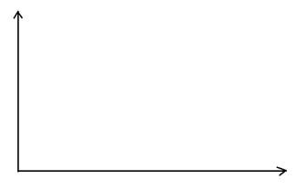
b).Explain the shape of the curve drawn above. (2 marks)
……………………………………………………………………………………………………….………………………..……………………………………………………………………………………………..…………………………………………………………………………………………………
c) State three ways in which carbon (IV) oxide is transported in animals. (3 marks)
………………………………………………………………………………………………………………………………………………………………………………………………………………………………………………………………………………………………………………………………………………………………………………………………………………………………………….…………

- The experimental set-up below was used by students at school to investigate a certain physiological process.
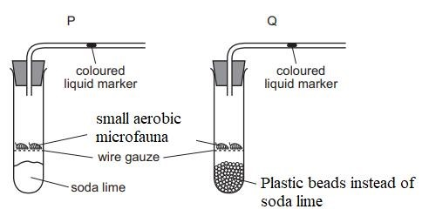
- Why was set-up Q included in the experiment. (1 mark)
……………………………………………………………………………………………………………………………………………………………………………………………………………………
- State and explain the observations made in set-up P above. (3 marks)
…………………………………………………………………………………………….………………
…………………………………………………………………………………………...........................................................................................................................................................................................................................................................................................................................................…………………
- Name two gaseous exchange structures found only in aquatic plants. (2 marks)
……………………………………………………………………………………………………………………………………………………………………………………………………………………………………….…………………………………….…………………………………………………

- List two differences between class Mammalia and Aves. (2 marks)
Mammalia | Aves

11. Study the diagram of the specimen below to answer the questions that follow.
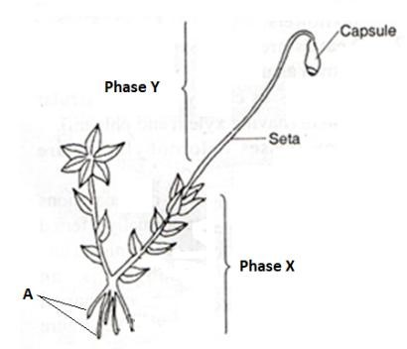
- Identify phase X and phase Y. (2 marks)
X.………………………………………………………...………………………………………Y……………………………………………………………...…………………………………..
(ii) Define the term alternation of generation (1 mark)
……………………………………………………………………………………………………………………………………………………………………………………………………………….……(a) 12.Name two theories that explain the evolution mechanism. (2 marks)
……………………………………………………………………………………………………………………………………...……………………………………………………………….…………… (b) Define the term organic evolution. (1 mark)
………………………………………………………………………………………………………………………….……………………………………...…………………………………………………
- In a case of disputed parenthood, a couple with 7 children went to court challenging the right parenthood of their last born son. The lawyer argued the case with fact that the Father had blood group A (heterozygous) and mother had blood group B (heterozygous) and saying there is no way they could have gotten the son whose blood group was different from them. Using a genetic cross, show the two possible blood groups that could have sparked the case. (5 marks)
…………………………………………………………………………………………………………
…………………………………………………………………………………………………………
…………………………………………………………………………………………………………
…………………………………………………………………………………………………………
…………………………………………………………………………………………………………
…………………………………………………………………………………………………………
- The diagram below represents a living organism. Study it and answer the questions that follows.
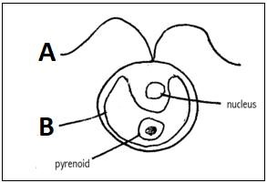
a) (i) State the kingdom in which the organism belongs. (1mark)
…………………………………………………………………………………………………..………
(ii) Give a reason for your answer. (1mark)
……………………………………………………………………………………………………………………………………….…………………………………………………………………………………(b) (iii).State the difference between structure labelled B and the one found in spirogyra (1mark)
………………………………………………………………………………………………………………………………………….………………………………………………………………………………
15. The diagram below indicates a type of response in a given animal when touching a sharp object.
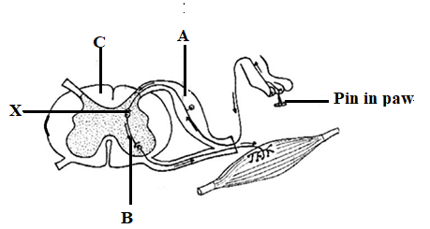
(a).Name the part labelled A. (1 mark)
……………………………………………………………………………………………………………………………….……………………………………………………………………………………
(b).In the space provided below give the letter(s) that represents the part of the reflex arc that consists mainly of axons of sensory and motor neurons. (1mark)
……………………………………………………………………………………………………………………………….……………………………………………………………………………………
(c).State the role of part labeled B. (1mark)
………………………………………………………………………………………………………….…………………………………………………………………………………………………………
(c). Name the enzyme that enable proper functioning in the part laballed X. (1mark)
……………………………………………………………………………………………………………………………………………………………………………………………………………………
16.Explain why plants and turtles increases in size as long as they live. (2marks)
………………………………………………………………………………………………………………………………………………………………………………………………………………………………………………………………………………………………………………………………
17. The set up below was prepared by a form one student study it and answer the question that follows.
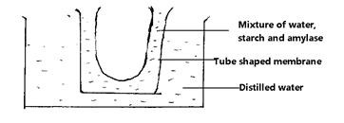
- After a few hours it was found that reducing sugars were present in the distilled water. State what happened;
  - Inside the tube shaped membrane (1mark)
……………………………………………………………………………………………………………………………………………………………………………………………………………………
  - At the walls of the membrane (1mark)
……………………………………………………………………………………………………...………………………..………………………………………………….………………………………
- Give the role of the physiological process above in reproduction in plants. (1mark)
……………………………………………………………………………………………………………………………………………………………………………………………………………………
- (a) Distinguish between parthenocarpy and parthogenesis. (1mark
....…………………………………………………………………………………………………………………………………………………………………………………………………………………

b).Name one organism where parthenocarpy takes place. (1 mark) ……………………………………………………………………………………………………………………………………………………………………………………………………………………
- What is the causative agent of the following conditions?
- Bilhazia (1mark)
……………………………………………………………………………………………………………………………………………………………………………………………………………………
- Candidiasis (1mark)
……………………………………………………………………………………………………………………………………………………………………………………………………………………
19. The diagram below illustrates the relationship between the human embryo and its embryonic membranes. Study it and answer the questions that follow:
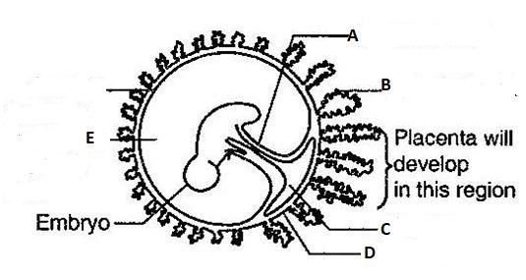
(a) Name the parts labelled B and C

B: …………………………………………………………………………………………………(1mark)
C: …………………………………………………………………………………………………(1mark)
(b) What makes up the part labeled E and give two of its roles. (3marks)
……………………………………………………………………………………………………………………………………………………………….…………………………………………………………
20. (a) What are the functions of the following eye muscles
- Lateral rectors muscles (1mark)
…………………………………………………………………………………………………………………………………………………………………………………………………………...…
- Superior and Inferior muscles (1mark)
………………………………………………………………………………………………………………………………………………………...……………………...………………………………
21. Examine the diagram below and answer the questions that follow.
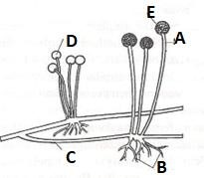
(a).Name the parts labelled A and C.
A ……………………………………………………………………………………………… (1 mark)
C ………………………………………………………………………………………………...(1 mark)
(b).Give the name of the vegetative body that makes the structures above. (1 mark)
……………………………………………………………………………………………………………………………………………………………………………………………………………………

22.The images shown below were taken from a given experiment whose objective was to determine germination using given seed that was subjected into various suitable conditions. Use the images given below to answer the questions that follows:
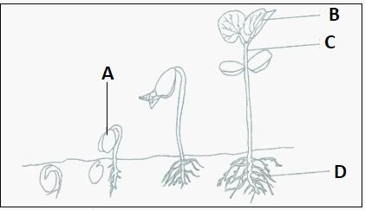
  - Name the parts labelled C (1mark)
………………………………………………………………………………………………………………………….…………………………………………………………………………………………
(b).What is the function of the part labelled D. (1mark) ……………………………………………………………………………………………………………………………………………………………………………………………………………………
(c).Explain how the part labelled A is carried above the soil level (2 marks)
……………………………………………………………………………………………………………………………………………………………………………………………………………………
23.(a) An elephant weighing 2000Kg requires 3000kJ per gram body weight while a rat weighing 100g requires 5000kJ per gram body weight. Explain (2marks)
…………………………………………………………………………………………………………………………………………………………………………………………………………………………………………………………………………….…………………………………………………………
(b).Name a plant excretory product used for the following functions.
  - Meat tenderizer (1 mark)
…………………………………………………………………………………………………
(ii).Treatment of leather and manufacture of ink (1 mark)
……………………………….…………………………………………………………………………
24.Insulin hormone increases during times of stress. Explain. (2 marks)
………………………………………………………………………………………………………………………………………………………………………………………………………………………………………………………………………………………………………………………………………………………………………………………………………………………………….……... 26.The diagram below represents a bone of a mammal. (SCAPULA BONE)
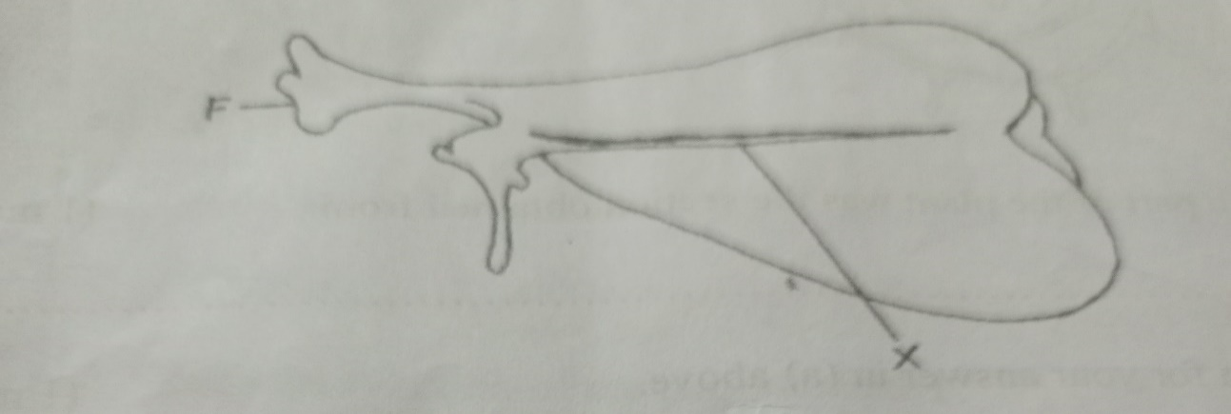
(a) Identify the bone (1mark)
…………………………………………………………………………………………………………………………………………………………………………………………………………………….(b) Name the part labelled X (1mark)
……………………………………………………………………………………………………………………………………………………………………………………………………………….……
(c) Name the bone that articulate with the bone at part marked F. (1mark)
……………………………………………………………………………………………………………………………………………………………………………………………………………………

