Name: ……………………………....…………. Index No: ……………………….…………….
School: ……………………………………….... Candidate’s Signature: ……………………… Date: ………………………..
231/3
BIOLOGY PRACTICAL
PAPER 3
JULY 2025
Time: 1 ¾ Hours

Kenya Certificate of Secondary Education

INSTRUCTIONS TO CANDIDATES
- Answer all the questions in the spaces provided.
- You are required to spend the first 15 minutes of 1 ¾ hours allowed for this paper reading the whole paper carefully before commencing your work.
- Candidates may be penalized for recording irrelevant information and for incorrect spelling especially of technical terms.

FOR EXAMINER’S USE ONLY
Question | Max Score | Candidate’s Score
1 | 14
2 | 11
3 | 15
TOTAL | 40
- You are provided with a water baths maintained at a 37⁰c and 50⁰c, Iodine solution,
- Benedict solution, thermometer 10ml measuring cylinder, labels, solution S (starch solution) and solution P.
- Label three test tubes 1, 2 and 3.
- Into test 1, 2 and 3 and 3cm³ of starch solution.
- Into test tube 1 and 2 add 2cm³ of solution P.
- Place test tube 2 water bath maintained at 50⁰c for 30 minutes.
- Place the remaining test-tube 1 and 3 in the water bath maintained at 37⁰c for 30 minutes.
- After the 30 minutes test for starch and reducing sugars in the contents of each test tube.
- Record your results in the table as shown below. (9 mks)
Test Tube | Test | Observation | Inference Conclusion
1

2

3

- What is the identify of solution P. (1 mk)

- Explain your influence for test tube 1 and 3.
Test tube 1. (2 mks)

Test tube 3 (1 mk)

- What was the role of test tube C in the set-up. (1 mk)

- a) Draw a well labeled diagram of a stem of a dicotyledonous plant (3 mks)

- From the micrograph, name two tissues concerned with support of plants.(2 mks)

- How does the above section differ from a section of a root from the same plant.
(3 mks)

- When preparing the above section the following practices were carried out. Give a reason for each.
- Cutting thin sections. (1 mk)

- Adding a drop of water before covering it with a cover slip. (1 mk)

- Staining the section. (1 mk)

- During an ecological tour, students collected animals some of which are shown below:

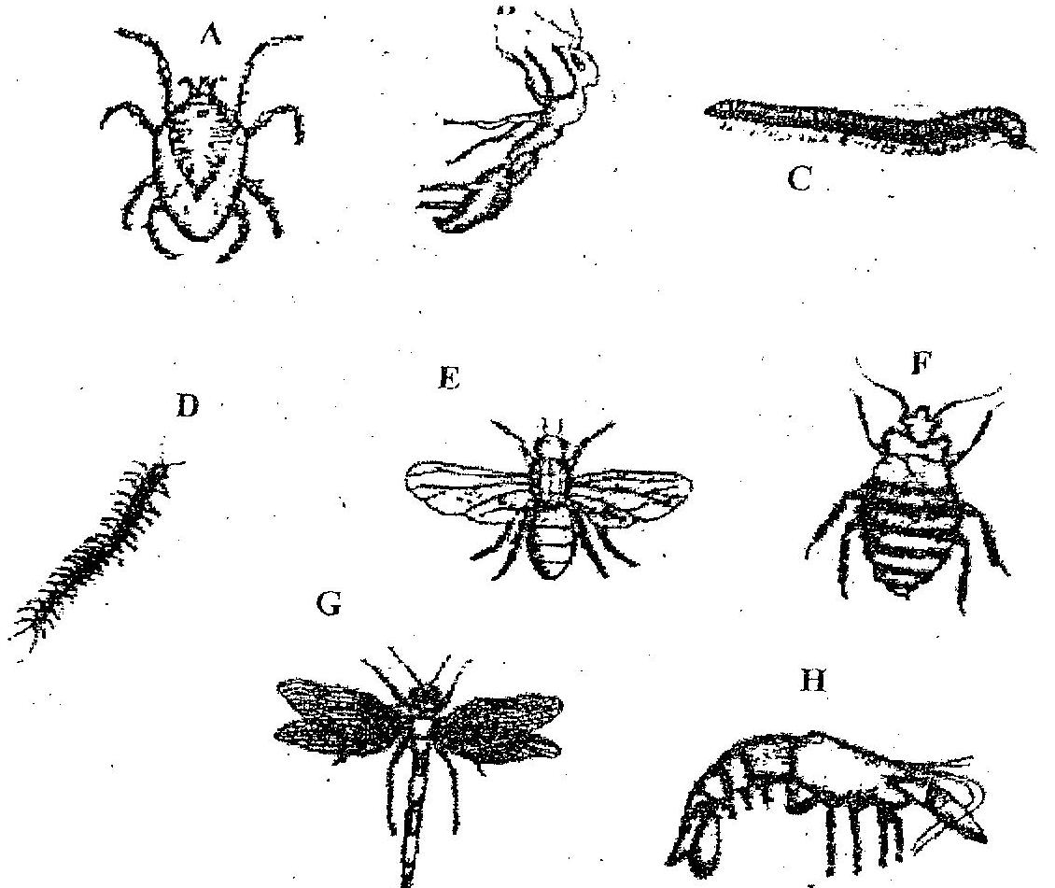

The teacher provided a dichotomous key(shown below) to enable them identify their family names;
Dichotomous keys
1 a Without wings………..………………………...Go to 2;
b Without wings………………………………….. Go to 3;
2. a) With broad abdomen….. ……………………...Go to 2;
b) With slender abdomen………………………… Go to 3;
3. a) With three pairs of legs ……………………..…...Go to 2;
b) with more than three pairs of legs……………… Go to 3;
4. a) With a constriction between the thorax and abdomen…………..Go to 2;
b) Without a constriction between the thorax and abdomen ……… Go to 3;
5. a Without antennae………..………………………...Go to 2;
b Without antennae………………………………….. Go to 3;
6. a Animal with carapace………..………………………...Go to 2;
b Animal with carapace ………………………………….. Go to 3;
7. a Body dorso-ventrally flattened……..………………………...Go to 2;
b Body cylindrical ………………………………….. Go to 3;

- Using the key provided above, identify the families of specimens A,B,C,D,E and H.
(12 mks)
Specimen | Identify | Steps
A
B
C
D
E
H

- Name the phylum to which the animals belong. (1 mk)

- Using observable features only, state two reasons for your answer in 9(b) above.(2 mks)

