NAME………………………………………………INDEX NO………………CLASS….....
Date……………………Sign …………….
231/2
BIOLOGY
PAPER 2 (THEORY)
END TERM 2 2025
JULY 2025
2 HOURS

FORM FOUR

Kenya Certificate of Secondary Education (K.C.S.E)
INSTRUCTIONS
- This paper consists of two sections A and B. Answer All the questions in section A in the spaces provided.
- In section B answer questions 6 (Compulsory) and either Questions 7 or 8 in the spaces provided.
FOR EXAMINER’S USE ONLY
SECTION | QUESTION | MAXIMUM SCORE |  | CANDIDIATE’S  SCORE
A | 1 | 8
A | 2 | 8
A | 3 | 8
A | 4 | 8
A | 5 | 8
B | 6 | 20
B | 7 | 20
B | 8 | 20
TOTAL SCORE |  | 80

This paper consists of 10 printed pages. Candidates should check carefully
to ascertain that all the pages are printed as indicated and no questions are missing

SECTION A (40 MARKS)
Answer all the questions in this section in the spaces provided after each question.
- The diagrams below represent two plant cells A and B placed in two different solutions. Study the diagrams and answer questions that follow:
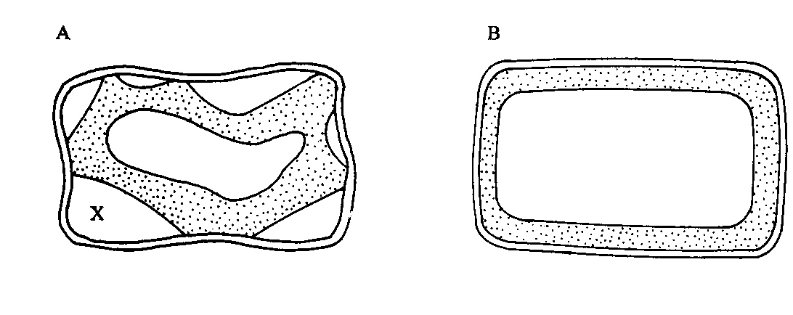
- Identify the nature of solution into which each cell was placed. (2mks)
A …………………………………………………………………………………........
B ………………………………………………………………………………………
- Name the physiological process responsible for the observed results. (1mk)
………………………………………………………………………………………
c) Give the correct biological term used to describe cell A. (1mk)
………………………………………………………………………………………...
- Describe what would happen if a red blood cell was placed in the solution in which cell B was placed. (2mks)
………………………………………………………………………………………………………………………………………………………………………………………………………………………………………………………………………
- Explain why freshwater amoeba do not burst when placed in distilled water.(2mk)
………………………………………………………………………………………………………………………………………………………………………………………………………………………………………………………………………
- a) What is meant by the term linked genes? (1mk)
……………………………………………………………………………………………………………………………………………………………………………………
b). Haemophilia is a genetic condition transmitted through a recessive gene linked to
X chromosome. The normal gene may be represented by X^{H}.
i) What is the genotype of a haemophilic female? (1mk)
…………………………………………………………………………………
ii) A woman who is a carrier for the haemophilia gene marries a normal man. Work out the phenotypic ratio for their offspring. (4mks)
……………………………………………………………………………………………………………………………………………………………………………………………………………………………………………………………………………………………………………………………………………………………………………………………………………………………………………………………………………………………………………………………………………………………………………………………………………………………………………………………………………………………………………………………………………………………………………………………………………………………………………………………………………………………………………………………………………..
………………………………………………………………………………………………………………………………………………………………………………………………………………………………………………………..

iii) Haemophilia is more common in males than in females. Explain this
phenomenon. (2mks)
……………………………………………………………………………………………………………………………………………………………………………………………………………………………………………………………………………………………………………………………………………………………………………………………………………………………

- Study the diagram below and answer questions that follow.
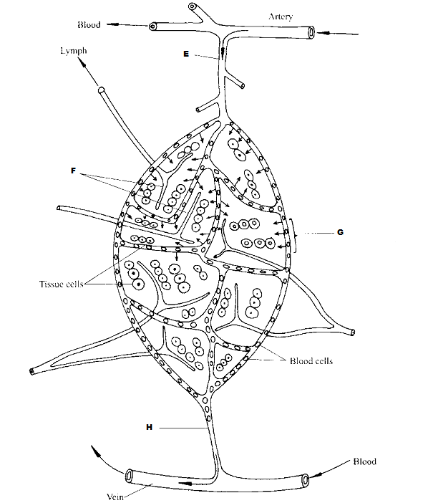

- Identify the parts labeled E, F and H. (3mks)
E……………………………………………………………………………………
F……………………………………………………………………………………
H……………………………………………………………………………………
- State the importance of the process represented by G in bodies of living organisms. (2mks)
………………………………………………………………………………………………………………………………………………………………………………………………………………………………………………………………………

- Compare the composition of blood in vessel E and H. (3mks)
………………………………………………………………………………………………………………………………………………………………………………………………………………………………………………………………………………………………………………………………………………………………………………………………………………………………………………………………………………………………………………………………………………………………………………………………………………………………………
- Use the figure below to answer questions that follow:
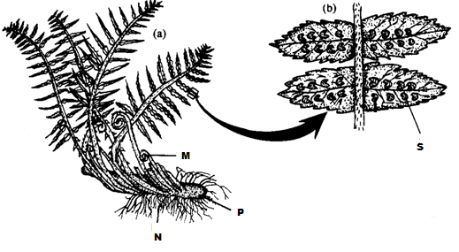
- Identify the division to which the specimen belongs. (1mk)
………………………………………………………………………………………
- Name the parts labeled M, N and P. (3mks)
M……………………………………………………………………………………N……………………………………………………………………………………
P……………………………………………………………………………………..
- Name the spore producing structures that constitute the part labeled S. (1mk)
………………………………………………………………………………………
- Identify three features that distinguish the specimen above from higher plants.
(3mks)
………………………………………………………………………………………………………………………………………………………………………………………………………………………………………………………………………

- The diagram below shows a wind pollinated flower.

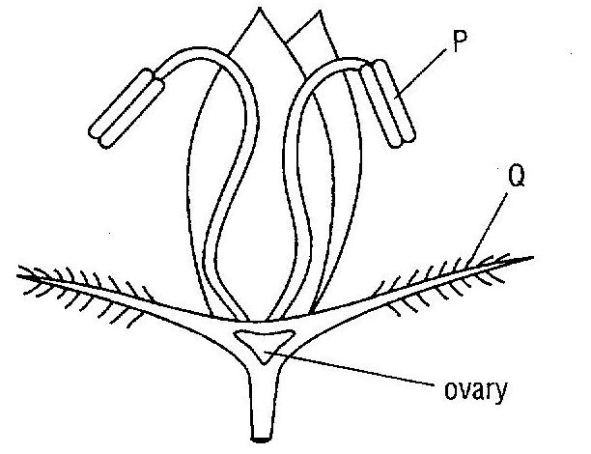

a)Name the parts labeled P and Q (1mk)

………………………………………………………………………………………………………………………………………………………………………………
- Give two features of wind pollinated flower shown in the diagram. (2mks)
………………………………………………………………………………………………………………………………………………………………………………
- What is the advantage of cross pollination as compared to self pollination. (1mk)
………………………………………………………………………………………………………………………………………………………………
- Name three mechanisms in plants that encourage cross pollination. (3mks)

- Identify the position of the ovary in the flower. (1mk)

SECTION B: 40 (MARKS)
Answer question 6 (Compulsory) and either question 7 or 8 in the spaces provided after question 8.
6. An investigation was carried out to determine the concentration of various substances in a river following the discharge of untreated sewage into the river. The results are shown in the table below.
Distance downstream in kilometers | 0.0 | 0.5 | 1 | 2 | 4 | 6 | 8 | 10 | 12 | 14 | 16
Concentration of oxygen(mg/L) | 10.0 | 10.0 | 8.8 | 5.8 | 5.0 | 4.0 | 5.0 | 6.0 | 8.2 | 9.4 | 10.0
Concentration of organic matter(mg/L) | 10.0 | 10.0 | 16.0 | 15.2 | 14.2 | 13.4 | 12.6 | 12.4 | 11.6 | 10.0 | 10.0
Concentration of nitrates(mg/L) | 10.0 | 10.0 | 10.6 | 12.2 | 14.2 | 15.0 | 15.2 | 14.6 | 12.6 | 11.4 | 10.0
- Using the same axes, draw graphs of concentration of named substances in the water against kilometers. (7marks)

(b) Identify the point of sewage discharge. (1 mark)
......................................................................................................................................................
(c) Account for the changes in the concentration of;
(i) Organic matter. (2 marks)
........................................................................................................................................................................................................................................................................................................................................................................................................................................................................................................................................................................................................................
(ii) Dissolved oxygen. (2 marks)
........................................................................................................................................................................................................................................................................................................................................................................................................................................................................................................................................................................................................................
(d) Nitrates. (2 marks)
........................................................................................................................................................................................................................................................................................................................................................................................................................................................................................................................................................................................................................
(e) Explain how heavy metals in industrial effluents may accumulate in bodies of humans to toxic levels. (2 marks)
........................................................................................................................................................................................................................................................................................................................................................................................................................................................................................................................................................................................................................
(f) State four human activities that affect population of animals in game parks. (4marks)
........................................................................................................................................................................................................................................................................................................................................................................................................................................................................................................................................................................................................................

7. Describe how the mammalian skin is adapted to its functions.(20mks)

8. Explain how each of the following serves as evidence of organic evolution:
- Fossil records. ( 4 marks)
- Comparative anatomy. (6 marks)
- Geographical distribution. (3 marks)
- Cell embryology (3 marks)
- Cell biology (4 marks)
..........................................................................................................................................................................................................................................................................................................................................................................................................................................................................................................................................................................................................................................................................................................................................................................................................................................................................................................................................................................................................................................................................................................................................................................................................................................................................................................................................................................................................................................................................................................................................................................................................................................................................................................................................................................................................................................................................................................................................................................................................................................................................................................................................................................................................................................................................................................................................................................................................................................................................................................................................................................................................................................................................................................................................................................................................................................................................................................................................................................................................................................................................................................................................................................................................................................................................................................................................................................................................................................................................................................................................................................................................................................................................................................................................................................................................................................................................................................................................................................................................................................................................................................................................................................................................................................................................................................................................................................................................................................................................................................................................................................................................................................................................................................................................................................................................................................
............................................................................................................................................................................................................................................................................................................................................................................................................................................................................................................................................................................................................................................................................................................................................................................................................................................................................................................................................................................................................................................................................................................................................................................................................................................................................................................................................................................................................................................................................................................................................................
............................................................................................................................................................................................................................................................................................................................................................................................................................................................................................................................................................................................................................................................................................................................................................................................................................................................................................................................................................................................................................................................................................................................................................................................................................................................................................................................................................................................................................................................................................................................................................
......................................................................................................................................................
........................................................................................................................................................................................................................................................................................................................................................................................................................................................................................................................................................................................................................
......................................................................................................................................................
..................................................................................................................................................................................................................................................................................................................................................................................................................................................................
......................................................................................................................................................
........................................................................................................................................................................................................................................................................................................................................................................................................................................................................................................................................................................................................................
......................................................................................................................................................
..................................................................................................................................................................................................................................................................................................................................................................................................................................................................
......................................................................................................................................................

