END TERM 2 2025
BIOLOGY PAPER 2 (231/2)
MARKING SCHEME
- a) A – Hypertonic / highly concentrated soln;
B – Hypotonic / lowly concentrated soln;
b) Osmosis;
c) Plasmolysis; rej plasmolysed
d) It will gain water by osmosis; swell and eventually burst;
e) Form contractile vacuoles; which get rid of excess water;
- a) Genes located on the same chromosome and are always transmitted together;
b) (i) X^{h}X^{h};
(ii) Parental genotype X^{H}X^{h} X X^{H}Y;

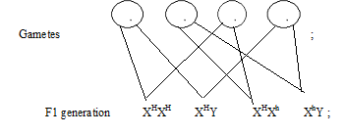

Phenotypic ratio 3 normal: 1 haemophiliac;
(iii) Males lack corresponding allele on the Y chromosome; therefore they cannot be carriers; OWTTE
- a) E – Arteriole;
F – Lymphatic vessels;
H – Venule;
b) Formation of tissue/ intercellular/ interstitial fluid; which is a medium of exchange of materials between body cells and blood;
c) blood in E is rich in nutrients while in H low in nutrients; blood in E has more oxygen, that in H has less oxygen; blood in E has less waste products of metabolism that in H has more waste products of metabolism;
- a) Pteridophyta; reject if does not start with capital letter
b) M – Young frond;
N – Adventitious roots;
P – Rhizome;
c) Sporangia;
d) Absence of flowers; it produces spores; stem is a rhizome; has adventitious roots;
- a)P= anther
Q=stigma.
b) i)anthers are long and are born on long flexible filament
ii) Stigma long and have feathery projections out of the flower.
c)i)cross pollination brings about variation/increase in hybrid vigour
d)i)Heterostylyi.e different arrangement of the style and stigma.
ii)Self sterility or incompatability.
iii)Protandry and protogyny.
iv) Dioeciouss plants.
v)Hermaphrodite plants.
e)

6(a)
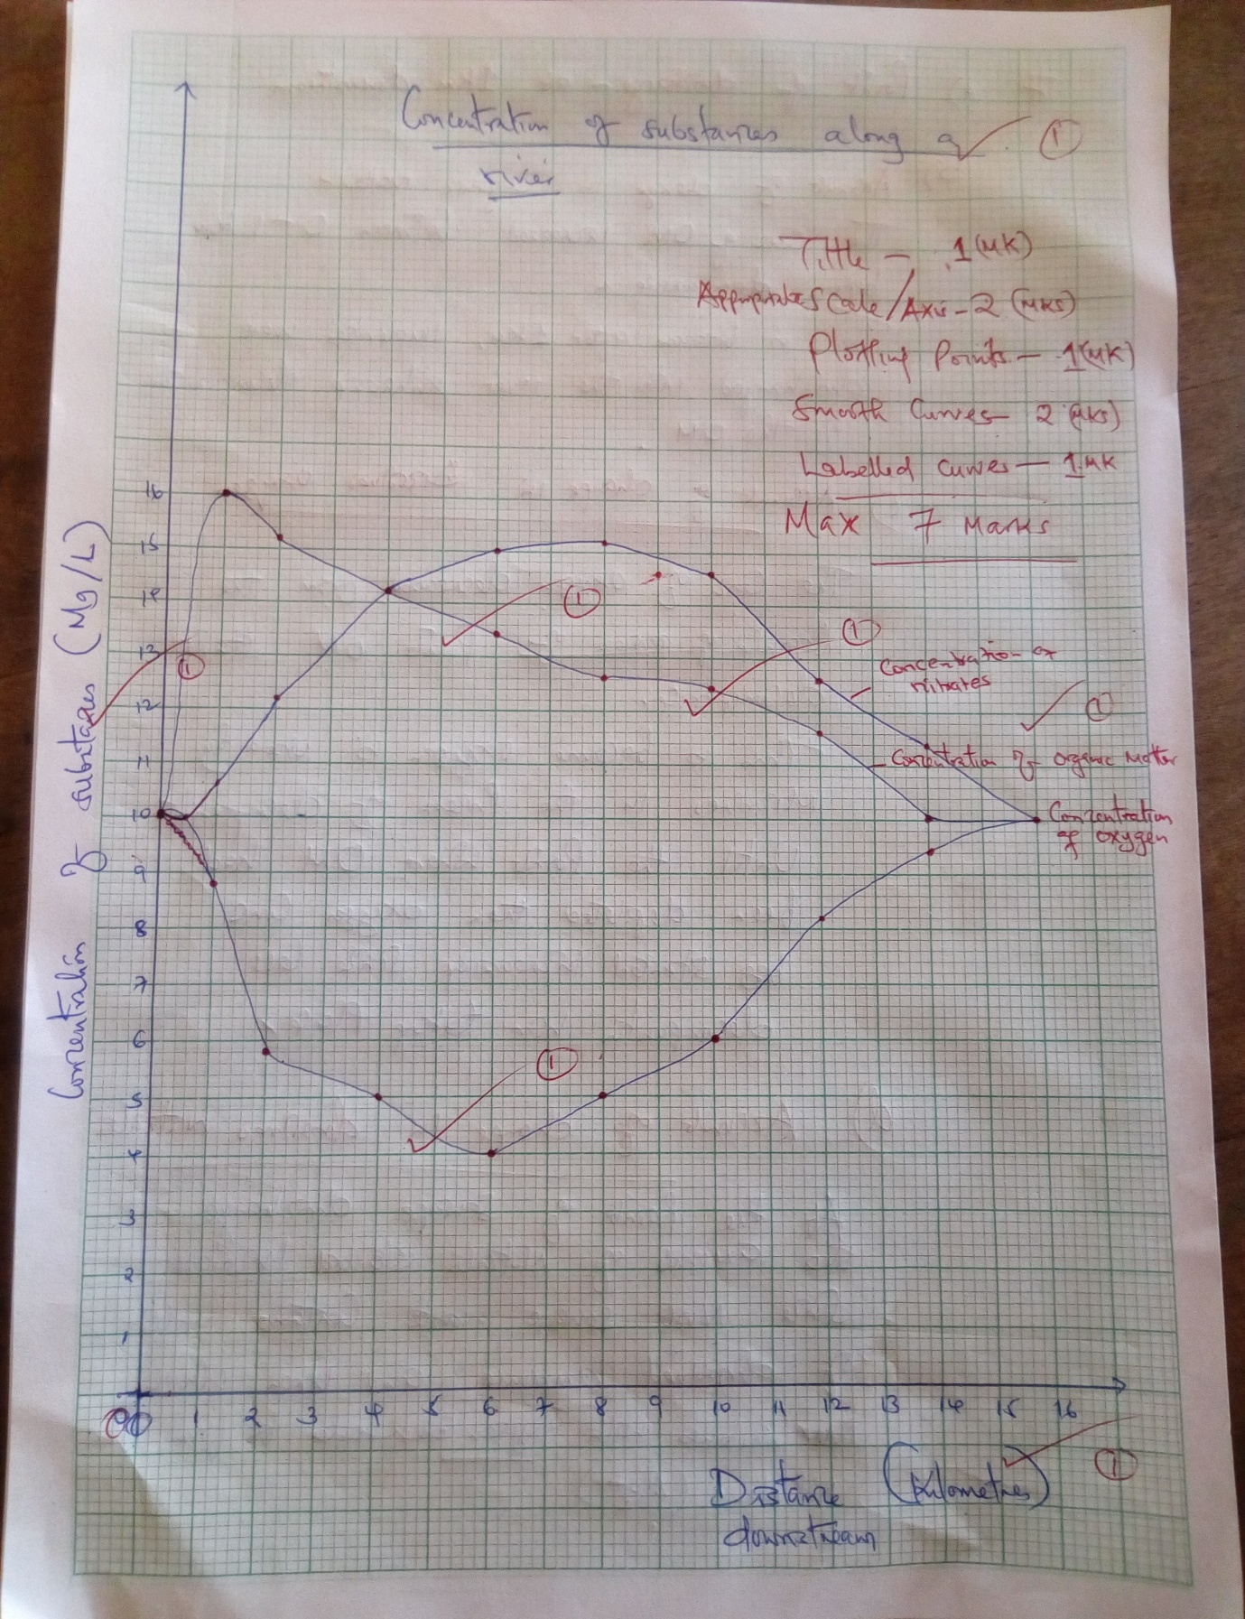

6(b) Identify the point of sewage discharge. (1mark)
At 1km downstream
(c) Account for the changes in the concentration of;
(i) Organic matter. (2 marks)
The concentration of organic matter increased between ( 0-1)km before decreasing;
This is because after 1km, untreated sewage were discharged into the river enhancing the process of decomposition of organic matter;
(ii) Dissolved oxygen. (2 marks)
The concentration of oxygen decreased from the point where organic matter started decomposing;
This is because oxygen is used by the micro organisms in the process of decomposition until the point where organic matter gets depleated then oxygen concentration increases;
(d) Nitrates. (2 marks)
Increase in organic matter increases the amount of nitrates since nitrates are a product organic decomposition;
Upon decline in organic matter concentration,the nitrates concentration also declines due to reduced decomposition.
(e) Explain how heavy metals in industrial effluents may accumulate in bodies of humans to toxic levels. (2 marks)
Toxic substances e.g lead and mercury end up in bodies of acquatic life and accumulate over time; through consumption of fish and other acquatic organisms the heavy metals end up in human bodies.
(f) State four human activities that affect population of animals in game parks. (4marks)
Poaching
Continous grazing
Charcoal burning
Enchroachment/illegal settlements
Accept any other reasonable answer

7.Describe the structure and function of the mammalian skin
It has a cornified layer made up of dead cells and is tough and impermeable to water; to protect the skin against mechanical damage; bacterial infections and water loss; granular layer; whose cells divide to form the cornified layer; malpighian layer; which is made up of diving cells that give rise to a new granular layer; contains melanin; to protect skin against ultra-violet rays/radiations; Sebaceous glands; which secrete sebum; to make the skin supple/soft and waterproof; sebum is also antiseptic; Blood vessels; dilate during hot weather; increasing blood flow near the skin surface; heat loss is enhanced; constrict; in cold weather; less blood flow; minimize heat loss; Sensory nerve endings and receptors; enable detection of external environmental changes; Highly coiled sweat glands; secrete sweat; to control body temperature; when hot sweat evaporates cooling the body; sweat contains excretory products; subcutaneous fat/adipose tissue in dermis; for insulation; hair; to regulate body temperature; in cold weather erector pili muscles contract; hair is raised, air trapped to insulate the body; in hot weather, erector pili muscles relax; hair lies flat reducing insulation; dense network of blood capillaries; supply nutrients/oxygen to skin tissues; as well as carrying away wastes and carbon (IV) oxide away from the skin tissues; adipose tissue/sub-cutaneous layer; serves as an insulator; helping in temperature control; helps in manufacture of vitamin D; Max. 20 mks

8. Evidence of organic evolution
- Fossil records (4mks)
Archeological findings have documented; that remains of ancient living organisms have primitive and undeveloped structures; as compared to recent organisms of the same ancestry; this means that evolution occurred and that structures of recent living organisms have advanced in development over the past million years.
ii) Comparative anatomy (6mks)
Studies on anatomical structures of living organisms reveals certain similarities; These structures have however displayed differences in function; The differences has been associated to evolution; Through divergent evolution, homologous structures which have had similar anatomy have over time been adapted to perform different functions; this is adaptive radiation; convergent evolution has also acted on analogous structures which did not have a common anatomy to perform a similar function. These structures have been observed in vertebrates whose pentadactyl limbs have been modified over time,an evidence of evolution.
iii) Geographical distribution (3mks)
the theory of continental drift postulates that in the past, the earth was a simple land mass and organisms were sharing a common ecological condition and therefore had similar features; During the geological era, the continent drifted and the various continents formed were isolated; The organisms in various ecological conditions were then observed to assume different features and characteristics; The current Ilama of South America and the camel of Africa is a real example of how geographical isolation lead to evolution.
iv. Cell embryology
v. Cell biology

