Name: ……………………………....…………. Index No: ……………………….…………….
School: ……………………………………….... Candidate’s Signature: ………………………

231/1
BIOLOGY
PAPER 1
(THEORY)
END TERM 2 2025
JULY 2025
TIME: 2 HOURS

Kenya Certificate of Secondary Education (K.C.S.E.)

BIOLOGY
PAPER 1
(THEORY)

TIME: 2 HOURS

INSTRUCTIONS TO CANDIDATES

- Write your name, Admission number and name of your school in the spaces provided above
- Sign and write the date of examination in the spaces provided.
- Answer all the questions in the spaces provided.
- This paper consists of 10 printed pages.
- Candidates should check to ascertain that all pages are printed as indicated and that no questions are missing
For Examiners Use Only
Question | Maximum score | Candidate’s score
1- 26 | 80

- State the functions of each of the following organelles
- Ribosomes (1mk)
........................................................................................................................................................................................................................................................................
- Golgi apparatus (1mks)
........................................................................................................................................................................................................................................................................
- The diagram below represents the pathway of water from soil into the plant.
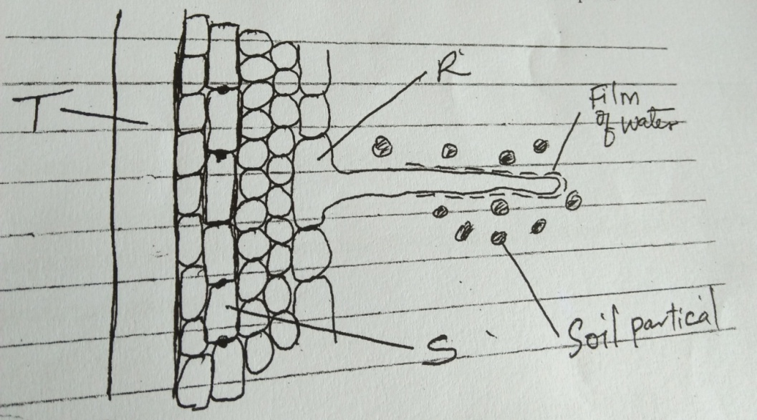

- Name the structure labeled T and S.
T................................................................................................................................(1mk)
S...............................................................................................................................(1mk)
- State two ways in which the structure labeled R is adapted to its functions (2mks)
.........................................................................................................................................................................................................................................................................................
- A student added equal amounts of blood to equal volumes of salt of different concentrations. She observed and counted the red blood cells at the beginning of the experiment. The results were as shown : -
Set up | Concentration of salt | Beginning | After 30 minutes
A | 0.1mol | 500 | 500
B | 0.01mol | 500 | 250

Account for the results in:
- Set up A (2mks)
..............................................................................................................................................................................................................................................................................
- Set up B (2mks)
.............................................................................................................................................................................................................................................................................
- Explain how each h of the following serves as evidence for evolution
- Fossil records (2mks)
............................................................................................................................................................................................................................................................................................................................................................................................................
- Comparative embryology (2mks)
............................................................................................................................................................................................................................................................................................................................................................................................................
- A student measured the length of a mitochondrion on a photomicrograph whose magnification was X 40000 found it to be 1mm. calculate the actual size of mitochondrion (3mks)

- State one way in which aerenchyma tissue in aquatic plants are adapted to their function
(1mk)
.......................................................................................................................................
- (a) Name the carbohydrates that is stored in Mammalian muscles (1mks)
..............................................................................................................................................................................................................................................................................................
(b) List down Two differences between polysaccharides and Monosaccharaides (2mks)

polysaccharides | monosaccharaides
..................................................................  ..................................................................  ..................................................................  ................................................................. | ................................................................  ................................................................  ................................................................  ................................................................
- (a) Name the kingdom whose members have a cell wall made of chitin (2mks)
...............................................................................................................................................................................................................................................................................................
(b) Besides the abdomen, name the other body part of the members of arachnida (1mk)
...........................................................................................................................................
(c) State two main characteristic features of members of division Bryophyta (2mks)
................................................................................................................................................................................................................................................................................................
- (a) State two ways in which human body is naturally protected against harmful bacteria
(2mks)
..............................................................................................................................................................................................................................................................................................
(b) State one way in which the composition of blood in pulmonary artery and that of pulmonary vein differ (1mk)
................................................................................................................................................................................................................................................................................................
- Describe the path taken by Carbon (iv) oxide released from the tissues of a cockroach into the atmosphere (2mks)
................................................................................................................................................................................................................................................................................................................................................................................................................................................

- Form one student set up an experiment shown below to investigate a certain physiological process. The set up was left for 30 minutes
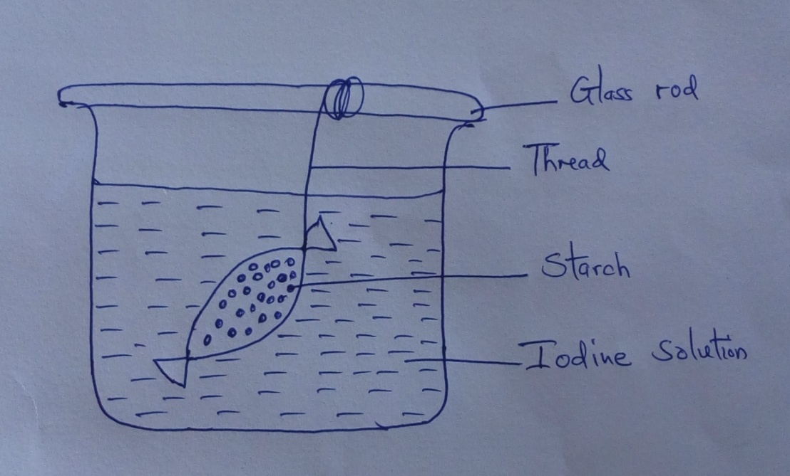

- Name the process under study (1mk)
.......................................................................................................................................
- State the expected results after 30 minutes (1mk)
................................................................................................................................................................................................................................................................................................
- Explain your answer in (b) above (3mks)
...............................................................................................................................................................................................................................................................................................................................................................................................................................................
- (a) Define the term mutation (1mk)
................................................................................................................................................................................................................................................................................................
(b) Name two sex – linked traits in humans attached to Y- chromosomes (2mks)
...............................................................................................................................................................................................................................................................................................................................................................................................................................................
- Explain why athletes train in high altitude in preparation for competition (2mks)
................................................................................................................................................................................................................................................................................................................................................................................................................................................
- Briefly describe three characteristics of populations. (3mks)
................................................................................................................................................................................................................................................................................................................................................................................................................................................................................................................................................................................................................................................................................................................................................

- (a) Define the following terms (2mks)
- Microbiology
..................................................................................................................................
- Genetics
....................................................................................................................................
(b) State two scientific skills acquired in studying biology (2mks)
................................................................................................................................................................................................................................................................................................

- The diagram below represents a cell organelle as seen as seen under electron microscope

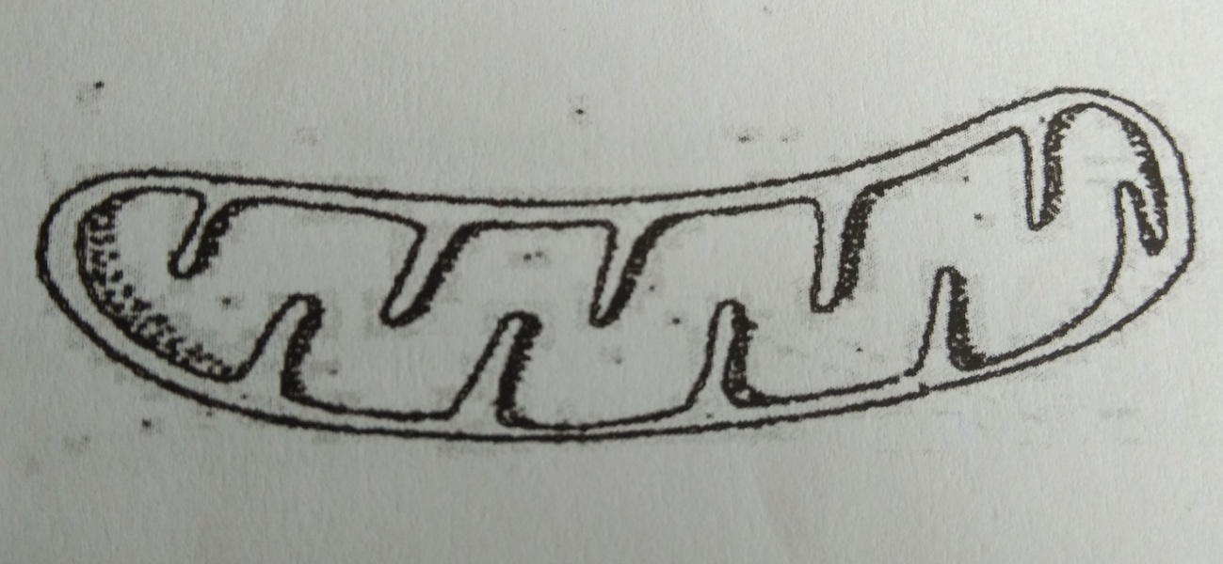

- (i) identify the organelle (1mk)
...................................................................................................................................

- State the function of the organelle named (a) (i) above the cell (1mk)
..............................................................................................................................................

- The figure below shows change in dry mass of germinating bean seeds with time.
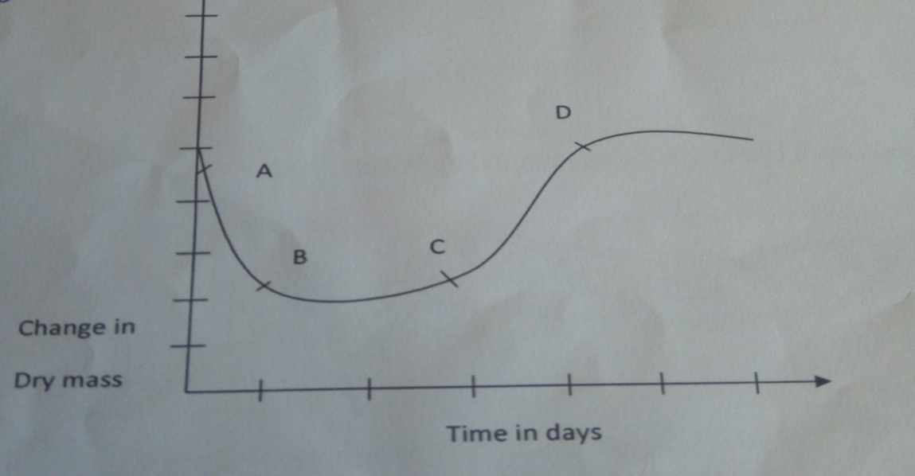

Account for the;
- Change in dry mass between A and B (2mks)
...................................................................................................................................................................................................................................................................................
- Rapid increase in dry mass C and D (2mks)
....................................................................................................................................................................................................................................................................................
- (a) Define pollination (1mk)
.............................................................................................................................................

(b) State three factors that strictly hinder self-pollination (3mks)
..............................................................................................................................................................................................................................................................................................................................................................................................................................................

- Outline the effects of acid rain in the environment. (3mks)
..............................................................................................................................................................................................................................................................................................................................................................................................................................................................................................................................................................................................
- State two precautionary measures which should be taken in preventing the spread of HIV.
(2mks)
................................................................................................................................................................................................................................................................................................

- The diagram below represents a section through a chloroplast as seen under the electron microscope

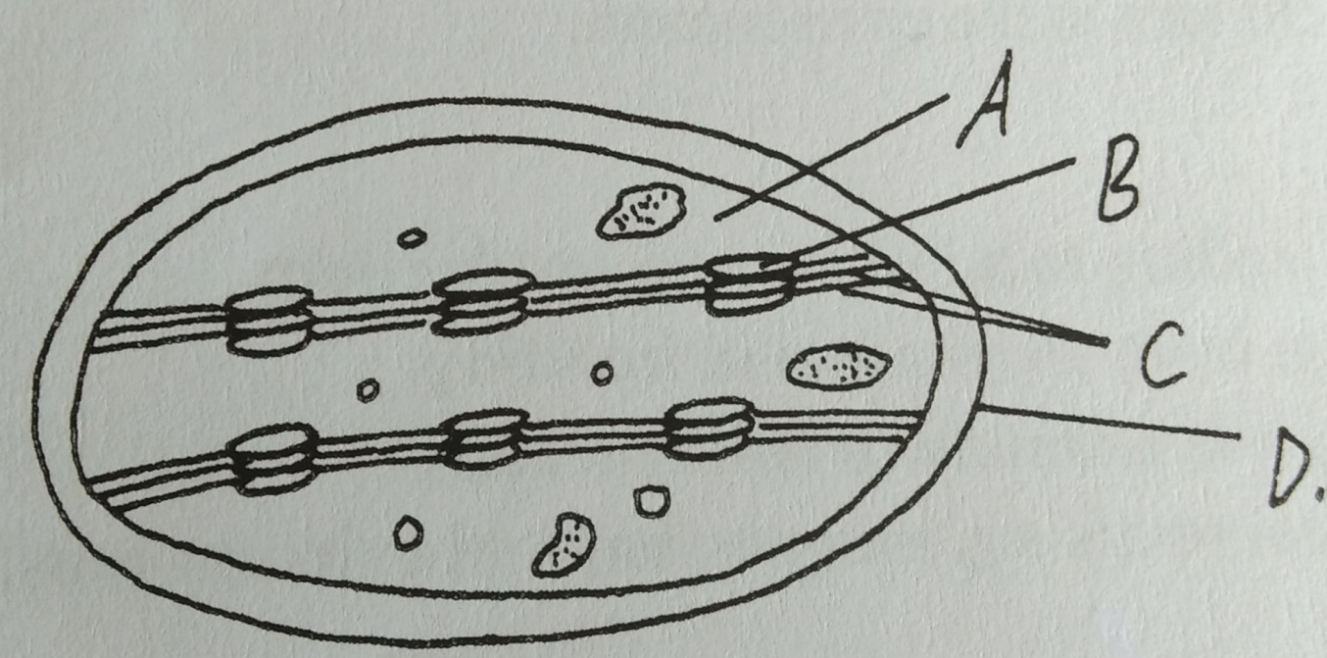

- Name the structure labeled D (1mk)
........................................................................................................................................

- In which labelled structure do we find chlorophyll molecule (1mk)
........................................................................................................................................

- Name the structure labeled, where carbon IV oxide fixation occurs (1mk)
...............................................................................................................................................

- (a) State two major roles of the kidney. (2mks)
................................................................................................................................................................................................................................................................................................

- State one economic importance of each of the following plant excretory products
(3mks)
- Quinine
....................................................................................................................................
- Papain
....................................................................................................................................
- Cocaine
....................................................................................................................................

- Define the following terms used in genetics
- Cloning

..........................................................................................................................................
- Gene therapy

..........................................................................................................................................
- The diagram below shows some growth in plant
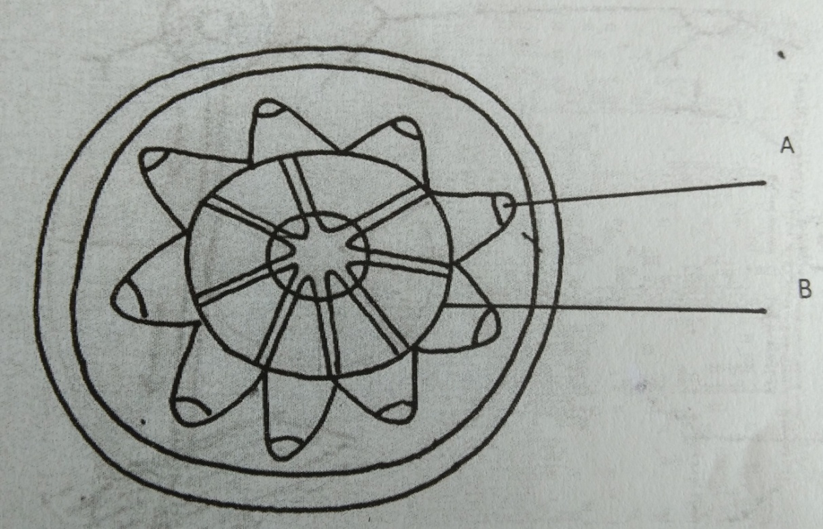

- Name the type of growth in the diagram (1mk)
...............................................................................................................................................

- Name the part labeled A (1mk)
............................................................................................................................................
- What is the function of the part labeled B (1mk)
............................................................................................................................................

- Below is a diagram of an organism
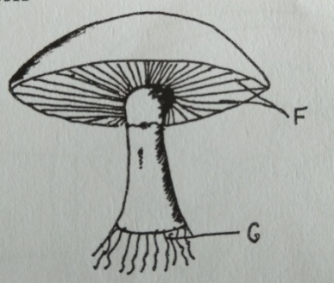
- Identify the kingdom to which the organism belong to (1mk)
..........................................................................................................................................

- State the functions of the structures labeled F and G (2mks)
F..........................................................................................................................................

G..........................................................................................................................................

- Name the material that makes the cell wall of the organism (1mk)
.........................................................................................................................................

- (a) State the significance of respiratory quotient (R.Q) values to a biologist (1mk)

...........................................................................................................................................

(b)The equation below is a respiratory reaction of a certain substrate. Study it and use it to determine its R.Q value. (1mk)
C₂₀ H4₀ O₂₀ + 20 O₂ 20 CO₂ + 20H₂O + Energy

