Name: ____________________________ Adm No: ____________Class: _____
Candidate’s Signature: _________________Date: __________________________

BIOLOGY
FORM TWO
END TERM 2 EXAMINATION
JULY/AUGUST 2025
Time: 2 HOURS

Instructions to Candidates
ANSWER ALL QUESTIONS IN THE SPACES PROVIDED

- State three characteristics of living organisms that are specific to plants. (3 marks)

- What is the Importance of collection of specimens for biology? (1 mark)

- Name the plant cell organelle: (2 marks)
a) That stores chlorophyll

b) Responsible for intracellular digestion

- Give the reasons for each of the following steps when preparing a cross-section of a stem or leaf for examination under the microscope
(4marks)
a) cutting very thin sections

b) Using a sharp razor blade during the cutting

c) Placing sections in water

d) Staining the sections with iodine before observing

- To make cell structures (chloroplasts, starch containing structures, granules or plastids distinct. Given that the diameter of the field of view of a light microscope is 2000um. Calculate the size of a cell in mm if 10 cells occupy the diameter of the field of view
(3marks)

- Briefly explain the fate of the following products from the light stage of the process of
Photosynthesis: (3 marks)
a) Oxygen atoms

b) Hydrogen ions

c) ATP

- A freshly obtained dandelion stem measuring 5 cm long was split lengthwise to obtain two similar pieces. The pieces were placed in solutions of different concentrations in Petri dishes for 20 minutes. The appearance after 20 minutes is as shown.
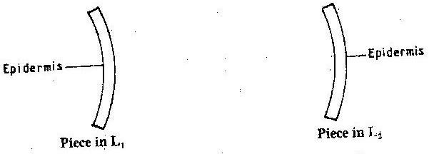
- Name the physiological process investigated. (1mark)

- Account for the appearance of the pieces in solutions L₁ and L2.
(6 marks)

- A form two student wanted to kill a cockroach by immersing its head in water for thirty minutes. Explain why the cockroach could not have drawn? (2 marks)

- Explain why it is advisable to breathe through the nostrils than the mouth.
(3 marks)

- Define the following terms. (3 marks)
a) Excretion

b) Secretion;

c) Egestion

- Whats the Importance of excretion in organisms (2 marks)

- Excessive blood loss can be rectified by blood transfusion in which blood from one-person donor, is transferred into the patients’ blood stream.
Complete the table. (4 marks)

Blood Group | Can donate blood to | Can receive blood from
A |  | A,O
B | B and AB
AB |  | A,AB,B,O
O | A,B,AB,O

a) What are the advantages and disadvantages of having blood group O? (2 marks)
Advantage.
Disadvantage.
b) State the advantage of having blood group AB. (1mark)

- Give the biological importance of photosynthesis. (2marks)

- Newborn babies have generally a heartbeat count of 120 to 140 per minute while that State of adult is 70 per minute on average. Account for the difference.
(2 marks)

- State two precautions which should be taken when storing a microscope after a laboratory exercise. (2marks)

- The diagram below shows a section through the mammalian skin

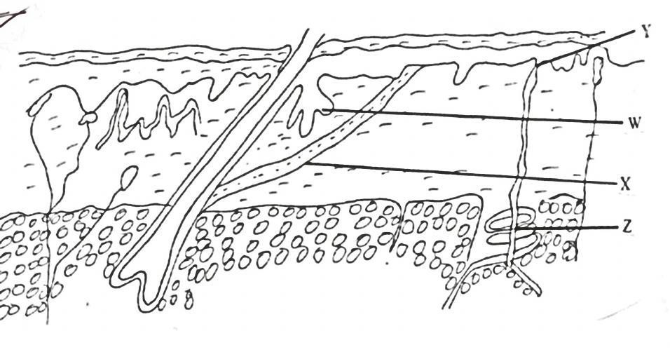
a) Name the parts labeled Y and X (2mks)
X
Y
b) State the function and role of the parts labeled W and Z (2mks)
W;
Z;

- The following photograph is of a common travelling animal
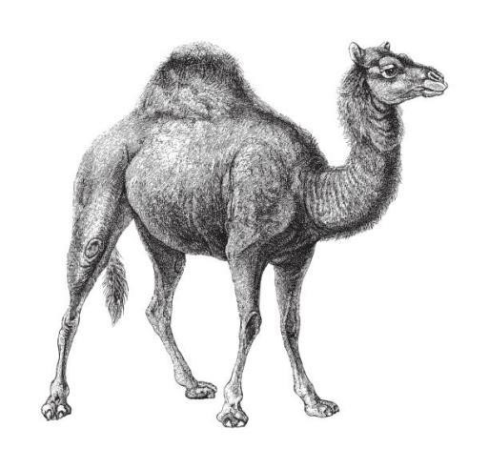

Q

  - Explain how part labelled Q adapts the animal to its life in the desert? (2marks)

  - State the expected feature in the kidneys of the animal shown above in terms of the following: (2 marks)

    - Number of nephrons
ii) Length of Loop of Henle

- Name the enzyme responsible for breaking down carbon (IV) oxide in mammalian blood into
weak carbonic acid . (1mark)

- Explain why plants lack complex excretory organs like those of animals. (3marks)

- Name the type of circulatory system found in Arthropods. (1mark)

- Name the process which occurs in mammalian liver that lead to formation of urea
(1mark)

- Name the three types of polysaccharides and in each case state its function in the living
cell. (3marks)

- In what part of the chloroplast does each of the following occur. (2mark)

i) light dependent stage
ii) light independent stage

- State three factors that determine the rate of diffusion of materials. (3 marks)

- State five adaptations of leaves to photosynthesis. (5marks)

- The diagram below shows a set up that was used to demonstrate a certain physiological process.
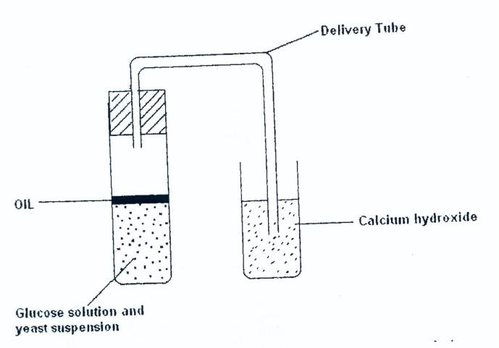
The glucose solution was boiled and oil added on top of it. The glucose solution was then allowed to cool before adding yeast suspension.
a) Identify the physiological process that was being investigated using the above set up.
(1 mark)
b) Why was glucose boiled during the experiment?
(1 mark)
c) What was the importance of cooling the glucose before adding the yeast suspension?
(1 mark)
- Give two characteristics that distinguish scientific names of organisms from other
ordinary names. (2marks)

- Name the blood vessel that conveys blood to the; (2 marks)
a) Heart cells
b) Kidney

