MARKING SCHEME
BIOLOGY
FORM TWO
END TERM 2 EXAMINATION
JULY/AUGUST 2025

1. Suggest a biological tool that is most suitable for collecting each of the following organisms. (3mks)
- Scorpions.
Pair of forceps

- Safari ants on a tree
Pooter

- Butterfly in a coffee farm
Sweep net;

2. Identify the discipline of biology that deals with the following.
- The relationship between organisms and their environment. (1mk)
Ecology
- Study of development of living organisms. (1mk)
Embryology
- Study of body functions of living organisms. (1mk)
Physiology
3. Name two supportive tissues in plants that are lignified. (2marks)
Sclerenchyma
Xylem
4.Name the polysaccharide which offers mechanical support in
(i)Arthropods(1mark)
Chitin
(ii)Plants(1mark)
Cellulose
5. a) State the muscle that regulates entry of food bolus into the stomach. (1mark)
Cardiac sphincter
b) How is parotid gland important in starch digestion. (2marks)
-Secretes salivary amylase;breaks down starch to maltose -Secretes saliva which provides an alkaline medium for working of amylase
6. Name the cell structures that synthesize the following cell organelles
(i) Ribosomes. (1mark)
Nucleolus
(ii) Lysosomes. (1mark)
Golgi apparatus
- A solution of sugarcane was boiled with hydrochloric acid then cooled. Sodium carbonate was added then Benedict’s solution. The solution was boiled and an orange precipitate was formed.
- Why was the solution boiled with hydrochloric acid? (1mark)
To break down/hydrolyse the disaccharide to monosaccharides

- To which class of carbohydrates does sugarcane belong? (1mark)
Disaccharide

- Name the type of reaction that takes place when:
(i) Simple sugars combine to form complex sugars (1mark)
Condensation
(ii) A complex sugar is broken down into simple sugars (1mark)
Hydrolysis

7. Identify two scientific skills acquired through the study of biology (2mark)
Observation; Drawing; Analysing; Evaluation

8. The illustration shown below is a graph of enzymatic reaction 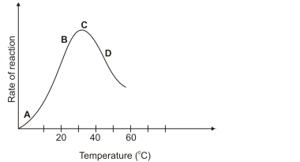
- Account for the rate of reaction shown at D. (2marks)
Declines; since high temperature beyond optimum denature/destroy enzymes;

- Why is the rate of reaction maximum at C? (1mark)
This is the optimum temperature thus maximum activation of enzymes;
9. Use the diagram shown below to answer questions that follow
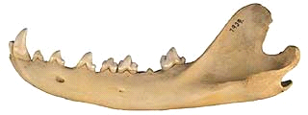
a) Give TWO reasons why the jaw shown above is of a carnivorous animal (2marks)
Long curved canine; Has carnassial tooth;
b) Use X to label the tooth used in seizing prey on the diagram above. (1mark)
c) A certain animal has no incisors, no canines, 6 premolars and 6 Molars in its upper jaw. In the lower jaw there are 6 incisors, 2 canines, 6 Premolars and 6 molars. Write its dental formula. (2mks)
(i)0/3 (c) 0/1 (pm) 3/3 (m) 3/3

10. Below is a diagram of a cell organelle. Study it and answer the questions that follow.
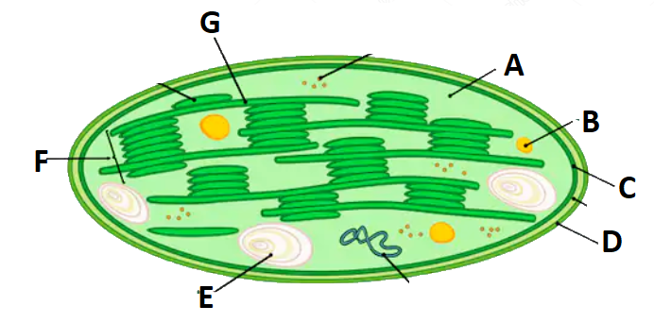
i)Identify the organelle. (1mk)
Chloroplast
ii)Name the part labelled A and C.(2mks)
A – Stroma

C – Inner membrane

iii) State the letter that represent the part where light stage of photosynthesis occurs. (1mk)
Letter F
iv)State two adaptations of the organelle to its function. (2marks)

v)What happens to the end products of light stage? (3 marks)
Oxygen; released to the atmosphere as a by product/used in respiration
Hydrogen atoms;Moves to the Dark stage and used in formation of simple sugars (Carbon (iv) oxide fixation)
ATP;Moves to the dark stage and provides energy for carbon (iv) oxide fixation.

11. The diagram shown below shows a leaf that was used to study photosynthesis. After the experiment, drops of Iodine solution were placed on the processed leaf

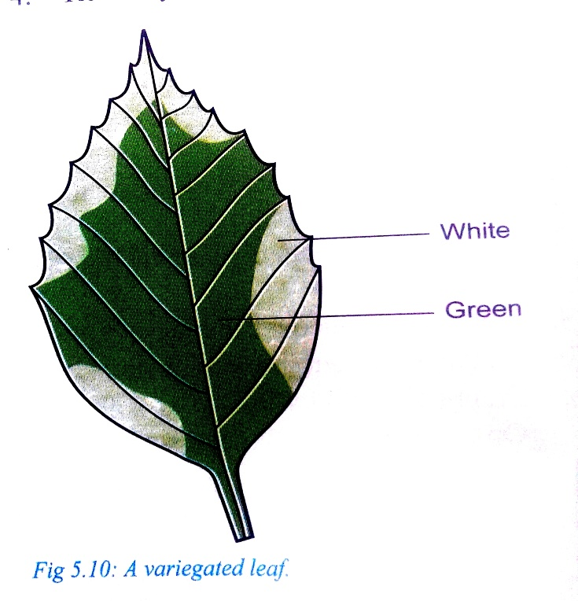
- Which food substance was being tested for? (1mark)
Starch

- Fill in the table below to show the colors observed in the following regions (2marks)
Region | Colour
White | The iodine solution remained brown
Green | Blue -black colour observed

- Account for observation made on white part of the leaf. (2marks)
The white part has no chlorophyll;No photosynthesis occurs here this starch is absent.

12. The experiment set up shown below was used to investigate a physiological process
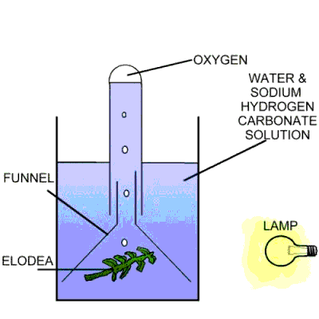
- What was the aim of the experiment? (1mark)
To test the gas produced during photosynthesis

- Why was Sodium Hydrogen Carbonate added in the water (2marks)
To increase amount of carbon (iv) oxide in the water

- How can one confirm that the gas released in the experiment is Oxygen. (1mark)
The gas relights a glowing splint

13.State 3 functional differences between arteries and veins(3marks)

Arteries carry blood away from the heart while veins carry blood towards the heart
Arteries carry oxygenated blood except pulmonary artery While veins carry deoxygenated blood except pulmonary vein.
Blood flows rapidly under high pressure in veins while Blood flows slowly under low pressure in veins
Blood flows in pulses in arteries while Blood flow in veins is smooth with no pulses.

14.Excessive blood loss can be rectified by blood transfusion in which blood from one person, the donor, is transferred into the patient’s blood system.
(i) Complete the table below(4marks)
Blood group | Can donate blood to | Can receive blood from
A | A ,AB | A, O
B | A and AB | B,O
AB | AB | A, AB, B, O
O | A, B, AB, and O | O

(ii)What are the advantages and disadvantages of having blood group O.(2marks)

Advantage -Universal donors
Disadvantage -Can only receive blood from blood group O

(iii)What is the advantage of having blood group AB. (1mark)
Universal recipients

15. (a)Heart muscles are myogenic. Explain(1mark)
They contract without nervous stimulation.

(b)Name the nerve that slows down the rate of the heart(1marks)
The vagus nerve

16. (a)What factors contribute to the formation of tissue fluid at the capillaries(2marks)
-High pressure in the capillaries
-Permeability of the capillary walls

(b)State the function of the tissue fluid(1mark)
Forms a medium of exchange of substances from the blood to the cells
(c)State 3 adaptations of capillaries to their functions (3marks)
-Numerous to increase surface area for exchange of materials
-Thin walled for faster diffusion of materials
-Narrow to maintain high pressure

17.State and explain 4 environmental factors that affect the rate of transpiration in plants(8marks)
-Temperature
-Humidity
-Atmospheric pressure
-Wind
-Light intensity
Any 4 expalined

