MARKING SCHEME

BIOLOGY
FORM TWO
END TERM 2 EXAMINATION
JULY/AUGUST 2025
Time: 2 HOURS

NB/ THIS MARKING SCHEME IS A GUIDLINE FOR MARKING; OWTTE APPLIES

- State three characteristics of living organisms that are specific to plants. (3 marks)
Autotrophic/ manufacture their own food/ photosynthesis; Show alternation of generation.
Have limited movement.
Have limited excretory products/ unspecialized respiratory structures.
Have localized growth/ growth occurs at specific regions.

- What the Importance of collection of specimens for biology? (1 mark)
It is important for further study; observations; and preservation for future reference in the laboratory.
- Name the plant cell organelle: (2 marks)
a) That stores chlorophyll- Chloroplast
b) Responsible for intracellular digestion- Lysosome.
- Give the reasons for each of the following steps when preparing a cross-section of a stem or leaf for examination under the microscope
(4marks)
a) cutting very thin sections
Thin sections allow light to pass through making it easy to observe the tissue
b) Using a sharp razor blade during the cutting

Sharp blade does not damage, deform, destroy or distort the surface of cell or tissue makes thin sections

c) Placing sections in water
maintains turgidity hence maintain shape of cell
prevents drying of the section

d) Staining the sections with iodine before observing

- To make cell structures (chloroplasts, starch containing structures, granules or plastids distinct. Given that the diameter of the field of view of a light microscope is 2000um. Calculate the size of a cell in mm if 10 cells occupy the diameter of the field of view
(3marks)

Size of one cell = diameter of field view
No. of cells arranged across the diameter
= 2000μm;
10cells
200μm = 0.2mm
N/B = 1μm = 0.001mms;

- Briefly explain the fate of the following products from the light stage of the process of
Photosynthesis: (3 marks)
(a) Oxygen atoms combines to form oxygen gas used for respiration. The rest is diffused out
during gaseous exchange
(b) Hydrogen ions enters the dark stage.

(c) ATP; provides energy for carbon(IV) oxide fixation

- A freshly obtained dandelion stem measuring 5 cm long was split lengthwise to obtain two similar pieces. The pieces were placed in solutions of different concentrations in Petri dishes for 20 minutes. The appearance after 20 minutes is as shown.
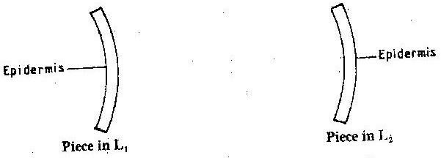
- Name the physiological process investigated. (1mark)
Osmosis
- Account for the appearance of the pieces in solutions L₁ and L2.
(6 marks)
In L₁ cortical cells/cells of the cortex/inner cells gained water by osmosis; becoming turgid hence increasing in length. The epidermal cells did not gain water because they are covered by a water proof cuticle leading to curvature.
In L₂ cortical cells/cells of the cortex/inner cells lost water by osmosis; leading to decrease in length. The epidermal cells did not gain water because they are covered by a water proof cuticle leading to curvature.

- A form two student wanted to kill a cockroach by immersing its head in water for thirty minutes. Explain why the cockroach could not have drawn? (2 marks)
Tracheal system /spiracles is located in the thorax and abdomen; hence it continued to carry out gaseous exchange.

- Explain why it is advisable to breathe through the nostrils than the mouth.
(3 marks)
The mucus; and cilia filter and trap dust and micro-organisms from the air; Air is warmed and moistened in the nasal cavity by numerous blood capillaries; The lining of the nasal cavity has chemoreceptor cells sensitive to detect and distinguish different types of smell for survival purposes.
- Define the following terms (3 marks)
a) Excretion separation and elimination of metabolic waste from the body.

b) Secretion; release of useful substances such as enzyme and hormones

c) Egestion removal of indigestible and undigested food substances from the alimentary canal of an animal.
- Whats the Importance of excretion in organisms (2 marks)
It creates a steady internal environment for cells to function normally.
Removes wastes that could accumulate in the body and become toxic to body cells.

- Excessive blood loss can be rectified by blood transfusion in which blood from one-person donor, is transferred into the patients’ blood stream.
Complete the table. (4 marks)

Blood Group | Can donate blood to | Can receive blood from
A | A, AB | A,O
B | B and AB | B,O
AB | AB | A,AB,B,O
O | A,B,AB,O | O

a) What are the advantages and disadvantages of having blood group O? (2 marks)
Advantage. Advantage – can give blood to all blood groups
Disadvantage – Cannot receive blood from any blood group except itself;

Disadvantage.
b) State the advantage of having blood group AB. (1mark)
can receive blood from all blood groups;
- Give the biological importance of photosynthesis. (2marks) Manufacture organic food / sugars consumed by animals; produces oxygen utilized in respiratory; utilized CO₂ in atmosphere which may be a pollutant;

- Newborn babies have generally a heartbeat count of 120 to 140 per minute while that State of adult is 70 per minute on average. Account for the difference.
(3marks) They lose more heat per unit weight due to larger surface area to volume ratio; resulting to higher rate of oxygen consumption / respiration to maintain their body temperature; Higher heart beat which increase blood circulation to supply O₂ to tissues & remove CO₂ & other wastes from tissues

- State two precautions which should be taken when storing a microscope after a laboratory exercise. (2marks) Click low power objective in position, in line with eye piece lens; store in a safe place free from moisture and dust;

- The diagram below shows a section through the mammalian skin

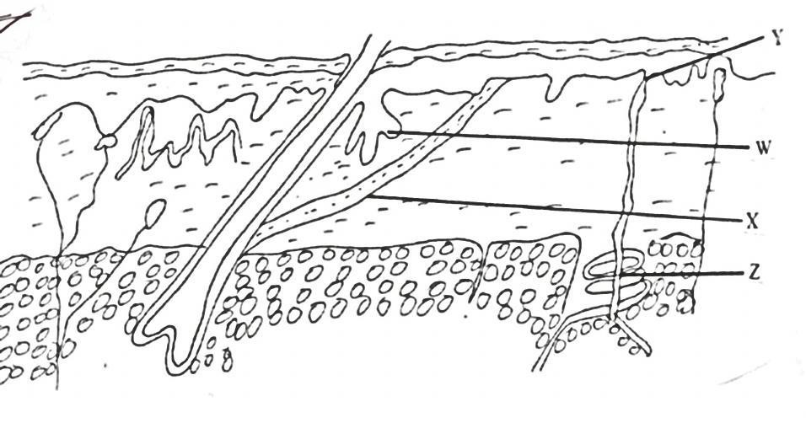
a) Name the parts labeled Y and X (2mks)
X erector pili muscle
Y sweat duct
State the function and role of the parts labeled W and Z (2mks)
W; Sebaceous gland; secretes sebum
Z; sweat gland; secrete sweat
- The following photograph is of a common travelling animal
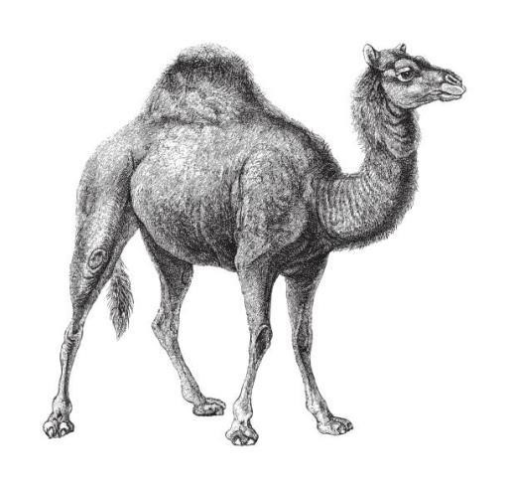

Q

  - Explain how part labelled Q adapts the animal to its life in the desert? (2marks)
Store fats; which when metabolized generates metabolic water
  - State the expected feature in the kidneys of the animal shown above in terms of the
following: (2marks)
    - Number of nephrons few
    - Length of Loop of Henle long

- Name the enzyme responsible for breaking down sodium hydrogen carbonate in mammalian blood to release carbon dioxide. (1mark)
Carbonic anhydrase
- Explain why plants lack complex excretory organs like those of animals. (3marks)
Plants have lower rate of metabolism; excrete non-poisonous products from carbohydrates unlike animals (protein metabolism); re-use some of their waste in protein synthesis / respiration / photosynthesis; store some wastes products in roots / fruits / leaves; Any 3

- Name the type of circulatory system found in arthropods. (1mark)
Open circulation;

- Name the process which occurs in mammalian liver that lead to formation of urea
(1mark)
Deamination
- Name the three types of polysaccharides and in each case state its function in the living
cell. (3marks)
Starch - Storage form of food in plants
Glycogen - Storage form of food (glucose) in animals
Cellulose - Used to make cell walls in plants.
Chitin- forms exoskeleton
- In what part of the chloroplast does each of the following occur. (2mark)
Light reaction
Dark reaction i) Light reaction : Giana
ii) Dark reaction : Stroma

- State three factors that determine the rate of diffusion of materials. (3 marks)

Temperature of the surrounding
Concentration gradient / concentration of material
Medium of travel
Density of material
Surface area to volume ratio
Size of diffusing molecule

- State five adaptations of leaves to photosynthesis. (5marks)

Broad lamina; to increase surface area
Thinness of leaf; to reduce distance covered by light
Presence of stomata; for gaseous exchange
Palisade cell with large number of chloroplasts
Network veins existence; for efficient transport of manufactured food, water and mineral salts
Large air spaces in spongy mesophyll for circulation of gases
Mosaic arrangement of leaves to prevent overshadowing and overlapping.
- The diagram below shows a set up that was used to demonstrate a certain physiological process.
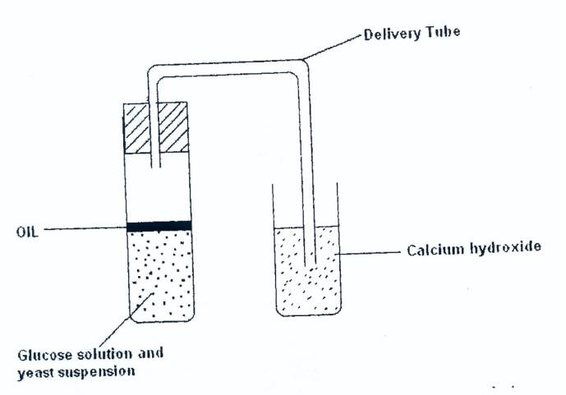
The glucose solution was boiled and oil added on top of it. The glucose solution was then allowed to cool before adding yeast suspension.
a) Identify the physiological process that was being investigated using the above set up.
Anaerobic respiration. (1 mark)
b) Why was glucose boiled during the experiment?
To expel air(oxygen). (1 mark)
c) What was the importance of cooling the glucose before adding the yeast suspension?
To prevent denaturing yeast cell. (1 mark)
- Give two characteristics that distinguish scientific names of organisms from other
ordinary names. (2marks)
Two names / generic and specific name
Genus / 1st name starts with Capital, 2nd name – small letters;
Both names underlined separately if handwritten / italized if printed;

- Name the blood vessel that conveys blood to the; (2 marks)
a) Heart cells Coronary artery
b) Kidney Renal artery

