

MARANDA HIGH SCHOOL
Kenya Certificate of Secondary Education
THE MOCK EXAMINATIONS, 2025
405/2 AVIATION PAPER 2
May/June, 2025 TIME: 2½ Hrs

Name: …………………………………….…….…… Admission No: …………
Stream: ……………….. Signature: ………............ Thursday, 5th June, 2025; 2:00-4:30pm
Instructions to Candidate
- Write your name, class, admission number, date and sign in the spaces provided.
- Candidate should have the following for this examination.
  - Drawing instruments
  - Drawing paper
- There are TEN stations in this examination
- Candidates are allowed 15 minutes at each station.
- At each station, candidates are not allowed to either review the previous station’s work or read instructions for other stations.
- Attempt all exercises in each station.
- All dimensions are in millimeters unless otherwise stated.
- Candidates should check the paper to ascertain that all the pages are printed as indicates and that no questions are missing.
- Candidates should answer the questions in English
FOR EXAMINER’S USE ONLY

STATIONS | 1 | 2 | 3 |  | 5 | 6 | 7 | 8 | 9 | 10 | Total
MARKS

Figure I show an assembly of an aircraft engine. On the space provided,
  - Sketch four assemblies of component detailed M
  - Label eight parts of the assemblies in component detailed M. (I0 marks)
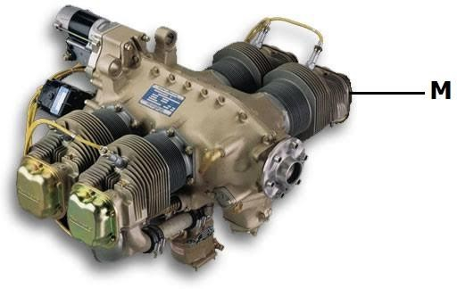

Using the tools, equipment and materials provided, make the aircraft undercarriage bracket as shown in Figure 2. (10 marks)
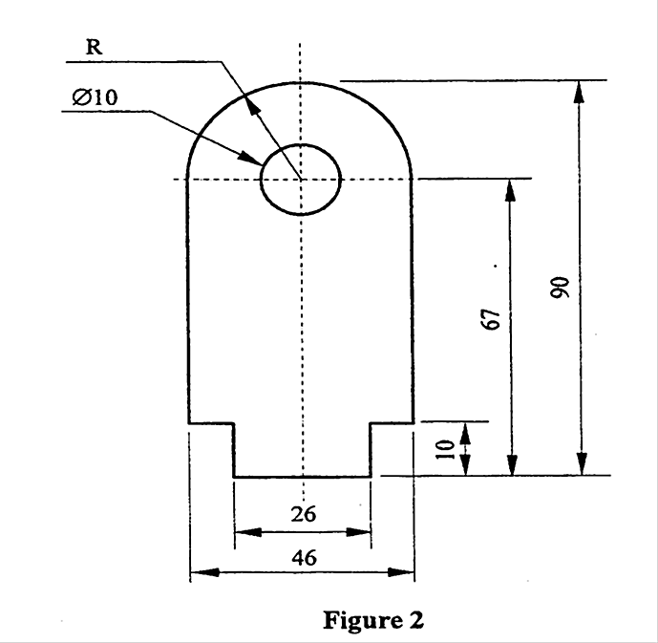

Study the aerodromes facilities and operations sketch attached and complete the tables below.
- Name the facilities marked 1, 2, 3, 4 and state the use of each. (4 marks)
Facility | Use
1
2
3
4

- Identify operational activities of the aircraft labeled A, B, C and D and state the reason for each observation. (4 marks)
Operational Activity | Reason
A
B
C
D

- State the function of the facility labeled E and F. (2 marks)
Facility | Function
E
F

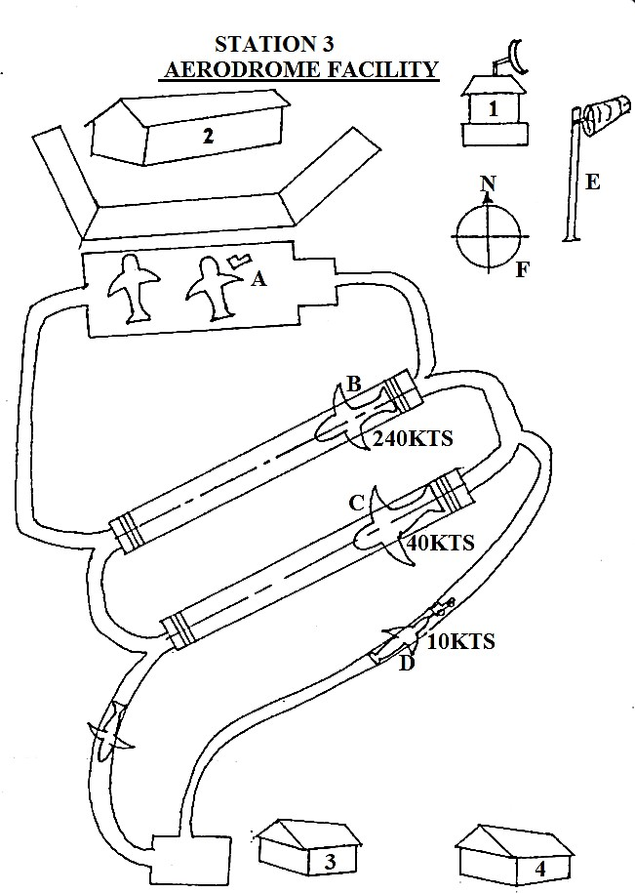

- Connect the components as shown in circuits 1.

Let the examiner check your work. (4 marks)
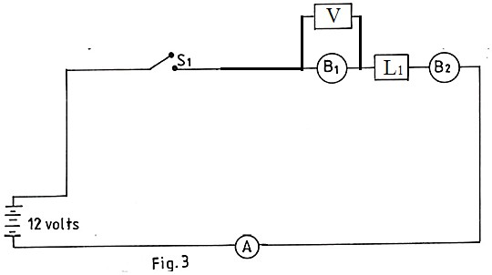

- (i) Select switch S1 to an on position. Record your observation. (2 marks) Observation……………………………………………………………………..
  - Select S1 to off position, replace L1 and L2 and record your observation. (2 marks) Observation…………………………………………………………………….
  - State the reason for the observation in (b) (i) and (b)(ii). (1 mark)

Reason…………………………………………………………………………..

  - State one application on an aircraft lighting system. (1 mark) Application …………………………………………………………………….

Using the tools and equipment provided, perform each of the following tasks.

- Study the assembly labeled D and identify the part.

Part (1 mark)

- (i) Dismantle the part labeled D. Let the examiner check your work. (1 mark) Examine and record the defects on each of the parts panted red, green, white and blue.
Red……………………………………………………………………………………………. Green………………………………………………………………………………………..
White……………………………………………………………………………………… Blue……………………………………………………………………………. (4 marks)
Demonstrate to the examiner the correct procedure of assembling part D while performing the task. (4 marks)

Carry out the following tasks using the tools and materials provided.
  - (i) Hold vertically and at mid-length each of the rods labeled K, L, M and N in a bench vice.
    - Using the tube labeled P, bend each rod fore and aft until it breaks. Record the number of bends for each rod.

K
………………………………………………………………………………………………………………………… L
………………………………………………………………………………………………………………………… M
………………………………………………………………………………………………………………………… N
…………………………………………………………………………………………………………………………
    - State the mechanical property being tested.
…………………………………………………………………………………………………………………………
…………………………………………………………………………………………………………………………
    - Comment on the relationship between the number of bends each rod takes to break to the mechanical property tested.
…………………………………………………………………………………………………………………………
…………………………………………………………………………………………………………………………
  - Cut each of the rod labeled K, L, M and N to determine the harder material. Hardest material (1 mark)
  - State one application and one reason of selecting each of the materials labeled K, L and M in an aircraft.
Material | Application | Reason
K
L
M

Using the tools and equipment provided perform the following tasks.
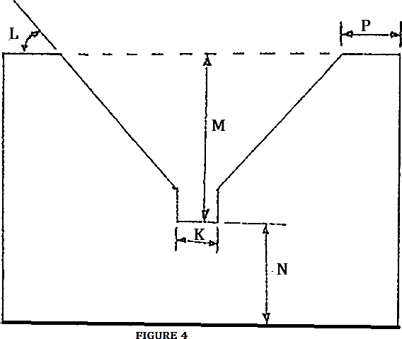
(a) Take and record the Vee block measurements K, L, M, N and P as shown on Figure 4.

Measurements (5 marks)
K …………………………………………………………………………….
L …………………………………………………………………………….
M …………………………………………………………………………….
N …………………………………………………………………………….
P……………………………………………………………………………….
(b)(i) Check and record the roundness of each of the rods A and B using the set up C. Roundness
A …………………………………………………………………………….
B……………………………………………………………………………. (2marks)
- State the reason behind the observation of rods A and B in (b)(i)
Reason (1 mark)
- Give the recommendation for the use on an aircraft from your observations in (b)(i)

Recommendations A
…………………………………………………………………………………………………
………………………………………………………………………………………………….
B ……………………………………………………………………………. (2 marks)

Using the tools, instruments and materials provided, perform the following tasks

  - Study the instrument labeled W₁, W₂, W₃ and complete Table 1.

    - Identify the type of instrument
    - Application on an aircraft
    - The principle of operation

Table 1

ITEM | IDENTIFICATION | APPLICATION | PRINCIPLE OF OPERATION
W₁
W₂
W₃
(4½ marks)

  - Construct a model anemometer. (5½ marks)

Using tools and component ‘F’ provided, perform the following tasks.
- Study the tools labeled 1 and identify: (2 marks)
  - Name of the tool ……………………………………………………………………………
  - Use of the tool ………………………………………………………………………………
  - Maintenance check required……………………………………………………………
  - Type ……………………………………………………………………………………............ (B)Study component ‘F’ and identify: (1½ marks)
- Component……………………………………………………………………………………
- Type ……………………………………………………………………………………………
- System applicable …………………………………………………………………………
- Dismantle component ‘F’
  - Identify parts G, H, J, K and L (2½ marks) G…………………………………………………………………………………………………………… H…………………………………………………………………………………………………………… J…………………………………………………………………………………………………………… K…………………………………………………………………………………………………………… L……………………………………………………………………………………………………………
  - State the use of parts painted white and blue. (1 mark) White…………………………………………………………………………………………………… Blue………………………………………………………………………………………………………
  - Examine parts G, J, K, and L and identify the maintenance checks for each.(2 marks)
G…………………………………………………………………………………………………………… J…………………………………………………………………………………………………………… K…………………………………………………………………………………………………………… L……………………………………………………………………………………………………………
- Record two failure indicators for component ‘F’ during engine run. (1 mark)
- ……………………………………………………………………………………………………………
- ……………………………………………………………………………………………………………

- Drop the ball marked Z in the jar labeled 10
  - Record your observation Observation
………………………………………………………………….……………………………………………
…………………………………………………………………………………………………………………
…………………………………………………………………………………………………………………
  - State the reasons behind your observation Reasons.
………………………………………………………………………..………………………………………
…………………………………………………………………………………………………………………
  - Explain the principle behind your observation. Principle.
………………………………………………………………………………………………………………………
………………………………………………………………………………………………………………………
  - State two areas where applicable in an aircraft.
Applications (4 marks)
………………………………………………………………………………………………………………………
- Using the materials provided, make each of the following aircraft wing plan forms
  - Elliptical (1 marks)
  - Delta (1 marks)
  - Sweepback (1 marks)
  - Rectangular (1 marks)
- State one application for each wing plan form in(b) (2 marks)
  - Elliptical……………………………………………………………………………………………
  - Delta……………………………………......................................................................................
  - Sweepback………………………………………………………………………………………
  - Rectangular………………………………………………………………………………………
(6 marks)

