

MARANDA HIGH SCHOOL
Kenya Certificate of Secondary Education
THE MOCK EXAMINATIONS, 2025
450/2 AVIATION PRACTICAL PAPER May/June, 2025 TIME: 2½ Hrs



Instructions to the examiner and

Marking scheme

STATION 1
Instructions to the examiner
To be placed on a suitable drawing table in a well-lit area
Drawing paper, Drawing Board, Pencils-HB,
Eraser, Drawing Set, Straight Edge, Rags.

INSTRUCTIONS
Figure I show an assembly of an aircraft engine. On the space provided,
- Sketches four assemblies of component detailed M
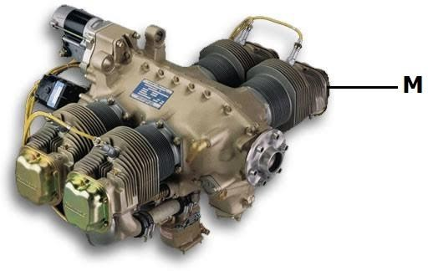
- Label eight parts of the assemblies in component detailed M. (I0 marks)

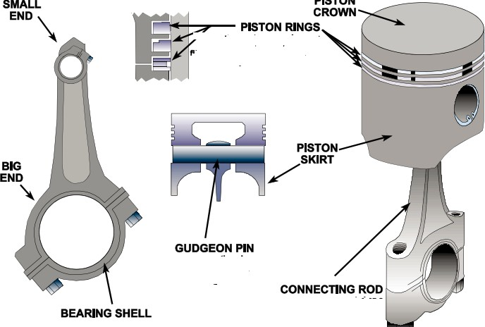
Assemblies ( 4 x 1.5 = 6marks) Labelling – ( 8 x 0.5 =4marks)

STATION 2

Instructions to the examiner
- To be placed on a working bench
- Mild steel plate (50mm⤬100mm⤬3mm thick),
- Long pillar drill,
- Ø10mm drill bits,
- Steel rule, Scriber,
- Dot punch,
- Set of files, groves,
- Goggles,
- Sufficient rags.

INSTRUCTIONS
Using the tools, equipment and materials provided, make the aircraft undercarriage bracket as shown in Figure 2. (10 marks)
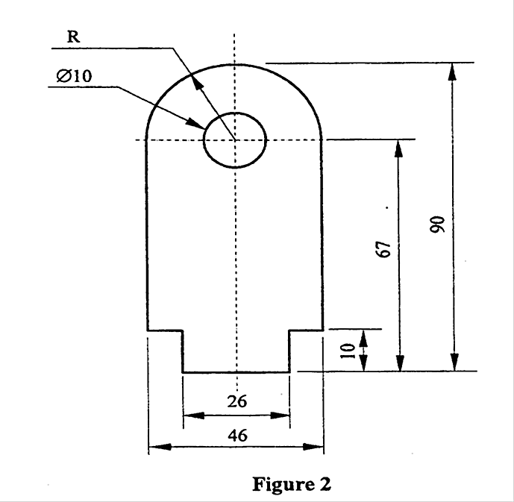

AREAS TO BE  MARKED | MAXIMUM  SCORE | AREAS TO BE  MARKED | MAXIMUM  SCORE
Dimensions  Length 90  Width 46  Width 26  Steps 10mm  Drilling | 1  1  1  1  1 | Correct Position of the hole Curve  Quality of curve Deburring Completeness  TOTAL | 1  1  1  1  1  10

STATION 3 INSTRUCTIONS
Study the aerodromes facilities and operations sketch attached and complete the tables below.
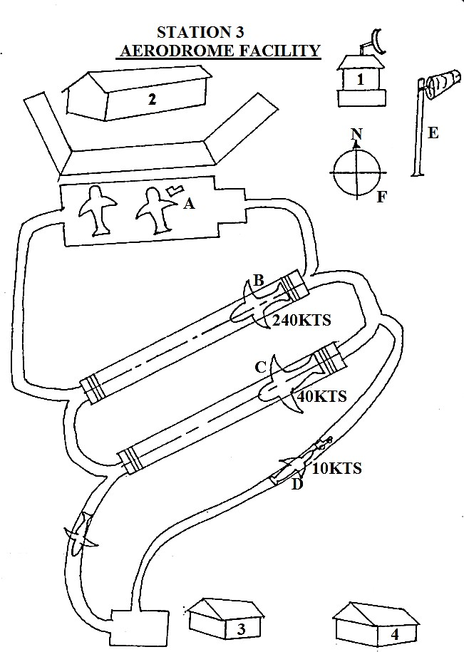
- Name the facilities marked 1, 2, 3, 4 and state the use of each. (4 marks)
Facility | Use
1. Control tower | Where the ATC monitors and direct aircraft movement  on the ground and in the air near the airport, ensuring safety and efficiency.
2. Terminal building | A building whwer passengers transfer between ground and transportation and aircraft, handling tasks ticket

 | purchase, check in, baggage handling, security and boarding.
3. Hangar | Is a large enclosed building designed to house, protect, and facilitate the maintenance and repair of aircraft.
4. Fire station | Respond to aircraft emergencies, including fires and accidents, and ensure the safety of passengers and crew.
- Identify operational activities of the aircraft labeled A, B, C and D and state the reason for each observation. (4 marks)
Operational Activity | Reason
A . Parking | At the ramp
B. Aircraft landing | Aircraft speed is higher
C. Aircraft taking off | Aircraft speed is lower, hence preparing to take off
D. Towing | The connection of the tow bar and the tug master/truck

- State the function of the facility labeled E and F. (2 marks)
Facility | Function
E | Speed and direction of the wind
F | Give magnetic north of the earth

STATION 4

Instructions to the examiner
Place the following on a suitable bench near a power source.
- Battery 12 volts (fully charged).
- Toggle switch marked S₁.
- Serviceable voltmeter marked V.
- Two 12 volts vehicle bulbs with holder marked B₁ and B₂.
- Insulated 1.5mm copper wire 30cm marked L₁.
- Insulated 2.5 mm copper wire 30cm marked L₂.
- Connecting wires with crocodile clips (quantity 10).
- Serviceable ammeter marked A.

INSTRUCTIONS
- Connect the components as shown in circuits 1.

Let the examiner check your work. (4 marks)

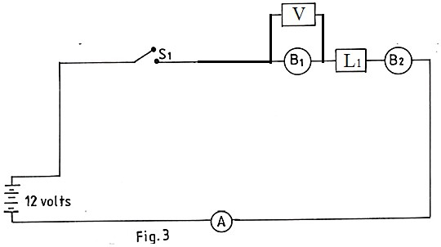

- (i) Select switch S1 to an on position. Record your observation. (2 marks) Observation……………………………………………………………………..
  - Select S1 to off position, replace L1 and L2 and record your observation. (2 marks) Observation…………………………………………………………………….
  - State the reason for the observation in (b) (i) and (b)(ii). (1 mark) Reason…………………………………………………………………………..
  - State one application on an aircraft lighting system. (1 mark) Application …………………………………………………………………….

PROVIDE SAMPLE DATA

AREAS TO BE MARKED | MAXIMUM SCORE | CANDIDATES SCORE
Battery connection to S1 | 1×0.5=0.5
S1 connection to V | 1×0.5=0.5
V connection to B1 | 1×0.5=0.5
B1 connection to L1 | 1×0.5=0.5
L1 to B2 connection | 1×0.5=0.5
B2 connection to A | 1×0.5=0.5
A connection to battery | 1×0.5=0.5
Safety during connection | 1×0.5=0.5
Total | 4 marks

STATION 5

Instructions to the examiner
Place the following on a suitable bench.
- Wire twister.
- Socket box (set).
- Torque wrench (0 to 60N).
- Rags.

- Open end spanner (set).
- Ring spanner (set).
- Soft hammer.
- Turbocharger assembly labeled D.
  - With turbine with signs of pitting panted red.
  - Compressor with signs of creeping painted green.
  - Broken volute painted white.
  - Centre part with signs of corrosion painted blue.
- Locking wire (0.8 mm).

INSTRUCTIONS
Using the tools and equipment provided, perform each of the following tasks.
- Study the assembly labeled D and identify the part.
Part ……………………… Turbocharger (1 mark)
- (i) Dismantle the part labeled D. Let the examiner check your work. (1 mark) Examine and record the defects on each of the parts panted red, green, white and blue. Red…………………pitting …………………………………………………… Green………………creeping ………………………………………………… White……………… Broken ………………………………………………………… Blue……………… corrosion (4 marks)
Demonstrate to the examiner the correct procedure of assembling part D while performing the task. (4 marks)
Marking points
Question | Areas to be marked | Maximum score | Candidate’s score
(b)(i) | Correct use of tools | 1×0.5=0.5
 | Dismantling | 1×0.5=0.5
(c) | Cleaning of parts | 1×0.5=0.5
 | Assembly of all parts | 1×1=1
 | Tightening the nuts | 1×0.5=0.5
 | Torque loading the nuts | 1×1=1
 | Safetying the nuts | 1×1=1
 | Total | 5 marks

STATION 6

Instructions to the examiner
To be placed on a working bench
  - K- Mild Steel rod ∅3 mm , 60 mm long.
  - L- Brass rod ∅ 3mm , 60 mm long.
  - M – Aluminium rod ∅3 mm , 60 mm long.
  - N- Copper rod ∅3 mm , 60 mm long.

  - 1pc pipe or a tube ∅5mm diameter 100 mm long
  - 1 pc hacksaw

INSTRUCTIONS
Carry out the following tasks using the tools and materials provided.
- (i) Hold vertically and at mid-length each of the rods labeled K, L, M and N in a bench vice.
  - Using the tube labeled P, bend each rod fore and aft until it breaks. Record the number of bends for each rod.
K …………Mild Steel …………………………..………………
L …………Brass……………………………………………………………..
M …………Aluminium……………………………………………………….
N …………Copper ……………………………………………………………
  - State the mechanical property being tested.
…………………Toughness/Turfness…………………………………………………….
  - Comment on the relationship between the number of bends each rod takes to break to the mechanical property tested.
…the higher the number of bends the tougher the material…………….
- Cut each of the rod labelled K, L, M and N to determine the harder material.
Hardest material ……Brass………………………………………….. (1 mark)
- State one application and one reason of selecting each of the materials labelled K, L and
M in an aircraft.
Material | Application | Reason
K. Mild Steel | Fasteners | Turf, malleable
L. Brass | Bushes | Non corrosive/self-lubricant
M. Aluminium | Aircraft skin | Non corrosive, light in weight
(3 marks)

STATION 7

Instructions to the examiner
Place the following on a suitable bench.
- Vee block
- Piston engine push rod (serviceable) labeled A.
- Piston engine push rod (slightly) dented labeled B.
- Dial indicator gauge set labeled C.
- True surface table.
- Micrometer set.
- Height gauge.
- Bevel gauge
- Steel rule
- Metre rule
- Rags.

INSTRUCTIONS
Using the tools and equipment provided perform the following tasks.
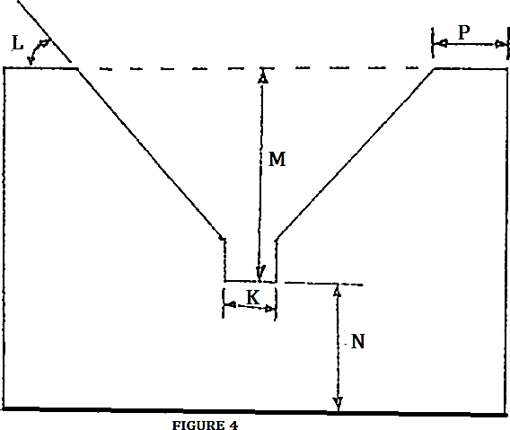
(a) Take and record the Vee block measurements K, L, M, N and P as shown on Figure 4.

Measurements (5 marks)
K Provide sample data
L Provide sample data
M Provide sample data
N Provide sample data
P Provide sample data

(b)(i) Check and record the roundness of each of the rods A and B using the set up C. Roundness
A ……………uniform roundness/cyndricity…………………………………………….
B dented/bent (2marks)
- State the reason behind the observation of rods A and B in (b)(i)
Reason ……B - excessive stress on the push rod (1 mark)
- Give the recommendation for the use on an aircraft from your observations in (b)(i)

Recommendations
A …serviceable(push rod A was ok)
B. to be replaced – as the valve will not be able to open and close (valve timing) (2 marks)

STATION 8

Instructions to the examiner
Place the following on a suitable bench
- Straws(2 per candidate)
- 3 OZ. paper cups (4 per candidate)
- Hole punch
- Push pins (2 per candidate)
- Pencil (1 per candidate)
- Thermometer marked W1
- 5 OZ. plastic cups (1 per candidate)
- White masking tape 1” (1 roll)
- Aneroid barometer marked W2
- Rain gauge marked W3
- Modeling clay
- Plastic bottle.

INSTRUCTIONS
Using the tools, instruments and materials provided, perform the following tasks
- Study the instrument labeled W₁, W₂, W₃ and complete Table 1.
  - Identify the type of instrument
  - Application on an aircraft
  - The principle of operation

Table 1

ITEM | IDENTIFICATION | APPLICATION | PRINCIPLE OF OPERATION
W₁
W₂
W₃
(4½ marks)

- Construct a model anemometer. (5½ marks)

Areas to be marked | Maximum  score | Candidate’s  score
Correct punching of two holes in cups at the side of each cup. | 1×0.5=0.5

Correct punching two holes directly across from each other ½ inch underneath centre cup. | 2×0.5=1
Making the bottom hole in the centre cup. | 1×0.5=0.5
Fixing the four cups at the end of the straws facing one  direction. | 1×0.5=0.5
Pushing one side of the pencil through the bottom hole in the  centre cup freely rotating | 1×0.5=0.5
Correct locking of straw to the eraser | 1×0.5=0.5
Mounting the assembly to soft board | 1×1=1
Checking the spinning ability | 1×1=1

STATION 9

Instructions to the examiner
Place the following on a suitable bench
- Ratchet Torque Wrench Labelled 1,
- Spur Gear Oil Pump Labelled F with housing labelled G, driver gear labelled J, driven gear labelled K, and pump outlet labelled L.

INSTRUCTIONS
Using tools and component ‘F’ provided, perform the following tasks.
- Study the tools labelled 1 and identify: (2 marks)
  - Name of the tool; Torque wrench.
  - Use of the tool; Tightening the nuts and bolts to the torque to avoid over torqueing or under torqueing.
  - Maintenance check required; Calibration.
  - Type; Ratchet.
- Study component ‘F’ and identify: (1½ marks)
  - Component; engine oil pump.
  - Type; spur gear type.
  - System applicable; lubrication system/ hydraulic system.
- Dismantle component ‘F’
  - Identify parts G, H, J, K and L (2½ marks)
G - Pump casing
H - Impeller gear
J – Driver Gear.
K – Idler Shaft
L – Drive Shaft.
  - State the use of parts painted white and blue. (1 mark) White……filling port.
Blue………locking.
  - Examine parts G, J, K, and L and identify the maintenance checks for each.
(2 marks)
G…Cracks and wear.

J……Play on spur gear, wear, cracks etc.
K…Play on driven impeller, gear wear.
L……Parallelism of the shaft and play.
- Record two failure indicators for component ‘F’ during engine run. (1 mark)
- Engine Overheating.
- High Temperature Indication.

STATION 10

Instructions to the examiner
Place the following on a suitable bench
- 250ml plastic beaker with graduated scale and half full water marked 10
- Table tennis ball marked Z
- Manila papers
- Pair of scissors or scalpel

INSTRUCTIONS
- Drop the ball marked Z in the jar labelled 10
  - Record your observation
Observation ……Ball remains floating but water level rises slightly.
  - State the reasons behind your observation
Reasons. ……Ball displaces its own volume(weight).
  - Explain the principle behind your observation. Principle. ……Upthrust (floatation).
  - State two areas where applicable in an aircraft. Applications ……Carburetor and fuel tank quantity.
(4 marks)
- Using the materials provided, make each of the following aircraft wing plan forms. (4 marks)
  - Elliptical
  - Delta
  - Sweepback
  - Rectangular
- State one application for each wing plan form in(b) (2 marks)
  - Elliptical………Low speed…………………………………………..
  - Delta …………Very high speed.....................................................
  - Sweepback………High speed………………………………………
  - Rectangular………Low speed………………………………………..

