

MARANDA HIGH SCHOOL
Kenya Certificate of Secondary Education
THE MOCK EXAMINATIONS, 2025
450/1 AVIATION PAPER 1 May/June, 2025 MARKING SCHEME (CONFIDENTIAL)

SECTION A (44 MARKS)
Answer ALL questions in this section.
1. Roles of aircraft dispatcher (3 marks):
- Ensures aircraft are properly loaded and fueled. (1 mark)
- Coordinates with pilots on flight plans and weather. (1 mark)
- Monitors and communicates changes during flight. (1 mark)
2. a) Precautions with compressed gases (2 marks):
- Store bottles upright and secured. (0.5 mark)
- Avoid exposure to heat or flames. (0.5 mark)
- Check for leaks using appropriate methods. (0.5 mark)
- Use proper regulators and ensure labels are intact. (0.5 mark)
2. b) Perceived reasons for aircraft accidents (2 marks):
- Human error. (0.5 mark)
- Mechanical failure. (0.5 mark)
- Weather conditions. (0.5 mark)
- Bird strikes. (0.5 mark)
3. a) Reasons for using composite materials (2 marks):
- Lightweight. (0.5 mark)
- High strength-to-weight ratio. (0.5 mark)
- Corrosion resistance. (0.5 mark)
- Design flexibility. (0.5 mark)
4. a) Apron vs Hangar (2 marks):
- Apron is the paved area for aircraft parking, loading, fueling; hangar is a shelter for maintenance/storage. (2 marks)
4. b) Ramp vs Parking (2 marks):
- Ramp refers to movement areas near terminal; parking is the designated area where aircraft is stationed. (2 marks)
5. a) Laminar vs Turbulent boundary layers (2 marks):
- Laminar: smooth, orderly airflow with low resistance. (1 mark)
- Turbulent: chaotic, mixed airflow with high resistance. (1 mark)
5. b) Forces acting on aircraft in flight (4 marks):
- Lift – supports aircraft against weight. (1 mark)
- Weight – gravitational pull. (1 mark)
- Thrust – forward motion. (1 mark)
- Drag – air resistance. (1 mark)
5. c) Types of drag (4 marks):
- Skin friction: caused by air rubbing against surface. (2 marks)
- Form drag: due to aircraft shape causing pressure difference. (2 marks)
6. Mechanical properties of metals (4 marks):
- Toughness. (1 mark)
- Ductility. (1 mark)
- Malleability. (1 mark)
- Tensile strength. (1 mark)
7. a) Good hydraulic system properties (2 marks):
- Low viscosity variation. (0.5 mark)
- Non-corrosive. (0.5 mark)
- Good lubrication. (0.5 mark)
- Incompressible. (0.5 mark)
7. b) Functions in hydraulic systems (4 marks):
- Actuating cylinder: converts hydraulic energy into mechanical motion. (2 marks)
- Selector valve: directs fluid to desired actuator. (2 marks)
8. a) Behavior of stable aircraft (1 mark):
- Returns to original flight path after disturbance. (1 mark)
8. b) Lateral stability design features (2 marks):
- Dihedral wings. (1 mark)
- High wing placement. (1 mark)
8. c) Methods of balancing control surfaces (2 marks):
- Mass balancing. (1 mark)
- Aerodynamic balancing. (1 mark)
9. Aircraft flight systems (4 marks):
- RMI: Radio Magnetic Indicator. (1 mark)
- VOR: VHF Omnidirectional Range. (1 mark)
- GPS: Global Positioning System. (1 mark)
- ILS: Instrument Landing System. (1 mark)
10. Technical drawing lines (4 marks):
- Centre line – denotes symmetry. (1 mark)
- Dotted line – hidden details. (1 mark)
- Bold line – visible outlines. (1 mark)
- Border line – encloses drawing area. (1 mark)

SECTION B (56 MARKS)
Answer any FOUR questions from this section. Each question carries 14 marks.
11. First Angle Projection (14 marks)
- Plan view (top) correctly drawn – 4 marks
- Front elevation accurately represented – 5 marks
- End elevation (side view) correct – 4 marks
- Proper dimensioning and projection line usage – 1 mark
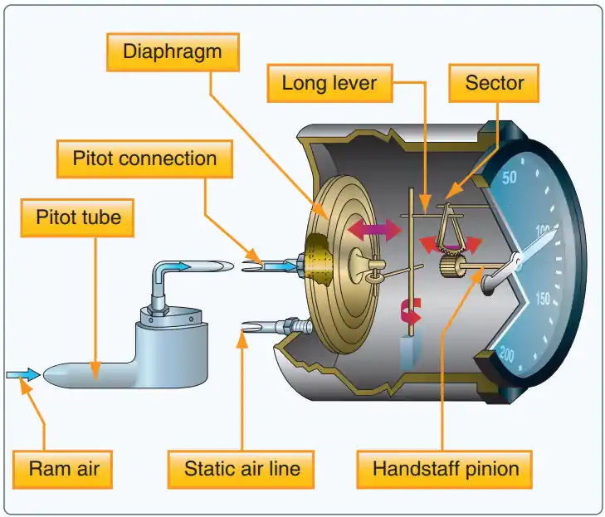
12. Airspeed Indicator (14 marks)
- The components of an airspeed indicator are:
- Static Port
- Static ports are air inlets mounted flush to the side of the aircraft in an area of minimally disturbed airflow. They take in air that is at ambient air pressure.
- Static Line
- The static line is the tube that runs from the static pressure port to the case of the airspeed indicator. If an aircraft has more than one static port it will have a static line running from each port.
- Pitot Tube
- A pitot tube is an L-shaped metal tube that opens into the relative wind and collects air to measure the ram air pressure generated by your plane’s motion. Air comes in through the pitot tube and flows into the pitot line.
- Pitot Line
- A pitot line is part of the pitot system, it connects the pitot tube to the airspeed indicator case. Ram air travels from the pitot tube through this line and into the pressure diaphragm that is housed inside the case.
- Case
- The case is the housing of the airspeed indicator. The case contains the pressure diaphragm and is connected to the static port via the static line. The case is not directly connected to the pitot line.
- Pressure Diaphragm
- The pressure diaphragm is an expandable container found inside the instrument case and attached to the pitot line. The diaphragm also connects to the needle in the instrument face through several rods and gears.
- Instrument Face
- The instrument face is the portion of the instrument that the pilot can see from the cockpit. A needle on the face displays the aircraft velocity in knots and is connected to the pressure diaphragm via levers and gears.
- Airspeed indicators work primarily by measuring air pressure differences around the aircraft. The speed indicator itself connects to a series of hollow pipes in the plane that connects to the various instruments on the flight deck, known as the pitot static system. Airspeed indicators have two major “feeds’ that they measure with.
- The pitot system captures dynamic, moving air. Dynamic pressure is often called ram air because it is ramming into the aircraft.
- Static pressure, or static air, is the air that is at rest relative to the motion of the plane.
- Speed indicators work by measuring pressure differences between static and ram air to find actual airspeed. If you have ever stuck your hand out of the window of a moving vehicle, you know that moving air creates force. In short, an airspeed indicator measures the ram pressure and compares it to static pressure to determine how fast a plane is moving

- Neat labeled sketch of the airspeed indicator – 4 marks
- Pitot tube mechanism explained – 3 marks
- Static port function in airspeed measurement – 2 marks
- Differential pressure principle described – 3 marks
- Operation clearly outlined – 2 marks
13. Airflow through Compressors (14 marks)
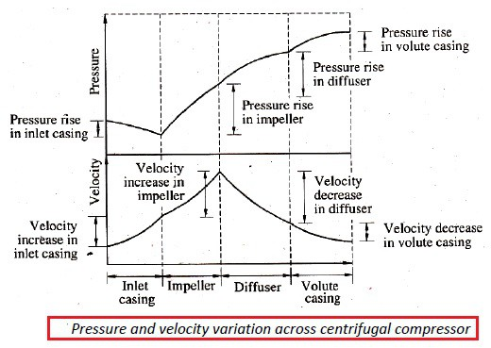

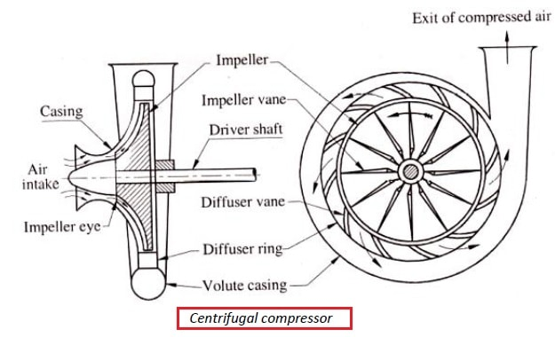
- A centrifugal compressor works by accelerating air radially outward using an impeller. The air enters at the center and is flung outward due to centrifugal force, increasing its velocity. This high-speed air then passes through a diffuser, where its velocity decreases and pressure increases. Centrifugal compressors are commonly used in smaller jet engines and auxiliary power units.
- Axial Flow Compressor Diagram :
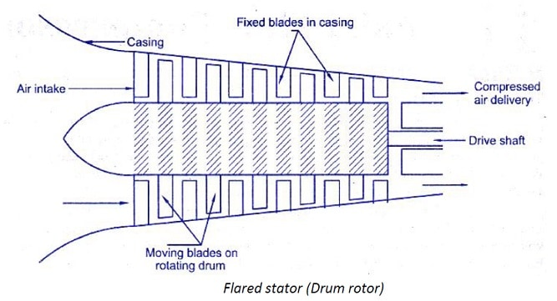
Working of axial flow compressor :
- As the air passes through the moving blades, the kinetic energy added to the air and pressure rises at the expense of a reduction in the relative velocity of the air; by providing diffuser passages between blades.
- The absolute velocity of air increases due to work input to the moving blades through the rotor shaft.
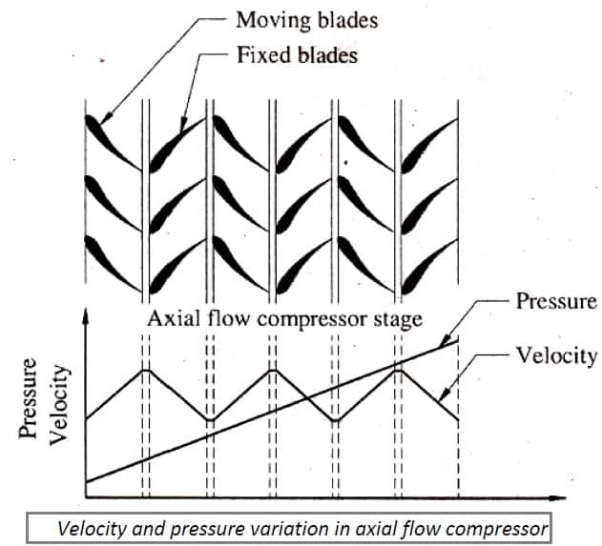
- Axial flow compressor sketch – 2 marks
- Explanation of airflow stages in axial compressor – 4 marks
- Centrifugal flow compressor sketch – 2 marks
- Explanation of centrifugal action and energy conversion – 4 marks
- Graph representation of pressure vs velocity – 2 marks

14. Pitching of Aircraft (14 marks)
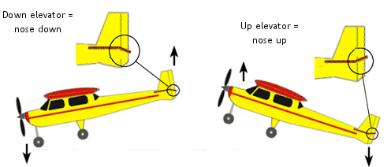
Pitch refers to the upward or downward movement of an aircraft’s nose, controlled primarily by the elevator on the tail.
(i) Nose Up Pitch
- Control Input: Pilot pulls back on the control yoke/stick.
- Elevator Movement: Elevators move upward.
- Effect on Tail: Downward force is applied to the tail.
- Effect on Nose: Aircraft nose rises.
- Result: Aircraft climbs or recovers from a descent.
- Common Uses: Takeoff, climbing, stall recovery.
(ii) Nose Down Pitch
- Control Input: Pilot pushes forward on the control yoke/stick.
- Elevator Movement: Elevators move downward.
- Effect on Tail: Upward force is applied to the tail.
- Effect on Nose: Aircraft nose lowers.
- Result: Aircraft descends or recovers from excessive nose-up attitude.
- Common Uses: Landing approach, descent, stall prevention.
- Sketch showing aircraft nose-up – 3 marks
- Explanation of tailplane producing downward force – 3 marks
- Sketch showing aircraft nose-down – 3 marks
- Elevator deflection impact described – 3 marks
- Correct labeling of forces – 2 marks

15. Aircraft Structures (14 marks)
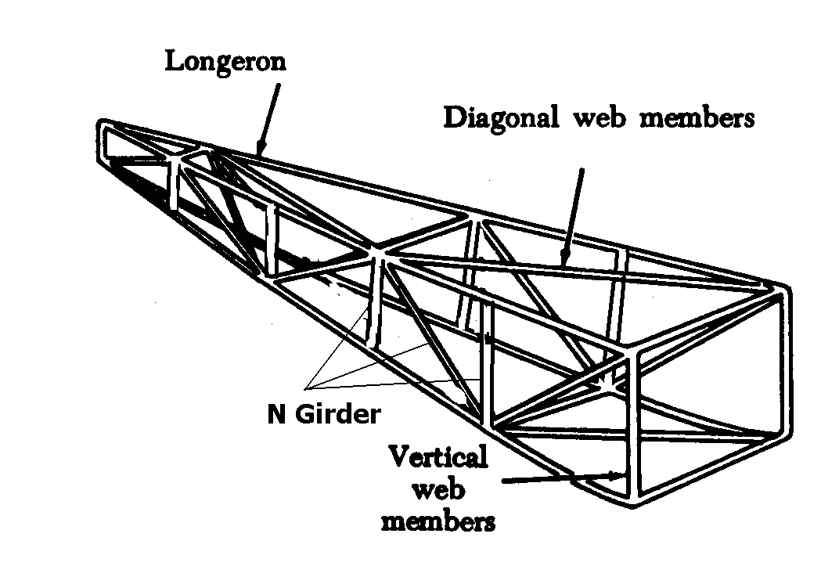

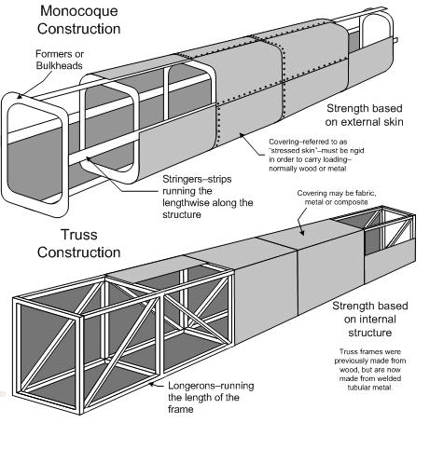
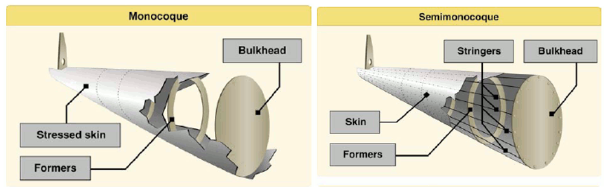
- (i) Truss Structure (4 marks)
- Definition: A rigid framework made of beams, struts, and bars arranged in triangular shapes.
- Construction: Uses welded or bolted steel or aluminium tubes.
- Strength: Provides excellent structural integrity and resistance to deformation.
- Common Use: Found in early aircraft and some light sport aircraft.

- (ii) Monocoque Structure (5 marks)
- Definition: A fuselage design where the external skin carries most of the structural load.
- Construction: Uses a strong shell without an internal framework.
- Strength: Lightweight but requires thicker skin for durability.
- Common Use: Found in smaller aircraft and some high-performance designs.

- (iii) Semi-Monocoque Structure
- Definition: A hybrid between truss and monocoque, using both a skin and internal reinforcements.
- Construction: Includes stringers, bulkheads, and frames to distribute loads.
- Strength: More durable than monocoque while remaining lightweight.
- Common Use: Used in most modern aircraft fuselages.

- Truss structure sketch – 2 marks
- Truss explanation – 2 marks
- Monocoque structure sketch – 2 marks
- Monocoque explanation – 3 marks
- Semi-monocoque sketch – 2 marks
- Semi-monocoque explanation – 3 marks

