NAME:..............................................................................CLASS..............................ADM............

443/1
AGRICULTURE
PAPER 1
END TERM 2 2025
JULY 2025
TIME: 2 HOURS

Kenya Certificate of Secondary Education (K.C.S.E)

443/1
AGRICULTURE
PAPER 1

TIME: 2 HOURS

INSTRUCTIONS TO THE CANDIDATES

- This paper consists of three sections, A, B and C.
- Answer all questions in section A and B.
- Answer any2 questions from section C.

SECTION A (30 MARKS)
Answer all the questions from this section
1. What is nomadic Pastoralism (1mk)
.............................................................................................................................................................................................................................................................................................
2. State four factors that influence choice of the farming method 4x½ (2mks)
........................................................................................................................................................................................................................................................................................................................................................................................................................................................................ ........................................................................................................................................................3. Outline four practices that destroy soil structure 4x½ (2mks)
........................................................................................................................................................................................................................................................................................................................................................................................................................................................................ ........................................................................................................................................................4. Name four methods of treating seeds before planting 4x½ (2mks)
........................................................................................................................................................................................................................................................................................................................................................................................................................................................................ ........................................................................................................................................................5. Give four factors that should be considered before choosing the method to apply in surface irrigation 4x½ (2mks)
........................................................................................................................................................................................................................................................................................................................................................................................................................................................................ ........................................................................................................................................................6. Give four roles of nitrogen in plant nutrition 4x½ (2mks)
........................................................................................................................................................................................................................................................................................................................................................................................................................................................................ ........................................................................................................................................................7. State four limitation of using seeds for propagation 4x½ (2mks)
........................................................................................................................................................................................................................................................................................................................................................................................................................................................................ ........................................................................................................................................................8. Enumerate four advantages of intercropping 4x½ (2mks)
........................................................................................................................................................................................................................................................................................................................................................................................................................................................................ ........................................................................................................................................................9. State two importance of storage of produce 2x½(2mks)
................................................................................................................................................................................................................................................................................................................
10. State four preparation done to vegetable before marketing 4x½ (2mks)
........................................................................................................................................................................................................................................................................................................................................................................................................................................................................ ........................................................................................................................................................11. Define the following terms as used in economics (2mks)
- Scarcity
............................................................................................................................................ ...........................................................................................................................................
ii. Opportunity cost
........................................................................................................................................................ ........................................................................................................................................................12. State four symptoms of viral diseases in plants 4x½ (2mks)
........................................................................................................................................................................................................................................................................................................................................................................................................................................................................ ........................................................................................................................................................13. Give two classification of pastures on basis of altitude 2x½ (1mk)
................................................................................................................................................................................................................................................................................................................
14. Outline four methods of utilizing maize as fodder crop. 4x½ (2mks)
...............................................................................................................................................................................................................................................................................................................................................................................................................................................................................................................................................................................................................................
15. Name three methods of land reforms that have been applied in Kenya since independence 3x½(1½mks)
............................................................................................................................................................................................................................................................................................................................................................................................................................................. ..........................
16. State three factors that affect the effectiveness of pesticides 3x½(1½mks)
.......................................................................................................................................................................................................................................................................................................................................................................................................................................................................

SECTION B 20 MARKS
Answer ALL questions from this section
17. Study the diagram below and answer the questions that follow
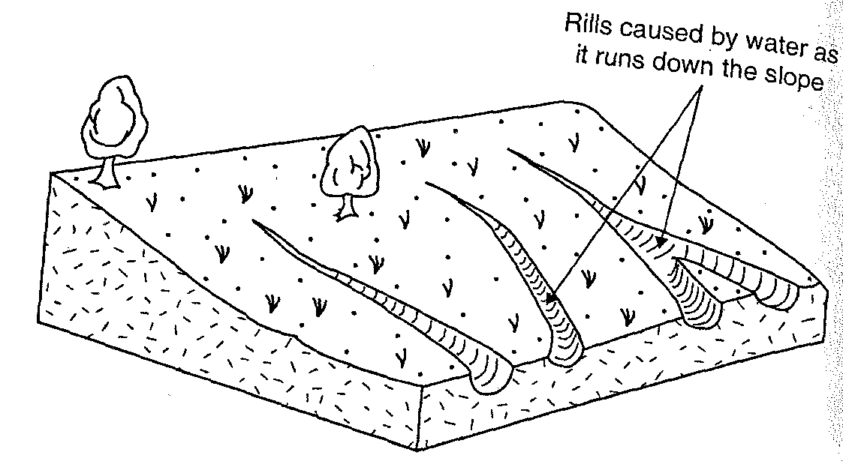
- Identify the diagram shown above (1mk)
...........................................................................................................................................
(b) Under what conditions would you expect the above diagram to occur (2mks)
..........................................................................................................................................................................................................................................................................................................
(c) State two ways of preventing the conditions shown in a above from occurring (1mk)
..........................................................................................................................................................................................................................................................................................................
18. The diagram below show a maize cob which is affected by a certain disease. Study it and answer questions that follow
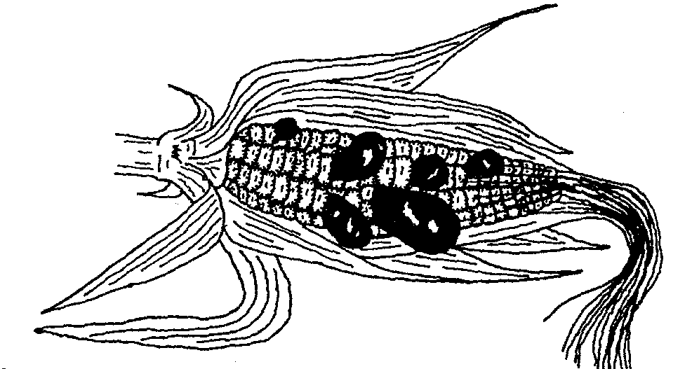
(a) Identify the disease (1mk)
..........................................................................................................................................
(b). Name the causal organism of the disease (1mk)
..........................................................................................................................................
(c) State TWO cultural methods of controlling the disease (2mks)
.........................................................................................................................................................................................................................................................................................................................................................................................................................................................

19. The diagram below show a method of crop propagation. Study it and answer the question that follows
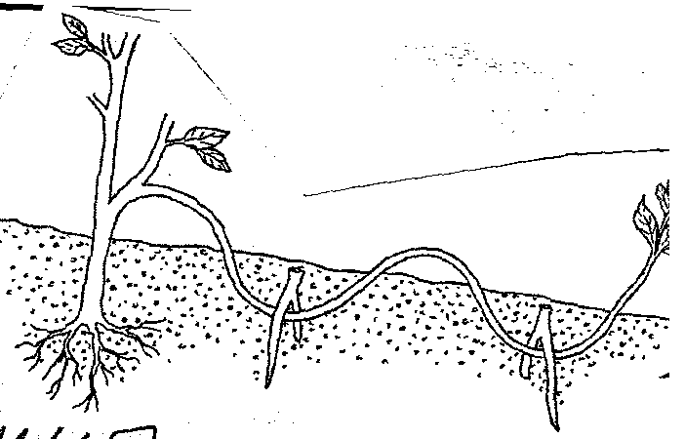
(a) Identify the method (1mk)
..........................................................................................................................................
(b) State one advantage of the above method over the other methods of crop propagation (1mk)
......................................................................................................................................................................................................................................................................................................
(c) State three factors which influence the rooting of cutting in vegetative propagation (3mks)
...................................................................................................................................................................................................................................................................................................................................................................................................................................................
20. The diagram below shows a certain farm structure.

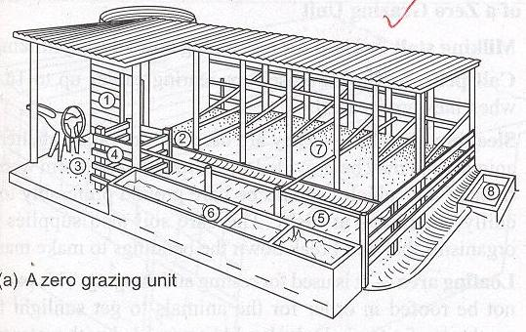
(a) Name the grazing system achieved by use of such a structure. ( 1 mark)
………………………………………………………………………………………………

(b) Outline SIX advantages of the grazing system named above. (3 marks)
…………………………………………………………………………………………………………
…………………………………………………………………………………………………………
……………………………………………………………………………………………………
…………………………………………………………………………………………………………
21. The diagram below shows a common weed plant.
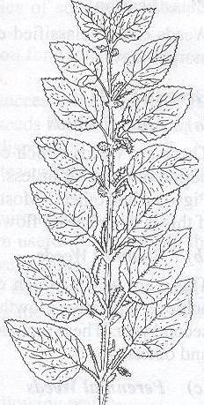
(a) Identify the weed. ……………………………………………………………….. ( 1 mark)
(b) Why is it difficult to eradicate the above weed? (1 mark)
…………………………………………………………………………………………………………
…………………………………………………………………………………………………………(c) Name two biological weed control methods. (1 mark)
…………………………………………………………………………………………………………
…………………………………………………………………………………………………………
…………………………………………………………………………………………………………

SECTION C 40 MARKS
Answer only TWO questions from this section.
22. (a) State and explain five methods of farming (10marks)
(b) Outline five influences of soil profile on crop production (5marks)
(b) Describe five chemical processes that are involved in soil formation (5marks)
23. (a) Describe ‘Importance of irrigation’. (5 marks)
(b) Show that you understand breeding and labour records. In each case, give the importance. (5 marks)
(c) Describe the field production of carrots under the following sub-headings.
(i) Seed bed preparation (2 marks)
(ii) Planting (4 marks)

(iii) Field management practices (4 marks)
24. (a) Outline seven effects of strong wind in agriculture. (6 marks)
(b) Briefly describe the soil sampling procedure. (6 marks)
(c) Discuss four methods used to prepare planting materials before they are planted. (8 marks)

……………………………………………………………………………………………………………………………………………………………………………………………………………………………………………………………………………………………………………………………………………………………………………………………………………………………………………………………………………………………………………………………………………………………………………………………………………………………………………………………………………………………………………………………………………………………………………………………………………………………………………………………………………………………………………………………………………………………………………………………………………………………………………………………………………………………………………………………………………………………………………………………………………………………………………………………………………………………………………………………………………………………………………………………………………………………………………………………………………………………………………………………………………………………………………………………………………………………………………………………………………………………………………………………………………………………………………………………………………………………………………………………………………………………………………………………………………………………………………………………………………………………………………………………………………………………………………………………………………………………………………………………………………………
…………………………………………………………………………………………………………
………………………………………………………………………………………………………………………………………………………………………………………………………………………………………………………………………………………………………………………………………………………………………………………………………………………………………………………………………………………………………………………………………………………………………………………………………………………………………………………………………………………………………………………………………………………………….…………………………………………………………………………………………………………………………………………………………………………………………………………………………………………………………………………………………………………………………………………………………………………………………………………………………………………………………………………………………………………………………………………………………………………………………………………………………………………………………………………………………………………………………………………………………………………………………………………………………………………………………………………………………………………………………………………………………………………………………………………………………………………………………………………………………………………………………………………………………………………………………………………………………………………………………………………………………………………………………………………………………………………………………………………………………………………………………………………………………………………………………………………………………………………………………………………………………………………………………………………………………………………………………………………………………………………………………………………………………………………………………………………………………………………………………………………………………………………………………………………………………………………………………………………………………………………………………………………………………………………………………………………………………………………………………………………………………………………………………………………………………………………………………………………………………………………………………………………………………………………………………………………………………………………………………………………………………………………………………………………………………………………………………………………………………………………………………………………………………………………………………………………………………………………………………………………………………………………………………………………………………………………………………………………………………………………………………………………………………………………………………………………………………………………………………………………………………………………………………………………………………………………………………………………………………………………………………………………………………………………………………………………………………………………………………………………………………………………………………………….

