AGRICULTURE MARKING SCHEME PAPER 1
END TERM 2 2025
- Keeping livestock whereby farmers move from one place with their livestock in search of pastures and water (1x1=1mk )
- Factors considered when choosing farming methods
- Land size
- Social cultural factors
- Taste and preference of the farmers
- Capital available
- Climatic condition
- Technical skills
- Market availability (4x½=2mks)
- Farming practices that destroy soil structure
- Over cultivation\pulverization of soil
- Using heavy machinery on wet or too dry
- Deforestation
- Overstocking leading to overgrazing
- Burning of organic matter (4x½=2mks)
- Name four methods of treating seeds before planting
- Seed cleaning
- Seed inoculation
- Seed dressing
- Breaking seed dormancy
- Chilting (4x½=2mks)
- - Topography of the land
- Amount of water supply
- Soil type
- Type of crop to be grown
- Capital available
- Role of nitrogen in plant nutrition (2mks)
- Influence reproduction
- Protein formulation
- Component of chlorophyll
- Increase grain size
- Regulate availability of phosphorous and potassium
- Promote vegetative growth (4x½=2mks)
- State four methods of fertilizer application
- Broadcasting
- Side dressing/banding /ring application
- Drilling
- Infection into the soil (4x½=2mks)
- Limitations of using seeds for propagation
- Not easy to control genetic variation
- Can spread diseases easily through imported seeds
- Delayed matural due to prolonged dormancy
- Not easy to determine viable seeds
- Can be easily destroyed by pest
- Cross pollination may bring undesirable characteristics (4x½=2mks)
- Advantages of intercropping
- Crop complement each other on nutrient use
- May offer protection from weed , pest and diseases
- Efficient use of land
- Efficient use of labour
- Insurance against total loss (4x½=2mks)
- State two importance of storage of crop produce
- Same seeds for planting
- Provide food between harvest seasons
- Provide farm animals with food
- Avoid heavy losses of produce in the field
- Fetch high market prices (2x½=2mks)
- Preparation done on vegetables before marketing
- Grading
- Washing
- Removal of diseased/ dead leaves
- Packing (4x½=2mks)
- (i) Scarcity – state of being limited in supply
(ii) Opportunity loot – the values of the bert alternative forgone (1x2=2mks)
- General symptoms of viral diseases in planting
- Clowning
- Stunted growth
- Mosaic mottling
- Necrosis
- Leaf curls (4x½=2mks)
- Classification of pastures on basis of attitude
- High altitude
- Medium altitude
- Low altitude (2x½=2mks)
- Four methods of utilizing maize as fodder crops
- Through direct grazing
- By cutting and feeding livestock as green fodder
- Making hay
- By making silage (2x½=2mks)
- Methods of land reform
- Land consolidation
- Land subdivision
- Land adjustments
- Land registration
- Settlement and resettlement 3x½=1½
- Factors affecting the effectiveness of a pesticide
- Concentration
- Weather condition
- Persistence of pesticide
- Formulation of pesticide
- Mode of action pesticide 3x½=1½
Section B
- (a) Rill erosion 1x1=1mk
(b)
- Where there is little vegetation
- Where land has first been plunged
- Where there is concetration of flowing water 1x2 = 2mks
(c) – practice cover cropping
- Cultivation along contours
- Mulching
- Intercropping 1x2=2mks
- (a) maize smut 1mk
(b) fungus ustilago fungus 1mk
(c) Crop rotation
-field hygein seeds
- use of cartified seeds 3x1 = 3mks
- The diagram below shows a certain farm structure.

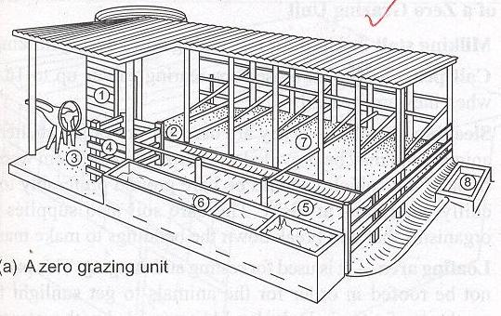
(i) Name the grazing system achieved by use of such a structure. ( ½ mark)
Zero grazing / stall feeding;
(ii) Outline five advantages of the grazing system named above. (2 ½ marks)
- There is quick accumulation of manure;
- Animals make good use of feeds without wastage;
- Animals produce high fields due to less wastage of energy;
- It is easy to control diseases and parasites;
- It requires little land;
- It allows high stocking rates;

21. The diagram below shows a common weed plant.
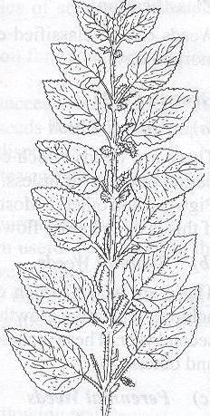
- Identify the weed. Stinging nettle/urtica massaica; ( ½ mark)
- Why is it difficult to eradicate the above weed? (1 mark)
It irritates the workers thus reducing the efficiency in which they are controlled;
- Name two biological weed control methods. (1 mark)
- Use of livestock of goats to graze and control the growth of weeds in plantation crops e.g. coconuts and cashew nuts;
- Use of certain weed eating fish to control aquatic weeds;
- Use of moths to control cactus;

SECTION C
- (a) five methods of farming
- Mixed farming
- Nomadic farming
- Shifting cultivation
- Organic farming
- Agro forestry (2x5 = 10mks)
Stating 1mk
Explaining 1mk
(b) – It determines the type of crops to be grown
- It influences the amount of moisture held in the soil
- Influences availability of nutrients
- Influences water holding capacity
- Influence soil mineral content
- Influence water infiltration
(c) Chemical processes of weathering
- Hydration where minerals absorb water and expand causing stress and fracturing of rocks
- Hydrolysis where hydrogen ions in rock lead to complete decomposition of the minerals
- Solution where soluble mineral present in the rocks are dissolved in water
- Carbonation where weak carbonic acid changes calcium carbonate to calcium bicarbonate that is readily removed in solution by ground water
- Oxidation and reduction (rusting) which occurs when mineral compound inn the rock mass take up oxygen to form soluble oxides

- (a) Describe ‘Importance of irrigation’. (5 marks)
- It adds water to the soil so as to supply the moisture essential for plant growth;
- Ensure that crop production is realized even during periods of moisture supply;
- Modify the soil environment by cooling the soil and the atmosphere thereby making the soil favourable for crop growth;
- Modify soil chemical environment by removing excess or dilute salts from the soil;
- Reclaim dry land;
- Modify the soil’s physical conditions by making soil softer, hence facilitating tillage operations;

(b) Show that you understand breeding and labour records. In each case, give the importance. (5 marks)
- Breeding records – shows breeding activities, and programmes of different farm animals; They help to detect poor breeders and to cull them;.
- Labour records – Show utilization in the farm; its availability; and whether skilled or not; they help in the calculation of the total cost of labour in the farm;
(c) Describe the field production of carrots under the following sub-headings.
(i) Seed bed preparation (2 marks)
- Plough the land before onset of rains to a depth of 20cm;
- Harrow the land to a fine tilth before planting;
- Manure should not be applied as it induces forking;

(ii) Planting (4 marks)
- Carrots are sown directly into the seedbed;
- Drill seeds continuously into rows made 20 – 30 cm apart;
- Seeds are then covered lightly and soil pressed down;
- Apply double superphosphate fertilize in drills at the rate of 90hg/ha;

(iii) Field management practices (4 marks)
- Thinning; – this is done, to attain a distance of 3 – 4 cm between plants within the row;
- Weeding; – The seedbed should be weed free and earthing up around carrot plants should be done to encourage root expansion;
- Top dressing;- 60kg/ha should be applied after weeding;
- Control of pests; – Use appropriate pesticides to control pests e.g. green aphids;
- (a) Outline seven effects of strong wind in agriculture. (6 marks)
- Increasing the rate of evaporation of moisture from the soil ;Causing lodging in cereals and damage crops;
- Blowing away and bringing rain-bearing clouds;
- Acting as agent of seed dispersal;
- Acting as agent of soil erosion;
- Increasing evapo-transpiration rate;
- Increasing the spread of diseases and pests;
- Destroying farm structures;
- Areas with high humidity tend to be hotter but when wind takes away water, a cooling effect occurs;

(b) Briefly describe the soil sampling procedure. (6 marks)
- Vegetation from the sampling spot is cleared and a vertical cut is made to a depth of 15 – 25cm for crop land and 5cm for pasture land;
- A slice is taken from the vertical cut, using a spade or preferably is soil auger;
- The soil is put in a clean polythene bag or any suitable container;
- The above steps are repeated in different parts of the field preferably 15 – 20 spots depending on the sampling method used;
- Soil from all the spots are thoroughly mixed, dried and crushed;
- A sub-sample from the mixture is taken and sent to the laboratory for testing;

(c) Discuss four methods used to prepare planting materials before they are planted. (8 marks)
- Breaking of seed dormancy; – Dormancy is the period whereby a seed cannot germinate. Dormancy can be broken through mechanical method/heat treatment/ chemical treatment/soaking in water;
- Seed dressing;- This involves the coating of seeds with a fungicide or an insecticide or a combination of the two chemicals to protect the seedlings from soil borne diseases and pests;
- Seed Inoculation; – This is the coating of legumes e.g. beans, clovers etc with inoculants in areas deficient in nitrogen to encourage nodulation hence nitrogen fixation;
- Chitting ;– This is the sprouting of potato setts to break dormancy before planting; (this is done by arranging setts in layers of 2 – 3 tubers deep in a partially darkened room where diffused light is allowed to pass through.

