Name: ____________________________________ Adm No: _______Class: _____
Candidate’s Signature: _________________Date: __________________________

AGRICULTURE
FORM TWO
END TERM 2 EXAMINATION
JULY/AUGUST 2025
Time: 2HOURS

Instructions to Candidates
Answer all the questions
1) State four effects of strong wind on agricultural production. (4mks)

2) List three ways in which primary cultivation can be done. (3mks)

3) Give five reasons for carrying out minimum tillage. (5mks)

4) Explain six ways of restoring soil fertility. (6mks)

5) State five factors affecting the quality of farm yard manure. (5mks)

6) a) Using the Pearson’s square method, compute a 100kg ration with 20% DCP oats which contains 10% DCP and simsim seed cake containing 60%DCP. (4 mks)

7)Describe four methods of applying synthetic fertilizers. (4mks)

8) Name three planting materials used in propagation of pineapples. (3 mks)

9. The illustrations below represents the stages of development of a three –host tick. Study it carefully and then answer the questions that follow:
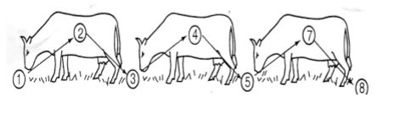
(a) Briefly explain what is happening in the following stages (4 marks)
1………………………………………………….………………………………………………….
4………………………………………………….………………………………………………….
5………………………………………………….………………….…………………………….
7………………………………………………….………………………………………………….
(b) Why do you think that tick control is difficult using acaricides? (1 mark)

(c) Name the most common sites the tick can be found on the body of an animal. (2 marks)

(d) Give two examples of a three-host tick (1mark)

10) Give six differences between ruminant and a non-ruminant animal. (6marks)

11)Give six reasons why farmers should embrace crop rotation in the growing of annual crops. (6mk)

12) Give five characteristics of a good grain store. (5mks)

13. Describe six post-harvest management practices carried out on various crops. (12mks)

14) Discuss cabbage production under the following sub-headings.
a) Varieties. (2mks)

b) Ecological requirements. (3mks)

c) Field management practices. (2mks)

d) Harvesting and marketing. (2mks)

