FORM TWO
AGRICULTURE
END TERM 2 EXAMINATION
JULY/AUGUST 2025
MARKING SCHEME
1) State four effects of strong wind on agricultural production. (4mks)
 Increasing the rate of evaporation of moisture from the soil.
 Causing lodging in cereals and damage to crops.
 Blowing away and bringing rain-bearing clouds.
 Acting as agent of seed dispersal.
 Acting as agent of soil erosion.
2) List three ways in which primary cultivation can be done. (3mks)
 Hand digging.
 Mechanical cultivation.
 Use of ox-plough.
3) Give five reasons for carrying out minimum tillage. (5mks)
 To reduce the cost of cultivation. This is by reducing the number of operations.
 To control soil erosion. Mulching and cover cropping greatly reduce chances of
soil erosion.
 To maintain soil structure. Continuous cultivation destroys soil structure hence it
is avoided.
 To conserve moisture. Continuous cultivation exposes the soil to the heat of the sun
thus enhancing evaporation of available moisture.
 To prevent exposure of humus to adverse conditions such as the sun’s heat that
causes volatilization of nitrogen.
4) Explain six ways of restoring soil fertility. (6mks)
 Control of soil erosion. The measures to control soil erosion aims at promoting
good water infiltration and reducing runoff.
 Crop rotation. Ensures maximum utilization of soil nutrients by growing a variety
of crops which have different nutrient requirements. Legumes in a rotation
Programme improves the soil nitrogen.
 Control of soil pH. Most living organisms do well at a pH around neutral. Extreme
pH inhibits the activities of living organisms.
 Proper drainage. Can be done by breaking hard layers impeding drainage. Were
poor drainage is as a result of poor soil structure and texture, water channels can
be used.
 Weed control. The weeds compete with crops for growth resources such as:
nutrients, soil moisture, space and sunlight.
 Intercropping and mixed cropping. Intercropping offers a better ground cover
thus, smothering weeds and controlling soil erosion. Legumes intercropped with
cereals fix nitrogen which is used by the cereal crops.
 Minimum tillage. Over cultivation destroys the soil structure leading to soil
erosion. Therefore, unnecessary land operations should be avoided.
 Use of manure. Supply organic matter, which on decomposition releases nutrients
into the soil.
 Use of organic fertilizer. Chemical substances which are manufactured to supply
specific plant nutrients. Once used they improves the soil fertility.

5) State five factors affecting the quality of farm yard manure. (5mks)
 The type of animal used. Dung from fattening animals has higher level of
nutrients than from that of dairy animals
 Type of food eaten. Feedstuffs that are highly nutritious results in manure with a
higher level of nutrients.
 Type of litter used. Wood shavings and sawdust are slow to decompose and
contain very little nutrients. Napier grass provides both nitrogen and phosphorus
but has low urine absorption capacity. Litter used should have a high urine
absorption capacity.
 Method of storage. Farm yard manure must be stored well in a leak proof and
concrete floor to prevent loss of nutrients though leaching and vaporization.
 Age of farm yard manure. Well rotten manure is rich in nutrients and it is easy to
handle and mix with the soil.
6)
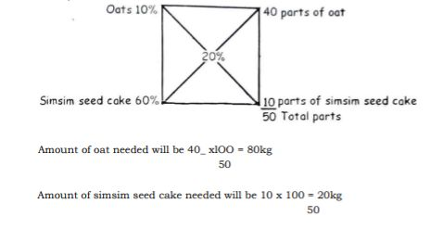

7)Describe four methods of applying synthetic fertilizers. (4mks)
 Broadcasting. Involves random scattering of fertilizer on the ground. Fertilizer
should be shallowly dug into the soil to prevent loss through volatilization.
 Placement method. Application of fertilizer in planting holes/drills. Used in application
of Phosphatic fertilizers and should be mixed thoroughly with soil.
 Side dressing. Placement of nitrogenous fertilizer at the side of the crop being top
dressed.
 Foliar spraying. Application of specially formulated fertilizer solution onto the foliage
and it is absorbed by leaves.
 Drip application/fertigation. Application of fertilizer dissolved in irrigation water
and it applied to individual crop during irrigation.
8) Name three planting materials used in propagation of pineapples. (3 mks)
 Crowns.
 Slips.
 Suckers.
9. The illustrations below represents the stages of development of a three –host tick. Study it carefully and then answer the questions that follow:
(a) Briefly explain what is happening in the following stages (4 marks)
1- Eggs hatch, larvae emerge
2. Larvae climb on to the first host and feed on blood
3. Engorged larvae fall to the ground and moult, nymphs emerge
4. Nymph climbs onto the second host and feed on blood,
5. Engorged nymphs fall to the ground and moult, adults emerge.
6. Adults climb onto third host feed on blood and mate
7. Engorged female falls to the ground and lays eggs.
(b) Why do you think that tick control is difficult using acaricides? (1 mark)
Ticks keep on dropping off the animal at every stage of development, so it is not affected by acaricides when the animal is sprayed/dipped
(c) Name the most common sites the tick can be found on the body of an animal. (2 marks)
Ears
Base of horns
Around the eyes
Tail switch
(d) Give two examples of a three-host tick (1mark)
Brown ear tick
Bont tick
East Africa bont tick
10) Give six differences between ruminant and a non-ruminant animal. (6marks)
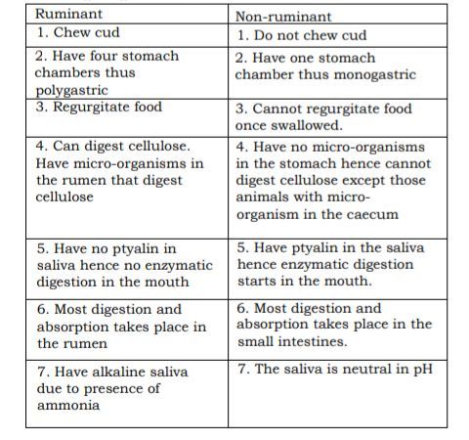
11)Give six reasons why farmers should embrace crop rotation in the growing of
annual crops. (6mk)
 Maximum utilization of nutrients. Different crops have different nutrient
requirements thus it helps to utilize all the nutrients in the soil.
 Control of soil borne pests and diseases build up. This is because crops of the
same family are attacked by similar pests and diseases thus alternating with
different family of crop helps to break the pest and disease cycle
 Control of weeds. Controls parasitic weeds that that are specific to certain family
of crops.
 Improvement of soil structure.by including a grass ley at the end of the
Programmed as grass binds oil particles together.
 Control of soil erosion.by alternating crops with poor ground cover with cover
crops help to protect soil against agents of soil erosion.
 Improvement of soil fertility. By including a leguminous crop in the rotation
Programmed to fix nitrates into the soil.
12) Give five characteristics of a good grain store. (5mks)
 Rat/vermin proof.
 Well ventilated.
 Easy to load and offload.
 Pest free.
 Leak proof.
 Well secured to minimize theft.
 Cool conditions to minimize overheating of grains that would lead to cracking of grains.
13. Describe six post-harvest management practices carried out on various crops. (12mks)
 Threshing or shelling. Can be done manually or by use of a machine. It facilitates
cleaning and subsequent storage.
 Drying. Grains are dried in the sun or by use of artificial driers to reduce moisture
content to prevent rooting or fungal attack of grains while in store.
 Cleaning. Cereals are cleaned by winnowing to remove chaff from the grains.
 Sorting and grading. Done according to quality freshness or size to enable buyers easily
select according to their preference
 Dusting. Appropriate chemicals are applied on the grains in form of dust powder to
prevent attack of grains by storage pests.
 Processing. Some produces are taken to the factory for processing to improve flavour
keeping quality or reduce bulkiness by changing the produce to final products
 Packaging. Placing the produce into containers to reduce damage and makes it easy to
quantify the produce and set prices for commodities.
14) Discuss cabbage production under the following sub-headings.
a) Varieties. (2mks)
 Early maturing varieties. They include; Sugar loaf, Mukuki, Golden acres, Gloria
hybrid and Copenhagen market.
 Late maturing varieties. They include; Early drum-head, Savoy cabbage, Prize drum
head, Perfection and Surc-head.
b) Ecological requirements. (3mks)
 Altitude. 1800-2900M above the sea level. Small varieties do well at altitude as low
as 900M.
 Rainfall. 750mm for small headed varieties and 2000mm for large headed varieties.
 Soils. Requires deep well drained and fertile soils that are slightly acidic. PH of 6.5.
c) Field management practices. (2mks)
 Top dressing. Top dress at 20-25 cm high with one teaspoonful of SA or CAN and repeat
3-4 weeks after the first top dressing.
 Weeding. The field should be kept weed free and hand weeding is done. Do not break
the leaves during weeding as it interferes with head formation.
d) Harvesting and marketing. (2mks)
 Takes 3-4 months after transplanting. Heads are cut when solid and compact. Delay
harvesting after maturing makes the heads to crack and start rotting especially during
the rainy season except for Gloria hybrid.

