COMPETENCY BASED CURRICULUM
GRADE FIVE- YEAR 2025
G5}
SCIENCE AND TECHNOLOGY
Process of reclaiming old materials and using them to create new products is called
A.reducing
B. reproducing
C.recycling
D.remarking
2. Which part of the human skeleton protects the brain?
A.Head
B. Breast bone
C.Shoulder bone
D.Skull
3. The function of the rectum in the human digestive system is to:
A, digest fats and oils
B. absorb water and mineral salts
C. store undigested matter temporarily
D. remove undigested matter
4.How does a snake move? It:
A.crawls
B. Slithers
C.glides
D. limbs
5. Which one of the following comprises of states of matter only?
A.Boiling,melting,solid
B.Liquid,solid,gas
C. Gas, melting and solid
D.Melting, recycling and boiling
6. Which one of the following is not an external parasite?

A.Ringworm
B. Tick
C.Lice
D. Tape worm
7. Below is part of classification of plants.
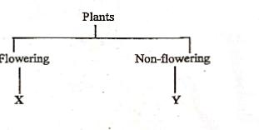

Which of the following pairs of plants can be used to replace Y and X respectively?

A. Maize, moss
B. Mango, bean
C. Moss, mango
D. Bean, algae
8. Which one of the following is the main characteristic of all vertebrates?
A. They give birth
B. They have a backbone
C. They are cold blooded
D.They are warm blooded
9.Mungolo wanted to save a document. He had already clicked the command written save as.Which one of the following would help him to choose where to save the document?
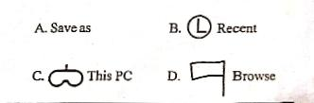

10.Which one of the following is a benefit of recycling?
A. It takes many years to finish
B. Recycling minimizes the pollution.
C. The government forces us to so
D. Recycling increases pollution
Use the diagram below to answer questions11-13
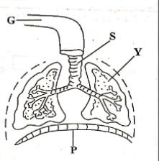

11.The above diagram represents the:
A. skeletal muscles
B. digestive system
C.respiratory system
D.circulatory system
12.In which part does gaseous exchange take place?
A.S
B.G
C.Y
D.P
13. What is the name of the part labelled P?
A.Lungs
B. Diaphragm
C.Trachea
D.Bronchus
14.Look at the picture below.
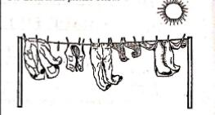
Which process is involved in the picture above?
A. Evaporation
B. Condensation
C. Melting
D.Freezing
15.Which one of the following substances is abase?
A.Vinegar
B. Sour milk
C. Ash solution
D. Orange juice
16.When Naphthalene gas changes to solid directly when cooled, the process is known as
A. Solidification
B. sublimation
C.freezing
Deposition
17. Below are properties of acids. Which one is not?
A.Have a bitter taste
B. Feel sticky
C. Burn the skin
D.Taste sour
18.Which one of the following is not a plant-based waste?
A. Wilted flowers
B. Fallen leaves
·C. Feathers
D. Bark pieces
19. Vibrating objects produce
A.heat
B.light
C.sound
D.magnetic force
20.Which one of the following is not a respiratory disease?
A. Pneumonia
B.Typhoid
Asthma
D. Influenza

