Name……………………………………….............. Index. Number…………..…………
Candidate’s Signature……………………………….. Date…………………………….
FORM FOUR
MATHEMATICS
MID TERM 2 JUNE 2025 TIME: 2½ hours
(SECTION I 50MARKS)
Attempt all the questions from this questions.

- The length of a rectangle is 8.3cm and its width is exactly 5. 45cm.Calculate the percentage error in its area, correct to four significant figures. (3marks)

- Express $\frac{4\sqrt{5}+3\sqrt{2}}{\sqrt{5}-\sqrt{2}}$ in the form a + b$\sqrt{c}$ where a and b are improper fractions.
(3marks)

- Make P the subject of the formula. (3marks)
$\frac{4}{d}$ =$\sqrt{\frac{R^{2}-K}{P^{2}}}$

- Two blends of tea costing Ksh 120and Ksh 150 per kilogram were mixed and the mixture sold at Sh 171.60. As a result a profit of 30% was made. At what ratio were they mixed. (3marks)

- A singular matrix M is given as shown, Find the possible value of T and hence write down the two possible matrices.
M = $\left[\begin{matrix}T-1 & 2 \\ T & T+2\end{matrix}\right]$ (3marks)

- Given that the position vectors of A is 3i -2j-k and that of B is i-3j+2k.
Find:
(i) AB in terms of i, j, and k (2marks)

(ii) The magnitude of AB correct to 2 decimal places. (2marks)

- a) Expand ${(1-\frac{1}{2}x)}^{5}$ up to the 4th term. (2marks)

b) Use your expansion above to evaluate (0.96)⁵ to four significant figures. (2mark

- Solve the equation 2 sin (2x-30º) = -1 for 0º ≥ x ≥360º (4marks)

- Calculate the semi-interquartile range of (2marks)
3, 4, 1, 2, 3, 6, 8, 5, 7, 9

- Solve for x in the equation. (3marks)
$$\log_{3}\left(7x+3\right)-\log_{3}\left(2-x\right)=1$$

- The original area of an object after two successive transformations given by the matrices $\left(\begin{aligned}2 1 \\ 3 5\end{aligned}\right)$ and $\left(\begin{matrix}3 & 2 \\ 0 & 1\end{matrix}\right)$in that order becomes 168 square units. Find the original area of the object. (3marks)

- What is the smallest number of terms that can be added so that the sum of 1+4+16+64+ is more than 25,000. (3mark

- The points with coordinates (5, 5) and (-3, -1) are the ends of the longest chord of a circle centre D. Determine
i) The coordinates of D. (1mark)

ii) The equation of the circle in the form of $x^{2}+y^{2}+ax+by+c=0$ Where a, b, and c are constants. (2marks)

- Quantity Q partly varies as quantity R and partly varies inversely as the square of R.
Given that Q = 3 when R = 1 and Q = 5 when R = ½.
Find the equation connecting Q and R. (3marks)

- The diagram drawn below is a triangle.
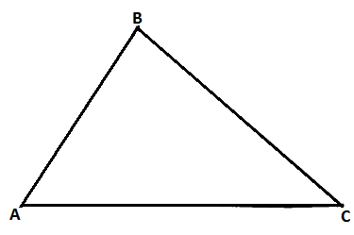
On the diagram show the locus of P such that AP > 4cm and that P is nearer to A than B.
Shade the region where p can be found. (3marks)

16 The data below shows marks obtained by 10 students in a test.
71, 55, 69, 45, 65, 57, 71, 82, 55, 50. Calculate the standard deviation using an assumed mean of 60. (3marks)

SECTION II (50 MARKS)
Answer any five questions in this section
- ABC is a triangle with vertices A (-7, 2) B (-2, 1) and C (2, 8). A¹B¹C¹ is the image under transformation.$\left[\begin{matrix}-1 & 0 \\ 0 & -1\end{matrix}\right]$
- (i) Find the co-ordinates of A¹B¹C₁ (2marks)

(ii) On the grid provided draw ABC and A¹B¹C¹ (2marks
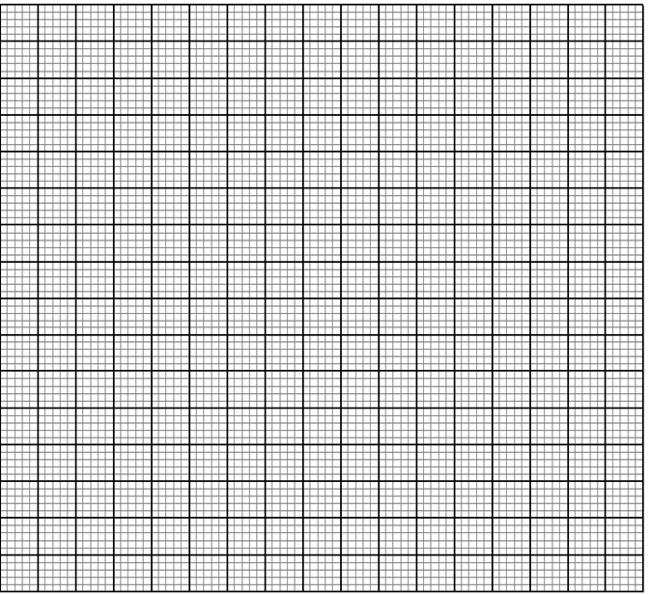
b. (i) Find the co-ordinates of A¹¹B¹¹C¹¹ the image of a triangle A¹B¹C¹ under
transformation matrix. $\left[\begin{matrix}0 & -1 \\ -1 & 0\end{matrix}\right]$ (2marks)
(ii) On the same grid draw A¹¹B¹¹C¹¹ (1marks)
c. (i) Find the single matrix that maps A¹¹B¹¹C¹¹ onto A¹B¹C¹ (2marks)

(ii) Describe the transformation represented by the matrix in c(i) above (1mark)

- The table below shows income tax rate for the year 2020.
Taxable income (Ksh per Month) | Tax rate (Ksh per Ksh 20)
1 – 12,000 | 2
12,001 – 22,500 | 3
22,501 – 33,000 | 4
33,001 – 43,500 | 5
43,501 – 54,000 | 6
54,001 and over | 7
Musa was earning a basic salary of Ksh 48,200 per month. He was entitled to the following allowances per month:
House allowance Ksh 12,000, medical allowances Ksh 4,200 and a non-taxable transport allowance of Ksh 5,200. He is entitled to a personal relief of Ksh 1,054 monthly. Calculate:
(a) Musa’s monthly taxable income (2marks)

(b) Musa’s monthly net tax. (5marks)

(c) The following deductions were also made from his salary per month. NHIF Ksh 3,000,
Bank loan –Ksh 9,500, WCPS Ksh 760. Determine his net monthly pay. (3marks)

- In the triangle OAB, $\vec{OB}$= $\underbrace{b}$ , $\underbrace{OA}$ = $\underbrace{a}$. Point N is on OB such that the ratio ON:NB=1:2 and the point M divides AB in the ratio 1: 3 line OM and AN intersect at point X.
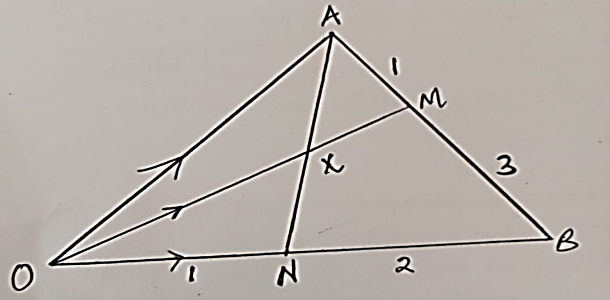
(a) Express in terms of vectors $\underbrace{a}$and $\underbrace{b}$ ,
(i) $\vec{ON}$ (1mark)

(ii) $\vec{OM}$ (2marks)

b) Further given that $\vec{OX}$ =h $\vec{OM}$ and OX =kAX, where k &h are scalars,
(i) Express $\vec{OX}$ in two different ways. (2marks)

(ii) Find the value of k and h. (4marks)

(c) Find the ratio AN: NX (1mark)

20. The figure below shows a plan of a roof with rectangular base ABCD.AB =26cm, BC
=16cm and the ridge PQ which is centrally placed above the base is 10cm. The faces
ADP and BCQ are equilateral triangles. M is the mid -Point of BC.
Calculate:
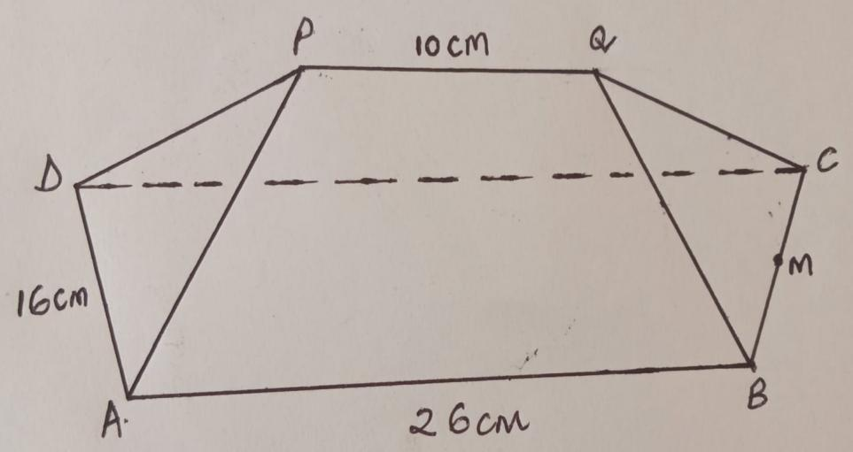
(a) The length of QM (2marks)

(b) The vertical height of p above the base. (2marks)

(c) The angle between line AP and the plane ABCD. (3marks)

(d) The angle between plane APQB and the base. (3marks)

21. The supply of milk in Tharaka-Nithicounty depends on two companies; Brookside and Tuzo. The probability that Brookside supplies milk on a certain day is $\frac{2}{3}$ while the probability that Tuzo supplies milk on the same day is $\frac{5}{8}$.
(a) Represent this information on the tree diagram. (2marks)

(b) i) Find the probability that there is no milk on that day (2marks)

ii) Only one company supplies milk on that day. (3marks)

iii) There is milk supply on that day. (3marks)

22. The towns on the earth surface are P(35ºN,140ºW) and Q(35ºN,40ºE). (Use π =$\frac{22}{7}$ and the radius of the earth R = 6370km)
(a) Calculate the shortest distance between P and Q in the nautical miles. (2marks

(b) Calculate the time taken by the plane to travel from town P to Q at a speed of 500knots along the shortest route.
(2marks

(c) A point B is westwards of Q; at a distance of 3408.05km. Find the longitude of B.
(3marks)

(d) A plane leaves point B above at 11.20 am local time and travels eastwards to Q at a speed
of 3000km/hr. At what time does it land at Q. (3marks)

23. The diagram below shows a circle centre O. PQ is the tangent to the circle at C. Angle
DCQ= 46º and angle BAC =27º.
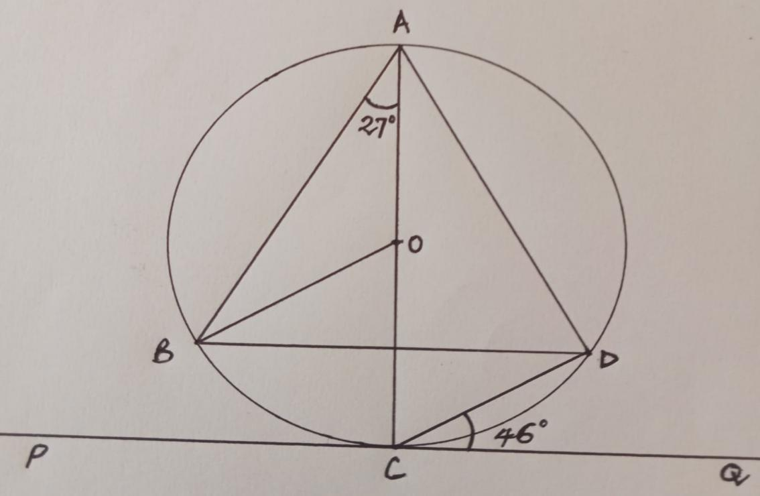

Find giving reasons the size of each of the following angles.
a) Angle OAD (2marks)

b) Angle DBO (2marks)

c) Angle ACD (2marks)

d) Angle BDA (2marks)

e) Reflex angle BOC (2mks)

THIS IS THE LAST PRINTED PAGE!

