Name……………………………………….............. Index. Number…………..…………
Candidate’s Signature……………………………….. Date…………………………….
FORM THREE
MATHEMATICS
MID TERM 2 JUNE 2025 TIME: 2½ hours
(SECTION I 50MARKS)
Attempt all the questions from this questions.

- Evaluate; (3 marks)
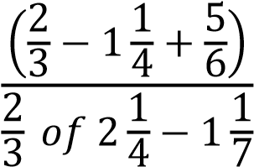

- (a) Without using mathematical tables and calculators simplify;
(3 − √7)(3 + √7). (1 mark)

(b) Hence evaluate; (2 marks)
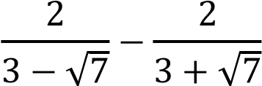

- Given that 2^{𝑥} × 3^{𝑦} = 108. Solve the value of 𝑥 and 𝑦 (3 marks)

- The figure below shows a rhombus PQRS with PQ = 9 cm, and ∠𝑆𝑃𝑄 = 60°. SXQ is a circular arc, centre P.
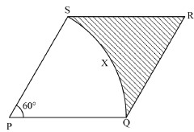
Calculate the area of the shaded region correct to 2 decimal places. (Take 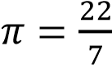)
(3 marks)

- A tourist arrived in Kenya with sterling pound (£) 4680 all of which he exchanged into Kenyan money. He spent Ksh. 51,790.40 while in Kenya and converted the rest of the money into U.S dollars. The exchange rates were as follows.
 | Buying (Ksh) | Selling (Ksh)
US dollar ($) | 147.16 | 147.36
Sterling pound (£) | 182.13 | 182.43

  - Convert (£) 4680 into Kenya shilling (2 marks)

  - Calculate the amount he received to the nearest U.S dollars (2 marks)

- Kamau leaves home for school at 10:00 a.m. He walked for 30 minutes, then took a rest for two hours. He then boarded a matatu for 4 hours. At what time did he arrive in
school? (2 marks)

- A refrigerator can be bought in cash for Ksh. 35,000. The same refrigerator can be purchased on hire purchase terms by first paying a deposit of Ksh 6,000 followed by 24
equal monthly instalments of Ksh. 1,500. Calculate the hire purchase price and the
carrying charge. (3 marks)

- Given that; 3 − 2𝑥 < 𝑥 − 3 ≤ 4
  - Form two inequalities (2 marks)

  - Solve for the value of 𝑥 (1 mark)

  - State all the integral values satisfying the inequalities. (1 mark)

- Line L1 passes through the point 𝐴(2, 6) and 𝐵(4, 8). Find the equation of L2 which is a
perpendicular bisector of line L1. (3 marks)

- The sum of interior angles of two regular polygons of sides; n and n + 2 are in the ratio
3:4. Calculate the sum of the interior angles of the polygon with n sides. (3 marks)

- Solve the following equation. (3 marks)
1 + log₅ 𝑥 = log₅ 12

- Find the volume of the cone whose slant height is 15 cm and a height of 9 cm. (3 marks)

- Convert the recurring decimal 12. 1̇8̇ into fraction (3 marks)

- The angle of elevation of the top of a tower from a point X on the horizontal is 28.5°. From another point Y, 8 meters near to the base of the tower, the angle of elevation of the top of the tower is 37.2°. Calculate, to one decimal place, the length of the tower.
(3 marks)

- The radius of a cylinder is 4.2 cm and the height is exactly 12 cm. Find the percentage
error in calculating its volume. (3 marks)

- Solve for the values of 𝑥 given that; (4 marks)
2 − 3𝑥 = 3𝑥² − 4𝑥 − 5

