COMPETENCY BASED CURRICULUM
GRADE FIVE – YEAR 2025
{G5}
MATHEMATICS
At is the place value of digit 4 in the sum of4286 and 4132?
A. Thousands
B. Hundreds
C. Tens of thousands
D. Tens
2. Which of the following numbers shows nine hundred and thirty four thousand, two hundred and twenty four?
A. 932404
B. 943242
C. 934224
D. 904224
3. Complete the pattern:-
7711,7715,7719,7723,
- 772, 7733
- 7728, 7736
- 7733, 7743
- 7727, 7631
4. The government donated 89908 bags of maize to people affected by floods. How many bags were they to the nearest thousands?
A. 90000
B. 89910
C. 89000
D. 90900
5. Find the H.C.F of 9, 18 and 27
A. 3
B. 6
C. 54
D. 9
6. Grandmother had 56 guavas. She wanted to share them equally among 10 grandchildren. How many more least numbers of guavas did she needs
A. 14.
B. 24.
C. 4
D. 34
7. A lorry weighs 4500kg when loaded with 30bags of beans. If each bag weighs 50kg, what is the mass of the empty lorry.
A. 6000kg
B. 3000kg
C. 1500kg
D. 2500kg
8. A school library had 78 shelves. Each shelfhad962 story books. Estimate the total number of books in the library by rounding off the factors to the nearest ten.
A.75040
B.75000
C.76800
D.72800
9. Subtract; 500g from 3 1/kg
A.2¼kg.
B.1½kg
C. 2 ½kg
D.2¾kg
10. Arrange these decimals in a descending order:
16.278, 16. 827, 16. 728, 16. 287
A. 16. 278, 16. 287 16. 728 16. 827
B 16. 728, 16. 827, 16. 278. 16. 287
C. 16. 827, 16. 287, 16. 728, 16. 278
D. 16. 827, 16. 728, 16. 287, 16. 278
11. what fraction is unshaded in the figure below
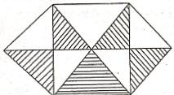
A. ⁴/10
B. ⁴/8
C. ⅝
D.⁵/10
12. Njoro drove from Lega to Senda and back, covering a distance of 1300km 670m. What is the distance between the two towns?
A. 600km 335m
B. 650km 335m
C. 2600km 340m
D. 2601 340m
13. What is the next fraction in the series?
½, ¼, ¹/16
- ¹/32
- ¹/68.
- ¹/256
- ¹/96
14. How many quarter litres are there in 48 litres?
A. 22.
B. 192
C. 12.
D. 96
15. Find the area of the figure below
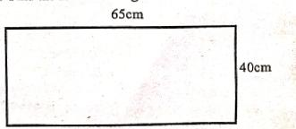
A.170c㎡B.170m C.2600m D.2600㎡
16. Work out:-
1 - ⁸/9 =__________________
- ⅛
- ⅑
- ¹⁷/9
- ³/9
17. Find the length of the figure below
A. 32m
B.4m
C. 8m
D. 16m

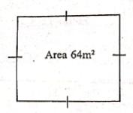
18. How many milliliters are there inlitre?7/1
A. 50ml
B. 500ml
C.5000ml.
D. O.5ml
19. Add 3737 to the difference of 7771 and 2945
A. 8553
B. 6979.
C. 8563.
D. 6799
20. Convert 49km 607m into metres
A. 55007m
B. 5507m
C. 49607m
D. 5060m
21. Container A had 15 litres 40ml of oil. Container B had 16 liters 300ml of the same oil. The two containers were emptied into container C. What was the capacity of container C?
A. 15 litres 670ml
B. 31 litres 340ml
C. 31 litres 700 ml
D. 31 litres 304ml

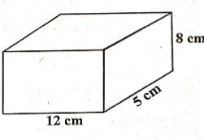
22. What is the volume of the figure below?

A.4800cm3
B.48000cm³
C.4080 cm³
D.480cm3

23. Find the L.C.M of 16, 20 and 24.
A. 60
B. 120.
C. 480
D.240

24. Which one of the following is not a prime number?
A. 73
B. 31
C. 39
D.47
25. Work out:-
184kg 600g+8
A. 23kg 75g
B.23kg85g
C.24kg 85g
D.23kg605g

26.Mika earns sh. 6000 as his salary. He spends3/4 of it and saves the rest. How much does he save?
A. Shs. 20000
B. Shs. 15000
C. Shs. 1500
D. Shs. 45000
27. Kanini took 2hrs 20mins to walk to the market. Lisa took 1 hr 45 mins to walk to the same market from the same house. Hoe much longer did kanini take than Lisa?
A. 1hr 5 min
B. 1 hr 25 min
C. 1 hr 55 min
D. 35 mins
28. Which one of the following is an obtuse angle?
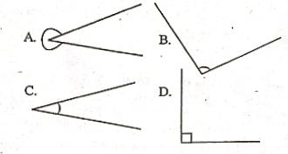
29. Male and female workers participated in cleaning a dumpsite in Gwira village for there days. The number of workers who participated is as shown in the table below. Use it to answer questions 29 and 30
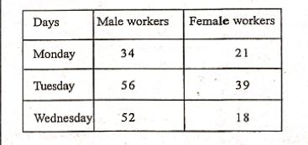

29. What is the total number of workers who did the work.
A. 218
B. 223
C. 220
D. 219
30. How many more males than females did the work?
A. 142
B. 78
C. 74
D. 64

