KENYA PRIMARY SCHOOL EDUCATION ASSESSMENT

GRADE 6 -END-TERM 2 - 2025
SCIENCE AND TECHNOLOGY

Time: 1 Hour 40mins

READ THESE INSTRUCTIONS CAREFULLY

- You have been given this question booklet and a separate answer sheet. The question booklet contains 50 questions.

- Do any necessary rough work in this booklet.

- When you have chosen your answer, mark it on the ANSWER SHEET, not in this question booklet.

HOW TO USE THE ANSWER SHEET
- Use only an ordinary pencil.

- Make sure that you have written on the answer sheet:

YOUR ASSESSMENT NUMBER
YOUR NAME
NAME OF YOUR SCHOOL

- By drawing a dark line inside the correct numbered boxes, mark your full Index Number (i.e. School Code Number and three-figure Index Number) in the grid near the top of the answer sheet.

- Do not make any marks outside the boxes.

- Keep your answer sheet as clean as possible and DO NOT FOLD IT.

- For each of the questions 1-50 four answers are given. The answers are lettered A, B, C, D. In each case only ONE
of the four answers is correct. Choose the correct answer.

- On the answer sheet, show the correct answer by drawing a line in the box in which the letter you have chosen is written.

Example
In the Question Booklet:

16. Example
Which one of the following is NOT grouped as a small domestic animal ?
A. Guinea pig
B. Goat
C. Rabbit
D. Parrot |  | Correct answer is B
On the Answer Sheet:
16. [A] [B | ] [C] [D] | 17.[A] [B] [C] [D] 18. [A] [B] [C] [D] 19.[A] [B] [C] [D]

In the set of boxes numbered 16 the box with B printed in it is lined.

- Your line MUST be within the box. Make your line as DARK as possible.

- For each question, ONLY ONE box is to be lined in each set of four boxes.

- Which one of the following is NOT TRUE
about water?
A. It is obtained from a certain source.
B. It can be polluted.
C. It is in liquid state.
D. It solidifies on heating.

- The largest planet is
A. Mercury B. Earth C. Saturn D. Jupiter

- Which type of soil erosion is small and shallow channels formed?
A. Rill B. Sheet C. Gulley D. Splash

- The following are characteristic of a certain type of soil:
i. Causes flooding.
- Has low air content.

- Is poor in drainage
- Cracks while dry.
The soil described above is
A. Sand B. Loam
C. Clay D. Mixture of clay and sand

- Which one of the following is an industrial use of water?
A. Use of fountains.
B. Watering plants and animals.
C. Watering buildings.
D. Fishing.

- Which one of the following is NOT a way of storing water?
A. Tanks B. Dam C. Pipes D. Drums

- Water used for domestic purpose
A. should be treated and well stored.
B. should be used for watering animals.
C. is used for mixing chemicals.

D. is usually dirty and unclean.

- Absorption of medicinal drugs in human beings takes place in the
A. ileum B. Stomach
C. Uterus D. Colon

- A Beam balance is used?
A. To compare masses of different materials.
B. used to measure the weight of the load.
C. To measure volume of an irregular solid.
D. To measure the amount of force required to lift an object.

- Which one of the following is NOT a way of maintaining simple tools?
A. Painting them regularly.
B. Washing them after use.
C. Oiling and greasing.
D. Replacing broken handles.

- Which of the following is NOT an example of deficiency diseases?
A. Anaemia B. Malaria
C. Marasmus D. Rickets

- Which one of the following is NOT a state of matter?
A. Water B. Gases C. Solids D. Liquids

- Which one of the following is NOT a characteristic of liquids?
A. They have definite mass.

B. They take the shape of the container
C. They have definite volume

D. They do not take the shape of the container.

- Which one is NOT a use of water in the body?
A. Making of blood.
B. Prevent the skin from drying.
C. It helps in cooling the body.
D. It prevents constipation.

- Which one of the following combination shows a balanced diet?
A. Fish, beans, rice
B. Oranges, termites, chips
C. Potatoes, rice, meat
D. Peas, maize, rice

- A push or a pull on an object is referred as
  - Weight.
  - Force.
  - Energy.
  - Volume.
- Grade five learners were doing an experiment on different substances. What happened when they put red litmus paper in ash solution? It turned
  - Blue
  - Yellow.
  - Grey
  - Red
- Three of the following are safety precautions when handling plants. Which one is not?.
  - Wear gloves on your hands.
  - Wash hands using soap after handling plants.
  - Wear protective gears.
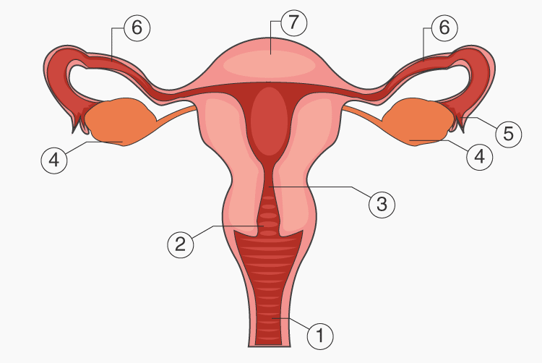
  - Any fruits or leaves.
Use the diagram below to answer question 19

- Which part in the above photograph shows where ova are produced?
  - 4
  - 7
  - 3
  - 1
- Which part of a plant absorbs water and supports the plant firmly?
  - Fruit
  - Flowers
  - Roots
  - Stem.
- Alisha and Maureen were playing on the see-saw as show below.
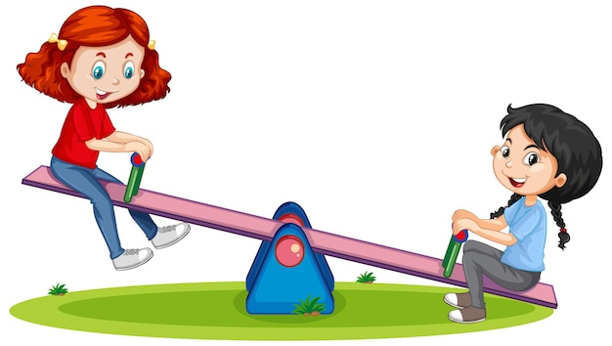
Which of the statements below is true? .
AISHA
MARY
  - Alisha is heavier than Maureen.
  - Maureen is heavier than Alisha.
  - For them to balance they should both move away from the fulcrum.
  - Alisha should move closer to the pivot for them to balance.
- The following are blood groups. Which group is referred to as universal donor?
  - B
  - O
  - A/B
  - A .
- Waste can be managed in the following ways except
  - Reducing.
  - Excretion
  - Reusing.
  - Recycling.
- Grade 4 learners were asked to type a friendly letter during their English lesson. Which part of the computer did, they use to enter the letters?
  - Central Processing Unit:
  - Monitor.
  - Keyboard.
  - Word.
- Below are characteristics of a certain group of animals.
  - They live partly on land and partly in water.
  - They lay eggs.
  - They do not have a constant body temperature.
  - They breathe through lungs.
Which of the following groups fit the description above?
    - Reptiles .
    - Fish
    - Mammals..
    - Bird.

- Which of the following parts is correctly matched with its function?

Z T

S V
  - S - Used To Give Instructions
  - T - Used To Type.
  - Z - Shows Or Displays What Is Happening.
  - V - Connects The Digital Device To The Hardware.
- The following are water pollutants. Which one is not?
  - Oils spills.
  - Smoke
  - Sewage.
  - Factory water
- Four learners were asked to identify the state of matter that has the following characteristics.
  - have definite shape.
  - have definite volume.
  - have definite mass.
Who gave the correct answer?
    - Juma - liquids.
    - Mariam insulators.
    - Abdi - gases.
    - Sarah - solids.
- A metallic ball sinks in water while a plastic one will float. This is due to
  - Material.
  - Shape.
  - Size.
  - Mass.
- Which waterborne disease can be controlled by draining stagnant water?
  - Dysentery.
  - Bilharzia.
  - Typhoid.
  - Cholera.

MARKING SCHEME
- D
- D
- A
- C
- D
- C
- A
- B
- A
- A
- B
- A
- D
- D
- B
- B
- A
- D
- A
- C
- A
- A
- B
- C
- A
- C
- B
- D
- A
- B

