NAME……………………………………………………………………CLASS…………………ADM……………………...
MID TERM TWO, 2025 EXAM (JUNE 2025)
FORM THREE GEOGRAPHY.
TIME: 1 HOUR 10 MINUTES
Instructions: Answer ALL the questions in the foolscaps provided.
- (a) Define the term mass wasting. (2 marks)
(b) Explain four effects of soil creep. (8 marks)
(c) State five causes of mechanical weathering. (5 marks)
2. (a) Identify a scale used to measure:
(i) The intensity of the earthquake. (1 mark)
(ii) The magnitude of the earthquake. (1 mark)
(b) State three characteristics of primary seismic waves. (3 marks)
(c) Give three natural causes of earthquakes. (3 marks)
3. (a) Name three minor oil producing countries in the Middle East region. (3 marks)
(b) Describe how oil was formed. (5 marks)
(c) Apart from seams and beds, give three other ways in which minerals occur.
(3 marks)
4. (a) State three reasons why it is important to study plate tectonic theory. (3 marks)
(b) Explain how gravitative pressure causes earth movements. (2 marks)
5. The diagram below shows intrusive volcanic features.
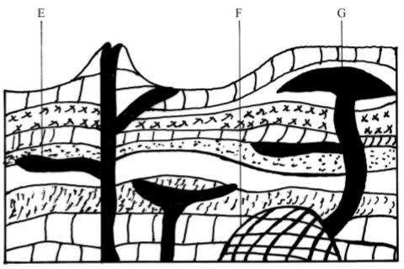
- Name the landforms marked E, F and G. (3 marks)
- (i) Distinguish between faulting and folding. (2 marks)
(ii) Explain three effects of faulting on drainage. (6 marks)

