MID TERM TWO, 2025 EXAM (JUNE 2025)
FORM THREE GEOGRAPHY.
MARKING SCHEME
- (a) Define the term mass wasting. (2 marks)
- Mass wasting is the downslope movement of weathered materials due to the influence of gravity.
(b) Explain four effects of soil creep. (8 marks)
- Accumulation of soil particles at the base of the slope results in deep soils.
- Accumulation of soil on road or railway cuttings which makes maintenance expensive.
- Soil creep causes posts and electric poles to bend due to pushing by soil particles.
- Upper slopes are left bare when soil particles move downhill making the slope to be exposed.
- Soil creep exerts pressure on stone walls across a slope thus may form cracks leading to destruction.
- Over a long period of time, soil creep leads to slope retreat making the slope gentler than before.
(c) State five causes of mechanical weathering. (5 marks)
- Temperature changes involving heating and cooling of rocks.
- Action of ice on rocks.
- Growth of salt crystal within a rock mass.
- Rainwater due to alternate wetting and drying of minerals.
- Reduction of weight of materials covering rocks.
2. (a) Identify the scale used to measure:
(i) The intensity of the earthquake. (1 mark)
- Rossi- Forel scale.
- Mercalli scale.
(ii) The magnitude of the earthquake. (1 mark)
- Richter scale.
- Moment magnitude scale.
(b) State three characteristics of primary seismic waves. (3 marks)
- Are the fastest of all earthquake waves.
- Are the first to be recorded.
- P-waves can pass through liquids, solids and gases.
- P-Waves cause crustal rocks to vibrate in push – pull manner.
(c) Give three natural causes of earthquakes. (3 marks)
- Vertical earth movements during isostatic adjustment.
- Energy release from the mantle.
- Movement of tectonic plates towards each other or past each other.
- Violent volcanic explosions and movement of magma in the crust.
- Sinking of crustal rocks due to gravitative pressure.
3. (a) Name three minor oil producing countries in the Middle East region. (3 marks)
- Bahrain.
- Qatar.
- Oman.
- Yemen.
- Syria
(b) Describe how oil was formed. (5 marks)
- According to the biogenic theory on the origin of hydro-carbons, oil is believed to have been formed from organic remains mainly dead animals.
- The remains accumulated under sea water in the absence of oxygen over a long period of time.
- These remains were buried deep below by thick layers of sediments after many years of deposition.
- Intense compressional pressure and heat squeezed out the fatty parts of the remains.
- With increase in pressure and heat, the remains were converted into oil.
- The surrounding sediments were converted to sedimentary rocks.
(c) Apart from seams and beds, give three other ways in which minerals occur.
(3 marks)
- As weathered products.
- As alluvial deposits.
- As veins and lodes.
- As evaporates.
4. (a) State three reasons why it is important to study plate tectonic theory. (3 marks)
- The theory explains the current position of continents.
- One is enable to understand how structural landforms were formed.
- One is able to understand how the earth maintains isostacy.
- Th theory explains the causes of earthquakes and volcanic eruption.
(b) Explain how gravitative pressure causes earth movements. (2 marks)
- Large quantities of magma that escape from the upper mantle to the surface leaving behind large voids/hollows.
- Force of gravity then acts on the crustal rocks overlying the void, exerting pressure on the rocks.
- Eventually the overlying crustal rocks crumble inwards to fill up the voids/hollow below, this leads to vertical displacement of rocks.
5. The diagram below shows intrusive volcanic features.
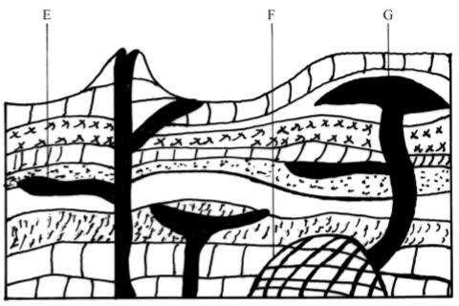
- Name the landforms marked E, F and G. (3 marks)
- E-Sill.
- F-Batholith.
- G-Laccolith.
- (i) Distinguish between faulting and folding. (2 marks)
- Faulting is the process through which crustal rocks fracture due to tectonic forces such as tension, compression or shear while folding is process of crustal distortion which causes crustal rocks to bend upwards or downwards.
(ii) Explain three effects of faulting on drainage. (6 marks)
- Faulting along a river course may change a rivers direction of flow. Such rivers may flow following Faultline thus fault-guided drainage pattern.
- Some rivers may disappear into Faultline thus forming underground rivers.
- Vertical faulting across a river valley leads to the formation of a waterfall.
- Subsidence of land due to faulting creates depressions that are filled with water to form inland lakes.
- Uplifting of land during faulting may force some rivers to reverse their direction of flow, forming back tilted drainage pattern.

