NAME______________________________________________CLS__________ADM___________
FORM TWO GEOGRAPHY.
TERM 2 2025 MID TERM EXAM TIME: 1 HOUR
1. (a) What are clouds? (2 marks)
………………………………………………………………………………………………………………………………………………………………………………………………………………………………………………………………………………………………………………………………………………………………………………………………………………………………………………………………
(b) State three characteristics of cumulonimbus clouds. (3 marks) …………………………………………………………………………………………………………………………………………………………………………………………………………………………………………………………………………………………………………………………………………………………………………………………………………………………………………………………………………………………………………………………………………………………………………………………………………………………………………………………………………………………………………………………………………………………………………
(C) List four types of fog. (4 marks)
…………………………………………………………………………………………………………………………………………………………………………………………………………………………………………………………………………………………………………………………………………………………………………………………………………………………………………………………………………………………………………………………………………………………………………………………………………………………………………………………………………………………………………………………………………………………………………
2. (a) Apart from convectional rainfall, list the two other types of rainfall. (2 marks)
………………………………………………………………………………………………………………………………………………………………………………………………………………………………………………………………………………………………………………………………………………………………………………………………………………………………………………………………
(b) Describe how convectional rainfall is formed. (6 marks)
………………………………………………………………………………………………………………………………………………………………………………………………………………………………………………………………………………………………………………………………………………………………………………………………………………………………………………………………………………………………………………………………………………………………………………………………………………………………………………………………………………………………………………………………………………………………………………………………………………………………………………………………………………………………………………………………………………………………………………………………………………………………………………………………………………………………………………………………………………………………………………………………………………………………………………………………………………………………………………………………………………………………………………………………………………………………………………………………………………………………………………………………………………………………………………………………………………………………………………………………………………………………………………………………………………………………………………………………………………………………………………………………………………………………………………………………………………………………………………………………………………………………………………………………………………………………………………………………………………………………………..…………………………………………………………………………………………………………………………………………………………………………………………………………………………………………………………………………………………………………………………………………………………………………………………………………………………………………………………………
(c) State three characteristics of convectional rainfall. (3 marks)
…………………………………………………………………………………………………………………………………………………..…………………………………………………………………………………………………………………………………………………………………………………………………………………………………………………………………………………………………………………………………………………………………………………………………………………………………………………………………
3. The diagram below shows a type of fault.
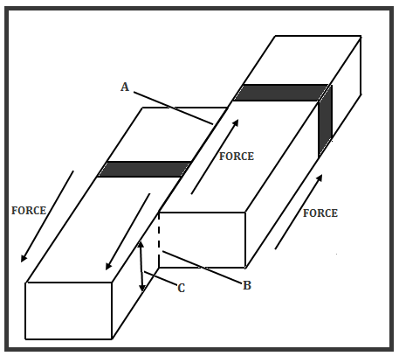

(a) Name the parts marked A, B and C. (3 marks)
……………………………………………………………………………………………………………………………………………………………………………………………………………………………………………………………………………………………………………………………………………………………………………………………………………………………………………………………………………………………………………………………………………………………………………………………………………………
4. (a) Apart from the Eastern/Gregory Rift valley, give three other branches of the Great Rift Valley in Eastern Africa. (3 marks)
……………………………………………………………………………………………………………………………………………………………………………………………………………………………………………………………………………………………………………………………………………………………………………………………………………………………………………………………………………………………………………………………………………………………………………………………………………………
(b) State four characteristics of the Gregory Rift Valley. (4 marks)
…………………………………………………………………………………………………………………………………………………………………………………………………………………………………………………………………………………………………………………………………………………………………………………………………………………………………………………………………………………………………………………………………………………………………………………………………………………………………………………………………………………………………………………………………………………………………………
5. You were to carry out a field study of faulting along a section of the Great Rift Valley section of Kenya:
(a) Give three reasons why it is important to prepare a route map. (3 marks)
……………………………………………………………………………………………………………………………………………………………………………………………………………………………………………………………………………………………………………………………………………………………………………………………………………………………………………………………………………………………………………………………………………………………………………………………………………………
(b) State three factors that you would consider when choosing methods of data collection. (3 marks)
……………………………………………………………………………………………………………………………………………………………………………………………………………………………………………………………………………………………………………………………………………………………………………………………………………………………………………………………………………………………………………………………………………………………………………………………………………………

6. (a) (i) State four causes of vulcanicity. (4 marks)
…………………………………………………………………………………………………………………………………………………………………………………………………………………………………………………………………………………………………………………………………………………………………………………………………………………………………………………………………………………………………………………………………………………………………………………………………………………………………………………………………………………………………………………………………………………………………………
(ii) Give three examples of volcanic materials. (3 marks)
……………………………………………………………………………………………………………………………………………………………………………………………………………………………………………………………………………………………………………………………………………………………………………………………………………………………………………………………………………………………………………………………………………………………………………………………………………………
(b) (i) List two types of surface longitudinal seismic waves. (2 marks)
………………………………………………………………………………………………………………………………………………………………………………………………………………………………………………………………………………………………………………………………………………………………………………………………………………………………………………………………
(ii) Explain three effects of earthquakes in built up areas. (6 marks)
……………………………………………………………………………………………………………………………………………………………………………………………………………………………………………………………………………………………………………………………………………………………………………………………………………………………………………………………………………………………………………………………………………………………………………………………………………………………………………………………………………………………………………………………………………………………………………………………………………………………………………………………………………………………………………………………………………………………………………………………………………………………………………………………………………………………………………………………………………………………………………………………………………………………………………………………………………………………………………………………………………………………………………………………………………………………………………………………………………………………………………………………………………………

