FORM TWO GEOGRAPHY
TERM 2 2025 MID TERM EXAM MARKING SCHEME
1. (a) What are clouds? (2 marks)
Clouds are masses of tiny visible water droplets or ice floating at various heights in the atmosphere.
(b) State three characteristics of cumulonimbus clouds. (3 marks)
- Are white in colour and grey at the sides.
- Extend to very high altitudes.
- Look like mountains in the sky/anvil.
- Are flat at the base.
- Are convection clouds.
- Are the largest clouds.
- Bring torrential rainfall.
- Are associated with thunder and lightning.
(C) List four types of fog. (4 marks)
- Hill fog
- Advection fog
- Radiation fog
- Steam fog
- Ice fog
- Frontal fog

2. (a) Apart from convectional rainfall, list the two other types of rainfall. (2 marks)
- Relief/orographic rainfall
- Frontal/Cyclonic rainfall
(b) Describe how convectional rainfall is formed. (6 marks)
- Convectional rainfall mainly occurs in hot lowland regions.
- A large water body such as a lake or sea is heated through insolation causing evaporation to occur.
- Maximum heating of both the land and the water body occurs in the afternoon.
- Heated moist air above the water body rises as cooler drier air descends to replace it forming convection currents.
- As the warm moist air rises, pressure decreases causing it to expand leading to rapid cooling.
- The cooled moist air condenses at higher altitude forming dense cumulonimbus clouds.
- When the clouds are heavy, they release the water in large torrential drops as convectional rainfall mainly in the afternoon.

(c) State three characteristics of convectional rainfall. (3 marks)
- Mainly occurs in hot lowland regions.
- It falls mainly in the afternoon.
- It fall in large torrential drops.
- At times accompanied by thunder and lightning.
- At times accompanied by strong winds.
- At times accompanied by ice pellets.
- Falls over a short period of time such as 15 – 20 minutes.
3. The diagram below shows a type of fault.
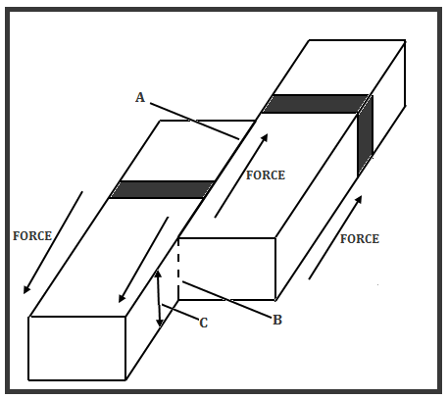
(a) Name the parts marked A, B and C. (3 marks)
- A – Fault line
- B – Shear fault
- C – Fault plane
4. (a) Apart from the Eastern/Gregory Rift valley, give three other branches of the Great Rift Valley in Eastern Africa. (3 marks)
- Ethiopian Rift Valley section
- Western Rift Valley section
- Malawi Rift Valley section
(b) State four characteristics of the Gregory Rift Valley. (4 marks)
- The width varies at different locations
- The altitude at the floor of the Rift Valley differs at various points.
- The height of escarpments varies.
- A number of fault blocks border the rift Valley at various points.
- Uneven sinking created depression that form several lakes.
- A number of volcanoes occur at the floor of the Rift Valley
5. You were to carry out a field study of faulting along a section of the Great Rift Valley section of Kenya:
(a) Give three reasons why it is important to prepare a route map. (3 marks)
- To show the direction to be followed during the study.
- To help in estimating the distance to be covered during the study.
- To help in preparation of a work schedule.
- To assist in estimating the time required for the study.
- To help in deciding the technique of data collection.
(b) State three factors that you would consider when choosing methods of data collection. (3 marks)
- The effectiveness of the method
- The method must be cheap to use/ budget – friendly
- One must consider the availability of the respondents/ their willingness to co-operate
- One must consider the literacy level of the respondent
6. (a) (i) State four causes of vulcanicity. (4 marks)
- High temperature in the interior which changes materials to molten form.
- High pressure in the interior released during earth movements.
- Faulting which creates lines of weakness such as vents and fissures.
- Ground water which is heated by hot rocks to form steam.
(ii) Give three examples of volcanic materials. (3 marks)
- Magma.
- Lava.
- Ash.
- Cinder.
- Lapilli.
- Volcanic bombs.
- Gases such as Hydrogen sulphide, Carbon (IV) Oxide and Sulphur (IV) Oxide.

(b) (i) List two types of surface longitudinal seismic waves. (2 marks)
- Rayleigh waves
- Love waves
(ii) Explain three effects of earthquakes in built up areas. (6 marks)
- Violent shaking of the ground results in collapsing of buildings thus loss of many lives.
- Shaking of bridges results in collapsing thus cutting off some areas.
- Cracking of the ground causes damage to roads resulting in inaccessibility.
- Buckling of railway lines due to lateral displacement in some parts.
- Damage to oil or gas pipelines may at times result in fires within affected cities.
- Displacement of many people who survive after buildings collapse or are weakened by the earthquake.

