COMPETENCY BASED ASSESSMENT
MONITORING LEARNER’S PROGRESS
GRADE 5 – YEAR 2025
SOCIAL STUDIES
TIME: 2 HR 15 MIN
NAME ………………………………………………………………………………………………………….
LEARNER’S NUMBER ……………………………………………………………………………………….
GENDER: BOY …………………………………………. GIRL ……………………………………
COUNTY NAME ………………………………………… COUNTY CODE ………………………
SUB-COUNTY NAME:………………………………….. SUB-COUNTY CODE…………………
SCHOOL NAME…………………………………………. SCHOOL CODE………………………..
FOR OFFICIAL USE ONLY
The grid below is to be filled by the teacher after marking the learner’s work
SOCIAL STUDIES
NUMBER OF MARKS

Assessment Rubric
Exceeds expectation  4 | Meet expectation  3 | Approaching expectation 2 | Below expectation  1

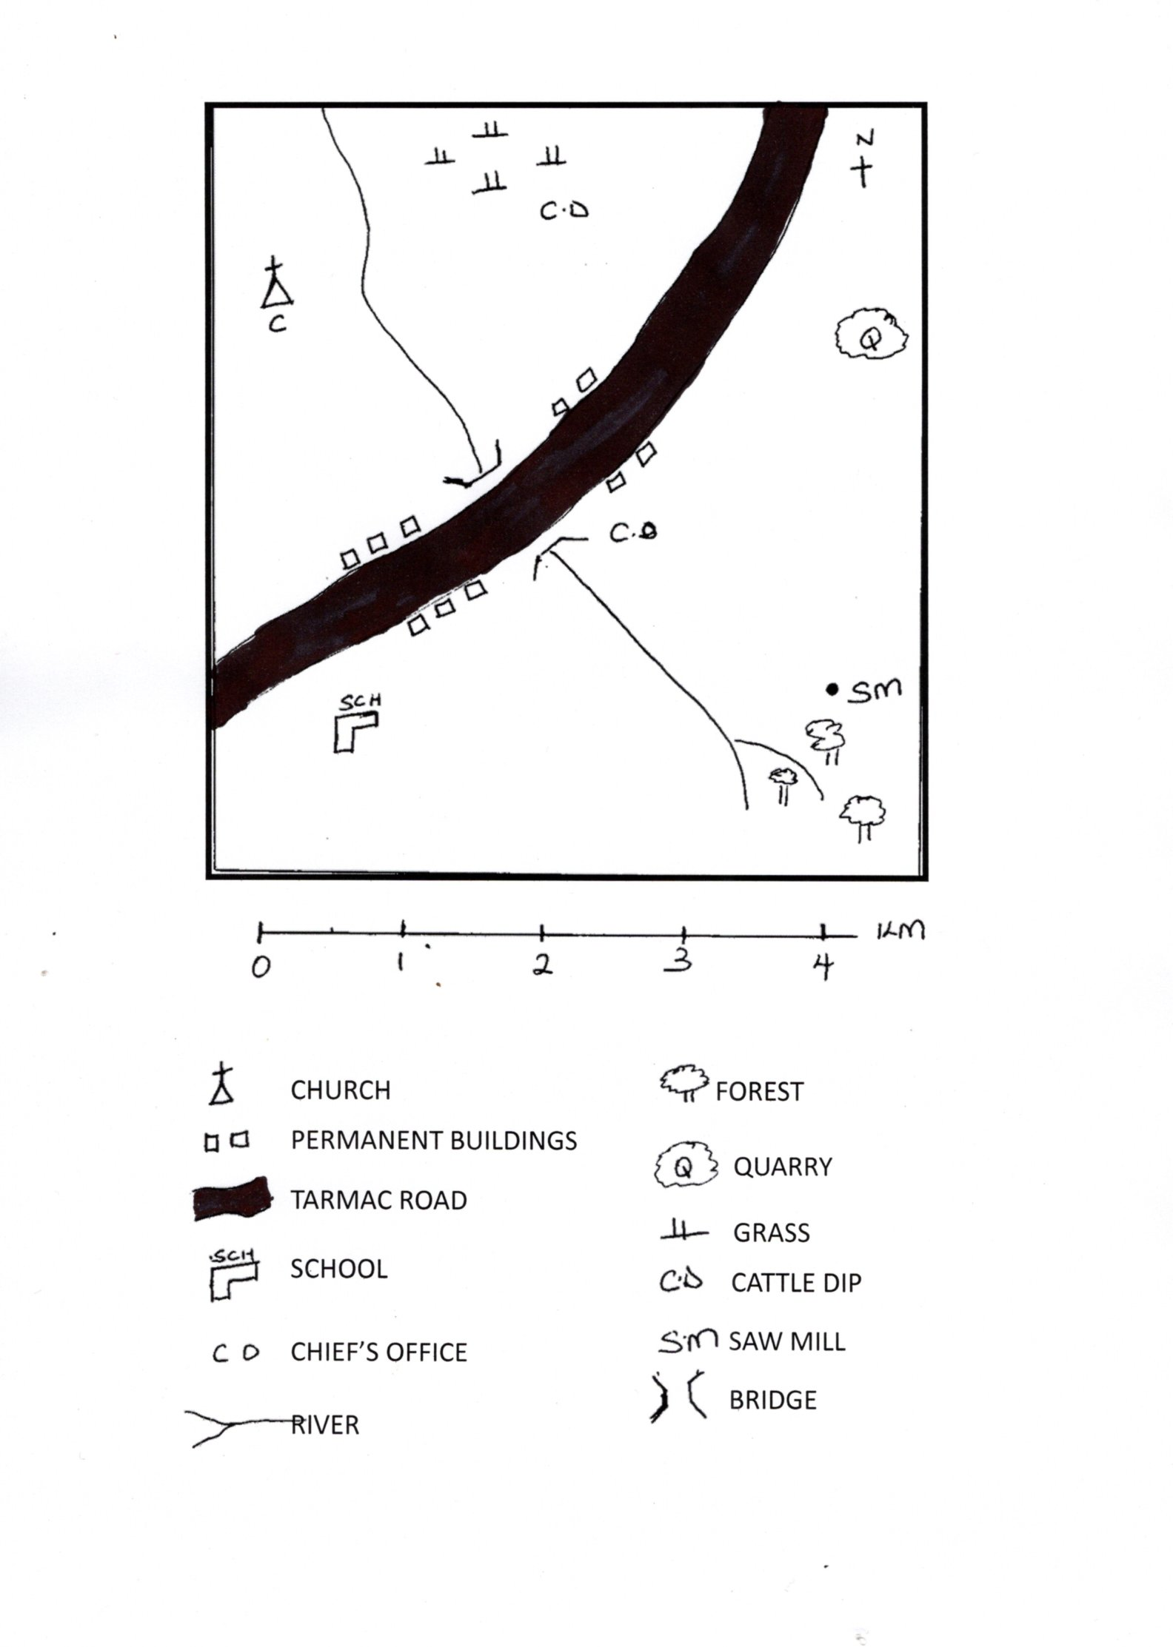
LURAMBI AREA

Use the map of Lurambi area to Answer questions a-d
- a). Name 3 elements of a map shown on the map of Lurambi area (3mks)
(i)________________________________
(ii)________________________________
(iii)_______________________________
b). What is the direction of the church from the school ________________________(1mk)

c). Which is the main cash crop grown in Lurambi area.______________________ (1mk)

d). Who is the government leader of Lurambi area__________________________(1mk)

- Name the neighbouring countries of Kenya found on the _________________ (3mks)

a). East _______________________
b). West ______________________
c). North ______________________
- Name three relief features found in Kenya (3mks)
- ___________________________
- ___________________________
- ___________________________

- Name two weather elements (2mks)
a). ______________________________
b). ______________________________
- Which climatic regions is generally hot and dry (2mk)
- ____________________________
- ____________________________
- List four examples of historic built environments in Kenya (4mks)
- _________________________
- _________________________
- __________________________
- _________________________
- Name two qualities of a good citizen. (2mks)
a)___________________________
b) ___________________________
8. Write one source of Money for the county government ____________________ ( 1mk)

9. Name one child abuse that you know
___________________________(1mk)

- Name four resources in Kenya. (4mks)
  - _________________________________
  - _________________________________
  - _________________________________
  - _________________________________
- State four ways of caring for resources in Kenya.
  - _________________________________
  - _________________________________
  - _________________________________
  - _________________________________(4mks)
- State three ways in which Kenya maintains good relations with her neighbours. (3mks)
  - __________________________________
  - __________________________________
  - __________________________________
- Name the places where the following minerals are mines in Kenya(3mks)
  - Diatomite__________________________
  - Soda ash__________________________
  - Fluorspar ____________________________

