COMPETENCY BASED ASSESSMENT
MONITORING LEARNER’S PROGRESS
GRADE 5 – YEAR 2025
SCIENCE & TECHNOLOGY
TIME:1HR
NAME ………………………………………………………………………………………………………….
LEARNER’S NUMBER ……………………………………………………………………………………….
GENDER: BOY …………………………………………. GIRL ……………………………………
COUNTY NAME ………………………………………… COUNTY CODE ………………………
SUB-COUNTY NAME:………………………………….. SUB-COUNTY CODE…………………
SCHOOL NAME…………………………………………. SCHOOL CODE………………………..
FOR OFFICIAL USE ONLY
The grid below is to be filled by the teacher after marking the learner’s work
 | SCIENCE & TECHNOLGY
NUMBER OF MARKS | 25

Assessment Rubric
Exceeds expectation  4 | Meet expectation  3 | Approaching expectation 2 | Below expectation  1

SCIENCE & TECHNOLGY
- Plants that produce flowers in environment are called _____________________ (1mk)
- Name two plants in your area that produce flowers. (2mks)
- ____________________________
- ____________________________
- Name three sense organs (3mks)
- _____________________________
- _____________________________
- _____________________________
- Name the best materials used to clean (2mks)
a). Ears __________________
b). Nose _________________
5. Name three types of muscles. (3mks)
___________________________
____________________________
_____________________________
- Name four parts of the human skeleton (4mks)
__________________________
__________________________
___________________________
___________________________
- Name any three major groups of vetebrates. (3mks)
_____________________________
_____________________________
_____________________________
- Give two examples of mammals. (2mks)
_____________________________
_____________________________
- Name a flying mammal (1mk) _____________________

- Study the diagram below.
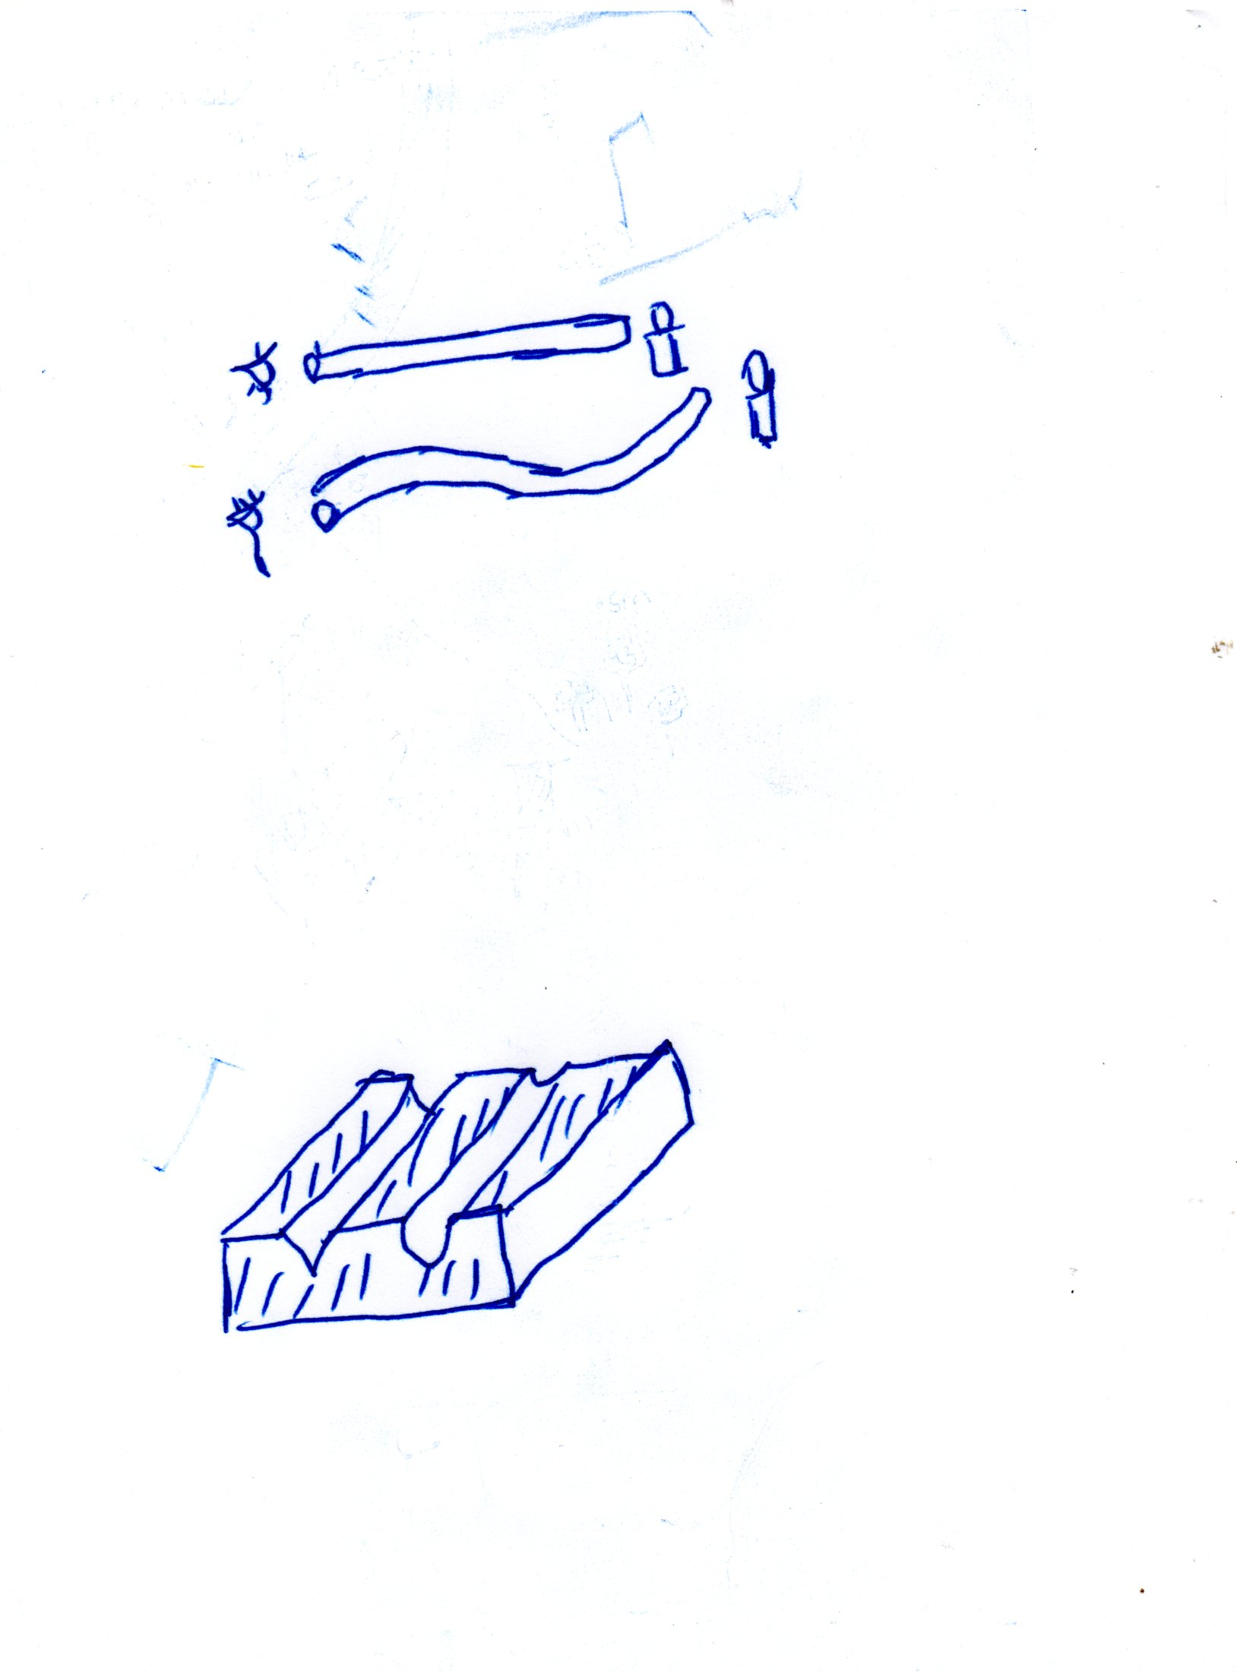

The above experiment show that light _______________________ (1mk)

- In the human digestive system, absorption of water and mineral salts takes place in the (1mk) ____________________________________________________________________________________________________
- Which type of teeth are used for tearing flesh from bones?______________________ (1mk)
- The transfer of heat through solids is called (1mk) _____________________________

- Study the type of teeth shown below
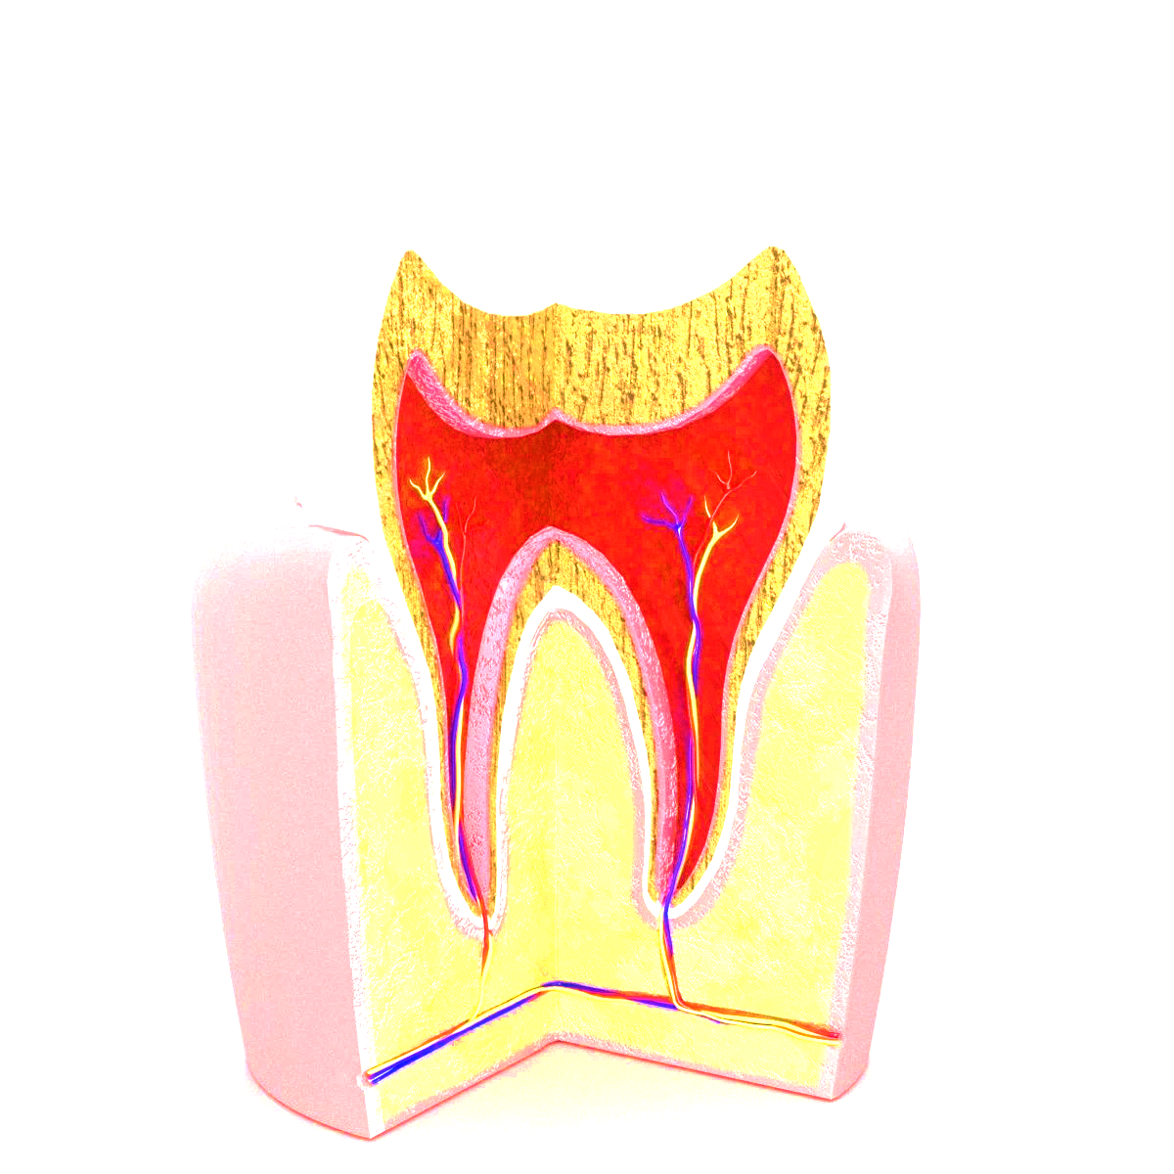
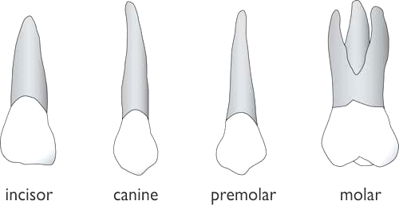

Identify
A_________________________
B_________________________

- Study the diagram of the human digestive system
Y
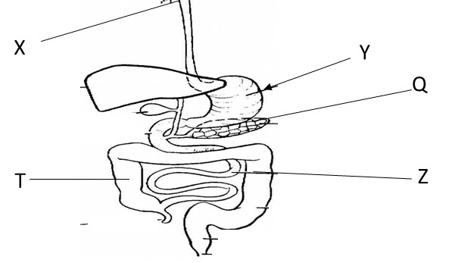
Q
Z

a). Identify the parts labeled
X:______________________
W: _____________________
Y:______________________
b). state the function of the part labelled
Z:_______________________________________
T:_______________________________________

- Below is a human breathing system. (3 marks)
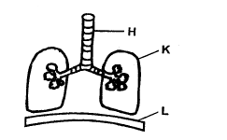
Name the labelled parts.
H - ____________________________________
K - ____________________________________
L - ____________________________________
- State the three states of matter. (3 marks)

- _______________________________
- _______________________________
- _______________________________

