COMPETENCY BASED ASSESSMENT
MONITORING LEARNER’S PROGRESS
GRADE 5 – YEAR 2025
C. R.E
TIME: 2 HR 15 MIN
NAME ………………………………………………………………………………………………………….
LEARNER’S NUMBER ……………………………………………………………………………………….
GENDER: BOY …………………………………………. GIRL ……………………………………
COUNTY NAME ………………………………………… COUNTY CODE ………………………
SUB-COUNTY NAME:………………………………….. SUB-COUNTY CODE…………………
SCHOOL NAME…………………………………………. SCHOOL CODE………………………..
FOR OFFICIAL USE ONLY
The grid below is to be filled by the teacher after marking the learner’s work
 | C.R.E
NUMBER OF MARKS | 25

Assessment Rubric
Exceeds expectation  4 | Meet expectation  3 | Approaching expectation 2 | Below expectation  1

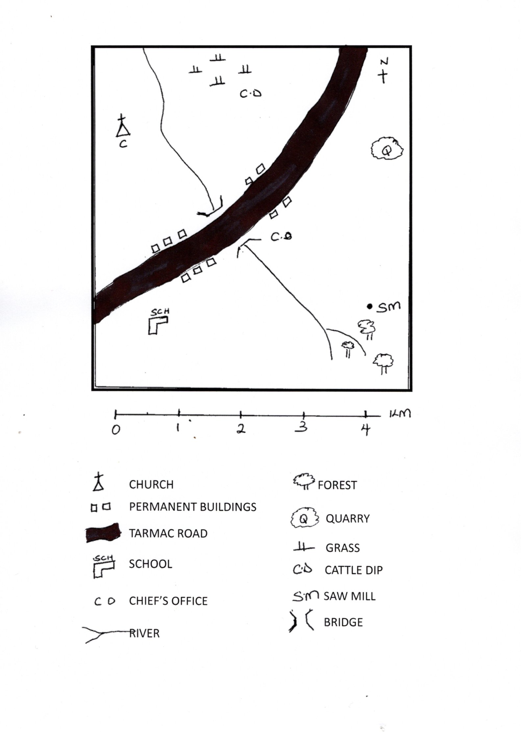
LURAMBI AREA

CHRISTIAN RELIGIOUS ACTIVITIES
- Name three things that the parable of the talents teaches us (3mks)
- _______________________________
- _______________________________
- _______________________________
- Write any two responsibilities given to human being by God (2mks)
- _____________________________
- _____________________________
- Where can you report cases of child labour (2mks)
- _______________________________
- _______________________________
- How did Adam and Eve disobeyed God? (1mk)

- Write down importance of family unity (2mks)
a)_________________________________
b)________________________________
- Name two fruits of the holy Spirit? (2mks)
a)_________________________________
b)________________________________

- Fill in the missing words in the Lords prayer. (2mks)
Our father in _________
May your holy name be honoured
May your _______________come.

- In which city were the believers first called Christians ___________________(1mk)
- Jesus had ___________________ disciples (1mk)

- Name 2 disciples of Jesus (2mks)
a)_____________________________
b)_____________________________

- Write two ways in which we serve God in Church (2mks)
a). ______________________________
b). ______________________________

- Write three things that will make us un holy if we do them _____________(3mks)
____________________________________________________________________________________________________

- Identify one way in which we can show love to your parents or guardians (1mk)
____________________________________________________________________________________________________

- The miracles that Jesus performed by raising the window’s son from the dead shows that Jesus has power over ___________________________________________________________________________________________________ (1mk)

