COMPETENCY BASED ASSESSMENT
MONITORING LEARNER’S PROGRESS
GRADE 5 – YEAR 2025
AGRICULTURE AND NUTRITION
TIME:1HR 40 MIN
NAME ………………………………………………………………………………………………………….
LEARNER’S NUMBER ……………………………………………………………………………………….
GENDER: BOY …………………………………………. GIRL ……………………………………
COUNTY NAME ………………………………………… COUNTY CODE ………………………
SUB-COUNTY NAME:………………………………….. SUB-COUNTY CODE…………………
SCHOOL NAME…………………………………………. SCHOOL CODE………………………..
FOR OFFICIAL USE ONLY
The grid below is to be filled by the teacher after marking the learner’s work
 | AGRICULTURE AND NUTRITION | LEARNER’S SCORE
NUMBER OF MARKS | 25

Assessment Rubric
Exceeds expectation  4 | Meet expectation  3 | Approaching expectation 2 | Below expectation  1

AGRICULTURE
- The process by which soil is removed by wind or water from one place to another is called______________________ (1mk)
- Excess water that flows on the ground surface after raining is called_______________ (1mk)
- Name three places where eroded soil can be deposited. (3mks)
- ___________________________
- ___________________________
- ___________________________
- List two uses of recovered soil.
_____________________________________________________ (2mks)
- Study the diagram below
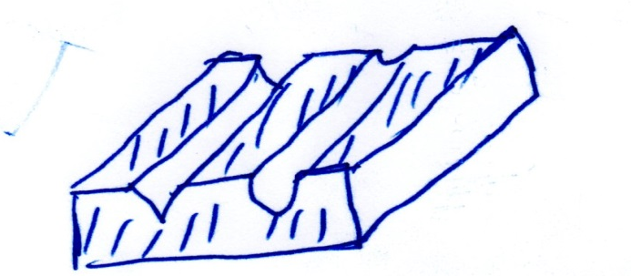

What is happening in the diagram above? (1mk)
______________________________________________________
- Name two tools used when constructing an organic waste pit (2mks)
- _______________________________________________________
- ______________________________________________________

- Give three materials that can be placed in an organic waste pit
- _____________________________________________________
- _____________________________________________________
- ______________________________________________________ (3mks)
- State two uses of water in the farm (2mks)
- _____________________________________________________
- _____________________________________________________
- Give two examples of legumes.
- _____________________________________________________
- ___________________________________________________ (2mks)
- State two factors to consider while siting a nursery bed
- _____________________________________________________
- ___________________________________________ (2mks)
- State two practices done to seedlings in a nursery bed.
___________________________
___________________________________________ (2mks)
- Spreading of dry leaves on the soil to conserve moisture is called _______________________________________ (1mk)

- Name the tools shown below.
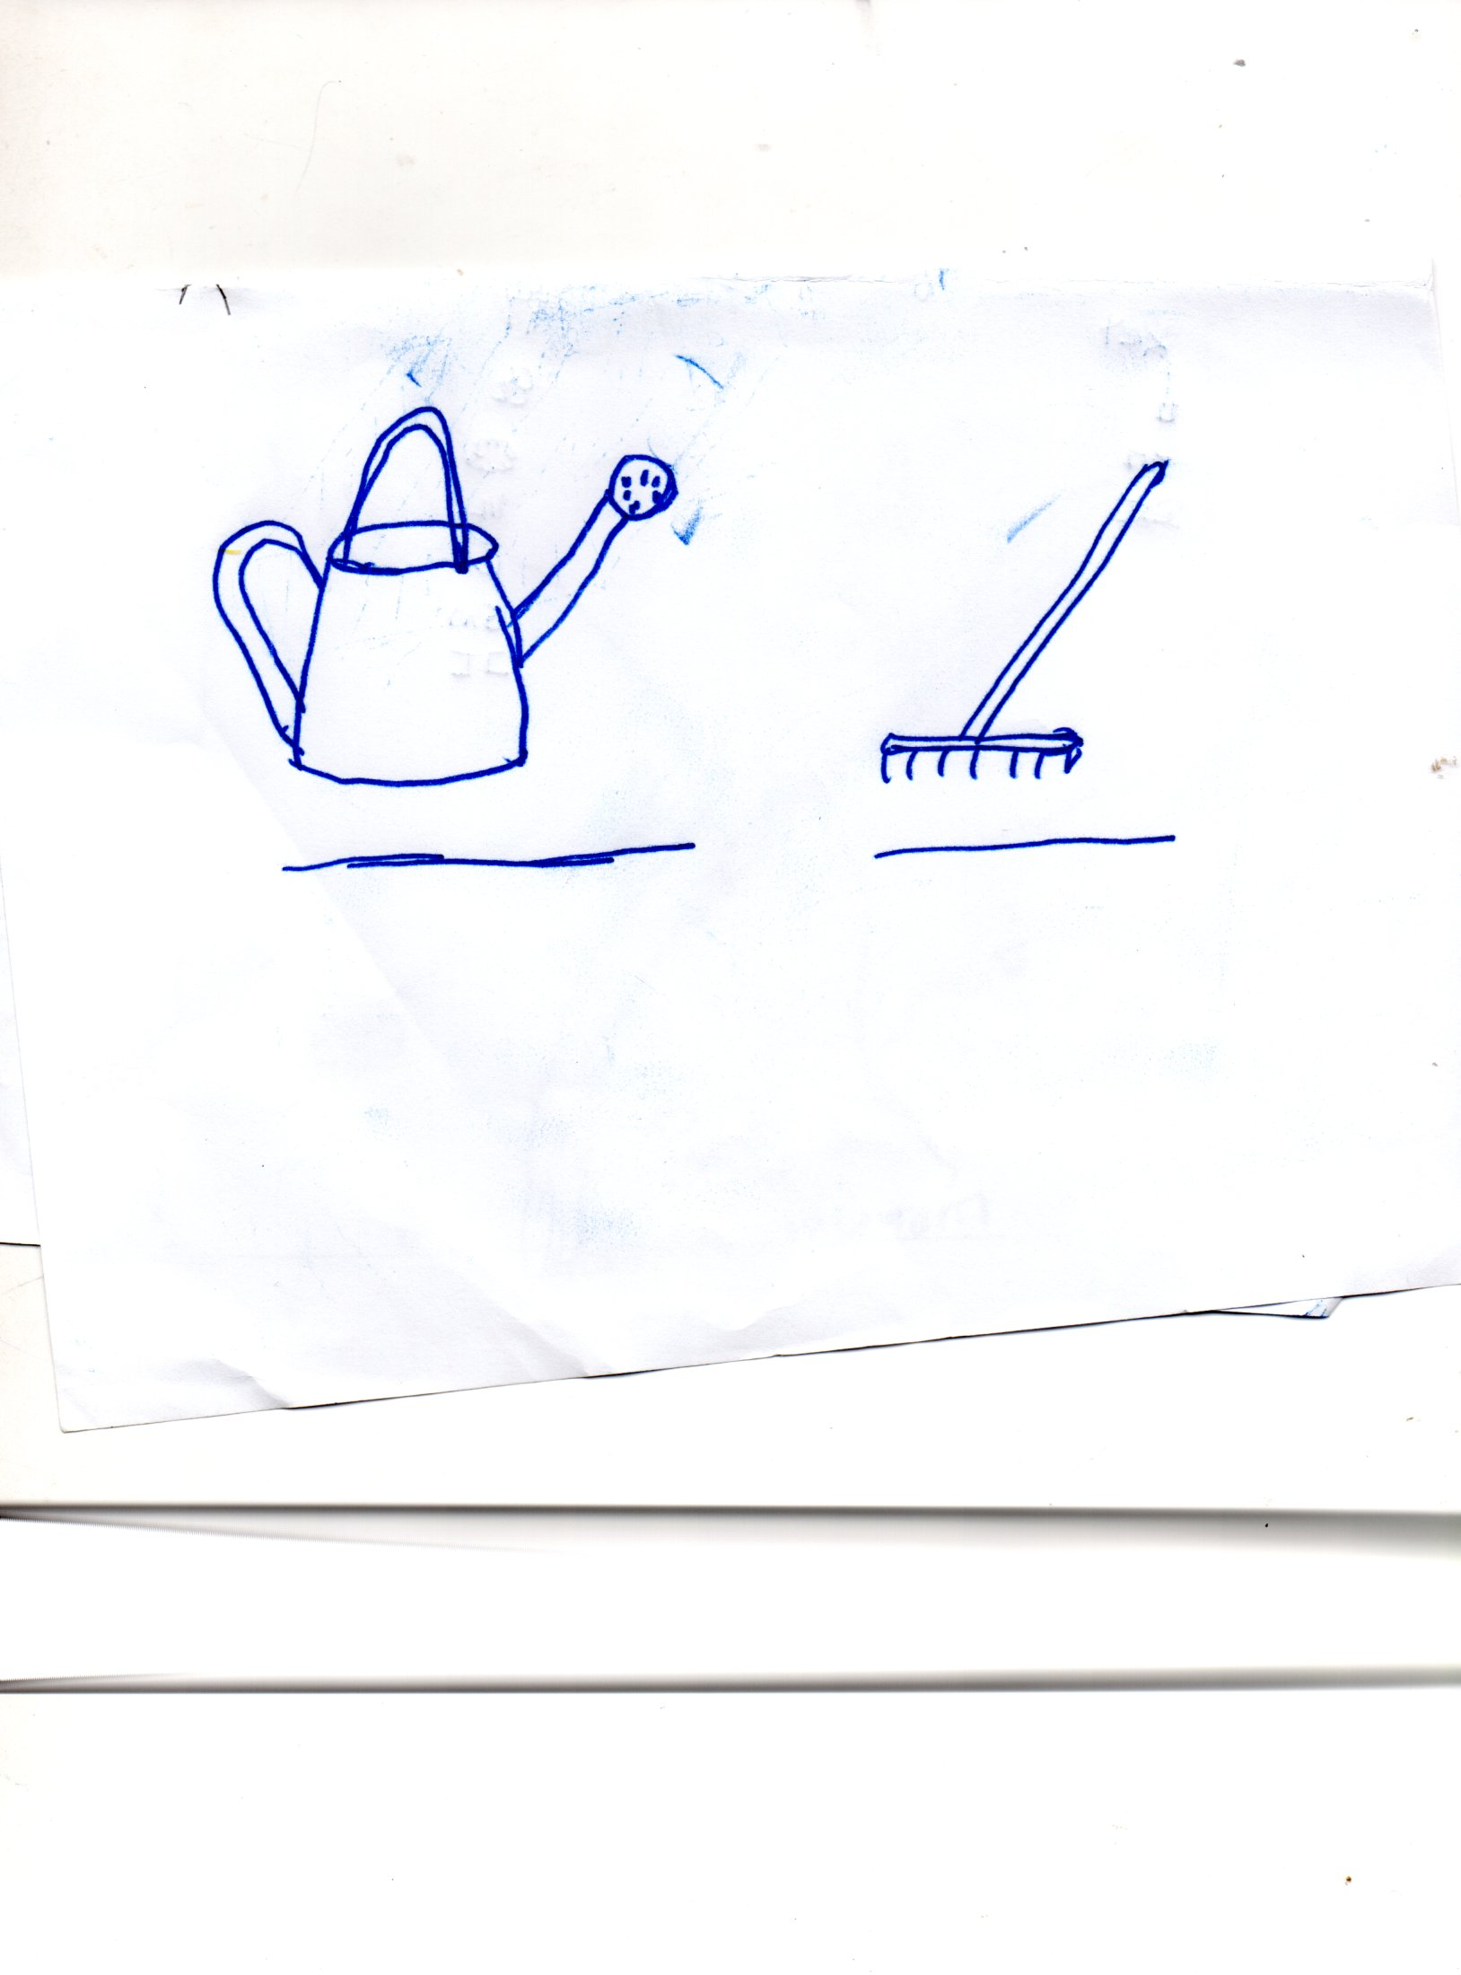

__________________________

- Drip irrigation is used to conserve _____________________________________
- A ______________is a child between the ages of 9 and 12 years (2mks)
- List 2 physical changes that take place in boys and girls.
- ____________________________________________________
- ____________________________________________________
- Draw and name three play items (3mks)

______________________ _____________________ __________________
- List two factors to consider in the choice of clothes for pre-adolescents (2mks)
- _______________________________________________
- _______________________________________________
- Juma was going to school what was he wearing _______________ (1mk)

- Name 3 activities you do during your leisure time (3mks)
- ____________________________
- ____________________________
- ____________________________
- Name 3 ways of preventing the spread of Covid 19/corona virus (3mks)
- _______________________________________________________
- _______________________________________________________
- _______________________________________________________
- Prepare a plan on how to spend time on Saturday (5mks)

- Draw and name three cleaning materials and tools used for cleaning different surfaces in the home(6mks)

- List three needle work tools (3mks)
- _____________________________
- _____________________________
- _____________________________
- Name 3 foods found in your locality that provide us with proteins. (3mks)
- _____________________________
- _____________________________
- _____________________________
- (Draw a person with ………….)
- Which common communication disease is the child suffering from? (1mk)

- The above mentioned disease can be prevented by
___________________________________________________ ________(1mk)
PRACTICAL (CLEANING WOODEN SURFACE)
a). The teacher will guide the learners on the type of surface to clean (wooden surface)
b). The surface should be made of plain wood
c). The surface can be of any size
d). The learners can share cleaning materials
e). The cleaning materials should be improvised as much as possible.
f). The teacher will use the scoring guide provided to assess each learner.
g). The teacher to allow learners enough time to finish the activity.

