NAME:………………………………………………………ADM NO:……………………CLASS:…………..
CANDIDATE’S SIGNATURE:……………………………….. DATE:……………………………………..

CHEMISTRY
FORM THREE
MID TERM 2 2025 EXAMINATION
TIME: 1HR 20MINUTES
INSTRUCTIONS TO CANDIDATES
- Write your name,adm no and class in the spaces provided
- Answer all questions in the spaces provided

1 a) State the Gay Lussac's Law. (1mk)

b) What mass of hydrogen peroxide would be needed to produce 120cm3 of oxygen gas at r.t.p in this experiment? (Molar gas volume at RTP = 24000cm3, H = 1, O = 16) [3 mks]

2 a)Use the information in the table below to answer the questions that follow. The letters do not represent the actual symbols of the elements. 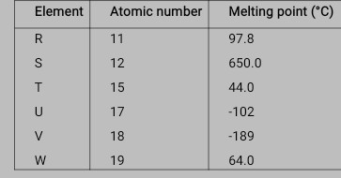
a)Give the reasons why the melting point of:
I) S is higher than that of R (2 mks)

ii)V is lower than that of U. (2mks)

b) How does the reactivity of W with chlorine compare with that of R with chlorine? Explain. (2mks)

c)Write an equation for the reaction between T and excess oxygen. (1mk)

d) i. Define ionization energy. (1 mark)

(ii) Explain why the 1st ionization energy of Al is higher than that of Na. (2mks)

3 The melting point of phosphorous(III)chloride is -91°C while that of sodium chloride
is 801°C. In terms of structure and bonding explain the difference in the melting
point. (2mk)

4. A fixed mass of gas occupies 200 cm3 at a temperature of 230c and a pressure of 740 mm Hg.Calculate the volume of the gas at -250c and 790 mm Hg pressure (3mks)

5) The empirical formula of lead(II) oxide was determined by passing excess dry hydrogen gas over 6.69g of heated lead(II) oxide.
a) What was the purpose of using excess dry hydrogen gas? (1mk)

b) The mass of lead was found to be 6.21g. Determine the empirical formula of the oxide.
(Pb =207.0 0 = 16.0) (3mks)

6)100 cm3 of ozone (O3) diffused through a certain apparatus in 96 seconds. Calculate the time
taken by 100 cm3 of carbon (IV) oxide to diffuse through the same apparatus under same
conditions. (O = 16.0 C = 12.0) (3 mks)

7) Explain why molten calcium chloride and magnesium chloride conducts electricity while carbon tetrachloride and silicon tetrachloride do not. (2 mks)
8) a) The set up below was used on a sample of an iron iii oxide. Study it and answer the questions that follow.

i)Identify the gas Q collected ( ½ mk)
ii) What observation is made on the excess iron (III) oxide? (1 mk)

iii) Write equations for the two reactions that take place in the combustion tube (2mk)

b) Diamond and graphite are both allotropes of carbon explain using structure and bonding why diamond is hard while graphite is soft. (2mk)

c) The diagram below was used by a form I student to prepare a certain gas. Study it and answer the questions that follow.
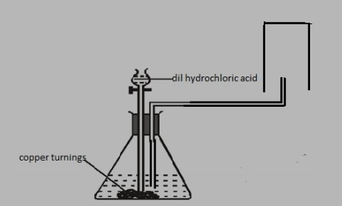
i) Identify two mistakes in the set up above. (2mk)

ii) Identify one of its physical properties apart from its solubility in water and one of its uses (2 mk)

Property-

Use –
d) A student was supplied with a colourless liquid suspected to be water describe one chemical test that could have been used to show that the liquid was water (1½ mk)

9) A student accidentally added potassium chloride into a mixture of zinc oxide and iron (III) chloride. Describe how you can help him obtain pure potassium chloride from the mixture. (3mks).

10) Using dots ( . ) and crosses (X) to represent electrons show bounding in phosphonium ion (PH4+) (2mks)

11) In the manufacture of sodium carbonate by solvay process, ammoniated brine trickles down the carbonator while carbon (IV) oxide rise up.
(a) What is ammoniated brine.(1 mark)
(b) What is the main source of carbon (IV) oxide in the above process.(1 mark)
c) State two recyclable wastes in the solvey process (2 mks)
12) Air is a mixture of different components. Identify;
i)A compound that turn lime water to a white precipitate[1 mk]

ii)A compound that changes cobalt(ii)chloride from blue to pink [1 mk]
iii) A diatomic gas that has triple bond[1 mk]

