NAME………………………………………………..ADM NO…………..CLASS………….

DATE……………………………..SIGN…………………….

FORM TWO
CHEMISTRY
MID TERM 2 2025 EXAMINATION

INSTRUCTIONS: ANSWER ALL QUESTIONS TIME 1HR 30 MINS

- An element W has an atomic number 13.
- Write the electronic configuration of the most stable ion of W ( 1 mark)

- Write the formula of the oxide of the element W (1 mark)

- Study the information in the table below and answer the questions that follow:
Element | Atomic radius (nm) | Ionic radius (nm)
W | 0.114 | 0.195
X | 0.072 | 0.136
Y | 0.133 | 0.216
Z | 0.099 | 0.181
  - Would these form part of a metallic or a non-metallic group? Explain (2 marks)

  - Suggest an element in the table above likely to be the most reactive. Explain (2 marks)

- a) Explain why the metals magnesium and aluminium are good conductors of electricity. (1 mark)

( c) Other than cost, give two reasons why aluminium is used for making electric cables while magnesium is not ( 2 marks)

- (i) What is an isotope? ( 2 marks)

(ii)An element Q consists of 3 isotopes of mass 28, 29, 30 and percentage abundance of 92.2, 4.7, 3.1 respectively. Determine the relative atomic mass of the element? (3 marks)

- Explain the trend in atomic radii across period 3 elements (2 marks)

- (i) Define electrovalent bond (2 marks)

(ii) Using a dot and cross diagram show how ionic bind is formed in magnesium oxide (3 marks)

- Use the grid below to answer the questions that follow the letters do not represent the actual symbols

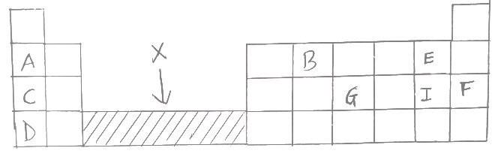

- (i) Which group of the periodic table do the elements A,C and D belong.Explain (2 marks)

(ii) Give with a reason the most reactive element for the elements A,C,D above (2 marks)

- Write the formula for the ion of B (1 mark)

- Select an element which is stored under water in the laboratory (1 mark)

- (i) How do the ionic radii of E and I compare (1 mark)

(ii) Select the most reactive non metal. Explain (2 marks)

- Identify the element that does not form a compound (1 mark)

- (i) what is the name given to elements in the region X (1 mark)

(ii) Give two reasons why Helium is used in weather balloons (2 mark)

- Oxygen is obtained on the large scale by the fractional distillation of air as shown on the flow chart below

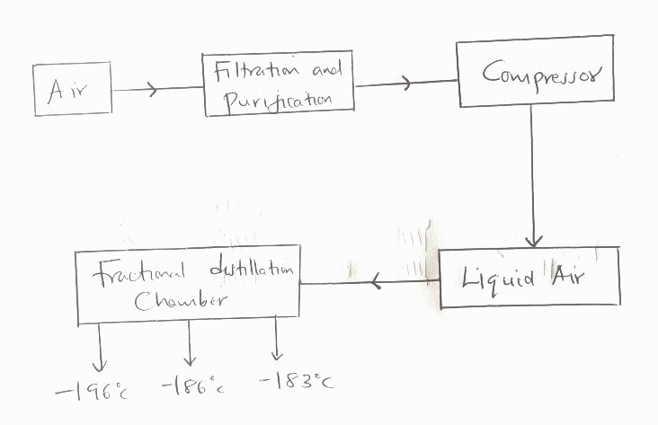

- Identify the substance that is removed at the filtration stage (1 mark)

- Explain why carbon (iv) oxide and water are removed before liquefaction of air (1 mark)

- Identify the component that is collected at -186ºc (1 mark)

b) (i) complete the diagram below to shows a set-up used to prepare oxygen gas (2 marks)

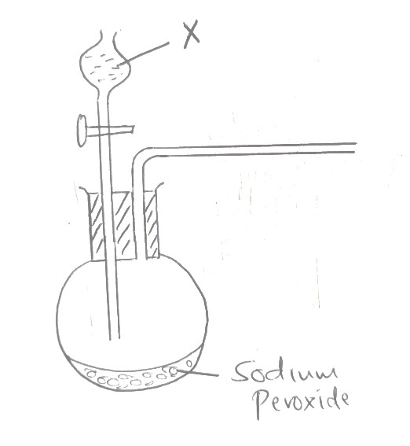
(ii) Name substance X (1 mark)

(iii) Write a well balanced chemical equation to show the reaction of sodium peroxide with the substance named above (2 mark)

- The set-up below is used to investigate the properties of Hydrogen gas

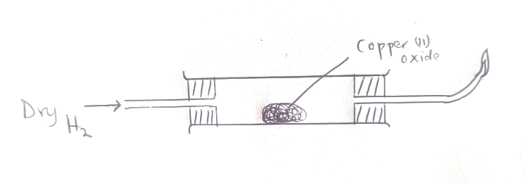

- On the diagram indicate what should be done for the reaction to occur (1 mark)

- Hydrogen gas is allowed to pass through the tube for sometime before it is lit. Explain (1 mark)

- Write an equation that takes place at the combustion tube (1 mark)

- What property if hydrogen is being investigated (1 mark)

- Why is Zinc oxide not used to investigate the property of hydrogen gas (1 mark)

- Use the table below to show the pH for the following

SOLUTIONS | pH
A | 2.1
B | 13.0
C | 7.0

Which letter represents
- NaOH (1 mark)

- H₂SO₄ (1 mark)

- MgCl₂ (1 mark)

