233/2
MARKING SCHEME

- It can react by losing one electron √
It can react by gaining one electron √
- J/ Mg √

- Amphoterism √
- Zinc/ lead √
- Atomic radius of element E is greater √ than that of element G. There is greater effective nuclear attraction in G than in E.
- $\frac{t1}{t2}=\frac{\sqrt{M1}}{\sqrt{M2}}$
$$\frac{50s}{t2}=\sqrt{\left(\frac{28}{64}\right)}$$
t2 = 75.59295s

- Down the family, strength/ number of van der Waal forces increases due to increasing molecular masses
- In arc welding as an insulator

- An acid that ionizes completely in solution yielding many hydrogen ions as the only positively charged ions.
- N. – Less heat is released when a weak acid is neutralized. Part of the heat is used for the complete ionization process.
- Heat absorbed = mc∆T
=(0.1kg* 4200J/kg.K* 2K)
= 840 J
2g 0.84kJ
80g $\frac{80g*0.84kJ}{2g}$
= + 33.6 Kj/mol

- H₂O_{2(l)} ^{x} H₂O_{2(g)}

-188 -133Kj/mol
Kj/mol

H_{2(g)} + O_{2(g)}
-188 kJ/mol + x = -133kJ/mol
X =(-133 + 188) kJ/mol
= +55 kJ/mol
Accept use of energy level diagram or addition of equations

- Iron (III) chloride
- Unreacted hydrogen chloride which is an acidic gas neutralized sodium hydroxide. Excess gas made the resulting solution acidic.
- It is less volatile and displaces hydrogen chloride a more volatile acid from sodium chloride

- Air is passed through NaOH to remove CO₂
- Air is then cooled to -25℃ to remove water
- Through repeated compression and expansion, air is cooled to liquid at -208℃
- Through fractional distillation, oxygen is separated from nitrogen and argon

- Concentrated sulphuric (VI) acid
- H₂SO_{4(l)} + SO_{3(g)} H₂S₂O_{7(l)}

- Platinum// platinum asbestos
- It is not easily polished
It is cheap
- Used in car batteries
Used in manufacturing detergents
Used in manufacturing of fertilizers
Used in manufacturing of synthetic polymers

- Prop-2-yne
- Butane
- Ethyl propanoate

- B
- They are biodegradable hence prevent pollution

- U- potassium ethoxide
X- carbon (IV) oxide
Y- Ethyl hydrogen sulphate
- Hydration/ hydrolysis

- Concentrated sulphuric (VI) acid
- Temperature range 160 – 180⁰C and excess
Concentrated sulphuric (VI) acid
- Leads to environmental pollution since it’s non-biodegradable

- Liebig’s condenser
- Increases surface area for condensation thus enhances efficiency of separation of the mixture
- The two liquids have different but close boiling points
- Methanol – this is because it has a lower boiling point

- Pure- the transitional temperature from one state to another is constant
- Water molecules absorb heat and gain kinetic energy
- Water molecules absorb heat and is used to break bonds existing between molecules thus no rise in temperature

- Rain water mixes with carbon (IV) oxide forming weak carbonic acid (H₂CO₃). Weak carbonic acid reacts with limestone (calcium carbonate [CaCO₃]). This forms calcium bicarbonate which is calcium hydrogen carbonate (Ca(HCO₃)₂

ii.) Half reactions:
M M²⁺_{(aq)} + 2e⁻ ;E^{θ} =+ 0.76V
2P⁺_{(aq)} + 2e⁻ P_{(s)} ; E^{θ} = + 0.80V
Voltage = (+0.76+0.80)V
=+1.56V
- M_{(s)}
- 2Q⁺_{(aq)} + N_{(s)} 2Q_{(s)} + N²⁺_{(aq)}
Reaction potential = -0.14V + 2,37V
= 2.23V
The reaction would occur. It is not possible to store QNO₃ in a container made of N. the container would corrode/ react with the content.

- Al³⁺_{(aq)} + 3e⁻ Al_{(S)}
- 0.27 = 3F
1800kg = $\frac{1800kg*3F}{0.27kg}$
= 200,000F

- Carbon (IV) oxide produced escapes from the open beaker.
- 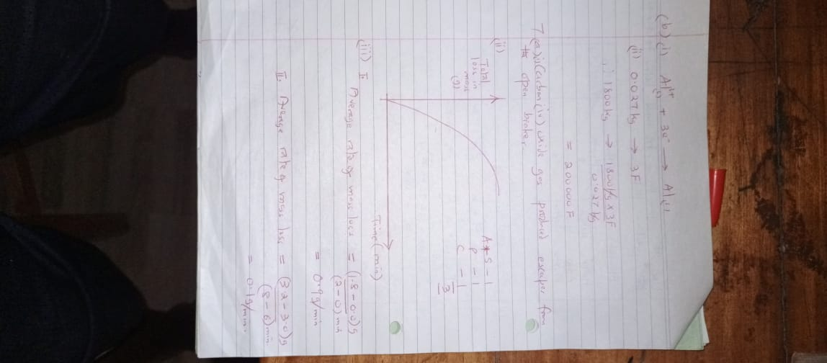
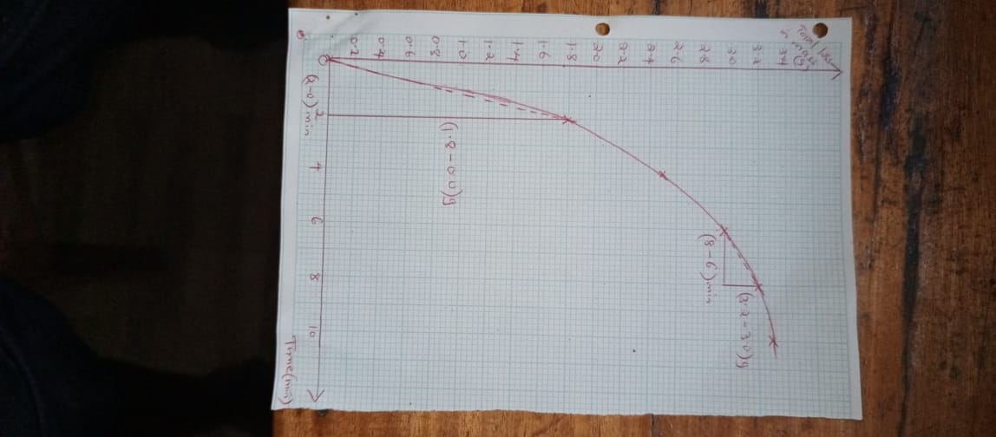

- Average rate of mass loss =$\frac{\left(1.8-0.0\right)g}{\left(2-0\right)min}$
= 0.9 g/min
- Average rate of mass loss =$\frac{\left(3.2-3.0\right)g}{\left(8-6\right)min}$
= 0.19 g/min
- In (I) the rate of loss of mass is higher than in II. Acid concentration and mass of zinc carbonate is higher in I than in II.

- Curve I. rate of reverse reaction increases as the amount of products increases with time.
- ‘q’ – equal rate of forward and reverse reactions
- ‘r’ – time when the reaction has attained equilibrium

