MARKING SCHEME
1 a) Importance of entrepreneurship to an economy.
- Creation of employment opportunities since the enterprises formed will require human labour hence reduce the unemployment problem
- Leads to formation of small business which leads to development of skills
- Increases participation of Kenyan citizens in economic activities thus reducing foreign dominance.
- Leads to increase in savings and investments by local Kenyans which encourage use of local resources which would have remained idle.
- Leads to development of small scale business in rural areas hence alleviating the problems of rural to urban migration.
- Small scale business helps in distribution of income in the society as the successful entrepreneurial ventures encourages other people to start their own.
- Entrepreneurship improves standards of living since most of the people are engaged in employment. Any 5 x 2 =10mks
b) sources of finance to the government include
i) Taxes / duties levied on imports / exports
ii) Fines imposed by courts on offenders
iii) Rent / rates paid for the use of govt. property.
iv) Licence fees paid by those who want to operate business.
v) Dividends / profits earned from govt. investments
vi) Proceeds from sale of govt. property
  - Interests on loans advanced by the govt. on firms.
  - Government internal / external borrowings
  - Grants / Aids received by the government.

Any 5 x 2 =10mks

2.a Difference between a private limited company and a public corporation
Public corporation | Private limited company
It is formed by an act of parliament | It is formed under the company’s act
It is not profit – motivated provides services to the general public. | It is profit motivated
It is financed by the government | Capital is raised through the sale of shares
Board of directors is appointed by the government | Directors are elected by shareholders
Losses are subsidized / borne by the government | Losses may lead to collapse of business
It is owned by the government | It is owned by shareholders

Any 5 x 2 =10mks no splitting
Maendeleo traders
Trading profit and loss account
For the period ending 31st – 12 – 2024

Opening stock 6000  Purchases 88,000  Return out 2,800  Carriage in 1000  Net purchase 86200 C.O.G.A.S 92,200  Closing stock 4,000 C.O.G.S 88,200  Gross profit 9,800  98,000  Discount allowed 2,200  Sundry expenses 4,000  Postage 800  Stationery 1200  Net profit 9,500 | Sales 100,000  Return –in 2,000  Net sales 98,000  98,000  Gross profit 9,800  Commission earned 3,500  Discount received 4,400
17,700 | 17,700

- Mark – up GP = 9800 × 100 = 11.11%
COGS 88,200
- ROSTO = COGS = 88200
AS 6000 + 4000 = 17.64 times
2
3a) Negative effects of an increasing population include
- Dependency burden: When increase of population is caused by new births and elederly
people living longer, a big proportion of population is to be supported by the few working adults.
- Low living standards: The standard of living usually decline because of the level of savings declining.
- Unemployment: With rapid increase in population, the majority of the people are young and therefore dependants.
- Social problems: Due to overcrowding in the residential areas which is caused by a rapid increase in population, social problems such as housing, pollution, crime e.t.c.
- Food shortages: Population increase can outdo the rate of food production.
- Strain on social amenities: Rapid population growth creates strain on social facilities e.g. schools, hospitals e.tc. Any 5 x 2 =10mks

3b)
price
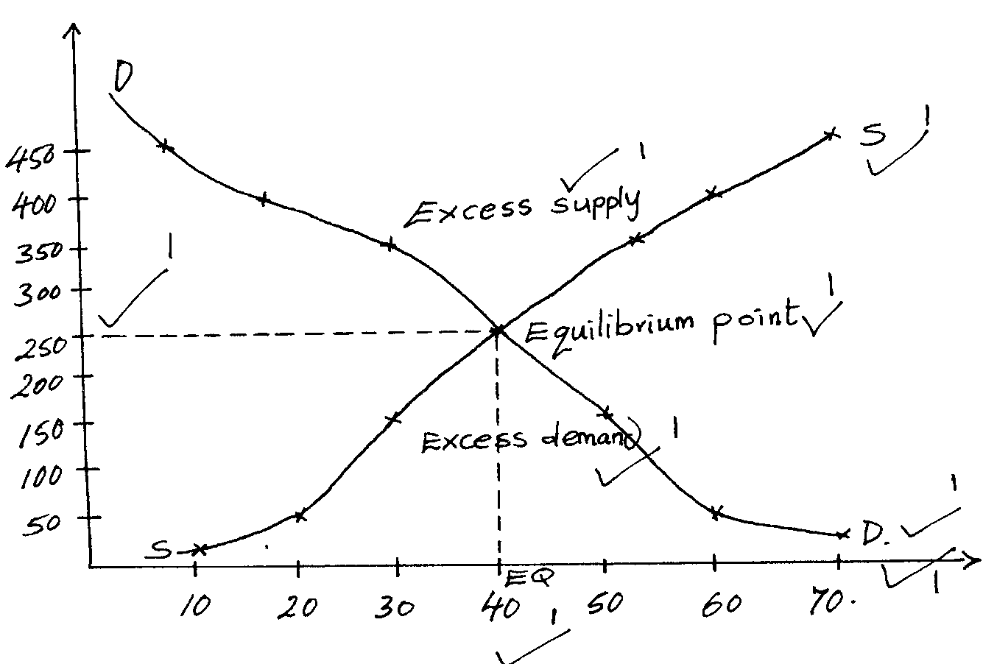
EP
quantity
Equilibrium price = 250
Equilibrium quantity demanded and supplied = 40
Award as follows:-
Equilibrium price (250) 1 mk
Equilibrium quantity (40) 1 mk
Supply curve 1 mk
Demand curve 1 mk
Excess supply 1 mk
Excess demand 1 mk
Equillibrium point 1 mk
Use of correct scale 1 mk

4.a) Ways in which the central bank of Kenya regulates the operation of commercial bank in Kenya.
a) i) Bank rate
By varying the bank rate, the central bank gives an indication to the commercial banks as to the rates and interests to charge to their customers
- Cash or liquidity ratio
By varying the cash or liquidity ratio, the bank may either increase or decrease credit expansion
- Special deposits/ compulsory deposits
By calling for special deposits from commercial banks, it reduces the cash base for them, and therefore reduces their ability to lend
- Selective credit control/ credit rationing
The central bank can determine the ceiling or priority sectors where the lending has to be channeled
- Direct supervision/ instruction
The central bank can direct supervision of commercial banks, to ensure that they follow the laid down regulations
- Open market operations
The central bank buys and sells treasury bills, to increase or decrease the lending ability of commercial banks
- Moral persuasion ;Under special circumstances, the central bank may persuade commercial banks to regulate their lending habits
Any 5 x 2 =10mks
4b) Merits of using road instead of railway transport.
- Road is faster than railway which is slower, so he can deliver his goods (maize) in good time to avoid damage.
- If the farmer has small quantity of maize to transport, it could be more convenient to transport by road.
- Road is flexible in that maize can be collected at his door-step or delivered at door step of the same.
- No fixed time or schedule and therefore collection / delivery can be done conveniently to both parties.
- The farmer can consider owning/ hiring his own trucks and Lorries hence he can have more control over transport problems
- Due to fewer time in offloading in road transport chances of loss/damage/pilferage are minimized or cost of handling is minimized.
Any 5 x 2 =10mks
5 a) Reason for government involvement in business activities in the country
- To prevent exploitation of the public by private investors especially in the provision of essential services.
- To provide essential goods and services especially in areas where the private sector are unwilling due to possible low profits or high risk.
- To create employment opportunities in the country.
- To prevent foreign dominance of the economy by investing in areas where the locals are not able to.
- To provide essential services which the private firms are unable due to large initial capital required.
- To attract foreign investments by initiating major business projects
- To provide goods and services which are too sensitive to be left in the hands of private sector
- To stimulate economic development in the country
Any 5 x 2 =10mks
b) Three column cash book
Date | Particulars | Folio | Disc | Cash | Bank | Date | Particulars | Folio | Disc. | cash | Bank
Jan 1 | Balance b/d |  |  | 4,000 | 27,000 | Jan 4 | Olweny T |  | 480 |  | 7,520
Jan 8 | Mutoma |  |  | 6,000 |  | Jan 16 | Bank |  |  | 4,500
Jan 16 | Cash |  |  |  | 4,500 | Jan 24 | Drawing |  |  |  | 9,200
Jan 29 | Kawawa |  | 1050 |  | 19,950 | Jan 31 | Bank | C |  | 4,000
Jan 31 | Cash | c |  |  | 4000 |  | Bal. c/d |  |  | 1,500 | 38,730
 |  |  | 1050 | 10,000 | 55,450 |  |  |  | 480 | 10,000 | 55,450
 | Bal. b/d |  |  | 1,500 | 38,730
N/B particulars should be correctly recorded.
6. a) Factors that influence decision on goods and services to produce include
i) Demand patterns:- If a commodity has a demand, it will certainly be produced
ii) Profitability of the venture:- The business can only continue with those products that yield some profits
- Level of competition:- Young firms produce goods whose competition is minimal
- Government policies:- The government encourage or discourage the production of certain goods and services
- Economic factors:- e.g. state of inflation, size of national income, income distribution e.t.c.
- Availability of technology:- Appropriate technology determine what goods or services a firm can produce
- Social cultural factors:- These factors have to do with the peoples core beliefs and attitudes
- Availability of factors of production:- e.g. land, capital, labour and entrepreneurship
- Environmental issues:- Production process should not pollute the environment
- Cost of production
- Amount and type of capital in the business – financial and physical capital facilitates the production process
Any 5 x 2 =10mks
b) Circumstances under which insurance contract may be terminated include;
- When the insured fails to renew the contract.
- When the insurance company is finally wound up
- When the policy matures thus signifying the end of the policy arrangement
- If the insured decided to discontinue the contract thus stopping to be party to the contact
- Where the insured ceases to have insurable interest in the property i.e. incase the property is sold
- When the insured has not acted in utmost good faith and is discovered
- When the court of law of orders termination of contract thus rendering it null and void
- When the risk insured has occurred and compensation period thus bringing an end to the contract.
Any 5 x 2 =10mks

