Name: _____________________________________________ Adm No: ____________Class: _____
Candidate’s Signature: ________________________ Date: __________________________

BIOLOGY FORM 4
TERM 2 2025 MID TERM 2 EXAMINATION TIME: 1 HOURS: 15 MINUTES.

Instruction: Answer all questions in the spaces provided.

- Equal amounts of crushed Irish potato was placed in equal volumes of hydrogen peroxide solution at indicated pH. The volume of the gas produced was measured and recorded as shown in the table below.
Ph | 4.0 | 7.0 | 9.0
Volume of gas (cm³) | 2.7 | 5.7 | 7.7

(a) Name the gas that was produced. (1mark)

(b)Account for the difference in the volume of the gas produced in pH 4.0 and pH 9.0 (2marks)

- . (a) A dog weighing 15.2kg requires 216kJ while a mouse weighing 50g requires 2736 kJ per day.
Explain (2marks)

(b) Under what condition is lactic acid formed in human muscles? (1mark)

- . Use the graph below to answer the following questions.


- Why does the activity of the enzyme become constant after a while? (1mark)

(b) State how the activity of the enzyme may be increased in (a) above. (1mark)
- . The diagram below shows an apparatus used during collection of specimen or biological study.
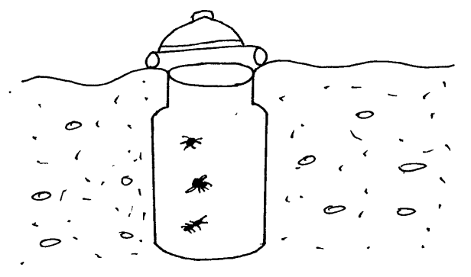

- Identify the apparatus? (1mark)

- What is the use of the apparatus named above? (1mark)

- List three limitations of fossil records as an evidence of organic evolution? (3marks)

- in mitosis in animal’s chromatids failed to separate and move to opposite poles
a) Name the organelle that the cell was lacking (1 mark)

b) Name one region in plants where cells actively undergo mitosis (1 mark)

- Below is a nucleotide strand
A A G T C

- Identify the type of nucleic acid (1 mark)

- Give a reason for your answer in (a) above (1 mark)

- (a) What are analogous structures? (1 mark)

(b) State comparative embryology as an evidence of organic evolution. (3 marks)

- State two reasons why biomass decreases as you move from a lower to a higher tropic level. (2 marks)

- In human beings, a downward pointed frontal hairline (“windows peak”) is a heritable trait. A person with windows peak always has at least one parent who has this trait; whereas persons with frontal hairline may occur in families in which one or even both parents have windows peak. Using B and b to symbolize genes for this trait.

a) Determine the F1 generation if a homozygous windows peak male parent is married to a
Homozygous frontal hairline female parent. (4 marks)

- State two advantages of natural selection. (2 marks)

- What are alleles? (1 mark)

- a) What is meant by the term vestigial structures? (1 mark)

- Name the type of evolution illustrated by (2 marks)
(i) Hind limbs of birds
(ii)Wings of birds and insects

- With reference to circulatory system only give two reasons why birds and mammals are more active compared to other organisms? (2 marks)

- Define the term parthenogenesis. (1 mark)

- Define the following terms. (4 marks)
- Genetic engineering.

(ii) Gene mapping.

- Heterosis.

- Gene sequencing.

- (a)What type of variation is exhibited by human beings having blood group A, B, AB or O. (1 mark)

(b) The paddles of whales and fins of fish adapt these two organisms to aquatic habitats;
Name the evolutionary process that may have given rise to such similar structures.

(1 mark)

(c) What name is given to such structures? (1 mark)

- (a) What is meant by the term sex-linkage? (1 mark)

- State the first law of inheritance. (2 marks)

- State the role of the following bacteria in the nitrogen cycle. (2 marks)
(a) Nitrosomonas

- Nitrobacter

- Name two disorders in humans caused by gene mutation. (2 marks)

