NAME: ……………………………………………………… ADM NO: ………….. CLASS: ………………..
FORM THREE BIOLOGY
MID TERM 2 EXAM - JUNE 2025

Answer all the questions in the spaces provided.

1. What are the main characteristics of kingdom protoctista. (3 marks)

2. Name the spore producing structures in (3 marks)
(a) Bryopyte –
(b) Pteridophyta –
(c) Fungi –
3. Study the figure below.

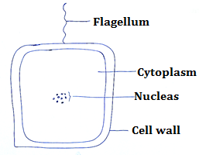

(a) Identify the organism. (1 mark)

(b) Give the name of the kingdom to which the organisms belongs. (1 mark)

(c) State two characteristics of the members of organisms in the kingdom you have mentioned in (b) above. (2 marks)

4. Write four differences of plants in the class monocotyledonae and class dicotyledonae

Monocotyledonae | Dicotyledonae

5. Name the main method of reproduction among bacteria. (1 mark)

6. Given the following organisms in a dam, construct a possible food chain for the dam.
Small Fish, mosquito larvae, microscopic algae large fish

7. Name two kidney diseases. (2 marks)

8. Why are plants able to accumulate most of the waste products for long? (1 mark)

9. Name three methods used by plants to excrete their waste productions. (3 marks)

10. State the conditions in human beings that results to the following:-
(i) Production of large quantities of dilute urine. (1 mark)

(ii) Release of aldosterone hormone (1 mark)

(iii) Release of glucagon hormone. (1 mark)

11. Name the class in the phylum arthropoda which has the largest number of individuals. (1 mark)

12. State two characteristics of fungi. (2 marks)

13. Give a sample of urine, name one test you would carry out to determine if it was obtained from a person suffering from diabetes mellitus. (3 marks)

14. Give a classification of a housefly by filling the table below. (3 marks)

Kingdom
Phylum
Class

15. State the changes that occur in arterioles in the human skin during thermoregulation. (2 marks)

16. Giving a reason in each case, name the class to which each of the following organisms belong. (4 marks)
Bean plant –
Reason –

Bat –
Reason –
17. State the use of Colchicine (1 mark)

18. Study the plant leaves than answers the questions that follow.

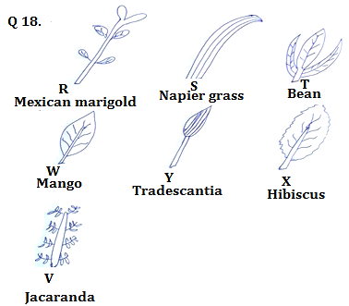

(a) Construct a possible dichotomous key to identify the leaf specimens. (3 marks)

(b) State the steps followed to identify the leaf specimens. (7 marks)

Steps followed | Identity

19. The following organisms were found in a grassland habitat.
Organism | Abundance
Insects | 3,500
Snakes | 8,900
Green plants | 12,000
Mongoose | 950
a) Construct a pyramid representing representing the order of feeding in the grassland. (4 marks)

