FORM 2 BIOLOGY
MID TERM 2 EXAM - JUNE 2025

1. Explain the following terms.
- Taxonomy(1 mark)
The science of classification

- Species(1 Mark)
Group of organisms whose members naturally interbreed to produce fertile offsprings

- State two main functions of a microscope.(2marks)
Magnification
Resolution

- State two functions played by the cell wall in plant cells and give the adaptation of the cell wall to performing each of the stated functions. (4 marks)

Function | Adaptation
Provides structural support | made up of cellulose
Allows exchange of materials | Fully permeable

- The experiment illustrated below was set up to investigate a certain physiological process using a raw tuber
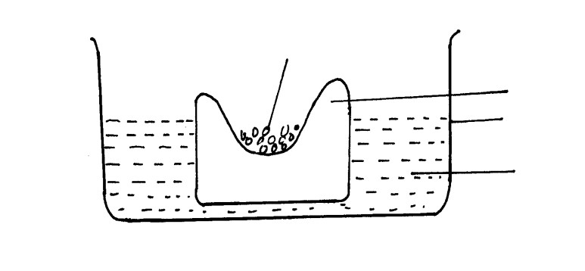

)
(
a
Suggest the physiological process that was being investigated.

(1
mark
)

Raw potato tuber

Trough

Distilled
water

Concentrated glucose
solution

Osmosis

(b)Explain the results obtained in the above experiment after a few hours(2 marks)
The glucose solution increased while the water level in the trough decereased.Water enters by osmosis into the potato tuber.

(c)State the observations that would have been made if the experiment was repeated using boiled potato.
(2 marks)
The water level remains the same in the trough and the glucose solution remains the same; No osmosis occurs sine the cell membranes of the potato cells are destroyed

- (a)State two importance of active transport in living organisms(2 marks)

Reabsorption of sugars and useful substances by the kidney
Absorption of mineral salts by plant roots.

(b)Why is oxygen concentration important in active transport?(1 mark)

Oxygen is important in formation of energy which is required in active transport

- What is the significance of each of the following in photosynthesis?
- Chlorophyll in the leaf(1 mark)
Traps light for photosynthesis

  - Stomata on the leaf surfaces(1 mark)

Allows for entry of carbon (iv) oxide and oxygen gas

  - Leaf midrib and veins(1 mark)

Leaf veins contain xylem and phloem(xylem transports water and mineral salts to the photosynthetic cells while phloem translocates manufactured food from the leaves.

- Name the form in which carbohydrates are stored in.(2 marks)
i). Plants tissues
Starch

ii). Animal tissues
Glyocogen

- An animal has the following dental formula

I 3 c 1 pm 4 m 2 3 1 4 3

  - Calculate the number of teeth. (1 mark)
42(show working)

  - Explain what would result from blockage of bile duct. (2 marks)
Impaired digestion of fats; emulsification is impaired

- The diagram below shows how food boles move along the human esophagus and the Intestine

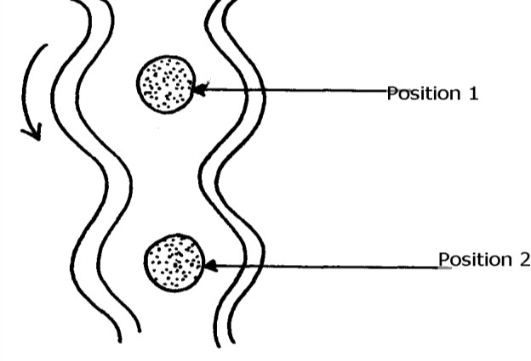
(a) Identify the process illustrated in the diagram (1 mark)
Peristalsis

(b)Name one component of a person’s diet that assists in the movement of food described in from position 1 and position 2 (1 mark)
Roughage

- The table below show the percentage composition of carbon (IV) oxide and oxygen inhales and exhales air
Gases | Inhaled air | Exhaled  air
Oxygen | 20% | 17%
Carbon  (IV) oxide | 0.04% | 4.0%

Explain the differences in the percentage of the two gases in inhaled and exhaled air.(2 marks)
. Exhaled air has less oxygen because some of the inhaled oxygen has been used in the tissues for respiration; exhaled air has more carbon (iv) oxide than inhaled air; respiration produces carbon (iv) oxide as a waste product

- The table below shows the energy use per day in kilojoules
Age(years) | Male | Female
2 | 5,500 | 5,500
5 | 7,000 | 7,000
8 | 8,800 | 8,000
11 | 10,000 | 9,200
14 | 12,500 | 10,500
18 | 14,200 | 9,600
25 | 12,100 | 8,800
a). From the table, explain why after age 8 males require more energy than females.(1 mark)
Males are more muscular; muscle tissues use more energy

b). Other than sex and age, name two other factors that determine energy requirements in human beings.(2 marks)
Basal metabolic rate
Occupation

12.  Single circulation-blood flows once through the heart for a complete circulation  Double circulation-blood flows twice through the heart for a complete circulation | a). Distinguish between single and double circulatory system |  | (2mark)
 | (b)  Thrombosis; arteriosclerosis | Name two defects of the circulatory system in humans. | (2 marks)
 | (c) | State two functions of blood other than transport. Regulation of body PH  Distribution of heat | (2 marks)
13. State two adaptations of xylem to water transportation |  |  | (2 marks)
Narrow to enhance cappilarity
Lignified to provide support

. The graph
14
below

show
the effect of temperature on an enzyme catalyzed reaction.

•

•

•

X

B

C

A

D

Rate of

Reaction

Temperature

(a) Account for the shape of the curve between.
    - A and B. (3 marks)
The rate of the reaction increases steadily as the temperature approach the optimum point.Enzymes work best within a narrow range of temperatures

    - C and D. (2 marks)
The rate of reaction drops;high temperatures denature enzymes

(b)What does the point marked X represent? (1 mark)
Optimum temperature;maximum rate of reaction
(c) Apart from temperature, state two other factors that affect the rate of enzyme controlled reaction(2 marks)
Substrate and enzyme concentration
Ph

14. (a)Distinguish between the terms homodont and heterodont. (1mk)
Homodonts-have teeth of same size and shape
Heterodonts-have teeth of different size and shapes

- What is the function of carnassial teeth? (1mk)
Tearing flesh from bones

- A certain animal has no incisors, no canines, 6 premolars and 6 molars in it’s upper jaw. In the lower jaw, there are 6 incisors 2 canines, 6 premolars and 6 molars. Write its dental formula.(1mk)

(i)0 (c)0 (pm) 3 (m)3
3 1 3 3

