MARCH /APRIL 2025 EXAMINATION
231 / 3
BIOLOGY
PAPER 3
MARKING SCHEME
- (a)(i)
 | Colour of content in visking tubing
Start of experiment | Clear / white / colourless;
End of experiment | Blue black
2marks
ii) Visking tube is semi – permeable; iodine molecules being small; moved from the beaker to the visking tubing by diffusion; reacting with starch hence the blue black colour; 3marks
Or
Starch molecules are large; hence cannot pass through the pores of visking tubing into the beaker; thus the colour of solution in the beaker remained unchanged;
iii)Diffusion Acc.Selective permeability/differential permeability; 1mark
iv) To remove traces of solution F; 1mark
v) (a) S – Ptyalin / salivary amylose; 2marks
R – Maltose;
(b) P – Glucose; 2marks
Q – Maltose;
vi) Polysaccharides; 1mark
2(a)(i) 6marks
1a Leaf simple ...................................go to 2
b Leaf compound............................. F
2 a Leaf network veined......................go to 3
b Leaf parallel veined........................E
3 a Leaf with entire / smooth margin...........H
b Leaf with serrated margin.....................G
Conditions
- Dotted lines must be present
- The term (go to) must be present in 1a,2a
- Reject identity by name
- Reject writings on dotted lines;
(ii) - Green – (presence of chlorophyl) to trap sunlight energy;
-Succulent to conserve water for photosynthesis;
- Long to increase surface area for absorbtion of sunlight for
photosynthesis; 2marks
(b)(i) 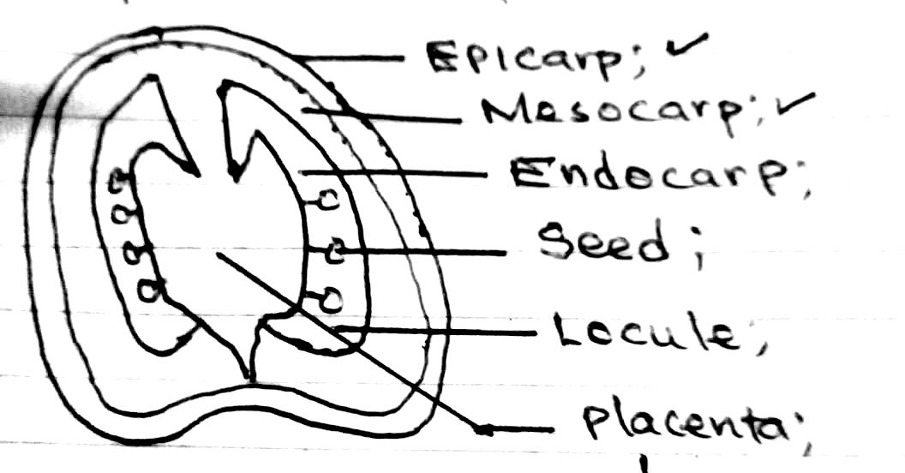
3marks

DRAWING MARK D1 Label mark L1
- Continous double outline - Correct labels
- No broken line - Label lines must touch the part
- No shading - Label lines should not cross
- No arrows on label line

b(ii) Type of fruit:- Berry; 4marks
Reason :- Numerous seeds in succulent endocarp;
Method of dispersal; Animals.
Reason ;Fleshy/juicy/succulent/scented
Brightly coloured;
3(a) – Gills; 1mark
(b) – operculum; 1mark
(c) – Class;Pisces; 1mark
Reason; Presence of scales;/presence of gills

(d)(i) 5marks
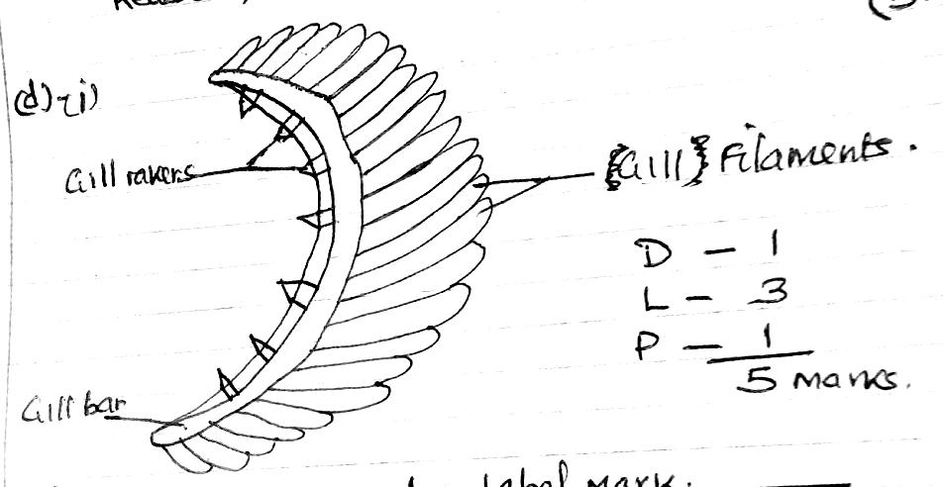

D – Drawing mark L – Label mark
- Continous outline - Label lines must touch the part
- No broken line - Label line do not cross
- No shading - No arrows on label line
P - Proportion mark - Label L and J must be in plural
- Drawing must configure to the standard shape of gill filment.
ii) – Numerous to increase surface area for gaseous exchange 2marks
- Highly vascularised for efficient transport of respiratory gases;
- Thin epithelium to reduce the distance for diffusion of gases;
e) Part ;-Lungs; 2marks
Function ;- Gaseous exchange;

