NAME___________________________________________CLS__________ADM___________
FORM TWO AGRICULTURE.
TERM 2 2025 MID TERM EXAM TIME: 1 HOUR.
ANSWER ALL THE QUESTIONS IN THE SPACES PROVIDED

1. List four methods of farming (4 marks)
………………………………………………………………………………………………………………………………………………………………………………………………………………………………………………………………………………………………………………………………………………………………………………………………………………………………………………………………………………………………………………………………………………………………………………………………………………………………………………………………………………………………………………………………………………
2. Name three underground water sources on the farms (3 marks)
………………………………………………………………………………………………………………………………………………………………………………………………………………………………………………………………………………………………………………………………………………………………………………………………………………………………………………………………………………………………………………………………………………………………………………………………
3 State four aspects of rainfall that a crop farmer should consider when choosing what to grow in certain regions. (4 marks)
………………………………………………………………………………………………………………………………………………………………………………………………………………………………………………………………………………………………………………………………………………………………………………………………………………………………………………………………………………………………………………………………………………………………………………………………………………………………………………………………………………………………………………………………………………
4. Name three surface irrigation methods (3 marks)
………………………………………………………………………………………………………………………………………………………………………………………………………………………………………………………………………………………………………………………………………………………………………………………………………………………………………………………………………………………………………………………………………………………………………………………………

5. a. State three benefits of rolling as a tertiary operation in seed bed preparation. (3 marks)
………………………………………………………………………………………………………………………………………………………………………………………………………………………………………………………………………………………………………………………………………………………………………………………………………………………………………………………………………………………………………………………………………………………………………………………………
b. State three methods of land clearing. (3 marks)
………………………………………………………………………………………………………………………………………………………………………………………………………………………………………………………………………………………………………………………………………………………………………………………………………………………………………………………………………………………………………………………………………………………………………………………………
6. State three types of spanners that can be found in a farm. (3 marks)
………………………………………………………………………………………………………………………………………………………………………………………………………………………………………………………………………………………………………………………………………………………………………………………………………………………………………………………………………………………………………………………………………………………………………………………………
7. Name four dairy goats that are kept in farms. (4 marks)
………………………………………………………………………………………………………………………………………………………………………………………………………………………………………………………………………………………………………………………………………………………………………………………………………………………………………………………………………………………………………………………………………………………………………………………………………………………………………………………………………………………………………………………………………………8. Name the appropriate tool for the following uses.
i. Cutting thin sheets of metal when constructing a farm structure. (1 mark)
………………………………………………………………………………………………………………………………………………………………………………………………………………………………………………………………………………………………
ii. Measuring length of timber when constructing (1 mark)
………………………………………………………………………………………………………………………………………………………………………………………………………………………………………………………………………………………………9. State four practices on the farm that makes agriculture to be viewed as an art. (4 marks)
………………………………………………………………………………………………………………………………………………………………………………………………………………………………………………………………………………………………………………………………………………………………………………………………………………………………………………………………………………………………………………………………………………………………………………………………………………………………………………………………………………………………………………………………………………
10. Name the branch of horticulture involved in the production of the following crops
i. Cabbages ________________________________ (1 mark)
ii. Avocado _________________________________ (1 mark)
11. State three factors influencing soil formation (3 marks)
………………………………………………………………………………………………………………………………………………………………………………………………………………………………………………………………………………………………………………………………………………………………………………………………………………………………………………………………………………………………………………………………………………………………………………………………
12. State two advantages of mixed farming (2 marks)
………………………………………………………………………………………………………………………………………………………………………………………………………………………………………………………………………………………………………………………………………………………………………………………………………………………………………………
13. Below is a land preparation operation. Study it and answer the questions that follow.
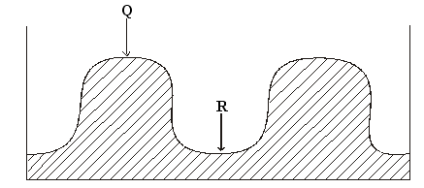
a) Identify the operation. (1 mark)
………………………………………………………………………………………………………………………………………………………………………………………………………………………………………………………………………………………………
b) Name the parts Q and R. (1 mark)
………………………………………………………………………………………………………………………………………………………………………………………………………………………………………………………………………………………………
c) Name one crop that can be planted in part labeled R. (1 mark)
………………………………………………………………………………………………………………………………………………………………………………………………………………………………………………………………………………………………
d) What is the advantage of planting the crop named in (c) above in the part labeled R? (1 mark)
………………………………………………………………………………………………………………………………………………………………………………………………………………………………………………………………………………………………
14. Name two types of inventory records. (1 mark)
………………………………………………………………………………………………………………………………………………………………………………………………………………………………………………………………………………………………………………………………………………………………………………………………………………………………………………
15. Use the diagram below to answer the questions that follow
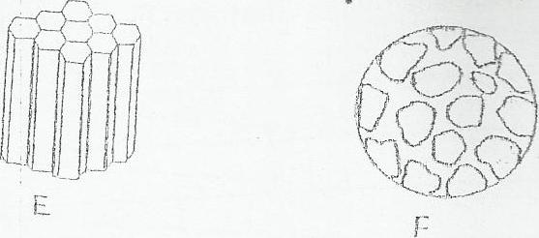

a) Identify each of the soil structures labeled E and F (1 mark)
………………………………………………………………………………………………………………………………………………………………………………………………………………………………………………………………………………………………………………………………………………………………………………………………………………………………………………
b) Give one place where the soil structure labeled F can be found. (1mark)
………………………………………………………………………………………………………………………………………………………………………………………………………………………………………………………………………………………………
c) State three ways in which a farmer can improve the structure of waterlogged clay soil. (3 marks)
………………………………………………………………………………………………………………………………………………………………………………………………………………………………………………………………………………………………………………………………………………………………………………………………………………………………………………………………………………………………………………………………………………………………………………………………………………………………………………………………………………………………………………………………………………

