AGRICULTURE
FORM 2
MID TERM 2 2025
MARKING SCHEME

- List four methods of farming (4mks)
  - □ Mixed farming

  - Nomadic Pastoralism

  - □ Shifting cultivation

  - □ Organic farming

  - □ Agro-forestry
- Name three underground water sources on the farms (3mks)
  - Springs
  - Wells
  - Boreholes
3 State four aspects of rainfall that a crop farmer should consider when choosing what to grow in certain regions.
  - Reliability
  - Amount
  - Distribution
  - Intensity (4mks)

- Name three surface irrigation methods (3mks)
  - Flood irrigation

  - Furrow irrigation

  - Basin irrigation
- a. State three benefits of rolling as a tertiary operation in seed bed preparation. (3mks)

- It increases seed-soil contact
- prevents wind erosion

b. State three methods of land clearing. (3mks)

  - Tree felling

  - Burning

  - Slashing

  - Use of chemicals

  - Removal of stumps

  - Removal of trash

- State three types of spanners that can be found in a farm. (3mks)
- Ring spanner
- Open ended
- Adjustable spanner
- State four dairy goats that are kept in farms. (4mks)
- Saanen
- Toggenberg
- British alpine

- Jamnapari
- Name the appropriate tool for the following uses.
- Cutting thin sheets of metal when constructing a farm structure (1mk)
- Tinsnips

- Measuring length of timber when constructing (1mk)

- Tape measure

- State four practices on the farm that makes agriculture to be viewed as an art. (4mks)
- Tillage of land

- Construction of farm structures

- Measuring distances

- Machine operations

- Harvesting of crops

- Feeding and handling animals.

- Marketing of agricultural products

- Name the branch of horticulture involved in the production of the following crops
- Cabbages _ OLERICULTURE (1mk)

- Avocado _pomology (1mk)

- State three factors influencing soil formation (3mks)
- Climate
- Time
- Topography
- Living organisms

- State two advantages of mixed farming (2mks)
- It is a method of diversification i.e. if one enterprise fail, the farmer can benefit from the other.

- There are mutual benefits between the crops and livestock and they later provide farmyard manure for the crops.

- Below is a land preparation operation. Study it and answer the questions that follow.
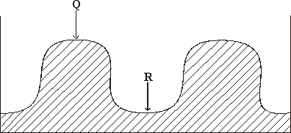
- Identify the operation. (1mk)

Ridging
- Name the parts Q and R. (1mk) Q-Ridge
R-Furrow

- Name one crop that can be planted in part labeled R.(1mk)

  - Sugarcane

- What is the advantage of planting the crop named in (c) above in the part labeled R. (1mk)

  - Soil and water conservation

- Name two types of inventory records . (1mk)

- Consumable good inventory records
- Permanent good inventory records

- Use the diagram below to answer the questions that follow

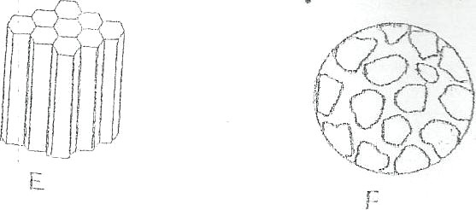
- (1mark)

Identify each of the soil structures labeled E and F

E-prismatic
F-single grained
- Give one place where the soil structure labeled F can be found. (1mark)
- Top soil of sandy soils, arid climates and alkaline soils.

- State three ways in which a farmer can improve the structure of waterlogged

clay soil. (3marks).
- Drainage
- Liming
- Organic manure

