COMPETENCY BASED CURRICULUM
GRADE FIVE-YEAR 2025
G5}
AGRICULTURE AND NUTRITION

- Which one of the following soils is likely to experience less soil erosion?
A. Clay soil
B.Sand soil
C .Loam soil
D . Silt soil
2. Birds kept at home for meat production are known as
A.layers
B. Broilers
C. Weaners
D. Fillet
3. The following are items that are made from the cow hide. Which one is not?
A.Shoes B.Belt C.Helmet D.Wallet
4. Which one of the following is not an agent of soil erosion?
A. Wind
B.Water
C.Sunlight
D. Human activities
5. Below is a climbing fruit that can grow well in many regions in our country.

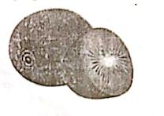
This fruit is mostly likely to be a fruit.
A. grape B. kiwi C.passion D.plum
6. Which one of the following is a drought tolerant crop?
A. Rice B. Maize C. Sorghum D. Yam
7.Below are ways of improving soil. Which one is not?
A. Crop rotation
B. Use of manure
C. Reducing the use of pesticides
D. Afforestation
8. Which one of the following activities would help to avoid tangling of stems in growing climbing fruits?
A Constructing a shade
B Watering regularly
C. Training and tying
D. Adding organic manure
9. When soil or rocks are moved by water or wind these materials are known as
A. Rock
B. sediments
C. Trash
D humus
10. Below is a small wild animal.
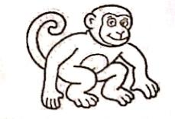

Which crop is it most likely to destroy most?
A. Beans
B. Rice
C. Bananas
D. Kales
11.Below are benefits of a certain domestic animal. Which one is not?
A. Provide wax
B.Provide honey
C.Attack any passer-by
D.Pollinate crops
12.Which one of the following is the odd one out?
A Spider weed
B. African night shade
C. Pigweed
D. Yam

13. Name the gardening tool shown below.
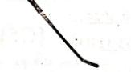

A. panga
B. slasher
C jembe
D. Rake
14.Why is mulch pushed off the seedling after emerging?
A To allow water to be absorbed by the seedling
B. To allow sunlight
C. To allow manure
D To allow growth
15. Identify the material used for the innovative gardening shown below.
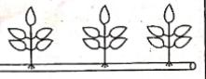
A. shelf
B. recycled bottle
C. broken pipe
D. Wall

NUTRITION
16. Ndolo bought shoes that made him move easily around. Which factor did he consider when buying the shoes?
A. Price
B. Occasion
C. Shape and size
D. Comfort
17. Which disease can be prevented by use of a clean handkerchief to cover your mouth or nose when coughing or sneezing?
A. Typhoid
B. Malaria
C. Tuberculosis
D. Asthma
18.Any substance we eat or drink to sustain life is called
A. nutrients B. food C. minerals D. nutrition
19. Which one of the following is a physical change in pre-adolescent boys only?
A. Increase in weight and height
B. Hair growth under arms
C. Broadening of the chest
D. Broadening of the waist
20. When a person buys items at the right time ,place and price as planned, this is known as
A. Cheap buying
B. impulse buying
C. expensive buying
D. Wise buying
21.What nutritional deficiency is the boy having in the diagram below?
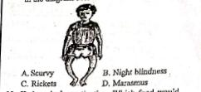
22. Kadogo had constipation. Which food would you advise her t include in her diet?
A.Cashew nuts B. Melon C.Pork D.Eggs
23.Which one of the following is not an example of a grain legume?
A. Lentils. B. Millet. C. Peas. D. Beans
24. Which is the best method to cook samosa?
A. Shallow frying. B. Roasting
C. Dry fat method. D. Deep frying
25. Shiko had ripe oranges, bananas, and melons. She wanted to make their own juice at home. What else did she needs?.
A. Scrapper. B. Strainer.
C. Blender. D. Fridge
26. Below are local materials used to clean kitchen utensils. Which one is not
A. Piece of cloth. B. Maize cob
C. Sieved charcoal. D. Super Brite
27. The following are characteristics of a good storage facility for cereals and pulses. Which one is not
A. Clean space. B. Free if pests
C. Very cool place. D. Have security
28. Kisha’s mothers cooking stick always looks new. How does she maintain it?
A. Scrubs it with steel wool
B. Sprinkles ash on it to wash
C. Dries it with a clean piece of cloth
D. Rubs it with a little cooking oil after cleaning it
29. Anemia deficiency is also known as
A. Enlarged thyroid. B. School disease
C. Weak blood. D. Mumps
30. The main nutrient we get from cereals is
A. Proteins. B. Vitamins
C. Minerals. D. Carbohydrates

