COMPUTER STUDIES
PAPER 1
2025
MARKING SCHEME
- State any two peripheral devices that are powered by the system unit. (1mark)
-Mouse
-keyboard
2. Explain any THREE functions of system software in a computer (3marks)
-Supports the development of other application software.
-Supports the execution of other application software.
-Monitors the effective use of various hardware resources e.g. CPU, memory, peripherals etc.
-Communicates and controls the operation of peripheral devices such as a printer.
-Performs a variety of system utility functions

- As a computer student you have been asked to assist in buying an input device. State any four factors to consider when buying input devices. (4 marks)
Type of data to be input
Speed
Accuracy of the input device
Cost of the device
Availability of the device
- (a) Define the term mail merging (1mark)
- Process of generating personalized documents or letters by combining main document with an existing data source.
(b) Name two files that are created in mail merging process (1mark)
-Primary file / Main document
-Secondary file/ Data source
-Merged file
- (a) Distinguish between a workbook and a worksheet as used in spreadsheets (2 marks)
- Worksheet: A component in which data values are entered. It contains rows and columns.
- Workbook: A group or collection of worksheets.
(b) What is the meaning of “what if analysis” with respect to spreadsheet?
(1 mark)
It’s a feature used in forecasting where, the probability of changing or altering of values is measured to predict likely future occurrences.

- Differentiate between the following terms as used in word processing
(3 marks)
- Drop Cap and Case
Drop cap is a large character at the start of paragraph that occupies more than one line downwards while text case is capitalization of text ( you can switch from either lower or uppercase)
- Superscript and subscript
A superscript appears just above the rest of the characters while subscript appears just below other characters while subscript appears just below other characters
- Indent and tab
An indent is a white space at the beginning of each line while tabs are used to add uniform spacing in the line of text
7. Benjamin was instructed by his teacher while typing a Microsoft word document to replace all the occurrences of the word MS with Microsoft. Highlight the steps to do this (3 marks)
- Click edit menu then replace command
-The find and replace dialog box appears
-In the find what box type MS
-In the replace with box type Microsoft
-Click find next button
-Click the replace all button
8. What is the difference between logical and physical file? (2 marks)
Logical file is viewed in terms of what data items it contains and details of what processing operations may be performed on the data items while a physical file is one that is viewed in terms of how data is stored in storage media and how the processing operations are made possible.
9. Give a reason why HTML is not considered as a true programming language. (1 mark)
-It does not have the declaration part and control structures.
10. Explain three types of control structures use in programming. (3 marks)
-Sequence
-Selection/decision
-Iteration/looping
11. State the following types of transcription errors: (2 marks)
i. 3455 instead of 3456
3455 instead of 3456 ( misreading)
ii. Simth instead of Smith
Simth instead of smith (Transposition)
12. Explain the following terms as used in desktop publishing (3 marks)
- Embedded object
a separate image/ graphic/ clip that is placed into a file e.g. movie clip pasted into DTP document
would be considered as an embedded object
- Auto flow
Auto flow: Facility that allows text to flow automatically from one textbox to the next when the first
text box is full
- Zoom
Zoom - changing the magnification of publication page either to get a closer view (zoom in) or to see more of the page at a reduced size (zoom out).
- State four ways of identifying an illegal copy of an operating system (4 marks)
No license agreement as certificate of authenticity
Prices that are extremely cheap
No documentation manual
When one connects to the internet for authentication, the report from the manufacturer indicates that the user may be a victim of software counterfeit.
Frequent run time or occurrence of fatal error when using the machine.
- Give three ways in which horticultural farmers can benefit from the use of information and communication technology (3 marks)
Source of information for the best farming practices
Searching tool for best market for their produce
Marketing tool
ICT can also be used by farmers to manage complex business systems
- Outline three roles of an internet service provider(ISP) (3 marks)
Link user to the internet
Host websites
Provide customized email addresses
Manage internet traffic
Provide firewalls

SECTION B (60MARKS)
Answer question 16 and any other three questions

- (a) Define ; (2 marks)
- Object code
It is a machine code produced by a computer
It is an output of a translator
It is a translated source code
Translated program code
- Source code
This is a program written in the specific programming language
Un translated program code
Program in human understandable
- Study this flowchart and use it to answer questions that follow
YES
NO
Start
S= 1

ENTER Y
Y = Y/10
Y < 10?
S = S+1

PRINT S
STOP

- Give the expected output from the flowchart when the value of Y is (6 marks)
- 48
1
(ii) 9170

- 800
1
- Write the pseudocode that can be used to create a program represented by the above flowchart (7 marks)
Start marks
S=1 start / stop – 1mk
Read Y initialization – 1mk
Repeat input/ output – 1mk
Y-Y/10 looping – 1mk
If Y <10 Then if statement -2mks
S=S+1 logical sequence – 1mk
End if
Until Y<10 total = 7mks
Print S
Stop

- (a) Define artificial Intelligence. (1 mark)
- Refers to the ability of a computer to mimic human capabilities
- It is the branch of computer science that is concerned with the development of machines that emulate human — like qualities such as learning, reasoning, communicating
- The science of attempting to develop machine that mimic human behaviours
(b) Explain the application of artificial intelligence in the following areas.
(6 marks)
(i) Natural language processing - have been used to produce voice recognition and synthesis system
(ii) Robotics - All have been used to control robot
- AT have been used to construct robots
- Computers are used to control machines in the place of man. E.g. welding, spraying, loading
(iii) Expert systems - At have been used to produce
- Expert systems that can be used in research, medical diagnosis etc
(b) Give any two symptoms of the following computer work-related disorders and two of their methods of prevention. (4 marks)
(i) Computer vision syndrome.
Symptoms
- Sore, tired, burning and itching or dry eyes
- Blurred or double vision
- Headache or sore neck
- increased sensitivity to light
Prevention
- Take a break of 5 to 10 minutes
- Reduce glare and reflection from the computer screen
- Adjust the contrast and brightness of the screen
- Prevent eye strain by adjusting the sitting height
- Gentle massage your eyes
(ii) Repetitive strain injury (4 marks)
Symptoms
- Numbness in the thumb or in fingers
- Extreme pain at the wrist
- Tingling in the finger
Prevention
- Take frequent breaks
- Position as the keyboard

18. (a) i. Subtract 110₂ from 11010₂ (1 mark)
11010₂
110₂
10100₂
ii. Find the sum of binary number 101.101₂ and 110.100₂ (1mark)
101.101₂
110.100₂
1100.001₂
(b) i). Convert binary number 11010110.1001₂ into octal number. (2 marks)
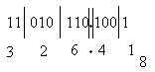
ii). Convert binary number 11010110.1001₂ into hexadecimal number. (1mark)
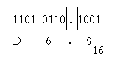
(c) Convert the following numbers to their decimal equivalent
i. 11.011₂ (2marks)
(2 ⁰ x 1) + (2¹ x 1) + (2 ⁻¹ x 0) + (2⁻² x 1) + (2⁻³ x 1)
= 1 + 2 +0+0.25+0.125
= 3.375₁₀
ii. 0.11011₂ (2marks)
0. (2 ⁻¹ x 1) + (2⁻² x 1) + (2⁻³ x 0)+ (2 ⁻⁴ x 1) + (2⁻⁵x 1)
0. 5 + 0.25+ 0.0 +0.0625+0.03125
=0.84375₁₀

(d) i). Convert ABCD₁₆ to Octal. (3marks)
A = 10 = 1010
B = 11 = 1011
C = 12 = 1100
D = 13 = 1101 1mk

001 010 101 110 001 101
1 2 5 7 1 5 1mk

Therefore ABCD₁₆ = 125715₈ 1mk
ii). Using one’s complement, calculate 5₁₀ – 9₁₀. use six bit in your calculation. (3 marks)
Conversion
5₁₀ = 000101₂
9₁₀ = 001001₂1mk

-9₁₀: ones complement = 110110
Adding 000101 1mk
110110 +
111011₂ 1mk
19. (a) i). What is an operating system? (1 mark)
- This is a suit of programs that provide a facilities that enable the other programs to use the hardware in a safe and controlled way
- Is a suit of programs that takes over the operation of the computer to the extent of being able to allow a number of programs to be run on the computer without human intervention by an operator
ii). Explain how an operating system controls I/O devices. (2marks)
The operating system manages the use of input and output devices. This is done by the use buffers .The operating instructs input and output buffers to take inputs from an input device or to take outputs from the processor while the process using the input or output is suspended .when the process which needs the input is made active once again, the operating system will command the buffer to send data.
iii). Maintaining security is one of the functions the operating system. Explain how the operating system maintains security (2 marks)
Maintaining security-in networks and larger computers each user is given a username or ID and passwords to gain access to the computer system. the operating system keeps a register of all the names so that the only persons with valid usernames or IDs passwords can access the system. The operating system keeps a log which records users logged in, the length of time each user stayed in the system and what they did.
- What do the following control measures against computer crime involve? (5 marks)
  - Audit trail
Careful study of an information system by experts to establish all weaknesses in the system that could lead to security threats
ii. Data encryption
Combination of letters and characters that deter unauthorized users of computers from accessing data
iii. Log files
These are special files that keep a record (log) of events on the use of computers and resources of an information system.
iv. Passwords
Is a combination of characters that prevents other users from opening and changing a document without permission?
v. Firewall
Monitor and control access to or from protected networks
(c) Briefly explain what happen during power on self-test (POST) (3 marks)
- A line of text start scrolling up on the screen
- Check on the existence and conditions of the drives such as keyboard, monitor and mouse
- If a problem occurs due to malfunction, the process is halted and error message is displayed on the screen

(d) Explain the functions of complementary metal-oxide semiconductor (CMOS) (2 marks)
- keep data that needs to be retained even when the computer is turned off and unplugged (a small battery is used to supply power to the CMOS chip)
- maintain system date, time among others
20. (a) State and explain the following types of relationship as used in database design
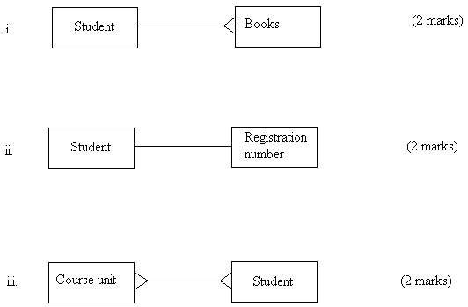

For the above figure:
i. One to many relationship. Means a student can borrow many books e.g in a library
ii. One to one relationship. Implies that a student has one registration number
iii. Many to many relationship. Implies that there are many course units that can be taken by many students
(b) i. Explain the difference between primary key and an index key as used in database application (2 marks)
A primary key is a unique identifier for a database record while index key
An index is a key used to more quickly find rows in the table based on the values which are part of the index
ii. Outline the functions of a primary key (2marks)
    - Uniquely identifies a record
    - It prevents null entry
    - Eliminates data redunduncy
(c) Describe the following types of database model
i. Network model (2marks)
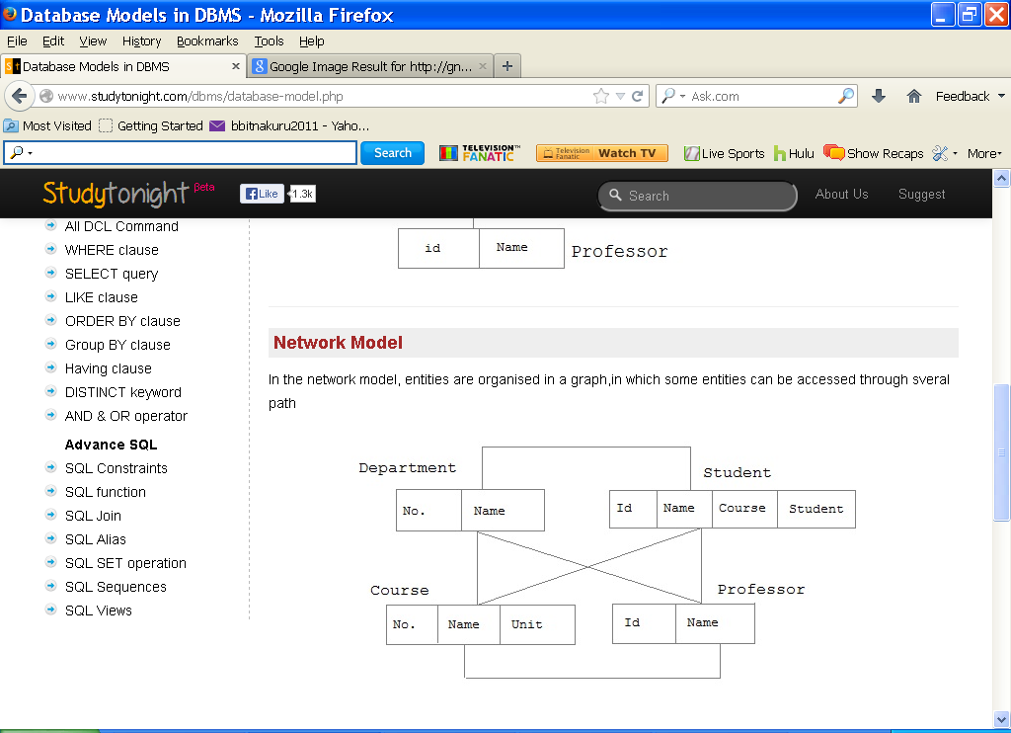
In the network model, entities are organized in which some entities can be accessed through several path
ii. Relational model (3marks)
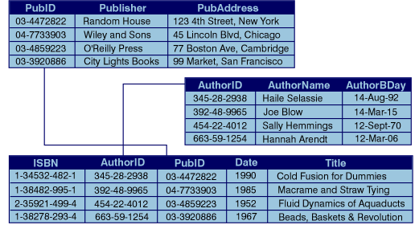
In this type of organization, related data items are stored together in a relations or tables. Relationship can be created between tables such that a record or records from one table relates to another or other records in another table.

This is the last printed page

