NAME:…………………………………………..........................................ADM NO.............
SCHOOL:……………………………………… CANDIDATE’S SIGN ……………..
DATE ………………………………
443/1

AGRICULTURE
Paper One
Time: 2 Hours
YEAR 2025

NYAMIRA NORTH
FORM FOUR 2025 CONTEST EXAM

INSTRUCTIONS TO CANDIDATES
1. Write your name and admission number in the spaces provided above
2. Sign and write the date of examination in the spaces provided above.
3. This paper consists of three sections: A, B and C
4. Answer all the questions in section A and B and any two questions from section C
5. Answers should be written in the spaces provided.

For Examiner’s Use Only

Section | Question | Maximum Score | Candidate’s Score
A | 1-17 | 30
B | 18-22 | 20
C | 23-25 | 40
 | Total Score | 90

SECTION A 30 MARKS
Answer all the questions in the spaces provided.
- State four characteristics of nitrogenous fertilizers . [2mks]
_______________________________________________________________________________________________________________________________________________________________________________________________________________________________________________________________________________________________________________________
- Give four ways in which pesticides are classified based on mode of action. [2mks]
_______________________________________________________________________________________________________________________________________________________________________________________________________________________________________________________________________________________________________________________
- State four advantages of communal land tenure system. [2mks]
_______________________________________________________________________________________________________________________________________________________________________________________________________________________________________________________________________________________________________________________
- Differentiate between intensive farming and extensive farming. [1mk]
_______________________________________________________________________________________________________________________________________________________________________________________________________________________________________________________________________________________________________________________
- State four factors to consider when selecting a crop for green manure. [2mks]
_______________________________________________________________________________________________________________________________________________________________________________________________________________________________________________________________________________________________________________________
- State four disadvantages of using vegetative materials in crop production. [2mks]
_______________________________________________________________________________________________________________________________________________________________________________________________________________________________________________________________________________________________________________________
- State two importance of sub soiling in crop production. [1mk]
_______________________________________________________________________________________________________________________________________________________________________________________________________________________________________________________________________________________________________________________
- Give four advantages of silage making [2mks]
___________________________________________________________________________________________________________________________________________________________________________________________________________________________________________________________________________________________________________________________________

- State four importance of keeping farm records. [2mks]
_______________________________________________________________________________________________________________________________________________________________________________________________________________________________________________________________________________________________________________________
- Give two methods of soil sampling. [2mks]
__________________________________________________________________________________________________________________________________________________________________________________________________________________________________________________________________________________________________________________________________
- Differentiate between pricking out and thinning in crop production. [1mk]
___________________________________________________________________________________________________________________________________________________________________________________________________________________________________________________________________________________________________________________________________
- Name four types of water pumps. [2mks]
___________________________________________________________________________________________________________________________________________________________________________________________________________________________________________________________________________________________________________________________________
- State three ways in which herbicides are classified. [1 ½ mks}
____________________________________________________________________________________________________________________________________________________________________________________________________________________________________________________________________________________________________________________________________
- State three agricultural activities that may pollute water in the farm. [1 ½ mks]
_______________________________________________________________________________________________________________________________________________________________________________________________________________________________________________________________________________________________________________________
- Give four ways of breaking seed dormancy. [2mks]
_______________________________________________________________________________________________________________________________________________________________________________________________________________________________________________________________________________________________________________________
- State four quality of a good root stock. [2mks]
_______________________________________________________________________________________________________________________________________________________________________________________________________________________________________________________________________________________________________________________
- State four reasons four treating water in the farm. [2mks]
_______________________________________________________________________________________________________________________________________________________________________________________________________________________________________________________________________________________________________________________

SECTION B( 20 MARKS]
Answer all the questions in this section in the spaces provided.

- . Below is a diagram of a weed. Study the diagram carefully and answer the questions
that follow.

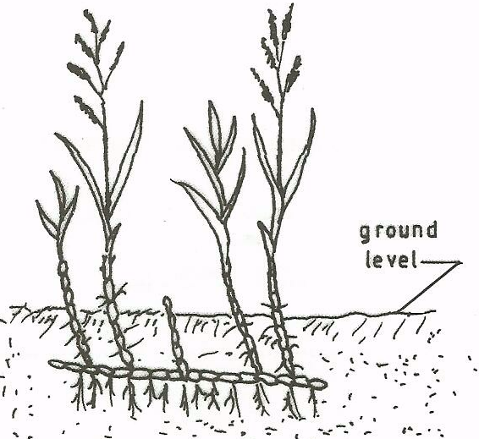

(a) Identify the weed illustrated above. (1 mk)
______________________________________________________________________________
(b) Why is the weed illustrated above difficult to control? (1 mk)
___________________________________________________________________________
(c) State four ways in which the weed can be controlled in a field of maize. (2 mks)
__________________________________________________________________________________________________________________________________________________________________

19. The diagram below illustrate a field management practice in tomatoes .study it
carefully and answer the questions that follow.
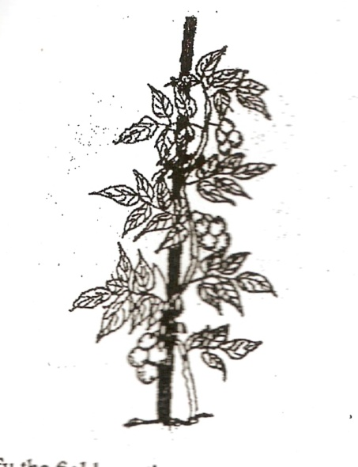
- Identify the field practice ( 1 mk)

________________________________________________________________________________

- State three reasons for carrying out the practice (3mks)
________________________________________________________________________________________________________________________________________________________________________________________________________________________________________________________________________________________________________________________________________________________________________________________________________________

- The diagram below illustrates a final seedbed after a tertiary operation done during land preparation. Study it carefully and answer the questions that follow.

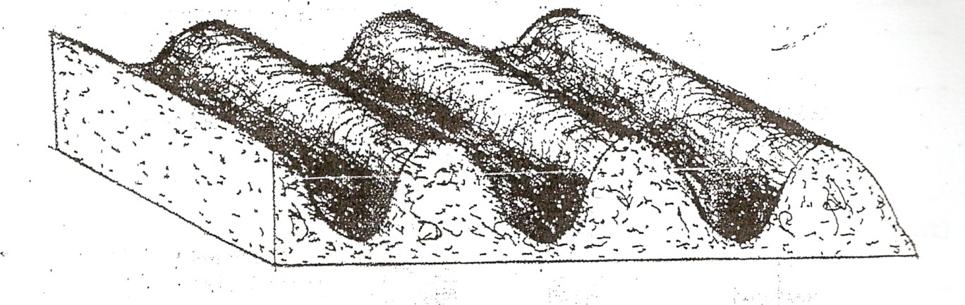

(a) Name the tertiary operation carried out on the seedbed (1mk)

(b) Describe how the tertiary operation named in one above is carried out. (1mk)
___________________________________________________________________________________________________________________________________________________________________________________________________________________________________________________

(c) Give two advantages of planting crops on a final seedbed illustrated above (2 mks)
___________________________________________________________________________________________________________________________________________________________________________________________________________________________________________________

21. The diagram below illustrates a seed potato prepared for planting. Study it
carefully and answer the questions that follow:

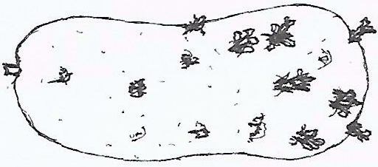

(a) Name the practice used in preparing the seed potato above for planting. (1 mk)
___________________________________________________________________________
b) Describe the procedure followed in preparing seed potatoes for planting. (3 mks)
______________________________________________________________________________________________________________________________________________________________________________________________________________________________________________________________________________________________________________________

22.The illustration below shows a structure used for controlling soil erosion. Study it carefully and answer the questions that follow.
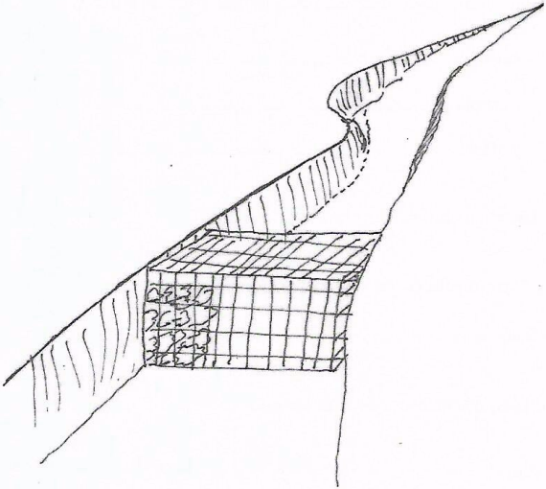

a) Identify the structure (1mk)
____________________________________________________________________________
_______________________________________________________________________________
b) Explain two ways in which the structure helps to control soil erosion (2mks)
________________________________________________________________________________
________________________________________________________________________________
c) Name two materials used for making the structure above. (1mk)
___________________________________________________________________________________________________________________________________________________________________________________________________________________________________________

SECTION C ( 40 MARKS)
Answer only two questions in the spaces provided after question 25
23. a) Explain five methods of fertilizer application. [10mks]
b) Explain five factors that determine the time of harvesting crops [5mks]
c) Explain five cultural methods of disease control in crops. [5mks]
24. a) Explain five importance of African settlement schemes. [5mks]
b) Explain five importance of organic matter in the soil. [5mks]
c) Describe five cultural methods of controlling soil erosion. [10mks]
25. a) Give five reasons for land registration in Kenya. [5mks]
b) Explain five importance of pruning in crop production. [5mks]
c) Describe the transplanting of tomato seedlings. [10mks]
_______________________________________________________________________________________________________________________________________________________________________________________________________________________________________________________________________________________________________________________________________________________________________________________________________________________________________________________________________________________________________________________________________________________________________________________________________________________________________________________________________________________________________________________________________________________________________________________________________________________________
__________________________________________________________________________________________________________________________________________________________________________________________________________________________________________________________________________________________________________________________________________________________________________________________________________________________________________________________________________________________________________________________________________________________________________________________________________________________________________________________________________________________________________________________________________________________________________________________________________________________________________________________________________________________________________________________________________________________________________________________________________________________________________________________________________________________________________________________________________________________________________________________________________________________________________________________________________________________________________________________________________________________________________________________________________________________________________________________________________________________________________________________________________________________________________________________________________________________________________________________________________________________________________________________________________________________________________________________________________________________________________________________________________________________________________________________________________________________________________________________________________________________________________________________________________________________________________________________________________________________________________________________________________________________________________________________________________________________________________________________________________________________________________________________________________________________________________________________________________________________________________________________________________________________________________________________________________________________________________________________________________________________________________________________________________________________________________________________________________________________________________________________________________________________________________________________________________________________________________________________________________________________________________________________________________________________________________________________________________________________________________________________________________________________________________________________________________________________________________________________________________________________________________________________________________________________________________________________________________________________________________________________________________________________________________________________________________________________________________________________________________________________________________________________________________________________________________________________________________________________________________________________________________________________________________________________________________________________________________________________________________________________________________________________________________________________________________________________________________________________________________________________________________________________________________________________________________________________________________________________________________________________________________________________________________________________________________________________________________________________________________________________________________________________________________________________________________________________________________________________________________________________________________________________________________________________________________________________________________________________________________________________________________________________________________________________________________________________________________________________________________________________________________________________________________________________________________________________________________________________________________________________________________________________________________________________________________________________________________________________________________________________________________________________________________________________________________________________________________________________________________________________________________________________________________________________________________________________________________________________________________________________________________________________________________________________________________________________________________________________________________________________________________________________________________________________________________________________________________________________________________________________________________________________________________________________________________________________________________________________________________________________________________________________________________________________________________________________________________________________________________________________________________________________________________________________________________________________________________________________________________________________________________________________________________________________________________________________________________________________________________________________________________________________________________________________________________________________________________________________________________________________________________________________________________________________________________________________________________________________________________________________________________________________________________________________________________________________________________________________________________________________________________________________________________________________________________________________________________________________________________________________________________________________________________________________________________________________________________________________________________________________________________________________________________________________________________________________________________________________________________________________________________________________________________________________________________________________________________________________________________________________________________________________________________________________________________________________________________________________________________________________________________________________________________________________________________________________________________________________________________________________________________________________________________________________________________________________________________________________________________________________________________________________________________________________________________________________________________________________________________________________________________________________________________________________________________________________________________________________________________________________________________________________________________________________________________________________________________________________________________________________________________________________________________________________________________________________________________________________________________________________________________________________________________________________________________________________________________________________________________________________________________________________________________________________________________________________________________________________________________________________________________________________________________________________________________________________________________________________________________________________________________________________________________________________________________________________________________________________________________________________________________________________________________________________________________________________________________________________________________________________________________________________________________________________________________________________________________________________________________________________________________________________________________________________________________________________________________________________________________________________________________________________________________________________________________________________________________________________________________________________________________________________________________________________________________________________________________________________________________________________________________________________________________________________________________________________________________________________________________________________________________________________________________________________________________________________________________________________________________________________________________________________________________________________________________________________________________________________________________________________________________________________________________________________________________________________________________________________________________________________________________________________________________________________________________________________________________________________________________________________________________________________________________________________________________________________________________________________________________________________________________________________________________________________________________________________________________________________________________________________________________________________________________________________________________________________________________________________________________________________________________________________________________________________________________________________________________________________________________________________________________________________________________________________________________________________________________________________________________________________________________________________________________________________________________________________________________________________________________________________________________________________________________________________________________________________________________________________________________________________________________________________________________________________________________________________________________________________________________________________________________________________________________________________________________________________________________________________________________________________________________________________________________________________________________________________________________________________________________________________________________________________________________________________________________________________________________________________________________________________________________________________________________________________________________________________________________________________________________________________________________________________________________________________________________________________________________________________________________________________________________________________________________________________________________________________________________________________________________________________________________________________________________________________________________________________________________________________________________________________________________________________________________________________________________________________________________________________________________________________________________________________________________________________________________________________________________________________________________________________________________________________________________________________________________________________________________________________________________________________________________________________________________________________________________________________________________________________________________________________________________________________________________________________________________________________________________________________________________________________________________________________________________________________________________________________________________________________________________________________________________________________________________________________________________________________________________________________________________________________________________________________________________________________________________________________________________________________________________________________________________________________________________________________________________________________________________________________________________________________________________________________________________________________________________________________________________________________________________________________________________________________________________________________________________________________________________________________________________________________________________________________________________________________________________________________________________________________________________________________________________________________________________________________________________________________________________________________________________________________________________________________________________________________________________________________________________________________________________________________________________________________________________________________________________________________________________________________________________________________________________________________________________________________________________________________________________________________________________________________________________________________________________________________________________________________________________________________________________________________________________________________________________________________________________________________________________________________________________________________________________________________________________________________________________________________________________________________________________________________________________________________________________________________________________________________________________________________________________________________________________________________________________________________________________________________________________________________________________________________________________________________________________________________________________________________________________________________________________________________________________________________________________________________________________________________________________________________________________________________________________________________________________________________________________________________

