COMPETENCE BASED ASSESSMENT
PRE-PRIMARY ONE TERM 1 2025
MATHEMATICS ACTIVITIES

NAME: ………………………………………………………….………….. DATE……………………………….

- How many are they? [match] (50 mks)
5
1
3

3

2

5

2
1

- Write numbers 1 – 5 in the dashes.(25 mks)
_______ _______ _______ _______ ________
8
6
- Colour the numbers; (10 mks)

2
5
3
- Complete these numbers;(15 marks)

COMPETENCE BASED ASSESSMENT
PRE-PRIMARY ONE TERM 1 2025
LANGUAGE ACTIVITIES

NAME: ………………………………………………………….………….. DATE……………………………….

- Circle sound b (40 mks) Circle sound f
b a b c b a
a b f
f c f c b f a f

g
j
- colour the letters (20 mks)



- Identify pictures below (20 mks)

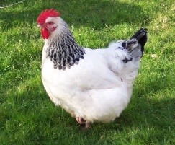

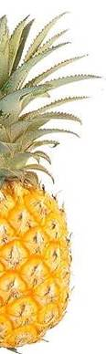

- Find the other half by matching (20 mks)




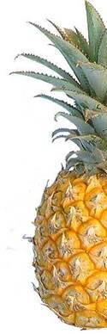




COMPETENCE BASED ASSESSMENT
PRE-PRIMARY ONE TERM 1 2025
LITERACY ACTIVITIES

NAME: ………………………………………………………….………….. DATE……………………………….

a b c d
e f g h
I j k l
m n o p

COMPETENCE BASED ASSESSMENT
PRE-PRIMARY ONE TERM 1 2025
CREATIVE ACTIVITIES

NAME: ………………………………………………………….………….. DATE……………………………….

- Complete the patterns; (2O mks)

____________________________

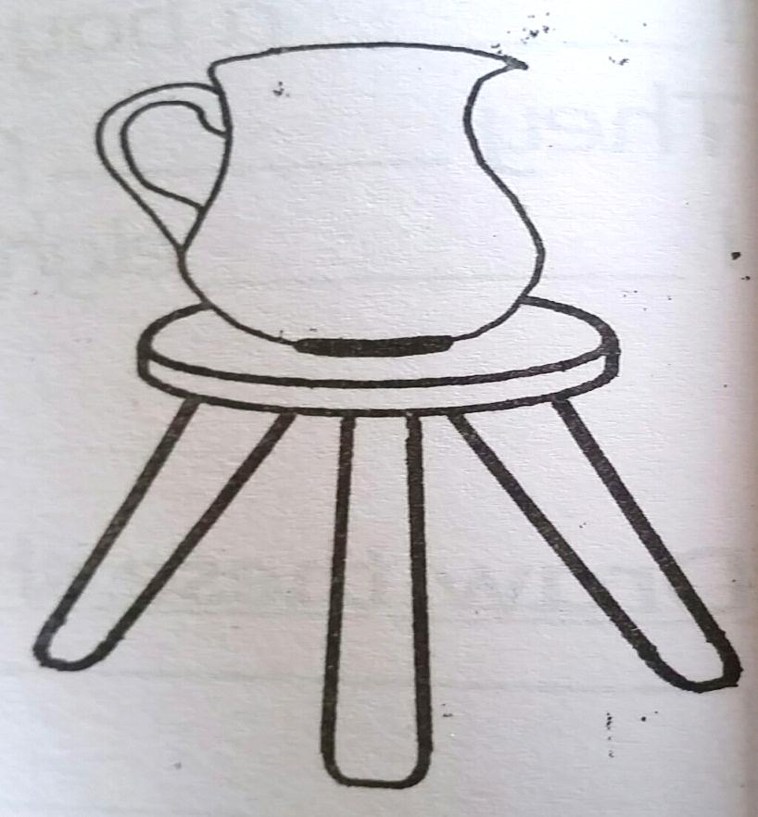
3 3 3 3 3 _______________________

- Colour the picture.(30 mks)

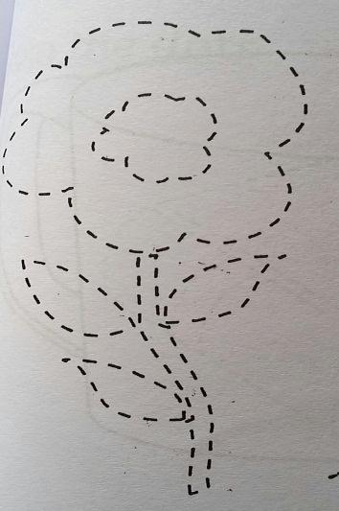
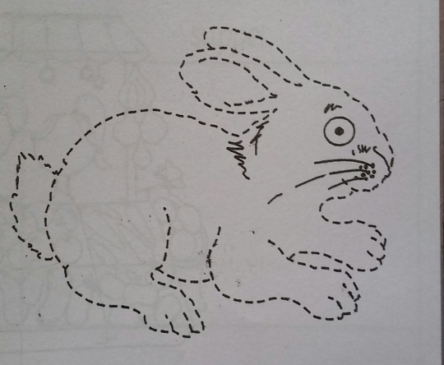
- Join the dots;(40 mks)

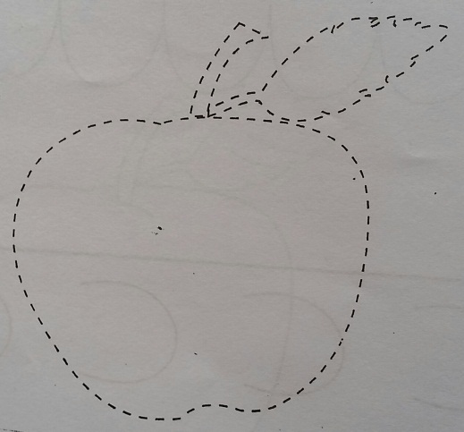
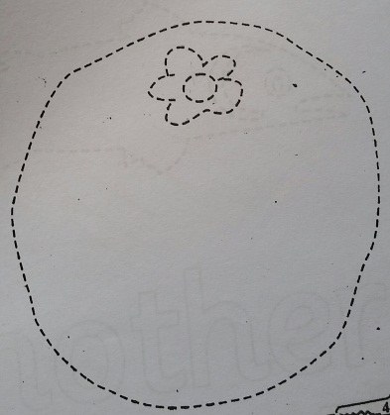

- Draw a house. (10 mks)

COMPETENCE BASED ASSESSMENT
PRE-PRIMARY ONE TERM 1 2025
ENVIRONMENTAL ACTIVITIES

NAME: ………………………………………………………….………….. DATE……………………………….

- Colour our clothes; (70 marks)




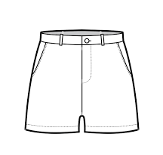

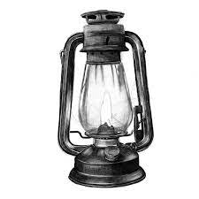
- Tick out the utensils from these pictures; (30 marks)
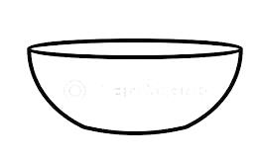

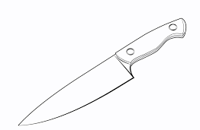




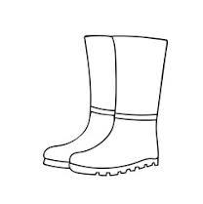

COMPETENCE BASED ASSESSMENT
PRE-PRIMARY ONE TERM 1 2025
RELIGIOUS ACTIVITIES

NAME: ………………………………………………………….………….. DATE……………………………….


- Colour the pictures.(50 mks)




- Colour the creation of God. (50 mks)

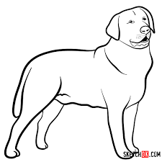
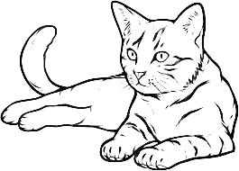

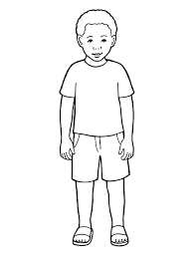




COMPETENCE BASED ASSESSMENT
PRE-PRIMARY ONE TERM 1 2025
LITERACY ACTIVITIES

NAME: ………………………………………………………….………….. DATE……………………………….

- Read the following aloud.
rat hat tap mat has

ball fall bag pan

bell hen tell ten

boy toy joy

